Faye Walters 30/01/23
Slide number | Slide talk through red is content on the slide | Suggested changes by facilitator
1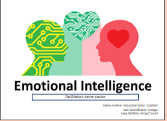 | Introduce yourself.  Welcome to the session on emotional intelligence today. Many people have heard of IQ but not as many have heard of EI. Although it is now more popular than it was 20 years ago, it is probably something you have not heard much about and  May understand a little at less. Has anyone heard of EI? Want to take a guess at what it may be?
2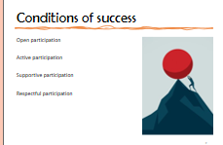 | To discuss with group:  We appreciate this is slightly different from the usual content of the programme. For us to get the most out of this, an open honest discussion will be best. Let’s look at some ground rules of open participation, active participation, supportive participation and respectful participation.  For facilitator:  Can be used to manage group dynamics/behaviour in the group, something to refer back to if these conditions of success are not being met.
3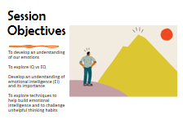 | - To develop an understanding of our emotions  - To explore IQ vs EQ  - Develop an understanding of emotional intelligence (EI) and its importance  - To explore techniques to help build emotional intelligence and to challenge unhelpful thinking habits
4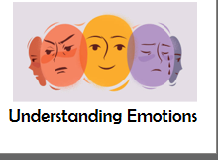 | Emotions can often be ignored and/or misunderstood and in many scenarios, particularly in the workplace, some people can feel uncomfortable displaying, sharing and talking about them.  Human beings are emotional. We experience a range of emotions throughout the day, and we often don't mind talking about and experiencing the pleasant ones, but many of us struggle with the less desirable ones. Understanding and navigating our own emotions is the first step in helping us to understand the emotions of others.
5  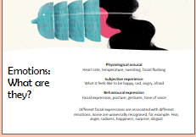 | Emotions don't happen independently of the person. Emotions impact the physical body, such as raising your heart rate and temperature, making your mouth dry or giving you butterflies in your stomach. Emotions are subjective, meaning each person will experience them differently and every person will have a different response to the same external stimuli/ trigger. For example, a sad song on the radio will trigger a different response from person to person. I might be a bit sad whilst my friend may be distraught. We will investigate why this may be later in the session.  Unless consciously trying to hide your emotions (which can be difficult to do), the way you feel will impact your body language such as your facial expressions, mannerisms, tone of voice, speed of talking and the energy that you give.
6  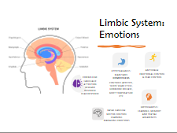 | Our emotional responses are formed by the development of a complex neural system in the brain.  Let’s explore a few of the brain functions which affect out emotions and our responses to triggers.  HYPOTHALMUS- A structure deep in your brain which acts as your body's smart control coordinating centre. Its main function is to keep your body in a stable state called homeostasis. It does its job by directly influencing your autonomic nervous system or by managing hormones.  HIPPOCAMPUS- Hippocampus has a major role in learning and memory. It is a plastic and vulnerable structure that gets damaged by a variety of stimuli. Studies have shown that it also gets affected in a variety of neurological and psychiatric disorders.  Emotions and thoughts, especially strong emotions, are often formed in response to trauma or significant events in life. This can alter the physical state of the brain.  BASAL GANGLIA- The “basal ganglia” is responsible primarily for motor control, as well as other roles such as motor learning, executive functions and behaviors, and emotions.  AMYGDALA- The amygdala is commonly thought to form the core of a neural system for processing fearful and threatening stimuli. It detects potential threats and activates an appropriate fear-related behavior in response. The amygdala initiates the fight/ flight/ freeze response to a perceived threat.  CEREBELLUM- Your cerebellum is part of your brain that helps coordinate and regulate a wide range of functions and processes in both your brain and body. While it's very small compared to your brain overall, it holds more than half of the neurons (cells that make up your nervous system) in your whole body.
7  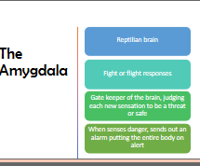 | The human species would not be where we are today without the amygdala keeping the body safe by constantly looking for threats and responding. However, in today's society the amygdala is bombarded with constant perceived threats which can create havoc with a person’s reality and can lead to feelings of unnecessary danger.  As cave people, the amygdala responded to threats of sabre tooth tigers and other predators, however in todays society it is overloaded with perceived threats from social media, university presentations and social situations. For example, if someone does not include us in a WhatsApp group, this can trigger the amygdala unnecessarily into a fight/ flight or freeze response and we can experience very strong emotions.
8  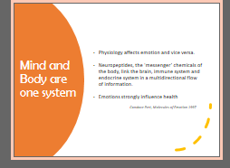 | Whether the mind lives in a states of reasonable calmness and healthy stimulation, or heightened chronic stress and anxiety, all will have an influence over the bodies physical health in the short term, and particularly impact on its longevity.
9  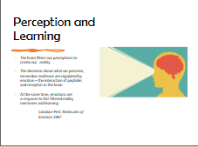 | It can be easily forgotten that the brain only responds to the messages it receives from the external world. The filtering system that takes place by the brain is unique to each individual, particularly the emotional side of the brain such as thoughts and feelings. These are often interpreted by the persons previous lived experience and memory of that event, rather than the absolute fact of the situation in front of them.  Have you ever had an experience you shared with somebody and their interpretation of it was very different from yours? Whose version was the correct one?
10  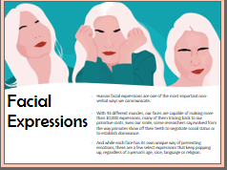 | - Human facial expressions are one of the most important non-verbal ways we communicate.  - With 43 different muscles, our faces are capable of making more than 10,000 expressions, many of them tracing back to our primitive roots. Even our smile, some researchers say, evolved from the way primates show off their teeth to negotiate social status or to establish dominance.  - And while each face has its own unique way of presenting emotions, there are a few select expressions that keep popping up, regardless of a person’s age, race, language or religion.  Thankfully there are a few common presentations to help us be a social species, and often, especially for those who are emotionally intelligent, it is possible to have an agreed awareness of another person’s emotions  Let’s see how good you are!
11  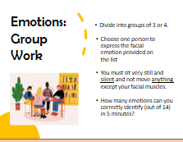 | Group work.  Re-group:  How did you find that? Sometimes we can be surprised how easy we find it to recognise emotions in other people. Ultimately, it can support our survival by helping us differentiate between friend and foe (and all the grey in between)!.
12 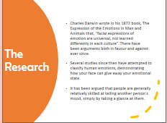 | - Charles Darwin wrote in his 1872 book, The Expression of the Emotions in Man and Animals that, “facial expressions of emotion are universal, not learned differently in each culture”. There have been arguments both in favour and against ever since.  - Several studies since then have attempted to classify human emotions, demonstrating how your face can give away your emotional state.  - It has been argued that people are generally relatively skilled at telling another person's mood, simply by taking a glance at them.
13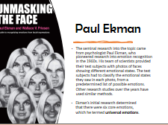 | - The seminal research into the topic came from psychologist Paul Ekman, who pioneered research into emotion recognition in the 1960s. His team of scientists provided their test subjects with photos of faces showing different emotional states. The test subjects had to classify the emotional states they saw in each photo, from a predetermined list of possible emotions. Other research studies over the years have used similar methods.  - Ekman’s initial research determined that there were six core emotions, which he termed universal emotions.
14  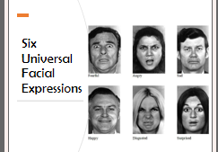 | These six expressions have been identified across all cultures.
15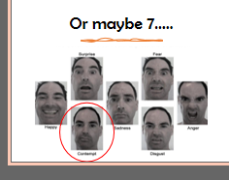 | How about an extra one? Contempt perhaps? It is more subtle but exists.  Contempt is the feeling that a person or a thing is worthless or beneath consideration
16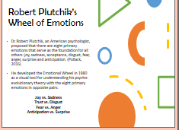 | - Dr. Robert Plutchik, an American psychologist, proposed that there are eight primary emotions that serve as the foundation for all others: joy, sadness, acceptance, disgust, fear, anger, surprise and anticipation. (Pollack, 2016)  - He developed the Emotional Wheel in 1980 as a visual tool for understanding his psycho-evolutionary theory with the eight primary emotions in opposite pairs:  Joy vs. Sadness  Trust vs. Disgust  Fear vs. Anger  Anticipation vs. Surprise
17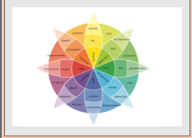 | When looking at this wheel of emotions is there any particular colour that you feel you experience more often than another? Is that a true reflection of the external environment you live in? Sometimes our emotions can become habits! The brain becomes quite used to feeling a particular way and thus filters out thoughts to find those that match a particular emotion. For example, if we are having a bad day, we may see everything as a negative and it could be hard to find a positive headspace. Even if positive things happen, our brain may interpret them as a negative/ struggle to see the positivity.
18  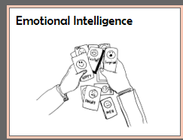 | Now that we have looked at emotions let us explore what emotional intelligence is…
19  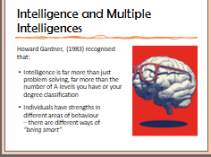 | For a long time, intelligence was based around areas that could be measured, typically the things that you learn in school. However, in more recent years, intelligence has been recognised as existing across many areas of the human condition/experience.  Howard Gardner, a developmental psychologist proposed the theory of Multiple Intelligences.
20  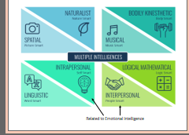 | His theory includes eight types of intelligence: spatial, naturalist, bodily kinaesthetic, musical, linguistic and logical mathematical.  Intrapersonal and Interpersonal intelligence are linked to the development of emotional intelligence. Intrapersonal is the understanding of our own emotions and interpersonal is the understanding of others.
21  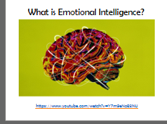 | Play video at start, watch all of the video.  After video:  This video is 10 years old, do you think there is more understanding and value of EI in todays society?
22  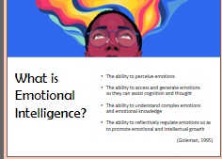 | - The ability to perceive emotions  - The ability to access and generate emotions so they can assist cognition and thought  - The ability to understand complex emotions and emotional knowledge  - The ability to reflectively regulate emotions so as to promote emotional and intellectual growth
23  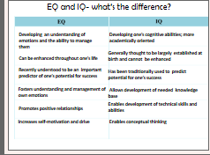 | Read thorough the slide
24  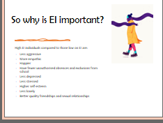 | High EI individuals compared to those low on EI are:  - Less aggressive  - More empathic  - Happier  - Have fewer unauthorised absences and exclusions from school  - Less depressed  - Less stressed  - Higher self-esteem  - Less lonely  - Better quality friendships and sexual relationships  Who would not want to be more of this? Do you think that being more emotionally intelligent can help you?
25  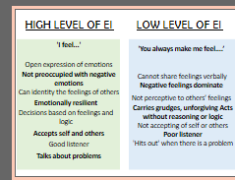 | When a high level of emotional intelligence exists, a person’s feelings thoughts and behaviours play out more genuinely and in line with the situation in front of them rather than in response to past baggage and experiences. As the person has a good understanding of their own emotions and responses, they are then not preoccupied with them and thus have the energy and focus to have empathy towards others and engage in healthy relationships.  For those with a lower level of emotional intelligence there is often confusion by the person experiencing the emotions as they are not able to identify and regulate them, but also for those who are interacting with them as often the emotions are not in line with what is happening within the current situation.
26 | The good news is that we can all become more emotionally intelligent. While some may be naturally better than others, ultimately there are many strategies help us to acquire this skill to have a positive impact on the management of our own emotions and to improve our interpersonal skills with others
27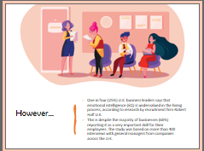 | Emotions have received a bad reputation in the past with ‘being emotional’ having some negative connotations, particularly within a work environment.  Regardless of whether recruiters or managers recognise emotional intelligence as a skill, we all still need this to support us to have a healthy working environment, as most professions cannot escape working with other human beings!
28  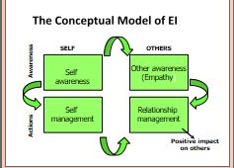 | The conceptual model of EI outlines interlinking areas of EI.  Being self-aware allows us to have a greater awareness of the emotions of others. Self-awareness also supports self- management which means being able to manage your emotional responses more effectively. Having an understanding of your emotions is the starting place to develop strategies to manage them. Being able to manage your own self can have a positive impact on your relationships with others as you will develop a sense of empathy toward their situation.
29  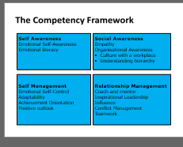 | Self-awareness:  When a person has self-awareness, they are able to identify and label what their emotions are. In addition, they can consider whether the emotions are appropriate for the given time and situation.  Social awareness:  When a person has social awareness, they can demonstrate a sense of empathy for other people.
30  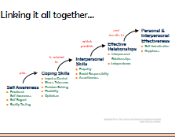 | Read slide
31  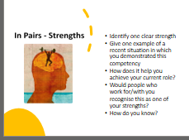 | Re-group  Was it easy or difficult to identify a clear strength? Is this something that other people recognise in you? is there anything others recognise in you that you don’t recognise in yourself?
32  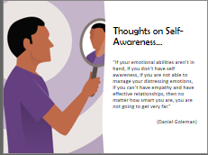 | It is surprising that emotions are not discussed more freely as left unchecked they can lead to all manner of difficulties for a person and those around them, but often we are just expected to know naturally how to respond to our emotions, our way of dealing with them is often developed through learnt behaviour of the significant adults in our lives.
33  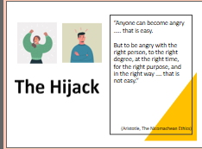 | Being self-aware is not about only experiencing happy calm emotions, what type of emotion isn’t the important things. It is that the emotion is in response to the situation and is felt and displayed in proportion to the event.
34  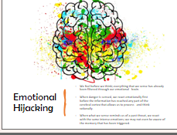 | Ever lost yourself in a situation? Ever looked back and think ‘what was I thinking??’ its likely you experienced an emotional hijack. The senses take in a lot of information and the brain decides a particular response is required, sometimes an unhelpful one and without discussing with you first! The brain is there to protect you and if it senses a whiff of danger it re-acts. The problem is that often the brain is over-re-acting to an event and it can be difficult to talk it around once the river of emotions has begun flooding.
35  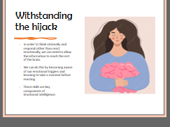 | Prevention is better than cure! It's easier to prevent a hijack rather than dealing with it, the more self-aware we can be of our emotional triggers the more we can take steps to manage them. When a hijack does take place, pausing and focussing on our breath is the best chance we can give ourselves in allowing the information to reach all areas of the brain.
36  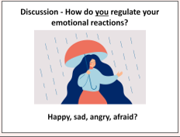 | Re-group:  What did you find? Are you better at regulating some emotions more than others? Why is that? Why does one way of dealing with some emotions not transfer to other emotions? Are some emotions too intense? Have we learnt unhealthy/unhelpful strategies?
37  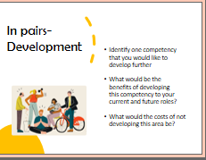 | Re-group:  How easy was it to identify an area for improvement? What one tangible action will you now take to develop in this area?
38  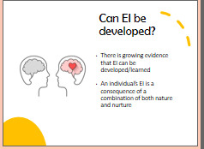 | The good news is that we can all improve our emotional intelligence, whilst some of us may be more predisposed to have good emotional intelligence that doesn't mean that those that are not, cannot improve greatly in this area of intelligence.
39  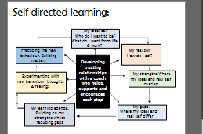 | Read slide
40  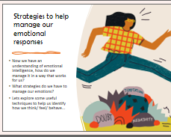 | Hopefully by now you are motivated to understand emotions more and have confidence in the ability to improve your emotional regulation.
41  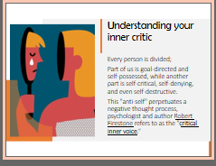 | Many different models of the human mind describe a personality that is divided into different ‘people/voices/parts’ one in particular by Robert Firestone refers to one that speaks as a critical inner voice.  This voice will often focus on negativity about oneself and/or their environment. The power of this critical inner voice is not to be underestimated and can at times have significant consequences if not acknowledged and soothed. Often people don't recognise that this is a, whilst unhelpful, normal aspect of the brain which can have its volume turned down.
42  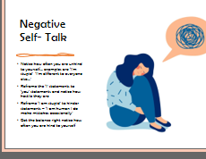 | I ask you, would you speak to someone you respected like that? what does that mean? That you do not respect yourself? Love etc.  What is your negative self talk? Does it have a theme? Are the voices in your own voice or resemble that of others i.e parents teaches etc?
43  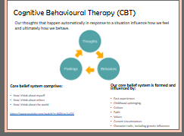 | Cognitive behaviour therapy is a technique used to understand how your thoughts affect your feelings and behaviours.  Play the video clip  https://www.youtube.com/watch?v=0ViaCs0k2jM#action=share  Explain - We look at situations, events, and interpret what other people say and do, according to our own set of past experiences, culture, faith, values, all of which help us form our beliefs about ourselves, about others, and about the world in general. The meaning we give events, the way we make sense of our world, is based upon our set of core beliefs.  Our minds are constantly trying to make sense of our world, forming judgements and opinions about every situation, event, interaction. Those judgements and opinions will be affected by our central or core belief system. It is as though we are looking at the world through distorted or coloured lenses - and everyone has their own personal prescription or colour for their glasses.
44  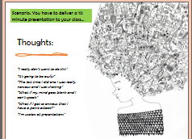 | Using the example of having to do a presentation. Explain often we will have thoughts such as:  “I really don’t want to do this.”  “It’s going to be awful.”  “The last time I did one I was really nervous, and I was shaking”  “What if my mind goes blank and I can’t speak.”  “What if I get so anxious that I have a panic attack?”  “I’m useless at presentations.”
45  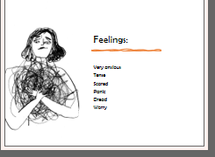 | These thoughts can affect how we feel:  Very anxious  Tense etc  We will all experience different emotions/ feelings- our response is informed by our environment, our personal experiences, the people around us etc
46  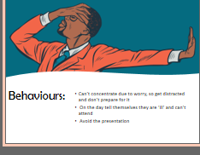 | And how we might behave:  Can’t concentrate, so get distracted and don’t prepare for it  On the day tell themselves they are ‘ill’ and can’t attend  One bad experience can affect how we respond to future situations.  An example here could be a poor mark on an assignment and automatically thinking they will get a poor mark next time around.  Or  Feeling nervous delivering a presentation and struggling to get words out. We may avoid future presentations for fear of looking flustered/ forgetting their words
47  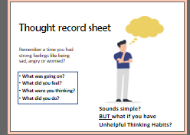 | Remember a time you had strong feelings like being sad, angry or worried?  - What was going on?  - What did you feel?  - What were you thinking?  - What did you do?  Something happens - we think about it – we act.  Sounds simple BUT what if you have unhelpful thinking habits? Let’s explore what we mean by ‘unhelpful thinking habits’
48  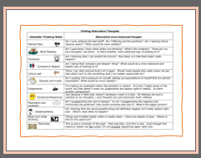 | Here are a few examples of ‘unhelpful thinking habits’. The more we are aware of how we think/ the thinking habits we use, the easier it is to challenge them. This takes practice and will get easier over time. As we start to recognise how we think and implement and practice techniques to challenge this, new neural pathways will start to form in our brain. This means we will not automatically jump to the usual thoughts/ conclusions but in fact will start to automatically look to the new learnt way of thinking. THIS TAKES TIME AND PRACTICE EVERY DAY! Keeping a thought diary will help you to identify your own personal thought processes and how you respond to them emotionally and physically.  It is a good idea to have this somewhere were you can see it regularly, such as the inside of your wardrobe or next to your mirror, to help you consider if your thinking is unhelpful
49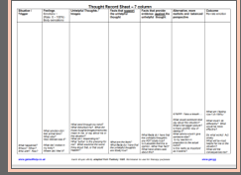 | Using a thought record sheet is a great way to work through unhelpful thoughts and replace them with alternative healthy ones. Making a commitment to challenge the thoughts and replace them, will overtime, impact on the feelings and lead to healthier behaviours too.
50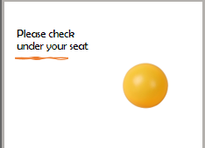 | Explain to the students you want to see how this works in action and will be asking 2 people to come up and deliver 2 slides to the group to see what their thought processes are about it.  Explain 2 chairs have a ping pong ball stuck underneath it. Whichever student has the ball will be asked to come up and deliver the slides.  Then allow a few minutes for the students to look….  Pick on a couple of students and ask – have you checked yours?  Then after a minute, explain and reassure no one has a ping pong ball…  Ask the group:  how did that feel?  How many people catastrophised?  Or was critical of how they would have ‘performed’ if it was them that had to go up?  When the reality was that whoever went up to deliver the slides, there wouldn’t have been any expectation from anyone to be any good at doing that all! But is likely many people had unrealistic thoughts about how they performed.
51  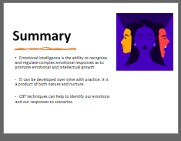 | Read out slide

