WHAT IMPACT, IF ANY, CAN BEHAVIOUR SPECIFIC PRAISE HAVE ON THE CLASSROOM CLIMATE WITHIN A SECONDARY CLASSROOM?

BY
2335573M

A dissertation submitted in part requirement for the degree of MEd Professional Practice

August 2022

Word Count- 16,485

ABSTRACT

Classroom management is the foundation for successful teaching with teachers having to ensure that learners are engaged in learning, build positive relationships with learners while effectively managing disruptive behaviours. BSP has been shown to support teachers in achieving this. This enquiry aimed to analyse the impact that the implementation of BSP could have within a secondary classroom, providing learner and teacher perspectives on the success of this. This enquiry was limited to two S3 Administration and IT classes. This action research project features both qualitative and quantitative research and used online questionnaires, focus groups and a teacher journal to collect data which was analysed to attempt to answer the research question.

ACKNOWLEDGEMENTS

I would like to take this opportunity to thank my supervisor, Dr Gabriella Rodolico who supported and guided me throughout this process. I would also like to thank my friends and family for their ongoing encouragement over the last year. Lastly, I would like to thank the learners who chose to take part and contribute to the findings of this enquiry as without their honest feedback and participation this research would not have been possible.

PERMISSION TO CONSULT

I give permission for this dissertation to be made available to any individual who wishes to access it by the University of Glasgow.

ABBREVIATIONS

AR | Action Research
ASN | Additional Support for Learning Needs
BGE | Broad General Education
BSP | Behaviour Specific Praise
CfE | Curriculum for Excellence
CPD | Continued Professional Development
EAL | English as Additional Language
GCC | Glasgow City Council
PPB | Promoting Positive Behaviour
SEBN | Social Emotional Behavioural Needs
SP | Senior Phase
UNCRC | United Nations Conventions on the Rights of the Child

OVERVIEW OF DISSERTATION

Chapter one introduces the background and context of the enquiry, providing the rationale and justification for the research. The objectives and research questions are presented here.

Chapter two details the literature review and provides a comprehensive overview and analysis of studies and policies surrounding the use of BSP within the classroom.

Chapter three details the methodologies and research methods selected for this enquiry, assesses the impact of using action research and the use of quantitative and qualitative data as a source of data collection. This chapter will also assess the effectiveness and credibility of these sources of data collection, the ethical considerations, and limitations of the design.

Chapter four will present and examine the findings from the research methods.

Chapter five will provide conclusions and recommendations and will ultimately determine whether this enquiry can provide answers to the research questions detailed in the first chapter.

TABLE OF CONTENTS

ABSTRACT 2
ACKNOWLEDGEMENTS 3
PERMISSION TO CONSULT 4
ABBREVIATIONS 5
OVERVIEW OF DISSERTATION 6
CHAPTER 1: INTRODUCTION 10
1.1 Introduction 10
1.2 Rationale 11
1.3 Specific Aims and Objectives 13
1.4 Research Questions 13
CHAPTER 2: LITERATURE REVIEW 15
2.1 Search Strategy 15
2.2 Introduction 16
2.3 The Classroom Climate 18
2.4 Praise 19
2.5 Behaviour Specific Praise 20
2.6 Impact of Behaviour Specific Praise in the Classroom 21
2.7 Behaviour Specific Praise in the Secondary Classroom 24
2.8 Conclusion 29
CHAPTER 3: METHODOLOGY 30
3.1 Participants 30
3.2 Action Research 30
3.3 Mixed Method Approach 32
3.4 Data Collection 34
3.5 Online Questionnaires 34
3.6 Focus Groups 36
3.7 Critically Reflective Teacher Practice Journal 37
3.8 Developing Questions for Questionnaires and Focus Groups 39
3.9 Developing Validity and Reliability 40
3.10 Data Analysis 41
3.11 Ethical Considerations 43
3.12 Limitations 45
3.13 Conclusion 46
CHAPTER 4: FINDINGS AND DISCUSSION 47
4.1 Quantitative Findings 47
4.2 Qualitative Finding 51
4.3 Classroom Climate 52
4.4 Attainment 56
4.5 Age Appropriate 58
4.6 Key Points Summary 60
CHAPTER 5: CONCLUSIONS AND RECOMMENDATIONS 62
5.1 Summary of Discussion and Findings 62
5.2 Key Findings 63
5.3 Limitations of the Study 64
5.4 Evaluation 65
5.5 Dissemination 65
5.6 Recommendations 66
5.7 Conclusion 66
APPENDICES 68
APPENDIX 1- Ethical Approval and Amendments University of Glasgow 69
APPENDIX 2 Glasgow City Council Approval 72
APPENDIX 3- Parental Plain Language Statement 73
APPENDIX 4- Parental Consent Form 76
APPENDIX 5- Learner Plain Language Statement 79
APPENDIX 6- Learner Consent Form 83
APPENDIX 7- Online Questionnaire Issued Before Intervention 85
APPENDIX 8- Online Questionnaire Issued After Intervention 86
APPENDIX 9- Focus Group Themes 88
REFERENCES 89

CHAPTER 1: INTRODUCTION

1.1 Introduction
Classroom management is the foundation for successful teaching with teachers having to ensure that all learners are engaged in learning, build positive relationships within their classroom, and effectively manage disruptive behaviours (Chandra, 2015). Disruptive behaviours can lead to time being wasted with significant learning time lost. Secondary teachers can find it more difficult to develop positive relationships with learners than their primary colleagues to the high number of learners they teach for a limited amount of time (Riley, 2009). During the lower years of secondary education for some learners their effort and attainment can decline (Walker, 2009). At this stage of development learners can be influenced by their peers than adults such as parents or teachers in authoritarian positions as noted within Erikson’s ‘Stages of Development’ (Thornburg et al, 2002). Low-level disruptive behaviour can have negative impacts for all stakeholders within classrooms (Narhi et al, 2015). It can threaten the attainment of the disruptive learner, can impact on teacher stress (ibid) and compassion burnout (Neff, 2003) as well as negatively impacting on other learners in the class (Narhi et al, 2015).

Learners have faced unprecedented challenges over the last few years due to the disruption which COVID-19 has had on the attainment and development of their social skills (Education Endowment Foundation, 2022). National lockdowns forced schools to close and return with restrictions to familiar routines which learners experienced before the pandemic. Governments are investigating the impact which these disruptions have had to seek solutions to issues which have arisen. The ‘Education Recovery: Key Actions and Next Steps’ report released by the Scottish Government (2021) illustrates that the time out of the classroom has impacted on learners’ mental health, their attainment and social development; especially for those learners who before the pandemic were already “experiencing adverse circumstances” (ibid, p.7). For learners to recover from this disruption they must be supported within safe environments. The ‘Compassionate transitions: Reconnecting school communities post- COVID-19 closures’ report issued from The British Psychological Society (2021) recognises this and emphasises the need for teachers to fully support learners’ recovery through developing positive relationships to support learner’s emotional, mental, and social needs.

Literature has identified several evidence-based strategies to control disruptive behaviour within classrooms to provide safe environments for all learners (Simonsen et al, 2008). Praise has been identified as a strategy which can improve learner-teacher relationships (Gable et al, 2009) by providing recognition and endorsement of their social behaviours (Epstein et al, 2008). BSP is a simple classroom strategy which can support appropriate classroom behaviour from learners by identifying effort and engagement within lessons (Caldarella et al, 2020). Within literature it has been shown to increase both academic and social experiences (Simonsen et al, 2008). Regular high rates of praise within classrooms can allow teachers to develop classrooms which are safe, have established routines that encourage learners to engage in positive social interactions (Wilson et al, 2007). However, this strategy is not utilised within secondary classrooms (Floress et al, 2015).

1.2 Rationale
Disruptive behaviour within schools provides challenges for teachers in providing high quality learning and teaching (Jenkins et al, 2015). However, teachers and unions are reporting that these disruptive behaviours are now extremely commonplace and are seen as the ‘norm’ (Independent, 2022). According to the union NASUWT (The Herald, 2022) the effects of COVID-19 school closures and disruption to classroom routines have resulted in increasing rates of low-level disruptive behaviour escalating to more serious incidents. Comments made by the General Secretary of the NASUWT claimed that teachers report that since learners have returned to the classroom, they are less engaged with their learning and have not developed social skills appropriate for their age, such as their ability to develop positive relationships and behave appropriately (NASUWT, 2022). Although COVID-19 has led to an increase in behaviour challenges, this has been an issue for many teachers within their classrooms for decades. In 2013 Emmer and Gerwels argued for new interventions to meet the needs of older learners to decrease disruptive behaviour to improve classroom climates and provide an environment where all learners feel safe and supported.

The author has seen an increase with these challenging behaviours within her own classroom. These are prevalent within broad general education (BGE) with some learners struggling to transition back into full time education after the disruption of COVID-19. This is an issue faced by teachers within the authors school and was identified as an area for improvement within the school improvement plan. The authors head teacher sought advice and training from a behavioural training organisation Crisis Prevention Institute (CPI). Four members of staff were chosen as ‘Behaviour Experts’ and trained by the company and tasked with the responsibility of training up the other members of staff. The author was one of the four chosen, this role was a voluntary leadership role and the author decided to take part as she had an interest in behaviour management. One strategy they encourage staff to use is BSP to make the classroom climate more positive and supportive for all learners (CPI, 2022). This strategy was debated among the four ‘Behaviour Experts’ as to how this could be implemented within our school. As the issues faced within the authors classroom are noted within literature such as increasing levels of low-level disruptive behaviour (Sullivan et al, 2014), disengaged learners (Narhi et al, 2015) and negative classroom climates (Epstein et al, 2006), there is a clear rationale to begin an enquiry to attempt to enhance the quality of a learner’s experience in the classroom (Elliot and Sarland, 1995).

This research will assess the impact of using BSP to improve upon ‘on-task’ behaviour within the classroom to allow the author to consider current methods of working (GTCS, 2021). The author will have a better awareness of her own teaching practice and recognise potential needs for development through this enquiry (McLaughlin et al, 2004). Evidence gathered will be used to improve learning and teaching in the author’s own classroom and provide solutions to the problems listed above (Gilchrist, 2018). This will also be used to shape and provide guidance on how to effectively implement this strategy as a whole school behaviour policy. The concept of teachers ‘trying their best’ within their curricular areas is no longer satisfactory, it is now expected that every teacher must employ evidence-based practices into their own classrooms (Timperley, 2007).

1.3 Specific Aims and Objectives
The intention of this enquiry is to evaluate the impact, if any of BSP on the classroom climate in secondary classrooms. Literature suggests that this strategy can aide teachers in developing positive relationships with learners (Wagner et al, 2005), improve upon classroom climates (Blaze et al, 2014) and reduce disruptive behaviour (Narhi et al, 2017). This enquiry seeks to evaluate the relationship which BSP can have on achieving the above benefits within a secondary classroom in a deprived area of Glasgow.

1.4 Research Questions
The overarching aim of this enquiry is to research the impact of BSP within a secondary classroom. In partnership with both the school improvement plan and local/national Government policies, the research question was further broken down to allow for a thorough literature search into three sub questions:
- What is BSP?
- What is a classroom climate?
- What is the impact of BSP on the secondary classroom?
The three sub questions were chosen to identify the key elements of this research. The first two sub questions can be answered through the literature review as there is extensive research on these. However, the third research question can only be partially answered through the literature review due to the lack of research of this intervention within secondary classrooms. This intervention has been proven to be successful within primary schools, but further research is required of analysing the impact within secondary schools as current research is conflicting.

CHAPTER 2: LITERATURE REVIEW

2.1 Search Strategy
This literature search was focused on answering the three sub questions. Multiple databases were used to search for relevant literature. These included ResearchGate, Sage, and ERIC.

The search began with the use of a Boolean search and the terms ‘impact and praise’ was used to provide a broad overview of the literature available (Punch, 2014) allowing for themes to be explored and further scrutinised (Boudah, 2011). The terms used within the search were then updated to include these new themes; ‘general praise and impact’, ‘BSP and impact’, ‘praise and classroom climate’ and ‘behaviour and classroom climate’. After narrowing down the particular aspects within the theme, the author used alternative search filters to try and source literature which was more specific to the research design. The search strategies were then updated to include ‘secondary schools’ to focus in on appropriate literature. At stage it was determined that there was very little evidence to support the use of BSP within a secondary classroom; the evidence was mainly focused on primary schools highlighting a significant gap in the literature (Narhi et al, 2017; Zoromski et al, 2021. Searches were then narrowed down to only include peer reviewed studies with duplicates being extracted.

The author also used the references and citations of sourced literature to provide further depth to the themes already identified. This is known within literature as a ‘paper chase’ strategy (Taber, 2013) and was used after the relevant literature was sourced using the noted search strategies and filters above. Several of these studies were used to establish key perceptions which were used to develop the research questions (Punch, 2009).

Figure 1- Search Strategy
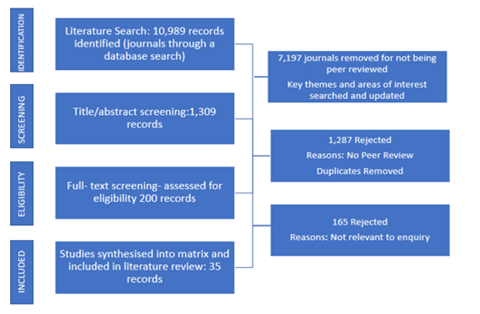

2.2 Introduction
This literature review seeks to answer the first two sub research questions and identify the gap in research when assessing the impact of BSP within the secondary classroom.

The social development of learners displaying challenging behaviours can be affected by interactions between themselves and teachers who are managing these behaviours (Emerson and Einfeld, 2011). These teacher-learner interactions can be negative and coercive which damages relationships encouraging further disruptive behaviour (Nelson and Roberts, 2000). A lack of knowledge of positive classroom behaviour strategies can result in negative classroom climates where reprimands and sanctions are used to manage behaviours (Haydon et al, 2020). This is true for secondary classrooms where other influences such as age and personality traits impact upon these relationships with the typical ‘teenage mood swings’ and pressures such as trying to fit in (Sutherland et al, 2001; Odlum, 1948) with learners experiencing new intense emotions (Main, 2018).

Literature advocates for the use of proactive interventions to improve learner engagement instead of reactive reprimands such as berating learners (Reinke et al, 2015; Sutherland et al, 2000). Due to this schools are now seeking proactive positive strategies which are intended to reinforce ‘good’ behaviours instead of punishing ‘disruptive’ behaviours (Sugai and Horner, 2006). The use of reprimands and punishments is extremely high within secondary schools, with teachers more likely to use detentions, referrals and suspensions which can unfairly affect disadvantaged learners such as those with ASL and SEBN (O’Handley et al, 2020; Owen et al, 2015). If teachers cannot provide positive classroom atmospheres where learners feel engaged; this can cause learners to feel disinterested and display disruptive behaviours (Pane, 2010). This results in lower academic attainment for these learners and can hinder the progress of classmates due to learning time being wasted dealing with disruptive behaviour (ibid).

Studies have shown when praise is introduced within the classroom instead of sanctions on-task behaviour is shown to increase (White, 1975). On-task behaviour is the period of time in which learners are engaged with the work set by the teacher. The longer the learner spends engaged on the task, the greater their attainment should be (Rivera et al, 2015). Praise can positively impact the classroom atmosphere making the classroom a more predictable environment for learners which promotes appropriate classroom behaviours (Narhi et al, 2017). These recognised benefits have been mostly found in primary classrooms; due to the additional pressure of academic attainment, time constraints of lessons and increased levels of behavioural problems it cannot be assumed that the above benefits will transfer to secondary classrooms (Friedman-Krauss et al, 2014). High school teachers can struggle with building positive relationships and knowing the preferred learning style of each individual learner due to the number of learners they teach as well as learners pushing boundaries as part of their normal emotional development (Thornburg, 2002).

2.3 The Classroom Climate
Classroom climate is described within literature as the place where teaching and learning processes established by teachers take place (Hirschy and Wilson, 2002). The method in which teachers deals with classroom management, known as classroom disciplinary climate, can shape this perception of these climates (Blank and Shavit, 2016) and significantly impact development of learner’s social skills (Sortaer and Reimer, 2018). If learners do not perceive the class disciplinary climate as being equitable this can contribute towards negative classroom climates. This can support learners or become a barrier preventing them from achieving socially and academically (Cengel and Turkoglu, 2016) affecting learners who are seen to be disadvantaged and attend schools within deprived areas (Palardy, 2008). Here learners from low socio-economic background are taught to obey rules within classrooms in a negative manner (Cengel and Turkoglu, 2016) which can be seen as an example of power distance (Hofstede, 1980). This creates a superior/subordinate relationship between the teacher and learners creating a power imbalance (ibid). Whereas within schools in more affluent area’s learners are taught to develop their social skills using more innovative methods (Cengel and Turkoglu, 2016). Participation and the encouragement of pupil voice through working groups is used within the authors school to limit the power imbalance.

Classroom climate has been shown in several studies to be a critical factor in learner attainment (OECD, 2009). Most of the literature surrounding classroom climate aims to promote more effective pedagogies which allow for better learner-teacher relationships (Pianta and Hamre, 2009). A positive climate provides a safe environment which allows teacher and learners to concentrate on learning instead of disruptive behaviours (Lipowsky et al (2009) cited in Bilican-Demir (2021)).

2.4 Praise
Brophy (1981) defines praise as verbal feedback which endorses appropriate classroom behaviour. This type of praise uses statements such as ‘good work’ and ‘well done’ to recognise learners for positive behaviours and effort (Jenkins et al, 2015). This form of praise is used regularly in the classroom (Brophy, 1981) and at home during developmental years (Kim, 2017). However, for some learners this concept will be completely alien to them. In the author’s experience this is true for those identified as experiencing hardship at home or who have developed ‘Attachment Issues’ where emotional connections between the learner and their parent/guardian have not developed (Owen et al, 2012). If learners have not experienced supportive environments at home, they may be uncomfortable or unsure how to respond to praise which can affect the impact of the strategy within the classroom (ibid).

Praise is in contrast to teacher reprimands which provides negative acknowledgements to learner’s behaviour or effort (Guo, 2019). Praise can encourage learners’ effort, develop their confidence, and promotes positive learner-teacher relationships (Ferguson, 2013). However, researchers argue that general praise does little to impact on learner’s behaviour as it is not specific to their behaviour or effort (ibid). Learners must be given the exact reasoning as to why they are being praised for them to understand exactly what behaviour is deemed as being acceptable and what is not. In the experience of the author, the use of general praise within the classroom can be the foundations for developing positive teacher-learner relationships through the role modelling of behaviours.

2.5 Behaviour Specific Praise
BSP is used to identify the appropriate desired learner behaviour so all within the classroom know exactly why they are being praised which can influence their behaviour and make it likely that they will display these behaviours again (Jenkins et al, 2015). An example of BSP is “well done David for working through tasks one to five quietly”. BSP is effective when it is delivered promptly after the behaviour has been noticed and used regularly in a genuine manner (Simonsen et al, 2010). Teachers who use BSP have reported it as a simple, cost-effective way of reinforcing classroom standards with very little planning required (Fitriati et al, 2020).

BSP has been implemented into several educational policies such as GCC’s (2011) ‘Promoting Positive Behaviour’ (PPB) which calls for ‘Planned Ignoring’ (p.20) which calls on teachers within the council to not react to low-level disruptive behaviour but instead praise appropriate behaviour displayed by others. Critics of BSP argue that it teaches learners they are only valued when they are meeting the standards of teachers, reinforcing the distance power balance where attention is only provided when teachers decide they have done something worthy of their attention (Kohn, 2013). Kohn argues that praise was designed to stamp out negative behaviour instead of providing every learner with unconditional care they are entitled too (ibid). The author is not comfortable with completely ignoring low-level disruptive behaviour due to the above arguments. She made a conscious choice to always respond to positive behaviour first before responding to learners displaying disruptive behaviour, showing learners which behaviours receive first attention from the teacher and which do not (Gable et al, 2009).

2.6 Impact of Behaviour Specific Praise in the Classroom
BSP is described within literature as an essential strategy for achieving positive classroom atmospheres, improving classroom management, and changing learners’ behaviour (Dutton et al, 2010). The introduction of BSP can provide positive attention for learners who adhere to and follow all teachers’ instructions but who scarcely receive praise from teachers and can feel ignored due to the focus on addressing negative behaviours from their classmates (Jack et at, 1996).

Research has advocated for the use of behaviour feedback for learners showing significant results on improving on-task behaviour and stopping low-level disruptive behaviour (Simonsen et al, 2008; Epstein et al, 2008). However not all studies were conducted within mainstream classrooms so findings may not be completely applicable to all classrooms. Research undertaken by Reinke et al (2015) found that by introducing BSP teachers were found to be more likely to respond to learners positively which limited potential confrontations, stopping situations from escalating. However, teachers must ensure when they are delivering praise, it is authentic and delivered using an appropriate tone otherwise learners may view the strategy as a gimmick (ibid). To ensure praise is genuine Webster-Stratton (2012) advocates for praise to be based on effort not attainment. This underpins the praise strategy which is promoted within the PPB policy (2011) which states that praise should be used for a “variety of efforts and achievements” and that praise should be used to “convey the message; your efforts are paying off” (p.20). This should ensure that every learner will receive a positive and supportive experience within school. For praise to seen to be genuine, trust and respect must form the base of classroom expectations otherwise the strategy may be viewed as manipulating which can damage the teacher-learner relationship (Fitriati et al, 2020). This is especially true for learners who have reputations of disruptive behaviour, anti-social issues and have negative perceptions of adults (Brophy, 1981). The teacher must be seen as being in control of the classroom otherwise it can be viewed as a “desperate attempt to change something” (Brophy, 1981; p.27). This strategy places additional pressure on teachers to develop relationships with all learners within their care which as previously mentioned is extremely difficult for secondary teachers. Further research is required to examine whether this would work with teachers who are experiencing burnout or stress.

BSP is recognised within International Policy in the ‘Reducing Behaviour Problems in the Elementary School Classrooms’ report from the US Institute of Education Services (2008). This declared that teaching and reinforcing appropriate behaviours is seen to have a substantial increase in creating positive classroom environments for learners thus creating positive relationships. However elementary school learners are between the ages of five and ten, the author could not locate similar policies showing the effects of this strategy on high school learners, once again showing the significant research gap on the impact of BSP in secondary classrooms.

Critics of BSP contest that praise is useless in motivating students. It has a harmful impact on their intrinsic motivation and capability (Guo, 2019; Kohn, 2012) leading to learners feeling reliant on praise to complete tasks which lessens the attention and focus of the learning (Robins, 2012). Praise can increase on-task behaviour of learners temporary however once praise is discarded the behaviour and effort of learners can dramatically decrease when the novelty wears off (ibid). Critics have deemed it as a short-term ‘fix’ due to the lack of evidence to support that this strategy can have in the long-term. Most studies do not provide a follow-up check on the levels of BSP once the intervention has stopped, the observations and prompts such as a MotivAider (a technological device which vibrates to remind teachers to deliver praise) have been removed. This questions the authenticity of using this strategy as a long-term fix, suggesting this strategy is good at grasping attention in the short-term however other strategies should be used after the effects has faded to maintain the same levels of positive behaviour.

Riveria et al (2015) followed up on this and found that once the MotivAider was removed rates of BSP fell dramatically to rates recorded before the intervention. Suggesting that praise should be issued authentically using natural rates of praise instead of prompting. However, within this study, data was only collected once a day for each teacher through a ten-minute observation. This suggests that the implementation was not long enough to naturally implement into teaching practices and to form a compelling body of evidence to provide accurate comparisons against. Riveria et al (2015) contributed these decreases in BSP to the possible high rates in on-task behaviour and those teachers no longer needed to use this strategy to limit disruptive behaviour. Within her research the author is not recording the rates of praise issued and is only using a MotivAider app to provide reminders to deliver statements. As this enquiry will be carried out in a short time frame the author is curious whether she will naturally use BSP without the reminders.

Royer et al (2019) found that introducing BSP into middle school classrooms; the intervention resulted in learners demonstrating more on-task behaviour, a reduction in low-level disruptive behaviour increasing engagement within lessons. However, this was only based on learners from the ages of eleven to thirteen. Rahimi and Karkami (2015) discovered that within English as a Foreign Language classrooms, teachers who used recognition strategies such as praise were recognised by learners to be more competent teachers which increased their motivation than those who used punitive strategies. Punitive strategies within this study had an indirect effect on the attainment as learners reported that these strategies were demotivating. However, within their selection of participants, a significant number of private schools was used in which cultural expectations could have impacted on perceptions. These results might not be reflective of public-school learners especially within an area of deprivation which can cause specific challenges for learners.

Systematic studies have examined literature surrounding BSP and concluded that teachers rarely administer BSP within secondary classrooms (Jenkins et al, 2015). Rates of BSP is extremely low within secondary schools (O’Handley et al, 2020). Due to the different structures of high schools compared to primary schools with learner’s having to meet the behavioural expectations of multiple teachers and adapt to these lesson by lesson it cannot be presumed the benefits of BSP will transition into secondary classrooms (Zoromski et al, 2021; Haydon et al, 2020). Within the literature there is a significant gap in the knowledge if the differing standards from various teachers can impact on the success of the behavioural strategies implemented within the classroom.

2.7 Behaviour Specific Praise in the Secondary Classroom
Although behavioural problems are extremely common within secondary schools most of the literature on behaviour management have been conducted within primary schools (Narhi et al, 2017; Zoromski et al, 2021). Few studies have examined the impact of BSP within secondary classrooms. Several studies which have focus on the total rates of praise issued instead of the benefits within the classroom (Haydon et al, 2020) or have combined BSP with other behaviour strategies (O’Handley et al, 2020). One possible reason for the lack of research on this strategy alone can be linked to the attitude that teaching appropriate classroom and social behaviours should be taught and explicitly learned in primary school years (Hawkins and Heflin, 2011). Some learners due to challenges and adversities at home; school may be the only place for them to learn acceptable social skills (Gresham et al, 2003). In a study conducted by Flannery et al (2009) more than 50% of secondary teachers surveyed stated that they did not think BSP was appropriate for promoting appropriate behaviours within their classrooms. This is contested by Epstein (2006) who argues that positive behaviour strategies such as BSP can be effective within any classroom.

The PPB policy (GCC,2011) advocates for the use of social and emotional approaches to develop positive classroom climates. Their policy states that primary and secondary schools will “educate the whole child and develop their personal and social skills” (p.13). However, they also advocate for use of praise “regularly but sparingly with other pupils” (p.22) which highlights a contradiction and leads to some teachers believing this strategy is more appropriate for primary classrooms. This enforces the attitude shared by some secondary teachers in which they believe older learners do not want to be praised and may find the strategy too childish and embarrassing (Geist and Horn, 2009). However, this has been challenged within literature where findings have shown that older learners do find BSP appropriate for their age (Fefer, 2016). However, some learners did specify that praise should be delivered privately instead of in front of their peers (ibid). Blaze et al (2014) examined this issue of whether praise should be delivered publicly or privately and found that both were appropriate. The author was unable to source any national level policies which support the implementation of BSP in the secondary classroom, this may also explain the lower rates of BSP and the reluctance of secondary teachers to implement this due to the lack of research of this strategy.

Another contributing factor for the lack of BSP within secondary as opposed to primary classrooms is the perceived lack of training of behaviour management strategies within teaching degrees (Freeman et al, 2018). Many teachers have reported feeling underprepared when dealing with disruptive behaviour as within secondary teacher degrees there is a lack of focus of developing learners’ social skills in comparison to primary degree programmes (ibid). The ‘Behaviour in Scottish School Research’ Report (2016) which was published by the Scottish Government shows that only 21% of secondary teachers surveyed said that they would use positive behaviour strategies to deal with low-level disruptive behaviour in comparison to 34% who would choose a reprimand strategy. 38% of primary school teachers would use positive behaviour strategies over reprimands. This highlights the differences in viewpoints of primary and secondary teachers in believing that sanctions are more appropriate within high schools to deal with disruptive behaviour. High school teachers are expected to prepare learners for transiting out of school into college/university/employment (CfE,2010) these teachers may believe reprimands is more appropriate to real life situations outside the classroom.

Findings by Beaman (2006) as cited in Clunies-Ross et al (2008) secondary teachers were shown to use praise towards their academic success but reprimands towards their social behaviours. A reprimand may temporarily stop the undesired behaviour, but it does not aid the development of learners’ social skills (Flores et al, 2021). Primary school teachers surveyed reported that the use of praise as a reward system was key for celebrating good behaviour and achievement and paying attention to positive behaviour. This was not mentioned within the findings of secondary teachers. This could suggest that the teacher training programmes are lacking in providing positive behaviour strategies for secondary teachers in managing disruptive behaviour.

Adequate training in positive behaviour strategies is crucial for successful implementation as “many teachers struggle to implement evidence-based interventions when they are not well trained” (Martinussen et al, 2011 as citied in Zoder-Martell et al, 2019; p.311). Freeman (2018) discovered that after secondary teachers had received training it did not increase their rates of implementing BSP into their own classrooms. This is intriguing as several studies have noted teachers claim they need behaviour management training to develop their skills (Reinke et al, 2015). This allows for a discussion on whether BSP was not implemented correctly or given enough time to become effective or whether it is not effective within secondary classrooms. Blaze et al (2014) contest that if BSP is implemented correctly and given time to become part of the classroom routine then challenging behaviour will decrease overtime developing more positive classroom atmospheres. However, they recognise the need for more studies on introducing BSP as a standalone strategy within secondary classrooms with interventions delivered over a longer timescale (ibid).

Although it was not an intended outcome of the research, the intervention had an impact on the number of negative reprimands teachers were issuing (Blaze et al, 2014). Teachers in the study were not told to lower the number of reprimands they issued to learners, however the increased levels of praise led to a reduction in these. The teachers noted that their relationships with learners were more positive and changed their classroom atmospheres. However, this is just based on opinions as within this study the rates of reprimands were not recorded so conclusions drawn that praise was responsible for this can be scrutinised. This study also used private BSP so the conclusion that BSP can influence other learners’ behaviour is limited as within these incidences learners would not hear why other learners were praised. O’Handley et al (2020) shows a direct link between the implementation of BSP within the secondary classrooms and an increase in learners on-task behaviour and that learners did not find the public praise embarrassing. These findings were based on data collected by observations with the prompt of MotivAider’s. There is no evidence to suggest that these results could have occurred with just natural rates of praise without any prompting or reminders through the observations. The author will be using the MotivAider app for prompting during her own intervention as she believes she may require reminders to deliver positive reinforcements. She will assess whether at the end of the intervention if this continues to be required or whether this became part of her natural classroom practice.

Burnett and Mandel (2010) found that most learners in secondary schools enjoy being praised with only 17% of learners not wanting to be praised. This does not necessarily mean they do not like BSP, for some of these learners they may not have the relevant social capacity to receive praise (Webster-Stratton, 2012). Kohn (2013) describes the use of BSP to promote positive behaviour as futile as it does not provide solutions to the causes of the disruptive behaviour within the classroom. This is contested by Bear (2010) who disputes that BSP is used to teach socially appropriate behaviours which are expected in wider society. This is something which the author believes is of paramount importance given the authors school is within an area of significant deprivation.

The few studies which have been implemented within secondary classrooms have found that behavioural feedback could dramatically change the classroom climate and resulted in less low-level disruptive behaviour (Simonsen et al, 2008; Epstein et al, 2008). These results are echoed in an earlier finding by Narhi et al (2014) where there were improvements within the classroom atmosphere making it more positive and there was a marked reduction with low-level disruptive behaviour. Haydon et al (2020) argues that for praise to be effective within the secondary classroom five critical factors must be taken in account- contingency, immediacy, proximity, consistency, and specificity. For praise to be effective it must be directly linked to the desired behaviours shown, delivered promptly and in close proximity to the learner so the intended learner is aware they are being given the praise, used consistently, and linked to the learner’s effort not ability (Ennis et al, 2018). Brophy (1981) consents that before introducing BSP, teachers must know their classes and must identify individuals who are uncomfortable receiving praise. The teacher must also observe every learner and make judgement calls on whether the praise is positively impacting their engagement. If a learner responds in a positive way with a smile, nod or looks satisfied; then the praise is likely positively impacting their attainment. However, if a learner is showing signs of discomfort or stops engaging with their desired behaviour; the strategy should not be used on them (ibid).

Within Johnson et al (1996) study three interventions were used to identify which was the most effective classroom management strategy within secondary classrooms (using the curriculum goals to set individual learner targets, using self-assessment of following classroom expectations, and regularly teaching appropriate classroom behaviour through BSP). The results showed that the use of BSP had the greatest impact when used by teachers who noticed marked deductions in low-level disruptive behaviour. It cannot be concluded that BSP was alone responsible for the increased engagement from learners as other interventions were implemented, the other interventions may have supported the deduction of disruptive behaviour (Narhi et al, 2017). The author would envisage that this strategy would be more successful when implemented as part of a whole school strategy within the school improvement plan.

2.8 Conclusion
BSP can positively impact on classroom atmospheres and result in more on-task behaviour and less disruptive behaviour as shown above. However, the impact on classrooms of this strategy is subjective and can be scrutinised. The use of BSP will vary with different teachers and classroom settings. There is extensive arrays of research conducted within primary schools however there is a significant gap within the literature for the impact of BSP in secondary classrooms. This has led to distinguishable gaps within the rates of BSP issued within primary schools compared with secondary schools. This literature review has addressed the first two research questions but the impact of BSP within secondary schools in the literature is limited and needs to be further examined. This will be further explored by the authors own intervention and will be analysed within the fourth chapter of this dissertation.

CHAPTER 3: METHODOLOGY

3.1 Participants
This enquiry took place between April-June 2022 within two S3 Administration and IT classes with twelve girls and eight boys aged between fourteen and fifteen years old. Both classes were inclusive and had 25-30% of learners with ASL and SEBN. It was conducted as a practitioner enquiry within the researcher’s own classes.

3.2 Action Research
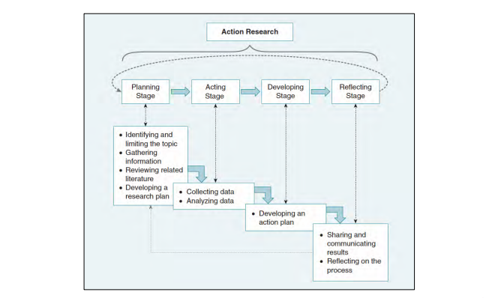
Action research (AR) places teachers at the heart of shaping educational change and advancing their teaching skills (Elliot, 2011). It provides a variety of enquiry methods which can be used to conduct and analyse an intervention including questionnaires, focus groups and journals (Feldman et al, 2018). The predominant aim of AR is to identify issues within the practitioner’s classroom that they believe merits an investigation to find improvements to pedagogies (Burns, 2010) AR allows for teachers to evaluate their teaching practices and can help to “bridge the gap” (Amin et al, 2019; p.30) between educational theories and practices within the classroom. AR provides evidence which has been systematically collected to form the foundations of changing teaching practice that are based on authentic judgements instead of presumptions to improve classroom procedures (Dana and Yendol-Hoppey, 2019).

Figure 1 The Four Stages of a Single Cycle of AR (Mertier, 2020)
The AR model (Lewin, 1946) is regularly employed within educational enquiries and has been further defined by other researchers (figure 1). After the first cycle has been completed, a second continuous cycle consisting of replanning, acting, observing, and reflecting will take place and so on (Amin et al, 2019). This is demonstrated by the AR Spiral diagram designed by Kemmis and McTaggart (2010). Within this enquiry only one cycle of AR was accomplished due to time limitations. However, this cycle can be altered in future planned enquiries so the impact of this AR intervention can provide the foundations for new cycles based on the evidence from this (Amin et al, 2019).
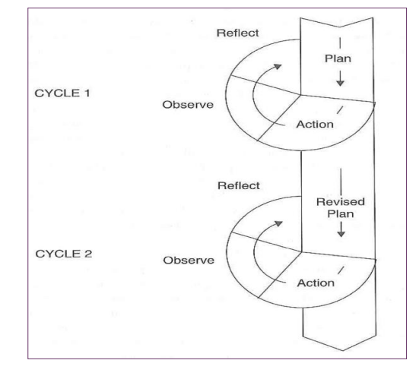

Figure 2- AR Spiral Kemmis and McTaggart, (2010) as citied in Burns (2010)

Mertler (2017; p.35) outlines the fundamental steps in designing an AR project:
- Identify and limit topic
- Gather information
- Review related literature
- Develop research plan
- Implement plan and collect data
- Analyse data
- Develop action plan
- Share and communicate

Research of any format must attire to systematic scrutiny (Mertler, 2022). The use of AR within this enquiry provided a flexibility which could be adapted to support the authors methodology (Punch, 2009). The use of AR ensured that there was validity (Mertler, 2022) within the enquiry through the rigorous research procedures and analysis to ensure they are not biased (Stringer, 2013).

3.3 Mixed Method Approach
When designing the paradigm of this AR enquiry a mixed-method approach was used to form a small-scale enquiry. The mixed-method approach as a third research paradigm can bridge the gap between quantitative and qualitative data collection methods (Johnson and Onwuegbuzie, 2004). Quantitative methods through the questionnaires were used to involve a larger sample and provide statistics which were timely to collect to identify variables. Qualitative methods through focus groups, questionnaires and a critically reflective teacher practice journal were used to provide some understanding of the perceptions of the author and participants (McKusker and Gunaydin, 2015). The quantitative data could measure the impact of the intervention with the qualitative explaining these trends. By triangulating these paradigms, safeguards were integrated into both research designs to limit any potential bias (Sandelowski, 1986). This tailored approach provided specific data relevant to the context of this enquiry (McBath, 2018). The design of mixed method studies allows for “diverse assessments which validate and triangulate the findings and conjoined separate studies under one study’s unified function” (ibid) providing “more possibilities for data collection and analysis than a one-sided study” (Gall et al, 2007).

As a mixed-method enquiry was used, the research was conducted using a pragmatism approach that was analysed through quantitative and qualitative methods. This approach allowed for the methods to be mixed together in a way which allowed for the research question to be addressed (Johnson and Onwuegbuzie, 2004). The use of multiple paradigms can result in tensions between both sets of data, providing checks and balances to improve validity (Creswell, 2009). This method engaged the learner encouraging the sharing of their perspectives allowing for them to be seen as active partners in the process influencing decisions taken in the classroom and not just subjects (Hill, 1997).

A mixed-method research model allowed for words and descriptions which were used to provide context to statistics created through numbers and vice-versa (Johnson and Onwuegbuzie, 2004). Providing a more accurate portrayal of the data collected (Lui, 2022) which adds insights which cannot be gained through a single-method alone (Johnson and Onwuegbuzie, 2004). However, this approach is more time-consuming and difficult for a researcher to conduct on their own due to vast array of data that can be collected (Creswell, 2009: Viadero, 2005). Methodological purists contest that research should either be qualitative or quantitative as within mixed-method approaches it is difficult to assign equal weight (Salehi and Golafshani, 2010). Caution must be taken when assigning weight as one method could significantly influence another method and the overall findings (Symonds and Gorard, 2010). This happens when data collected from one method is used to construct the design of another method (ibid) which questions the validity of the methodology (Salehi and Golafshani, 2010).

My epistemological perspective has been influenced by my own experiences of learners displaying low-level disruptive behaviour within my classroom. Within this enquiry I will be taking an interpretivist approach when gathering qualitative data to gain an accurate and deep understanding into subjective perspectives of the learners “lived experiences” within my classroom (Saunders and Tosey, 2012; p.58). However, gathering these perspectives through questionnaires and focus groups can be prejudiced and may be “value bound” (ibid). When analysing the quantitative data, I will be using a positivism approach to allow for a more precise and structured system of measuring data. This process will not be swayed by the authors values. These findings may be limited in detail and substance in comparison to the qualitative data due to the precise and structured process of this data collection method.

3.4 Data Collection
Methodology is the framework of the enquiry; it sets out the size of the sample, the protocols and methods applied to collect data and procedures used to analyse it (Cohen et al, 2011). The author decided to utilise primary data to collect comprehensive data to provide findings which conclusions can be drawn from to answer the research question. The author decided that online questionnaires, focus groups and a journal would be the most appropriate methods.

3.5 Online Questionnaires
Questionnaires have shown within literature to be successful at gathering classroom climate perceptions (Bulter and Meyer, 2015). When designed and structured correctly questionnaires can gather diverse ranges of perceptions in a simple, economical, and timely manner (Anderson et al, 1998). Within the enquiry, the questionnaire was designed to include both open and closed book questions to gather the most relevant data (ibid). Closed book questions such as dichotomous and rating questions which are based on level of measurement were used to acquire the quantitative data (Menter et al, 2021). Participants were also asked to explain the answers to the above questions to provide qualitative data (Anderson et al, 1998). Online questionnaires were chosen over paper-based questionnaires as they are less time consuming to create and analysis which suited this enquiry due to the limited timescale (Anderson et al, 1998) providing a more accurate data analysis (Ward et al, 2014). The questionnaire was used to gather perceptions of learners on the impact that BSP had on them and the classroom climate.

Online questionnaires are part of normal classroom practices to promote participation and learner voice (ibid). Microsoft Forms was used to create the questionnaires as it allowed responses from a wide range of participants- some of whom would not be comfortable with other methods such as focus groups (Menter et al, 2011). Two questionnaires were issued to learners one before the intervention consisting of four questions gauging learners’ opinions on the classroom and their general opinions of praise. The second, issued at the end of the intervention consisted of twelve questions, providing a comparison and baseline to measure whether the intervention had changed learners’ perceptions (Cohen et al, 2011). The author deliberately made both questionnaires short to encourage learners to complete them as it is the experience of the author that if a questionnaire is too long, learners can stop half-way through due to lack of focus leaving the data incomplete.

Participants for the questionnaire were chosen through a non-probability and deliberate sampling. When issuing the questionnaires, the author was careful to directly email out the link to only learners who had provided full consent (Evans and Mathur, 2005) ensuring no ethical challenges arose. Paper copies were available to any learner who wished to complete the form by hand instead of electronically, however all participants decided against this. The online survey provided the learners with anonymity and allowed for participants to answer questions truthfully without fear of getting into trouble as handwriting could not be identified (Ward et al, 2014). The questionnaires were administered within class so support could be given with any confusions (Menter et al, 2011). Child friendly language was used to ensure that learners were able to read through questions with limited misunderstandings (Anderson et al, 1998). Earphones were provided for learners with poor literacy skills such as participates with ASN/EAL so Immersive Reader could be used, with questions read out to them. An additional room was offered for learners who wanted to use dictation on their iPads to answer questions allowing for privacy. All participants were reminded that they had the right to withdrawn from the questionnaires with no reprimands right up until the questionnaires were submitted and could opt out of completing the second questionnaire.

The quantitative data gathered was quickly turned into charts and tables to allow for identification of themes. The use of online questionnaires allows for a thorough and accurate analysis of data as it limits the chance of mistakes when entering data (Ward et al, 2014). Wright (2017) contests that there is ambiguity surrounding the use of online questionnaires over the credibility of the data gathered, sample of participants used and the overall composition and analysis of the survey (Wright, 2017). Unlike in other data collection methods such as focus groups, responses within questionnaires cannot be clarified and additional questions outside the constraints of the questionnaire cannot be asked, which can lead to insufficient analysis (Menter et al, 2011).

3.6 Focus Groups
Focus groups allow for planned discussions to gather perceptions on specific topics (Krueger and Casey 1994). They do not seek to “reach agreement but to gain insights on topics of discussion” (Newcomer et al, 2015). Focus groups were chosen over an interview as the relaxed setting of focus groups supports learners in giving their perceptions in a “permissive, non-threatening environment” (Krueger and Casey, 2009; pg. 2) which limits some of the power imbalances which occur during interviews ((Adler et al, 2019; Shaw et al, 2011). Focus groups allow for learners to have their voices heard by examining fundamental issues within their learning (Palomba and Banta, 1999) which places learners at the core of the enquiry (Education Scotland, 2022). The author took on the role as moderator who “facilitated discussion in a non-biased way” (Gibson, 2007; pg. 474) encouraging participants to communicate with each other rather than her. Within the focus group feedback from one participant influences the reply of the next participant in a coordinated way allowing for data to be gathered which cannot be acquired within the other methodologies (Hoppe et al, 1995).

The size of the focus group is important in ensuring the success of the session. If the group is too big, not all participants will be able to share their perceptions but if the group is too small the researcher may not be able to collect sufficient data (Green and Hart, 2003). Two focus groups sessions were facilitated using a non-probability and convenience sample from both classes. Both groups were made up of learners at different levels within the class and behavioural issues such as learners who can display off-task behaviour as well as those who continually display on-task behaviour. Both were deliberately chosen to participate to assess the impact the intervention had on them. Each focus group was recorded on the authors iPad with notes made during the session which were transcribed soon after the sessions, so key information was not forgotten, and records were as accurate as possible (Rio-Roberts, 2011). The focus groups were used to explore the trends which emerged from the questionnaires (Flores and Alonso, 1995) which helped to authenticate this data (Cyr, 2016). For some participants the dual role of the teacher as the researcher may have stopped them fully expressing their opinions. The nature of a focus group also presents particular challenges when collecting data. Due to the various participants taking part within the session, transcribing and analysing data gathered can be strenuous. The author had to interrupt discussions to ensure that dominant participates were respectful and did not speak over other members so that quieter participants had a fair chance of contributing to the discussions to ensure data obtained would not be selective (Gibson, 2007).

3.7 Critically Reflective Teacher Practice Journal
A critically reflective teacher practice journal was employed throughout the intervention to gain descriptive qualitative data to use as a source of ongoing assessment and self-reflection (Education Scotland, 2017). This was effective in recording the teachers’ perceptions on the intervention (Cohen et al, 2011) by allowing the author to personally reflect and evaluate the process (Elhussain and Khojah, 2020). Reflecting on their practice is expected from teachers (GTCS, 2021) but due to the dynamics of teaching this can be challenging. A journal can be seen as a “powerful tool in any form of inquiry-based teaching, such as reflective practice, capable of providing professional support to teachers” (Burton et al, 2009; p.6). The qualitative data from this was used in combination with data gathered within the focus group discussions to provide substance to the evidence collected. Despite the benefits recognised by literature of using a critically reflective teacher practice journal, they are rarely used (Donyaie and Afshar, 2019).

The journal was used after every period with improvements within on-task behaviour and the classroom climate noted. Reflecting after each period allowed the author to address any challenges, she faced such as identifying how often praise should be given. This collection method did not interfere with the teaching provided by the author which allowed for a normal relaxed atmosphere within the classroom. The sampling for this method was again non-probability and deliberate. To ensure that no learner was disadvantaged through their choice of not participating within the enquiry, all learners were targeted to receive BSP with the author conscious of monitoring the progress of all learners to ensure it did not negatively impact learners. A word document was saved onto an encrypted memory stick with each lesson dated and reviewed before the next lesson to allow for developing trends to be recognised. Comments made by learners regarding the intervention were noted as well as the perceived enjoyment of tasks and peer interactions. The author used a postit note to record certain behaviours and phrases to ensure that the evidence within the journal was accurately recorded. These changes in attitudes and behaviour would not have been detected within other methods of data collection (Donyaiea and Afshar, 2019). The perceptions of the author and participants was used to provide a fuller understanding of the impact of BSP in secondary classrooms.

Teacher journals allows for the author to assess her own practice in order to grow professionally (Korkko et al, 2016). This collection method did present challenges to the author which Donyaie and Asfar (2019) describe as “teacher issues” where “a lack of time, teachers’ unfamiliarity with the concept and lack of motivation” (p.83) can hinder the implementation of this method. Through the intervention a lack of time was noted as a challenge faced by the author. The author tried to set aside time after each period to write down perceptions of the intervention during that period, however this was not always possible due to timetable constraints and other issues which had to prioritised first. Journals can also be criticised for a lack of reliability due to the changing dynamics of this as the results may not be replicated within future studies (Bashan and Holsblat, 2017).

3.8 Developing Questions for Questionnaires and Focus Groups
When designing questions, age-appropriate language was used which ensured participants could understand (Anderson et al, 1998). The first questionnaire sought to gain quantitative data which included the use of dichotomous and multiple-choice questions which provided a level of comparison and measurement (Menter et al, 2011). Open ended and comment on questions were used within the questionnaire and focus groups to gain detailed responses explaining learners’ own perceptions of the intervention (Anderson et al, 1998). Careful consideration was given to ensure that questions were designed in an impartial way to limit any misleading questions which persuade participants to answer in a particular manner (Menter et al, 2011). Participants were free to answer in the manner they wanted with some providing in-depth answers and others with shorter less detailed answers (Seidman, 2006).

Focus groups allow for fundamental perspectives identified to be examined further (Anderson et al, 1998). The focus groups discussed whether learners felt that BSP was appropriate for their age group, if they felt that the intervention had any impact on the classroom climate or their own behaviour and if it was a better use of the teacher’s time. The author deliberately avoided the use of closed questions to ensure there was no leading questions and for participants to answer questions with their own “lived experiences” (Seidman, 2006; pg. 9). Regular discussions were had with the authors dissertation supervisor with updates made to the wording of the questions to strengthen the validity of the data collected.

The online questionnaire used Likert Scaling to allow participants to select an answer which goes from one extreme to another for example strongly agree to strongly disagree as well as allowing answering in an indifferent manner (Menter et al, 2011). Using a sequence which is weighted allowed the author to interpret the data more efficiently. However, criticisms of Likert-Scales have been shown within literature such as they can be difficult to decipher or correctly “translate into narrative form and apply in the real-world setting” (Ho, 2017; pg. 677). Likert Scales can also be seen to be bias due to the lack of replicability (ibid) which can affect the creditability of data collected (Menter et al, 2011).

3.9 Developing Validity and Reliability
Within qualitative research “reality is holistic, multidimensional and ever-changing” (Merriam, 1998; p. 202). It is the authors responsibility to attempt to integrate validity into the enquiry from the compilation of data through to analysis and conclusions, ensuring the research is truthful and is analysing its purpose (Zohrabi, 2013). This data was collected by the author within a dual role as teacher and researcher, traditional standards of ensuring validity are not always appropriate (Cresswell, 2013). As the author involved is the teacher of the classes, the author cannot truly be impartial so the focus of data collection must be on collecting perspectives of participants which are authentic (Cohen et al, 2011). Reliability is dependent on the consistency and ability to replicate the findings captured (Nunan, 1999). This is easily obtained within quantitative studies however trying to duplicate and achieve identical results from qualitative studies can be difficult as these are subjective (Zohrabi, 2013). Lincoln and Guba (1985) suggest that within qualitative research ‘dependability’ and ‘consistency’ are more appropriate with the goal to be that collection methods are consistent and dependable, not to achieve the same results. Internal and external validity such as triangulation were used to gain data from different sources so data would not be seen as biased and to substantiate findings (Feldman, 2007). Each stage of the research process was explicitly expressed throughout this enquiry to further increase reliability (ibid).

Definitions of validity and reliability have been reinterpreted many times (Feldman, 2007) “little remains of the original meaning and intent of validity and reliability” (Heikkinen et al, 2007; p.7). When researching for these within AR, the quality of the research should instead be judged (Denzin and Lincoln, 2000). This can be achieved by measuring the quality of data collected to assess truthfulness (Feldman, 2007; Zohrabi, 2013). When analysing data collected the author measured this against the reliability of the enquiry. A truthful representation of all data collected was provided by the author within the findings chapter of this dissertation which provided reliable findings if the account is accurate (Hammersley, 1992). Onerous steps were taken to ensure legitimacy and authenticity of this enquiry. All data gathered was maintained from all sources of collection to certify results. The data obtained was used to analyse and provide findings, conclusions and recommendations and identify any effects which the author could have had on results to ensure that findings were based on factual comprehensive data to allow for the enquiry to be valid.

3.10 Data Analysis
A significant amount of data was transcribed from the focus groups and information collected from the questionnaires and the journal had to be consolidated before any analysis or conclusions could be drawn. As the author collected data from three separate methods (focus group, critically reflective teacher practice journal and online questionnaires) a thematic analysis was used to consolidate and provide an in-depth understanding of the data which proved to be useful when analysing the perspectives of learners (Braun and Clark, 2006). The method is used to identify, analysis, organise, describe and report themes found within data collected (ibid) resulting in a method with is “rigorous and methodical and can yield meaningful and useful results” (Nowell, 2007; pg. 1). The method was flexible enough in design that it could be modified for the requirements of the research and allowed for the gathering of detailed and extensive data (King, 2004). This was useful when analysing and summarizing the extensive amount of data as it forced the author to take a highly organised and well-structured strategy to handling data which helped produce clear findings (King, 2004). As both quantitative and qualitative data was gathered, this thematic approach allowed for the collection of these as it provided a common language and approach between both methods allowing for commonalities to be identified (Boyatzis, 1998). The author decided on using this approach as opposed to using an online data analysis programme which is often common practice due to the cost of purchasing access to this software and the reliability of low-cost or free versions of this.

As the focus groups were recorded and transcribed the author was able to note down observations of body language and non-verbal cues (Cohen et al, 2011). After each session had been transcribed each line was numbered and notes from the focus group and emerging themes were recorded in a side column. These emerging themes were then identified and coloured coded and placed under different headings creating a thematic map, these were labelled and defined which allowed for the identification of potential subthemes. The journal and qualitative data were subject to the same rigorous process. The quantitative results were quickly and conveniently processed in charts which allowed for emerging trends to be identified in a reader friendly view (Muijs, 2012). Conclusions were then drawn based on the findings to address the research questions with supported evidence.

3.11 Ethical Considerations
Any enquiry involving human applicants, ethical considerations must be reviewed, and appropriate consent obtained (Anderson and Arsenault, 1998). As this research is part of the requirement of Glasgow University’s PDGE master’s degree, the author had to obtain ethical approval from the University’s Ethics department. When designing the enquiry, the author referred to standards issued by the British Educational Research Association (BERA, 2011) and that it was underpinned by GTCS (2021) ‘Standards for Full Registration’ 2.1.2 and 3.3.2 which expects teachers to “engage with practitioner enquiry to challenge and inform professional practice” and
“commit to career-long professional learning” to improve upon learning and teaching “taking into account the feedback from others including young people to support school improvement” (3.3.2) (p.7). At the core of these standards is social justice and respecting the rights of all learners as detailed in the UNCRC (1990) which outlines that every learner has the right to be included in decisions regarding their learning.

The author also had to apply to GGC for ethical approval as well as from the schools headteacher. As all participants were under 16 consent was required from parents/guardians as well as the learner. Plain language statements and consent forms were issued to both parents/guardians and learners. Time was taken to review and explain the forms to learners which provided learners with the opportunity to ask questions and understand the benefits and limitations to taking part and allowed for further discussion to be had at home (Cohen et al, 2011). The plain language statement, consent forms and privacy notices all detailed the objectives of the research, how data would be collected and stored under the requirements of the Data Protection Act 2018.

To ensure learners had no feelings of coercion and joined voluntarily without fear of retribution, learners were explicity told they can withdraw their partipication at any time (Cohen et al, 2021). As the questionnaires were completely anonymised to protect the privacy of participants, participants were unable to withdraw their responses once submitted; instead they will be given the option to withdraw their participation (Anderson and Arsenault, 1998). Learners were also told that they could consent to the online questionnaire and could opt of the focus group. For learners choosing to participate within focus groups consent was sought for the recording and transcriptions of discussions within the sessions. To protect anonymity, each participant was allocated a pseudonym within the focus group which only the author had knowledge of. This allowed the author to retrieve and remove data if any participant wished to withdraw their participation as well as providing extra security to the information. BERA (2011) identifies the dual role of the teacher and researcher as a potential ethical issue. The author was careful that the intervention did not impede with the quality of learning and teaching within the classroom and that no learner’s academic attainment suffered. To guarantee this the role of the teacher would always take priority within the classroom over the role of the researcher. Learners were also given assurances that if they chose to not participate within the enquiry, this would have no effect on their attainment or relationship with the teacher. The intervention was viewed as a naturally occurring classroom planning strategy, any participate who chose to withdraw from the research or decided against participating were still a part of the intervention within the class, so they were not disadvantaged. All data gathered throughout the intervention were stored in a locked filing cabinet and on an encrypted memory stick to ensure privacy of participants. The data was only used for explicit purpose of the research questions in order to comply with the Data Protection Act (2018).

3.12 Limitations
Several limitations were identified within the process of this AR, the main one was the time and perseverance required when conducting this enquiry along with everyday teaching requirements which led to significant increases in the authors workload. The author was cautious of managing her time appropriately so that her standard of teaching would not be negatively impacted. The author ensured that all enquiry resources were prepared in her own free time so that all learning time within the classroom was utilised appropriately. However, some of the normal classroom activity time at the beginning of the enquiry was used to explain the intervention to learners. The author deemed that the anticipated benefits from the enquiry were greater than any recognised disadvantages.

Another limitation of this AR was the use of the qualitative data and the issue of whether comparable findings could be collected with other participants over a significant timescale or produce similar findings with participants she didn’t teach (BERA, 2011). The author had to frequently check that measures were put in place to detach herself from the findings to allow for impartiality. It was crucial that author did not draw any premeditated conclusions and not take any findings personally or try to adjust findings or the research design to provide objectivity.

The relationships between participants and the researcher can affect the findings of an enquiry (Weiss, 1968). The author worked hard establishing positive relationships with learners to develop this so that participants could feel comfortable answering questions to provide honest feedback to reduce any potential bias (Holbrook et al, 2003). Within one of the focus groups the author had to intervene at times to allow for all learners to have the opportunity to speak as other learner began to dominate the group discussion so that authentic data could be collected (Krueger, 1994). However, there is no guarantee that learners did not allow their responses to be swayed by the responses of other participants or that they answered focus group and online questionnaires honestly.

3.13 Conclusion
A wide-ranging and comprehensive amount out of qualitative and quantitative data was collected during this enquiry. Throughout this intervention learners were active participants within the process as their perceptions would be used to shape whole school policies (Education Scotland, 2022), although further research is still required. Nevertheless, it is important to recognise that data gathered through the focus groups and online questionnaires are restricted to the perceptions of a particular number of learners within two S3 Administration and IT classes within a solitary Scottish high school. The perceptions gathered through the critically reflective teacher practice journal were of one solitary teacher working within the same school.

CHAPTER 4: FINDINGS AND DISCUSSION

This chapter will evaluate and discuss the findings from the vast range of data gathered from the focus groups, questionnaires and critically reflective teacher practice journal using the methodologies described in the previous chapter to assess the impact of BSP within secondary classrooms. Overall, the responses for the use of BSP within the classroom was positive with learners giving detailed reasons to explain their perceptions.

4.1 Quantitative Findings

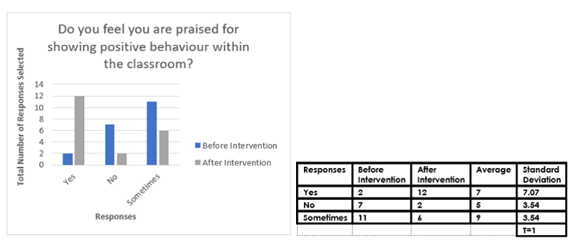
Figure 2- Rates of Praise Before and After Intervention

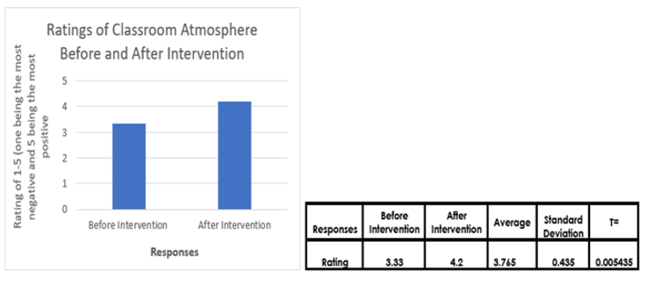
Figure 3- Ratings of Classroom Atmosphere Before and After Intervention

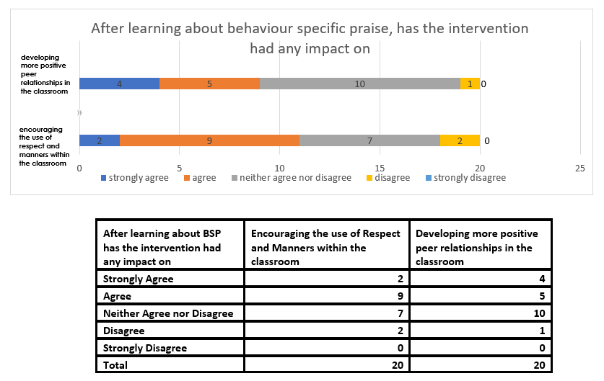
Figure 4- The Impact of BSP on Peer Relationships and the Use of Respect and Manners in the Classroom
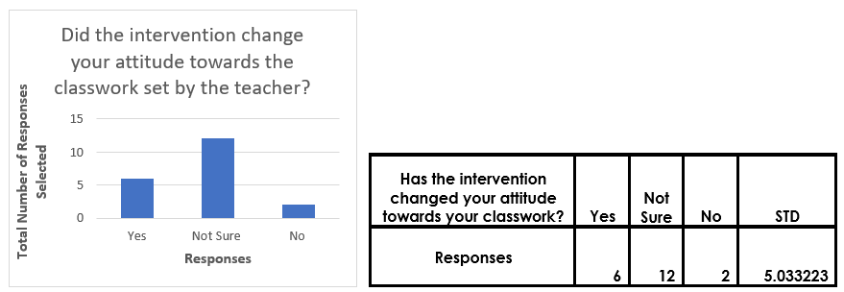
Figure 5- The Impact of BSP on Attitudes Towards Work

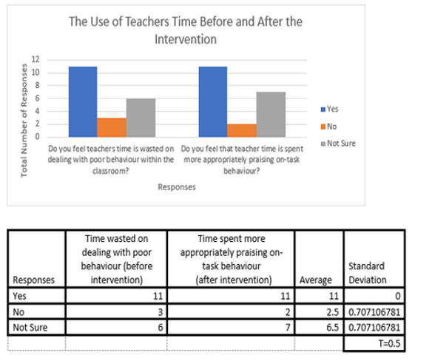
Figure 6- The Use of Teachers Time Before and After the Intervention
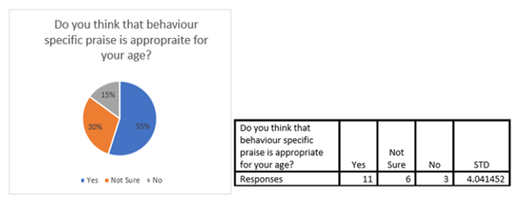
Figure 7- Appropriateness of BSP for age groups

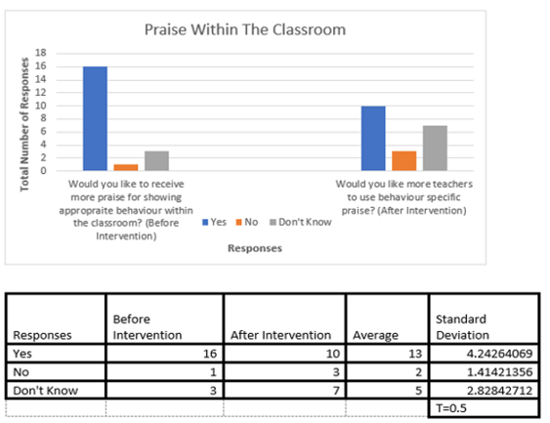
Figure 8- Use of BSP Within the Classroom

4.2 Qualitative Finding
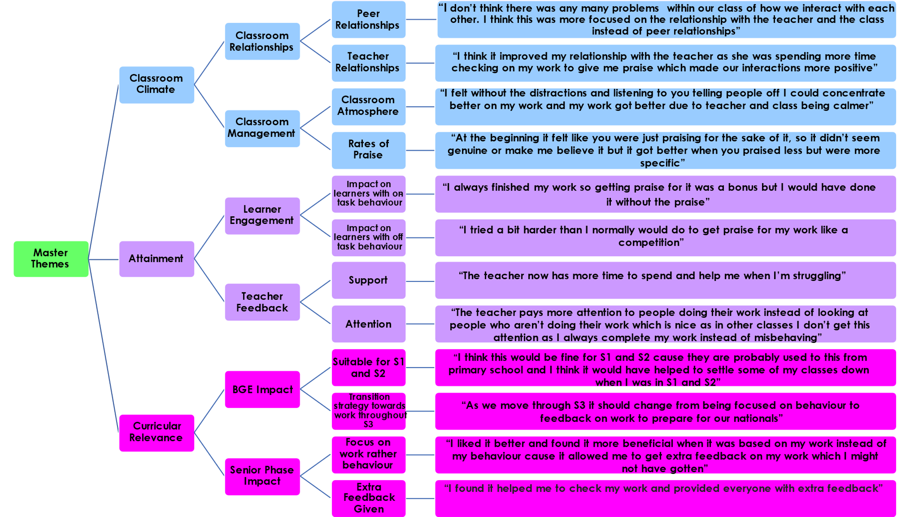
Figure 9- Thematic Map of Focus Groups and Critical Teacher Practice Reflective Journal Findings

Discussion

The above data was further summarised to allow for a thorough and comprehensive discussion surrounding the findings.

Figure 10- Summary of Main Themes Identified
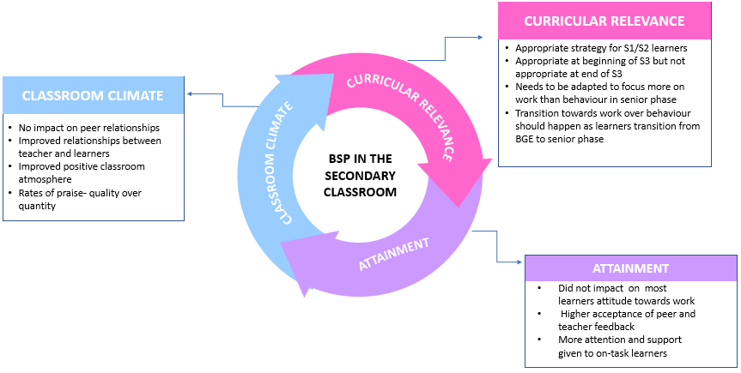

4.3 Classroom Climate
The first theme which emerged was the impact that BSP had on relationships within the classroom. The introduction of BSP resulted in learners receiving more praise for their effort and behaviour encouraging a more positive learner-teacher relationship. Figure 2 illustrates that BSP led to a significant rise in learners receiving more praise from the teacher. However, the chart also highlights potential inconsistencies with the level of praise which was issued. Although the number of learners responding that they are only praised sometimes had fallen from the first questionnaire, this still identifies a potential area for improvement to ensure all learners are given fair levels of praise. One possible explanation for learners believing they did not receive satisfactory amounts of praise may result from the author constantly adapting the rates of praise issued throughout the intervention. Originally the author had planned on using the methodology advocated by Blaze et al (2014) and deliver a praise statement every two minutes. However as noted within the journal this was not feasible as the author found this difficult to implement into a practical classroom where time is allocated at the beginning of every lesson for setting up. As the author was feeling overwhelmed at delivering these statements every two minutes, the author reflected and changed this to every three minutes to allow her to properly set up the class and deal with any ICT issues and support learners where appropriate. The author found this allowed for learners to feel better supported which meant that most learners were kept on-task resulting in a more relaxed climate. This was supported by discussions within the focus groups which agreed that the praise made the classroom a nicer and calmer environment to work in where effort and hard work was rewarded improving their relationship with the teacher.

The change within the amount of praise statements delivered was also due to perceptions from the author recorded within the journal that the praise did not seem natural within her classroom setting. In the first week of the intervention the author recorded that she felt “awkward” and “overwhelmed” at trying to deliver a praise statement every two minutes. During the second week of the intervention the author found it “stressful” at trying to keep up, provide class demonstrations and support struggling learners which led to the author recording that she believed the intervention was not developing a positive atmosphere due to the author feeling stressed and not believing she was contributing to a calm environment. This led to the author accidentally putting her phone onto flight mode which meant that the MotivAider app that the author relied on to send reminders did not work. Interestingly this was the first period which the author felt more natural and comfortable delivering praise. This may have been due to the lack of prompting which allowed for praise to be delivered at her own natural rates without pressure of meeting specific targets. Focusing more on the quality of the statements, so they were genuine and delivered in a more relaxed manner allowed the author to enhance relationships with learners. The author then decided to stop using the MotivAider to deliver the statements in a way which she felt the most sincere. However as this was during the third week the author could have felt more natural delivering the praise as the strategy could have begun naturally integrating into her teaching practice. Similar observations were made by participants, with some believing that at the beginning they were “praised just for the sake of it”, “it didn’t really seem genuine” and “it was a bit weird cause you could see you weren’t comfortable”. A consensus was reached in the focus groups that when praise was delivered less but was more “specific” it was more sincere and resulted in a more positive learner-teacher relationship.

Within this enquiry the importance of praise being genuine was more important to learners over the rates of praise issued supporting claims from Webster- Stratton (2012). The quality of the statements was more important than the quantity issued as the quality allowed for credibility, otherwise it could be seen as a gimmick. These findings dispute Blaze et al (2014) claims that praise must be issued every two minutes to positively impact the classroom climate. Results from this enquiry show that when fewer but more meaningful statements were delivered it was more effective in developing positive relationships.

BSP within the classroom was not significantly impact peer relationships. Figure 4 shows that although the majority of learners either agreed/ strongly agreed that BSP encouraged the use of respect and manners within the classroom, they did not believe it impacted them developing more positive peer relationships. This theme was discussed further within the focus groups. From the perspective of learners, the intervention did little to change peer relationships as there “wasn’t any problems with peer relations to begin with in the class”. The strategy did encourage learners to model the school’s ethos of showing respect and manners to their teachers and peers, but this was not enough to note a marked improvement within their interactions with each other. From the learner’s perspective the use of BSP alone cannot significantly change peer relationships. These findings are in stark contrast to the findings of Ferguson (2013) who emphasise that praise can promote better peer relationships within the class. Instead, supporting claims of Cengel and Turkoglu (2016) that the use of BSP alone cannot impact upon peer relationships and that relationships do not have significantly impact on creating positive classroom climates. However, from the perspective of learners in this enquiry this may have not impacted on peer relationships as some participants did not believe there were any issues with these to begin with.

The implementation of BSP did have an impact on creating a more positive classroom atmosphere (Narhi et al, 2017). Figure 3 highlights the positive impact BSP had on the classroom climate. However, the rating had only slightly increased which could support the findings of O’Handley et al (2020) that BSP is rarely used as a standalone behaviour management strategy as it cannot dramatically change a classroom climate. For a greater impact it may have to be combined with another strategy to be more effective. However, within this enquiry the short timeframe may explain the limited impact it had on the classroom climate, as BSP may not have been implemented for long enough to dramatically effect or change learners’ perceptions within the timeframe.

Within the focus group the majority of participants commented that from their perspective the classroom atmosphere did not dramatically change as it was okay to begin with and the only major difference was that the teacher wasn’t having to repeatedly tell learners within the class off. However, some participants found that this helped the atmosphere as “without the distractions of other people getting told off I could concentrate better” and “without this it made the class a nicer place to be a part of”.

The above findings show that BSP can positively impact a classroom climate but due to the short timescale of this enquiry the impact was limited. Other strategies may need to be implemented alongside BSP to achieve a more dramatic impact. The strategy may not have had a significant impact on the classroom atmosphere as from the perspective of learners the atmosphere was fine to begin with.

4.4 Attainment
The use of BSP had varied impact on learner attainment. Figure 5 demonstrates that most participants were unsure if BSP impacted on their attitude towards their classwork. This contradicts literature which stresses that BSP resulted in marked improvements in learners focus and engagement improving their attitude towards classwork raising their attainment (Riveria et al, 2015). This has shown to be true for primary schools but is lacking in research for secondary schools. This finding could provide up-to-date evidence that the use of BSP alone is not enough to impact learners’ motivation to complete classwork. Learners who regularly displayed on-task behaviour claimed that the strategy had little impact on their attitude towards work as without the praise they would have still completed it. Instead, learners were appreciative of the recognition which the praise provided them with: “it’s nice to be praised for completing my tasks instead of just being expected too”. However, for some learners, BSP did impact on their attitude towards their work. The author noted in the journal that learners who usually engaged in low-level disruptive behaviour, the quality of their work improved due to the increase in their on-task behaviour. One learner commented that “I tried harder than I normally would do to get praise for my work like a competition”. For these learners the use of BSP had a positive impact on their effort within the classroom thus increasing their attainment. However, this may be a result of these learners attempting to win back attention from the teacher or because of the competitive nature of these learners that are motivated by competition. Participants identified learners who they believed the strategy positively impacted on, “this worked with [Pupil A] as once you stopped giving him attention, he tried harder to get that attention back making him a lot calmer” and “same with [Pupil B] he likes attention and when you stopped telling him off and started giving other people attention, he had to stop his behaviour to get the attention back. It literally forced him to behave”. These findings suggest that for learners who are demonstrating high levels of on-task behaviour and complete most of the work which is expected of them; this strategy had little impact upon them it only provided them with recognition for their achievement. This strategy was effective in encouraging more on-task behaviour from learners who usually display off-task behaviour. However, this may not have the same impact on all learners who display off-task behaviour, due to some of these learners viewing the strategy as a competition. For learners who are not motivated by competition this strategy could have little impact upon them.

BSP refocused the teacher’s feedback and resulted in more learners getting attention and support from the teacher. Figures 6 highlights the impact that BSP had on the allocation of the teacher’s time within the classroom. Before the intervention the majority of learners stated that the teachers time was wasted on dealing with poor behaviour. The same number of learners indicated after the intervention they believed that the teachers time was better spent praising on-task behaviour. Learners believed that through this intervention they received more attention from the teacher than they usually would which led to the sub theme of increased teacher support. By not constantly addressing off-task behaviour and instead praising the author was able to better support struggling learners within the class. One learner commented that the teacher had a lot more free time as when addressing off-task behaviour “it might take a while to explain to that person why they shouldn’t do something and what they should do instead but if you praise someone for something they automatically know what they should be doing”.

These findings highlight that BSP allows for learners to receive more attention and are better supported within the classroom by the teacher as their time isn’t being taken up with disruptive behaviour. This supports the findings of McKenna et al (2014) with the teacher better meeting the needs of all learners within the classroom. However, comments were made that at times the teacher still paid too much attention to off-task behaviour and that for other learners they did not believe the intervention made much difference to amount of time spent supporting learners as “compared to other classes the teacher didn’t have a lot of bad behaviour to begin with so wasn’t wasting as much class time as other teachers.” This may again be down to the limited timeframe in which the intervention had and that it had not fully integrated into the teacher’s natural classroom practice so at times she gave more attention to off-task behaviour than she should have. The short timescale was not long enough for learners to notice a difference in the amount of attention and support the teacher was providing during the intervention in comparison to the attention shown before this enquiry.

4.5 Age Appropriate
The last key theme which emerged from the data was whether learners believed that the strategy was age appropriate as within the literature there is a lack of research on the impact of BSP within secondary schools.

Figure 7 shows that although the majority of learners thought BSP was appropriate for their age there was a significant number that were either unsure or did not believe it was. Learners who agreed, enjoyed the recognition as they do not receive praise for their effort and behaviour within other classes which supports the findings of Fefer (2016). However, for those learners who were not sure or did not believe it was an appropriate strategy suggested that this was too childish to be used at the end of third year and it was more suited for first and second years. This issue dominated the focus groups discussions with learners all coming to a consensus that the strategy would need to be adapted if it was to be implemented into senior phase (SP) classes. BSP would be appropriate for BGE as learners would be more familiar and receptive to it as it was a common primary school strategy. This could support learners and help them with settling in when transiting to high schools as participants noted that most behaviour issues was within this stage. Learners commented that if BSP was successfully implemented into BGE classes, it would not be needed within third year apart from the start of the year to settle classes down as one learner stated, “I think when you look at COVID-19 and us being in and out the school, some people within our year group struggle to behave”. Participants agreed that within BGE there was a greater focus on behaviour within classes as opposed to academic attainment. The perceptions of this being more suited for learners in BGE may come from the fact that these learners do not have the additional pressures of preparing for academic attainment (Friedman-Krauss et al, 2014).

As learners transition from BGE to SP in third year the strategy should be adapted as it becomes too “childish to focus on behaviour then”. Participants discussed how the strategy could be adapted with one common idea expressed. As learners move towards SP the praise should be solely based on their work instead of their behaviour to help prepare them for national qualifications with feedback geared “towards our work and skills”. When the author adapted the praise to focus on work learners believed this was more valuable as they were to get extra feedback on work which they would not have gotten otherwise. Similar observations were noted within the journal with the author recording that learners were “more responsive to the feedback when it was based on their work rather than behaviour”. Several learners stated that they used feedback issued to other learners based on work to check for example if they had used the correct formulas. This allowed them the opportunity to change any mistakes before peer or teacher marking. The author is not aware of this issue being raised within literature as to whether the strategy should shift away from behaviour to classwork as learners progress towards SP. The deliverance of praise should be made more subtle as learners transition towards the SP. One learner stated that “it should gradually be toned down, instead of standing at the front delivering it might be better to be a bit more private”. However, this sparked a debate with other learners who disagreed as they felt the praise had to be public so everyone could hear why people were being praised especially if it was focused on work, if private praise was used other learners would not be able to use this. Again, the author is unaware of any debates within the literature regarding changing praise from being public to private as learners transition into SP. The literature surrounding this either focuses on whether public praise is appropriate within secondary schools (Blaze et al, 2014) or whether praise should only be delivered privately (Fefer, 2016). These discussions may provide a justification for the results of Figure 8 which shows that before the intervention 83% of learners stated that they would like to be praised for showing appropriate behaviour. However, after the intervention only 55% of learners stated that they would like more teachers to use BSP. This would support claims that BSP is appropriate to use within BGE but learners did not think this strategy without any adaptions should be used within SP.

4.6 Key Points Summary
To conclude the implementation of BSP led to learners gaining more praise and attention from the teacher than they had previously received. From the intervention learners believed that the teachers time was spent more appropriately praising learners which resulted in a more positive classroom atmosphere. However, the intervention alone was not enough to change learners’ attitude towards their work. To impact on attitudes towards work it needs to be adapted to focus and provide feedback on work instead of behaviour. BSP in its current form would be appropriate to be introduced to BGE classes but needs adapted as learners progress towards SP. From the authors perspective, her confidence and skills developed when issuing praise which made her more comfortable delivering the praise in a more natural way. This was noted by learners who valued the feedback being more specific and genuine which led to the success of the strategy within her classes. However, if a teacher is not skilled at adapting the strategy to suit learners within their class the strategy may not be as effective or as successful. Their motivation to participate in this could also impact on the outcome, as the author already had a keen interest within behaviour management, she was fully prepared to implement this strategy into her practice and willing to persevere and adapt this strategy when issues arose to suit her classroom. If a teacher does not have the same persevere or interest, this may affect how successful BSP could be within their classroom.

CHAPTER 5: CONCLUSIONS AND RECOMMENDATIONS

5.1 Summary of Discussion and Findings
Literature advocates for the introduction of BSP into primary classrooms with multiple studies showcasing its positive impact in these classrooms. However, there is a lack of evidence within the literature of the benefits of introducing BSP into secondary classrooms. In this enquiry questionnaires, focus groups and a critical reflective teacher practice journal were used to assess the impact of BSP within secondary classrooms. The feedback was mostly positive with most learners confident that BSP could be used effectively within BGE to enhance positive learning environments. However, changes were suggested to make BSP more appropriate for learners transitioning from BGE to SP.

Within the intervention the author noted that there was less low-level disruptive behaviour within the classroom with limited time being wasted addressing these incidents which allowed for a quick and effective method of keeping learners on-task. The strategy allowed for attention from the teacher to be shared more equally across the class and for learners to gain more feedback on their classwork. Although this was a relatively small, based enquiry data collected from focus groups, questionnaires and journal suggests that BSP did positively impact the classroom climate. For BSP to be successfully implemented into a whole school behaviour policy; all teachers must ensure they are committed to incorporating the strategy into their everyday behaviour management practice to ensure the school is a calm and supportive environment for all learners.

5.2 Key Findings
Some of the key findings of this enquiry have been recognised within the literature. BSP impacted on the classroom climate through relationships and the classroom behavioural climate. It positively impacted on the teacher-learner relationship as learners received more attention from the teacher than they would have previously gotten. However unlike within the literature the strategy did not significantly impact on peer relationships within the classroom. This may be because of perceptions by learners that the strategy was more focused on the teacher-learner relationship instead of improving peer relationships or that they did not believe there was any issues with peer relationships before this intervention. In conformity with recognised benefits of BSP within literature, the use of BSP within the classroom resulted in a more positive atmosphere. Although the questionnaires highlighted only a slight difference in making the classroom atmosphere more positive. This may be due to the short timeframe of the intervention which was not long enough to dramatically change the perception of the atmosphere, for some learners the atmosphere did not need to change or as recognised within literature as a standalone strategy BSP cannot significantly impact the atmosphere. When delivering praise statements, unlike within the literature the author did not have a targeted amount statements to deliver which allowed for praise to be delivered more natural which was seen as more credible by learners.

BSP had a varied impact on attainment through learner enagagement and teacher feedback. Unlike in literature, BSP did not impact on attitude or motivation towards work from learners who regularly displayed on-task behaviour but did upon on learners who were more likely to display off-task behaviour. Learners were able to receive more attention from the teacher as time was not taken up dealing with low-level dispruptive behaviour, resulting in learners feeling better supported. This corresponds to the findings of several studies within the literature review that BSP supports teachers to better meet the needs of all learners.

This enquiry assessed both teacher and learners perceptions to implementing this strategy into BGE and SP. BSP could be implemented into BGE classrooms successfully as this stage is more focused on behaviour and transitioning learners into secondary schools instead of academic attainment. However as learners transition from BGE towards SP this strategy should be adapted and move away from behaviour at the beginning towards feedback on classwork to prepare learners for national qualifications. The use of praise has been advocated in literature and educational policy, the impact of praise within secondary schools is still relatively unknown and there is a significant gap in research which allows for further enquiries to be carried out.

5.3 Limitations of the Study
Following on from the discussion in chapter 3, this enquiry had a number of limitations. Time constraints and the process of applying and gaining ethical approval from the university and the council meant it could only be conducted within six weeks using a relatively small sample size. The timeframe and sample size meant the author was unable to collaboratively work with any colleagues. The nature of this intervention meant that the majority of the data collected was qualitative which gathered the perceptions of learners and the author involved and relied on the author correctly providing the data gathered and providing a resolute analysis of this. However, currently all comments and observations from the journal, questionnaires and focus groups have not been substantiated or conformed by the participants involved so an accurate representation of learner’s perceptions cannot be guaranteed as the author was unable to get learners to certify or clarify their comments due to timetable changes. The dual role of the teacher as the researcher within the enquiry may have impacted learners and influenced them to respond to the questionnaires and focus group discussions with social-desirable bias leading to inaccurate responses being recorded impacting upon the data collected.

5.4 Evaluation
If the author were to carry out this enquiry again, there would be significant changes to how it would be conducted. Firstly, the time scale of the project would be extended to allow for a more in-depth analysis which due to reasons out-with the authors control this one did not allow for. The author would try to conduct this enquiry with colleagues from different departments across the school providing a wider range of learner perceptions allowing for more varied data and the opportunity to interview staff as part of the methodology to gain more insight into how teachers view the impact the intervention had on their classes. The author would conduct more focus groups at regular intervals throughout the intervention to continue to modify the enquiry allowing for an intervention which meets the needs of all learners.

5.5 Dissemination
These findings will be submitted to the National Teacher Repository and the link from this will first be shared with the school’s headteacher and other ‘Behaviour Experts’ in shaping the schools roll out of this strategy. The results will be presented to the team to allow for discussions in which this strategy can be fully utilized and adapted to properly support learners within our school community. A working group of learners will be formed to gauge a wider range of perceptions from across all year groups. The findings will also be used to support collegiate development to ensure that learners have the same positive atmosphere within all classrooms to enhance their learning experience. The link will be shared with learners who participated within the research as well as with GCC to support their key policy ‘The Nurturing City’ to ensure that the classroom offers a safe base where learners are respected and encourages the development of a learner’s self-esteem. This provides a for professional dialogue and collaboration with the council should they wish to update its ‘Promoting Positive Behaviour’ policy or create any new classroom management policies within the future. The author also plans to submit these findings to related journals and Education Scotland should this area become a subject of interest for them in creating new policies.

5.6 Recommendations
As this will be implemented within the whole school behavioural policy further research should be carried out with the strategy implemented into different curriculum classes and year groups across the school. Allowing for a greater collection of learners perceptions which could validate the findings of the enquiry and substantiate the changes expressed by learners. The author plans to implement this strategy with her new timetabled S3 Admin classes over a much longer timescale to see if this will provide different results to those collected in this enquiry. The author will form a working group of learners who participated within the study as well as other learners across different year groups to adapt this policy to suit the diverse range of learners within our school. This will then be presented to all staff within the in-service day with both staff and learners coming together to train up other members of staff on this strategy. Further CPD training on this strategy will also be provided to further support staff and share good practice. Further studies within the council should be supported to verify the findings of this enquiry as this was a small-scale study within a limited timeframe. This could potentially provide a clearer link between GCC’s behavioural and nurturing policies in the transition from primary to secondary and from BGE to SP.

5.7 Conclusion
This enquiry set out to assess the impact of BSP on the classroom climate within secondary classrooms through an AR study and aimed to provide an understanding of how it could be used as a behaviour management strategy. The enquiry was designed to draw upon detailed perceptions of learners with the methodology. The findings of this enquiry suggest that BSP could be used within secondary classrooms to positively impact upon classroom atmosphere, however it would need adapted as learners transition from BGE to SP. To validate these findings further research is required including implementing the strategy over a longer timescale and introducing it into different curriculum subjects and year groups which would allow for a greater understanding of how BSP can be tailored to meet the needs of all learners. A whole school approach is critical to implementing this strategy to ensure all learners have access to the same safe environment and for it to become part of the natural school teaching pedagogy, if not the strategy will be seen as tokenistic. In this enquiry the majority of learners provided positive feedback to implementation of this strategy within their class. However, these findings come from a limited number of participants within a single enquiry; a larger scale enquiry involving departments across the school with a greater number of learners would help to bring greater validation and credibility to the issue which was beyond the parameters of this enquiry. As teachers face greater pressure within classrooms such as planning and academic attainment of learner’s expectations, increasing behaviour problems and a greater number of learners within their classrooms with ASL or SEBN; it is essential that access to evidence-based strategies which can be employed into the classroom with little time and effort required.

APPENDICES

Appendix 1 | Ethical Approval and Amendments University of Glasgow
Appendix 2 | Glasgow City Council Approval
Appendix 3 | Parental Plain Language Statement
Appendix 4 | Parental Consent Form
Appendix 5 | Learner Plain Language Statement
Appendix 6 | Learner Consent Form
Appendix 7 | Online Questionnaire Issued Before Intervention
Appendix 8 | Online Questionnaire Issued After Intervention
Appendix 9 | Focus Group Themes

APPENDIX 1- Ethical Approval and Amendments University of Glasgow

25 February 2022

Dear Willie,

School of Education Research Ethics Committee
Project Title: Cohort Approval for MEd Professional Practice

Application No: 402210061 (Group Approval)
The School of Education Research Ethics Committee has reviewed your application and has agreed that there is no objection on ethical grounds to the proposed group application. It is happy therefore to approve this application, subject to the following conditions:

- Start date of ethical approval: 03/01/22
- Project end date: 30/09/22
- Procedures for approving individual projects under this umbrella application are as sent in separate document
- Any proposed changes in the protocol should be submitted for reassessment as an amendment to the original application. The Request for Amendments to an Approved Application form should be used: https://www.gla.ac.uk/schools/education/research/ethics/forms/

Thank-you for establishing a group ethics approval application for your programme and for your patience with the process this year.

Yours sincerely,

Dr Paul Lynch
School of Education Ethics Officer

Request for Amendments to an Approved Ethics Application
(please complete this document and forward it with any supporting documentation to the School of Education Ethics Committee at education-ethics@glasgow.ac.uk, cc-ing the Ethics Officer, Dr Paul Lynch: Paul.Lynch@glasgow.ac.uk

Undergraduate Student Research Ethics Application ☐
Postgraduate Taught Student Research Ethics Application ☒
Student ID Number: 2335573m
Application Number: 40219….. (please don’t forget to add this number)
Applicant’s Name: Natalie McLeish
Project Title: What is the impact of behaviour specific praise on the learning experience of all pupils in a secondary classroom?
Original Start Date of Application Approval: 21/03/2022
Original End Date of Application Approval: 24/06/2022
_____________________________________________________________________________________________________
Amendments Requested
Extension to Approval Period: ☐ Documents to be amended: ☐
Participant Group, change or addition: ☒ Information Sheet/Plain Language Statement: ☐
Methodology: ☐ Consent Form: ☐
Addition/Change to Researcher team: ☐ Recruitment Document: ☐
Other: ☐

Justification for Amendments proposed: e.g. extension to approval end date required; addition of new participant group; change in project focus. Please confirm here that you have considered the ethical implications of such changes – e.g. will the fieldwork still be able to ensure privacy and confidentiality for the applicant? Will the data still be kept securely? Will consent (verbal or written) still be recorded for each participant? Etc.

In the original proposal I had planned on using S2 classes for the intervention. I have four S2 classes who I seen one period a week. Originally, I had planned to complete the intervention over an 8-week period (8 lessons in total for each class). However due to having to apply for ethical approval from Glasgow City Council this will not be possible. The ethics department at the council only meet 4 times a year and met on the 24th of March (the week I had originally planned to start the intervention) to discuss and look at proposal. I received confirmation of approval from the council on the 30th of March and by that time I had already taught my S2 classes for that week meaning I would have to wait until after the Easter holidays to begin the intervention on week beginning 18th April and would only have to 6 weeks to implement the intervention into my classroom. On the 31st of March my school was told that on the first week back after the Easter holiday (week beginning 18th of April) HMI inspectors would be visiting to evaluate schools’ recovery from lockdowns and COVID-19. This would mean that my intervention could not start until the following week- beginning the 25th of April meaning I would only be able to implement this over 5 weeks (5 lessons in total) due to the school wanting a focus on showcasing high quality learning and teaching and engaging planned lessons and them not wanting any distractions. Due to this I have requested a change in participants and would like to use S3 classes instead. I have two S3 Administration and IT classes which I have for three periods a week making the data collected more reliable due to me being able to properly embed the strategy into the classroom. This intervention will now take place over 5 weeks (which is 15 periods for each class). I can confirm that I have considered the ethical implications of such changes and can provide assurance that the intervention will still ensure the privacy and confidentiality of the participants and all data will still be kept securely. Consent forms will be issued as planned to both learners and parents/guardians (due to participants still being under the age of 18).

List of Supporting Documents attached:

Updated plain language statement for learners
Updated plain language statement for parents/guardians

Declaration:
I certify that to the best of my knowledge the information given above, together with any accompanying information, is complete and correct.

Signature(s)
Applicant: Natalie McLeish

Supervisor (if student project):
_____________________________________________________________________________________________________

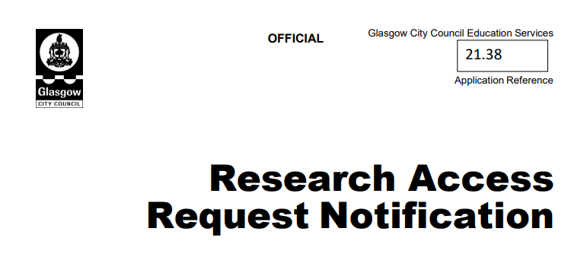
APPENDIX 2 Glasgow City Council Approval
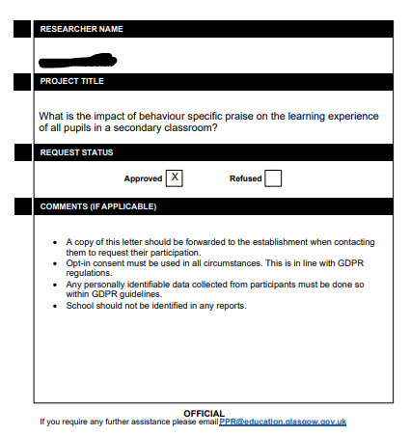

APPENDIX 3- Parental Plain Language Statement

Plain Language Statement

Parents / Guardians

Title of project and researcher details:
What is the impact of Behaviour Specific Praise on the learning experience of all pupils in a secondary classroom?

Researcher: Natalie McLeish
Supervisor: Gabriella Rodolico
Course: MEd Professional Practice
Title | First and Surname | Email
Miss | Natalie McLeish | 2335573m@student.gla.ac.uk
Mrs | Gabriella Rodolico | Gabriella.Rodolico@glasgow.ac.uk

Your child is being invited to take part in a research project into the impact of Behaviour Specific Praise in the classroom.
Before you decide if you want your child to take part, it is important for you to understand why the research is being done and what it will involve. Please take time to read the information on this page carefully and discuss it with others if you wish. Ask me if there is anything that is not clear or if you would like more information. Take time to decide whether or not you wish your child to take part.
I hope that this sheet will answer any questions you have about the study.

1. What is the purpose of the study?
The purpose of this study is to find out whether Behaviour Specific Praise can have a positive impact on the learning experiences of all learners within a secondary classroom. Behaviour Specific Praise is a teaching strategy that teachers can use to both increase positive behaviour and to decrease problem behaviour within the classroom. This strategy identifies desired positive behaviours within class and seeks to increase the use of these appropriate behaviours instead of calling out inappropriate behaviours. An example of this may be “thank you Johnny for sitting quietly waiting on the Spreadsheet demonstration to begin”. This will be used instead of reprimanding another pupil who may be taking or turning around in their chair. This strategy models which behaviour is appropriate for the classroom by continually providing feedback on their social skills as well as on their academic progress. This study will identify if Behaviour Specific Praise can be used effectively in your child’s classroom to create a positive classroom atmosphere, increase quality learning time, and provide attention to those learners who are constantly engaged within the lessons and doing their work instead of reprimanding and giving attention to learners who are not engaged in their work. The objective of this study is to increase all learner’s willingness to follow on task behaviour within the classroom through the modelling and praise of appropriate on task behaviour. On task behaviour can be defined as following all classroom rules such as being respectful to the teacher and fellow learners in the class, completing all tasks to the best of their abilities and contributing to a positive classroom environment.

2. Why has my child been chosen?
Your child is being asked to take part because they are in an S3 Admin class which the researcher only has three periods a week in which teacher attention can be taken up through addressing off task behaviour. Your child will experience Behaviour Specific Praise which praises on task behaviour as opposed to challenging not on task behaviour. This is aimed to enhance positive attitudes and to allow learners to follow positive behaviour with a peer role modelling approach.

3. Does my child have to take part?
Your child does not have to take part in this study. If you decide that they should not take part, or if your child does not want to take part, they will still be involved within the class intervention so they will not be disadvantaged within their learning or with their interactions with the classroom teacher. If, after your child has started to take part, you or they change your mind, just let me know and I will not use any information they have given me in my writing.

4. What will happen to my child if they take part?
If your child decides to take part with your permission, they will answer two questionnaires in the form of a Microsoft Form before and 6 weeks after the implementation of Behaviour Specific Praise in the classroom. Your child will then be invited to take part within a focus group where they will be asked for their opinions on the strategy. Focus group is a more relaxed way to ask for pupils’ opinions within the safe environment of the classroom where 3 or 4 classmates will be chatting with the researcher about their opinions on the intervention and how the Behaviour Specific Praise worked (or not) for them. The focus is on the positive atmosphere (if any) experienced in class and if this could or not enhance their learning experience
They do not have to answer any questions that they do not want to. The focus group will take no longer than 30 minutes. I will record the answers on a voice recorder so that afterwards I can listen carefully to what was said. The recording will then be transcribed and deleted after this.
I will be finished gathering data by June 4th, 2022, which will also include the 6 week intervention.

5. Will the information that my child gives you in this study be kept confidential?
I will keep all the data I collect about the intervention in a locked cabinet and in a locked file on my computer. When I write about what I have found, your child’s name will not be mentioned. All entries in the questionnaire will be anonymous and I will use de-identifiers (such as Pupil A, Pupil B etc) when transcribing the focus group recording and when writing up the assignment. However, if during our conversation I hear anything which makes me worried that your child might be in danger of harm, I might have to inform relevant agencies of this.

6. What will happen to the results of this study
I will analyse the data I collect from the children and present this in the dissertation which I am writing for my qualification, MEd Professional Practice. Children who have participated, and their parents, will receive a written summary of the findings and I will also present the information to colleagues. I will destroy the data at the end of the project.

7. Who has reviewed the study?
This study has been reviewed and agreed by the School of Education Ethics Forum, University of Glasgow

8. Who can I contact for further Information?
If you have any questions about this study, you can ask me, Natalie McLeish (gw18mcleishnatalie@glow.sch.uk)
or my supervisor, Gabriella Rodolico (Gabriella.Rodolico@glasgow.ac.uk)
or the Ethics officer for the School of Paul Lynch paul.lynch@glasgow.ac.ukglasgow.ac.uk

Thank you for reading this.

Natalie McLeish

APPENDIX 4- Parental Consent Form

Consent Form

Title of Project: What is the impact of Behaviour Specific Praise on the learning experience of all pupils in a secondary classroom?

Name of Researcher: Natalie McLeish
Supervisor: Gabriella Rodolico

Title | First and Surname | Email
Miss | Natalie McLeish | 2335573m@student.gla.ac.uk
Mrs | Gabriella Rodolico | Gabriella.Rodolico@glasgow.ac.uk

Please tick as appropriate

Yes ☐ No ☐ I confirm that I have read and understood the Participant Information Sheet and/or Plain Language Statement for the above study and have been given contact information to ask further questions.

Yes ☐ No ☐ I understand that my child’s participation is voluntary and that they are free to withdraw at any time, without giving any reason.

Consent on method clause

Yes ☐ No ☐ I consent to my child taking part in the questionnaires

Yes ☐ No ☐ I consent to my child taking part in the focus group

Yes ☐ No ☐ I consent to focus groups being audio-recorded

Yes ☐ No ☐ I acknowledge that participants will be referred to using a false name

Yes ☐ No ☐ I fully understand that all collected data will be kept anonymous.

Yes ☐ No ☐ I acknowledge that there will be no effect on my child’s grades arising from their participation or non-participation in this research.

I agree that:

Yes ☐ No ☐ All names and other material likely to identify individuals will be anonymised.

Yes ☐ No ☐ The material will be treated as confidential and kept in secure storage at all times.

Yes ☐ No ☐ The paper files will be destroyed once the project is complete.

Yes ☐ No ☐ The material will be retained in secure storage for use in future academic research

Yes ☐ No ☐ The material may be used in future publications, both print and online.

Yes ☐ No ☐ I waive my copyright to any data collected as part of this project.

Yes ☐ No ☐ Other authenticated researchers will have access to this data only if they agree to preserve the confidentiality of the information as requested in this form.

Yes ☐ No ☐ Other authenticated researchers may use my words in publications, reports, web pages, and other research outputs, only if they agree to preserve the confidentiality of the information as requested in this form

Yes ☐ No ☐ I acknowledge the provision of a Privacy Notice in relation to this research project.

I agree for my child to take part in this research study ☐

I do not agree for my child to take part in this research study ☐

Name of Participant ……………………………………………………..

Name of Parent/guardian …………………………………………………….

Signature …………………………………………………….. Date ……………………………………

Name of Researcher ………………………………………………… Signature ………………………………………

Date …………………………………

APPENDIX 5- Learner Plain Language Statement

Plain Language Statement
(pupils / children)

Title of project and researcher details
Researcher: Miss McLeish
Supervisor: Mrs Gabriella Rodolico (gabriella.rodolico@glasgow.ac.uk)
Course: Master’s in Professional Practice

You are being invited to take part in a research project into the effects which praise for appropriate classroom behaviour can have within the classroom.

This research project is a method which allows the school, the Council and the university to learn about how praise can affect a classroom.

Before you decide if you want to take part, it is important for you to understand why the research is being done and what it will involve.

Please take time to read the information on this page carefully and discuss it with Miss McLeish and your parents/carers if you wish. Ask me if there is anything that is not clear or if you would like more information. Take time to decide whether or not you wish to take part.

I hope that this sheet will answer any questions you have about the study.

What is the study the purpose of the study? | A positive classroom atmosphere is important for successful learning to take place within the classroom.  However sometimes it can be negative with some pupils not meeting the standard and the teacher having to take time to deal with this instead of helping other pupils.  This study is to see if Behaviour Specific Praise can have a positive impact on our classroom atmosphere and rewards learners for following classroom rules and expectations.  An example of this could be “thank you Ellie for completing task 1 quietly so the register can be taken” instead of “John can you stop talking while I am trying to complete a register” (which would be a telling off).  This can help me understand how to increase your enjoyment of lessons and ensure that everyone gets the fair amount of attention from the teacher.
Why me? | You are in one of my S3 classes
Do I have to take part? | No, you can choose to take part or not.  If you choose to not take part you will still take part in normal class activities, you just won’t fill in the questionnaires and won’t take part within the focus groups. Your thoughts and opinions will not be discussed in this dissertation.  Although you are free to express and discuss with me your opinion on this teaching strategy at any point.
What will happen I do if I choose to take part? | - Everyone in the class will have the opportunity to receive praise based on your behaviour and will all be working on the same activities.  - Everyone has the chance to complete a questionnaire before and after the intervention based on your thoughts and opinions on Behaviour Specific Praise.  - In addition, at the end of the 5 weeks I will ask for volunteers to take part in a focus group where we will be discussing in a little more detail your thoughts on the Behaviour Specific Praise strategy.  - The focus group will take about 30 minutes. I will record your answers on a voice recorder so that afterwards I can listen carefully to what you said.  - The teacher will take notes on the progress of the strategy within the class and how it is impacting on the classroom atmosphere and make notes on whole class behaviour during the intervention.  - The research will be complete by the 6th June.  If you choose not to take part, you will still participate in the normal classroom activities and the intervention as this will be the normal classroom practise. Your data however will not be discussed within this dissertation, and you will not complete the questionnaire or participate within the focus group.
What will happen to the information collected about me? | - I will keep the information in a locked cabinet or in a locked file on my computer.  - When I write about what I have found, your name will not be mentioned.  - All responses from the questionnaire will be collected from Microsoft Forms and will be anonymous (meaning I won’t know your name).  - I will use de-identifier codes for all data collected from the focus group. This means instead of using your name you will be referred to as Pupil 1, Pupil 2 and so on. No one will know which code name is yours except from myself as your classroom teacher and the researcher.  - However, if during our conversation I hear anything which makes me worried that you might be in danger of harm, I might have to tell other people who need to know about this (same as I would always do). This will not have any impact on your marks.
What will happen to the information collected in this study? | - All information gathered will be used to write up a dissertation (like a big essay) as part of the university degree I am studying.  - I then submit this to be marked by lecturers at the University.  - I will also share with you and other pupils that have taken part what I have found out through this intervention.  - I will destroy all of my notes and recordings when the project is finished.
Who do I speak too if I have more questions? | - Contact me Miss McLeish (gw18mcleishnatalie@glow.sch.uk)  - Or my supervisor/teacher Gabriella Rodolico (gabriella.rodolico@glasgow.ac.uk)  - Or ethics officer Paul Lynch (paul.lynch@glasgow.ac.uk)

APPENDIX 6- Learner Consent Form

Consent Form
I would like to hear what you think about the use of praise for appropriate classroom behaviour and what effect it had on our classroom atmosphere.

- You do not have to answer any questions you do not like.
- You can stop participating at any time.

Do you want to complete two short questionnaires (no more than 10 questions) about the effects which Behaviour Specific Praise had on our classroom atmosphere?
- Behaviour Specific Praise is a teaching strategy which is used to encourage positive classroom behaviour and decrease problem behaviour in the class.
- This strategy rewards learners for following all classroom rules and expectations with praise instead of challenging learners for not following the classroom rules.
- An example of this could be “thank you Ellie for completing task 1 quietly so the register can be taken” instead of “John can you stop talking while I am trying to complete a register” (which would be a telling off).

Please put a circle around your answer.

Would you like to participate within a focus group to discuss the intervention? If you choose to participate within the focus group your answers will be recorded so I can transcribe them (write the important points up).

Please put a circle around your answer.

Can I write up your answers into a dissertation (long essay) and tell other people your thoughts and opinions? I will not write down or tell other people your name, your thoughts and opinions will be anonymous (no one apart from me will know what you said).

Please put a circle around your answer.

Please write your name in the box below.

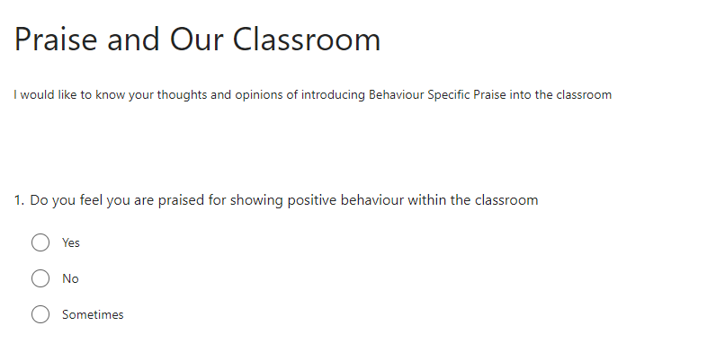
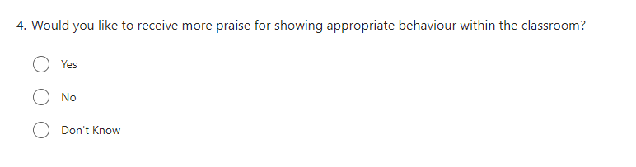
APPENDIX 7- Online Questionnaire Issued Before Intervention

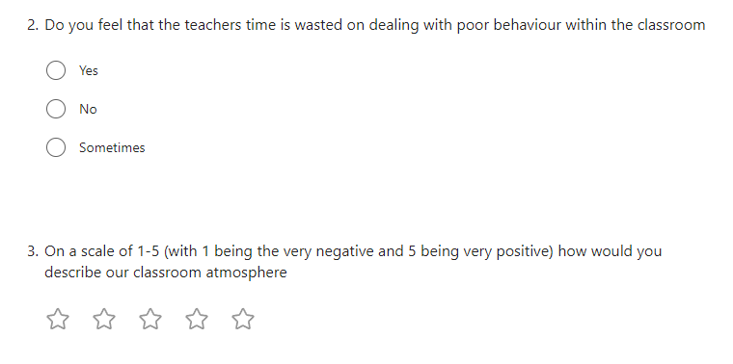

APPENDIX 8- Online Questionnaire Issued After Intervention
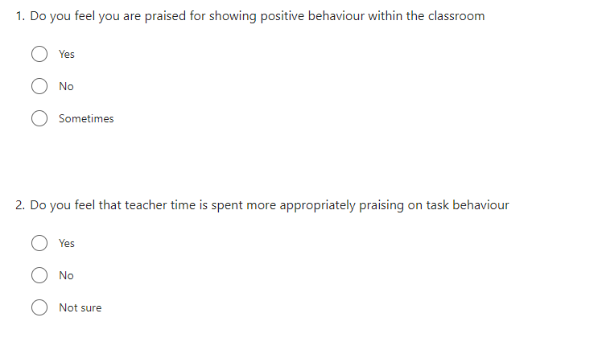

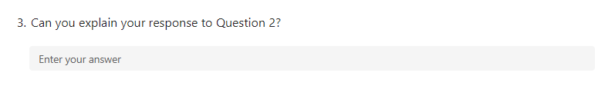

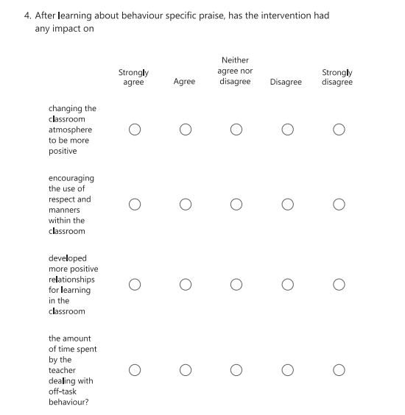

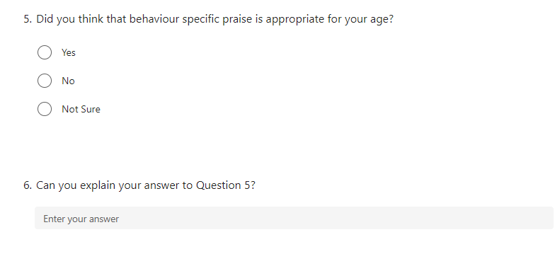

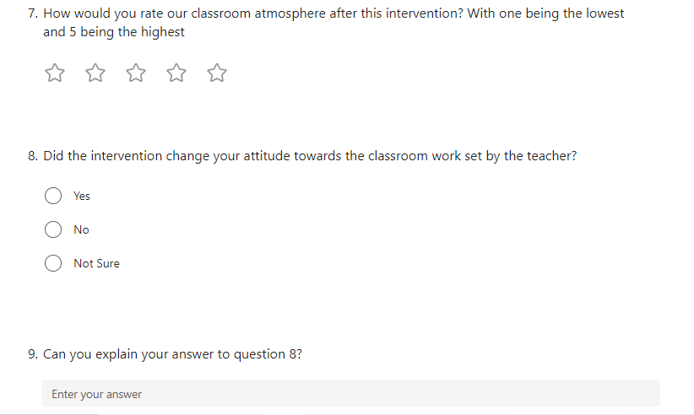

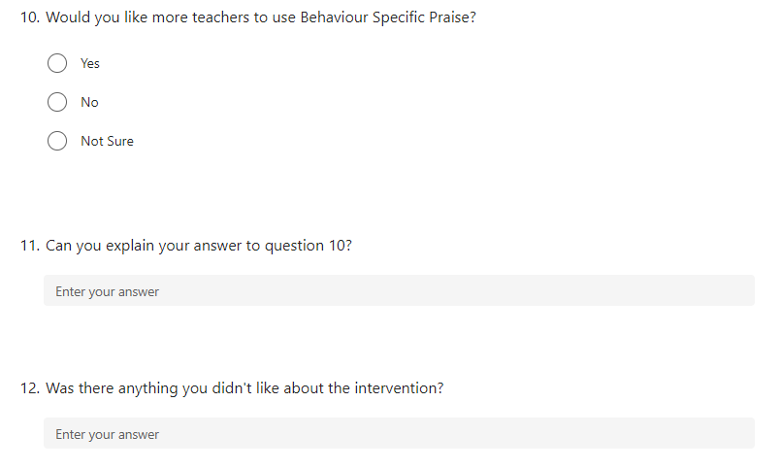

APPENDIX 9- Focus Group Themes

- Did you enjoy being praised for showing appropriate and positive behaviours?
- Did behaviour specific praise have a positive impact on the classroom climate?
- Did behaviour specific praise have a positive impact on your on-task behaviour?
- Did you receive more positive attention from the teacher through behaviour specific praise?
- Was behaviour specific praise an appropriate strategy to use with your age group?
- Is there any changes or improvements we can make to the strategy to increase its impact?
- Would you like other teacher within the school to use this strategy?
- Is there any other comments you would like to make?

REFERENCES

2014. Council for Exceptional Children: Standards for Evidence-Based Practices in Special Education. [online] Exceptional Children, pp.504-511. Available at: <https://eric.ed.gov/?id=EJ1048534> [Accessed 2 April 2022].

Adler, K., Salanterä, S. and Zumstein-Shaha, M., 2019. Focus Group Interviews in Child, Youth, and Parent Research: An Integrative Literature Review. International Journal of Qualitative Methods, [online] 18, pp.1-15. Available at: <https://journals.sagepub.com/doi/full/10.1177/1609406919887274?msclkid=8de3451ec4c611ec80e1338aa8306cd8> [Accessed 24 April 2022].

Amin, M., Rashid, R. and Teh, K., 2019. Investigating Issues and Challenges in Employing Action Research for Teacher Training in Malaysian Context. International Journal of Education and Practice, [online] 7(1), pp.30-40. Available at: <https://files.eric.ed.gov/fulltext/EJ1209945.pdf> [Accessed 23 April 2022].

Anderson, G. and Arsenault, N., 1998. Fundamentals of Educational Research. 2nd ed. London: Taylor & Francis, pp.179-211.

Anderson, L., Stevens, D., Prawat, R. and Nickerson, J., 1988. Classroom Task Environments and Students' Task-Related Beliefs. The Elementary School Journal, [online] 88(3), pp.281-295. Available at: <https://eric.ed.gov/?id=ED286861> [Accessed 14 May 2022].

Bashan, B. and Holsblat, R., 2017. Reflective journals as a research tool: The case of student teachers’ development of teamwork. Cogent Education, [online] 4(1), pp.11-15. Available at: <https://link.springer.com/content/pdf/10.1007/s10972-016-9462-7.pdf> [Accessed 30 April 2022].

Beaman, R. and Wheldall, K., 2000. Teachers' Use of Approval and Disapproval in the Classroom. Educational Psychology, [online] 20(4), pp.431-446. Available at: <http://tandfonline> [Accessed 20 March 2022].

Bear, G., 2010. School Discipline and self-discipline. The Guilford Press, [online] pp.35-39. Available at: <https://www.bing.com/search?q=School+Discipline+and+self-discipline+bear&cvid=717a8b1d2765420fb5422bc9722bf37f&aqs=edge..69i57.2558j0j1&pglt=43&FORM=ANNTA1&PC=HCTS> [Accessed 26 March 2022].

Bilican- Demir, S., 2021. The Characteristics of Teachers in Effective Schools: A Secondary Analysis of Talis. International Online Journal of Education and Teaching, [online] 8(1), pp.525-545. Available at: <https://files.eric.ed.gov/fulltext/EJ1286592.pdf> [Accessed 15 May 2022].

Black, C., Eunson, J., Murray, L., Zubairi, S. and Bowen, L., 2017. Behaviour in Scottish Schools. [online] Edinburgh: Scottish Government, pp.1-96. Available at: <https://www.gov.scot/publications/behaviour-scottish-schools-research-2016/> [Accessed 8 April 2022].

Blank, C. and Shavit, Y., 2016. The Association Between Student Reports of Classmates’ Disruptive Behavior and Student Achievement. AERA Open, [online] 2(3), p.233285841665392. Available at: <https://journals.sagepub.com/doi/pdf/10.1177/2332858416653921> [Accessed 14 May 2022].

Blaze, J., Olmi, D., Mercer, S., Dufrene, B. and Tingstom, D., 2014. Loud versus quiet praise: A direct behavioral comparison in secondary classrooms. Journal of School Psychology, [online] 52(4), pp.349-360. Available at: <https://www.researchgate.net/publication/264632513_Loud_versus_quiet_praise_A_direct_behavioral_comparison_in_secondary_classrooms#:~:text=Blaze%20et%20al.%20%282014%29%20systematically%20compared%20the%20independent,appropriately%20engaged%20behaviors%20and%20decreased%20their%20disruptive%20behaviors....> [Accessed 26 March 2022].

Boudah, D., 2011. Understanding relevant literature and writing a literature review. In Conducting educational research: Guide to completing a major project, [online] pp.43-63. Available at: https://sk.sagepub.com/books/conducting-educational-research [Accessed 12 April 2022].

Boyatzis, R., 1998. Transforming qualitative information: Thematic analysis and code development. Thousand Oaks: Sage, pp.1-38.

Braun, V. and Clarke, V., 2006. Using thematic analysis in psychology. Qualitative Research in Psychology, [online] 3(2), pp.77-101. Available at: <https://www.researchgate.net/publication/235356393_Using_thematic_analysis_in_psychology> [Accessed 21 May 2022].

British Educational Research Association, 2011. Ethical Guidelines for Educational Research. London: BERA.

Brophy, J., 1981. Teacher Praise: A Functional Analysis. Review of Educational Research, [online] 51(1), pp.5-32. Available at: <https://www.jstor.org/stable/1170249> [Accessed 20 March 2022].
Bulter, H. and Meyer, H., 2015. Teaching climate as a determinant of learning success. Motivation durch Beziehung, [online] pp.25-67. Available at: <https://link.springer.com/chapter/10.1007/978-3-658-07416-6_2> [Accessed 15 May 2022].

Burnett, P. and Mandel, V., 2002. Teacher Praise and Feedback and Students' Perceptions of the Classroom Environment. Educational Psychology, [online] 22(1), pp.5-16. Available at: <https://www.tandfonline.com/doi/abs/10.1080/01443410120101215> [Accessed 27 March 2022].

Burns, A., 2009. Doing action research in English language teaching: A guide for practitioners. Doing Action Research in English Language Teaching, [online] (1). Available at: <https://www.taylorfrancis.com/books/mono/10.4324/9780203863466/action-research-english-language-teaching-anne-burns> [Accessed 23 April 2022].

Burns, A., 2010. Doing action research in English language teaching. New York: Routledge, pp.1-15.

Burton, J., Reichmann, C. and Peyton, K., 2009. Reflective writing, a way to lifelong teacher learning. Collaborative Reflections on Learning Another Language: Implications for Teaching, [online] pp.1-6. Available at: <https://www.researchgate.net/publication/299565428_COLLABORATIVE_REFLECTIONS_ON_LEARNING_ANOTHER_LANGUAGE_IMPLICATIONS_FOR_TEACHING> [Accessed 30 April 2022].

Caldarella, P., Larsen, R., Williams, L., Downs, K., Wills, H. and Wehby, J., 2020. Effects of teachers’ praise-to-reprimand ratios on elementary students’ on-task behaviour. Educational Psychology, [online] 40(10), pp.1306-1322. Available at: <https://www.researchgate.net/publication/338900586_Effects_of_teachers'_praise-to-reprimand_ratios_on_elementary_students'_on-task_behaviour> [Accessed 9 April 2022].

Cengel, M. and Turkoglu, A., 2016. Analysis through Hidden Curriculum of Peer Relations in Two Different Classes with Positive and Negative Classroom Climates. Educational Sciences: Theory & Practice, [online] pp.1893-1919. Available at: <https://files.eric.ed.gov/fulltext/EJ1130765.pdf> [Accessed 15 May 2022].

Chandra, R., 2015. Classroom Management for Effective Teaching. International Journal of Education and Psychological Research (IJEPR), [online] 4(4), pp.13-15. Available at: <https://www.researchgate.net/publication/313889949_Classroom_Management_for_Effective_Teaching> [Accessed 7 May 2022].

Clunies‐Ross, P., Little, E. and Kienhuis, M., 2008. Self‐reported and actual use of proactive and reactive classroom management strategies and their relationship with teacher stress and student behaviour. Educational Psychology, [online] 28(6), pp.693-710. Available at: <https://www.tandfonline.com/doi/abs/10.1080/01443410802206700?journalCode=cedp20> [Accessed 2 April 2022].

Cohen, L., Manion, L. and Morrison, K., 2011. Research methods in education. 7th ed. London: Routledge, pp.159-433

Creswell, J., 2003. RESEARCH DESIGN Qualitative, Quantitative. and Mixed Methods Approaches. 2nd ed. California: SAGE, pp.1-26.

Creswell, J., 2009. Research Design Qualitative, Quantitative and Mixed Methods Approach. 3rd ed. London: Sage, pp.1-73.

Crisis Prevention Institue. 2022. About Us | Crisis Prevention Institute (CPI). [online] Available at: <https://www.crisisprevention.com/en-GB/About-Us> [Accessed 15 February 2022].

Cyr, J., 2016. The Pitfalls and Promise of Focus Groups as a Data Collection Method. Sociological Methods &amp; Research, [online] 45(2), pp.231-259. Available at: <http://32. ERIC - EJ1139887 - The Pitfalls and Promise of Focus Groups as a Data Collection Method, Sociological Methods & Research, 2016-May (ed.gov)> [Accessed 24 April 2022].

Dana, N., 2019. The reflective educator's guide to classroom research. 3rd ed. CA: Thousand Oaks, pp.143-167.

Denzin, N. and Lincoln, Y., 2000. Handbook of qualitative research. 2nd ed. Thousand Oaks: Sage.
Donyaie, S. and Afshar, H., 2019. EFL Teachers’ Reflective Journal Writing: Barriers and Boosters. Iranian Journal of Teaching Research, [online] 7(3), pp.71-90. Available at: <https://files.eric.ed.gov/fulltext/EJ1230316.pdf> [Accessed 30 April 2022].

Dutton Tillery, A., Varjas, K., Meyers, J. and Collins, A., 2010. General Education Teachers’ Perceptions of Behavior Management and Intervention Strategies. Journal of Positive Behavior Interventions, [online] 12(2), pp.86-102. Available at: <https://journals.sagepub.com/doi/abs/10.1177/1098300708330879> [Accessed 26 March 2022].
Education.gov.scot. 2017. National Improvement Hub- Self Evaluation. [online] Available at: <https://education.gov.scot/improvement/search/?orderBy=relevance&originSubsite=NationalImprovementHub&query=self%20evaluation> [Accessed 10 July 2022].

Education Scotland, 2021. Assessment within BGE 2020/21 (Update). Livingston: Education Scotland, pp.1-9.

Education Services, 2011. Promoting Positive Behaviour. [online] Glasgow: Educational Services, pp.1-22. Available at: <https://www.glasgow.gov.uk/CHttpHandler.ashx?id=12202&p=0> [Accessed 3 April 2022].

EEF. 2022. Best evidence on impact of Covid-19 on pupil attainment. [online] Available at: <https://educationendowmentfoundation.org.uk/guidance-for-teachers/covid-19-resources/best-evidence-on-impact-of-covid-19-on-pupil-attainment> [Accessed 7 May 2022].

Elhussain, S. and Khoja, A., 2020. Collaborative reflection on shared journal writing to foster EFL teacher CPD. Cypriot Journal of Educational Sciences, [online] 15(2), pp.271-281. Available at: <https://files.eric.ed.gov/fulltext/EJ1252646.pdf> [Accessed 30 April 2022].

Elliot, J., n.d. The Educational Action Research and the Teacher. [online] Action Research. Available at: <http://www.actionresearch.gr/> [Accessed 23 April 2022].

Elliott, J. and Sarland, C., 1995. A Study of ‘Teachers as Researchers’ in the Context of Award‐bearing Courses and Research Degrees. British Educational Research Journal, [online] 21(3), pp.371-386. Available at: https://bera-journals.onlinelibrary.wiley.com/doi/epdf/10.1080/0141192950210309?saml_referrer [Accessed 12 April 2022].

Emerson, E. and Einfeld, S., 2011. Challenging Behaviour. The British Journal of Psychiatry, [online] 199(6), pp.520-561. Available at: <https://www.cambridge.org/core/journals/the-british-journal-of-psychiatry/article/challenging-behaviour-3rd-edn-by-eric-emerson-stewart-l-einfeld-cambridge-university-press-2011-4000-pb-228pp-isbn-9780521728935/B9C152AE7832C8645EC18214F16E7A29> [Accessed 2 May 2022].

Emmer, T. and Gerwels, M., 2013. Classroom management in middle and high school classrooms. Handbook of classroom management: Research, practice, and contemporary issues, [online] 1, pp.403-437. Available at: <https://www.taylorfrancis.com/chapters/edit/10.4324/9780203874783-23/classroom-management-middle-high-school-classrooms-edmund-emmer-mary-claire-gerwels> [Accessed 26 March 2022].

Ennis, R., Royer, D., Lane, K., Menzies, H., Oakes, W. and Schellman, L., 2018. Behavior-Specific Praise: An Effective, Efficient, Low-Intensity Strategy to Support Student Success. Beyond Behavior, [online] 27(3), pp.134-139. Available at: <https://www.jstor.org/stable/26974070> [Accessed 20 March 2022].

Epstein, M., Atkins, M., Cullinan, D., Kutash, K. and Weaver, K., 2006. Reducing behavior problems in the elementary classroom. National Center for Education Evaluation and Regional Assistance, [online] 1(1). Available at: <https://eric.ed.gov/?id=ED502720> [Accessed 26 March 2022].

Epstein, M., Atkins, M., Cullinan, D., Kutash, K. and Weaver, R., 2008. Reducing Behavior Problems in the Elementary School Classroom. [online] National Center for Educational Evaluation and Regional Assistance, pp.1-50. Available at: <https://files.eric.ed.gov/fulltext/ED502720.pdf> [Accessed 10 April 2022].

Evans, J. and Mathur, A., 2005. The value of online surveys. Internet Research, [online] 15(2), pp.195-219. Available at: <https://www.researchgate.net/publication/220146842_The_Value_of_Online_Surveys> [Accessed 30 April 2022].

Fefer, S., DeMagistris, J. and Shuttleton, C., 2016. Assessing adolescent praise and reward preferences for academic behavior. Translational Issues in Psychological Science, [online] 2(2), pp.153-162. Available at: <https://www.academia.edu/28753247/Assessing_Adolescent_Praise_and_Reward_Preferences_for_Academic_Behavior> [Accessed 2 April 2022].

Feldman, A., 2007. Validity and quality in action research. Educational Action Research, [online] 15(1), pp.21-32. Available at: <https://www.tandfonline.com/doi/pdf/10.1080/09650790601150766?needAccess=true> [Accessed 28 May 2022].

Feldman, A., Altrichter, H., Posch, P. and Somekh, B., 2018. Teachers Investigate Their Work. 3rd ed. Routledge, pp.219-243.

Ferguson, M., 2013. Praise: What Does the Literature Say? What Are the Implications for Teachers?. KAIRARANGA, [online] 14(2), pp.35-39. Available at: <https://files.eric.ed.gov/fulltext/EJ1025643.pdf> [Accessed 27 March 2022].
Fitriati, S., Fatmala, D. and Anjaniputra, A., 2020. Teachers’ classroom instruction reinforcement strategies in english language class. Journal of Education and Learning (EduLearn), [online] 14(4), pp.599-608. Available at: <https://files.eric.ed.gov/fulltext/EJ1276485.pdf> [Accessed 26 March 2022].

Floress, M., Briesch, A., Jenkins, L. and Hampton, K., 2021. Teacher Praise and Reprimand: Examining the Generalizability and Dependability of Observational Estimates. Behavioral Disorders, [online] pp.1-11. Available at: <https://journals.sagepub.com/doi/abs/10.1177/01987429211012020?journalCode=bhda> [Accessed 6 April 2022].

Freeman, J., Kowitt, J., Simonsen, B., Wei, Y., Dooley, K., Gordon, L. and Maddock, E., 2018. A High School Replication of Targeted Professional Development for Classroom Management. Remedial and Special Education, [online] 39(3), pp.144-157. Available at: <https://journals.sagepub.com/doi/abs/10.1177/0741932517719547> [Accessed 20 March 2022].

Friedman-Krauss, A., Raver, C., Morris, P. and Jones, S., 2014. The Role of Classroom-Level Child Behavior Problems in Predicting Preschool Teacher Stress and Classroom Emotional Climate. Early Education and Development, [online] 25(4), pp.530-552. Available at: <https://www.researchgate.net/publication/271753637_The_Role_of_Classroom-Level_Child_Behavior_Problems_in_Predicting_Preschool_Teacher_Stress_and_Classroom_Emotional_Climate> [Accessed 2 May 2022].

Gable, R., Hester, P., Rock, M. and Hughes, K., 2009. Back to Basics. Intervention in School and Clinic, [online] 44(4), pp.195-205. Available at: <https://journals.sagepub.com/doi/10.1177/1053451208328831> [Accessed 9 April 2022].

GABRIELLE, L., 2018. USING A MIXED METHODS STUDY TO IMPROVE K-12 ALTERNATIVE EDUCATION INSTRUCTIONAL DESIGN. i-manager's Journal on School Educational Technology, [online] 13(4), p.1. Available at: <https://eric.ed.gov/?q=quantitative+research&pr=on&ft=on&pg=4&id=EJ1184250> [Accessed 1 May 2022].

Galini, R. and Efthymia, P., 2009. Dimensions of the classroom climate, as perceived by the students, related to their teachers' evaluation approach on their overall performance in a Greek primary school sample. New Horizons in Education, [online] 57(2), pp.109-119. Available at: <https://files.eric.ed.gov/fulltext/EJ860829.pdf> [Accessed 14 May 2022].

Gall, M., Gall, D. and Borg, R., 2007. Educational Research: An introduction. 8th ed. Boston: Pearson Education, pp.80-150.

Gibson, F., 2007. Conducting focus groups with children and young people: strategies for success. Journal of Research in Nursing, [online] 12(5), pp.473-483. Available at: <https://journals.sagepub.com/doi/10.1177/1744987107079791?msclkid=ea0eb8ecc4c411eca976517ffc441f2c> [Accessed 24 April 2022].

Gilchrist, G., 2018. Professional Development with Impact for Teachers, Schools and Systems. 1st ed. London: Routledge, pp.1-35.

Gilflores, J. and Alonso, C., 1995. Using Focus Groups in Educational Research. Evaluation Review, [online] 19(1), pp.84-101. Available at: <https://journals.sagepub.com/doi/10.1177/0193841X9501900104?msclkid=87e7f776c4c711ec9884ba9471aa626b> [Accessed 24 April 2022].

Good, T. and Grouws, D., 1977. Teaching Effects. Journal of Teacher Education, [online] 28(3), pp.49-54. Available at: <https://journals.sagepub.com/doi/10.1177/002248717702800310> [Accessed 14 May 2022].

Gresham, R., Ramsay, M. and Walker, H., 2003. Heading off disruptive behavior: How early intervention can reduce defiant behavior-and win back teaching time. American Educator, [online] pp.6-21. Available at: <https://www.researchgate.net/publication/313090985_Heading_off_disruptive_behavior_How_early_intervention_can_reduce_defiant_behavior-and_win_back_teaching_time> [Accessed 8 April 2022].

Gtcs.org.uk. 2021. Standard-career-long | General Teaching Council for Scotland. [online] Available at: https://www.gtcs.org.uk/professional-standards/Standard-career-long.aspx> [Accessed 12 Apri 2022].

Hammersley, M., 1992. Some Notes on the Terms ‘Validity’ and ‘Reliability’. British Educational Research Journal, [online] 13(1), pp.73-82. Available at: <https://www.jstor.org/stable/1501231> [Accessed 28 May 2022].

Hardré, P., Crowson, H., Debacker, T. and White, D., 2007. Predicting the Academic Motivation of Rural High School Students. The Journal of Experimental Education, [online] 75(4), pp.247-269. Available at: <https://www.researchgate.net/publication/254346914_Predicting_the_Academic_Motivation_of_Rural_High_School_Students> [Accessed 14 May 2022].

Hawkins, S. and Heflin, L., 2011. Increasing Secondary Teachers’ Behavior-Specific Praise Using a Video Self-Modeling and Visual Performance Feedback Intervention. Journal of Positive Behavior Interventions, [online] 13(2), pp.97-108. Available at: <https://journals.sagepub.com/doi/10.1177/1098300709358110> [Accessed 20 March 2022].

Haydon, T., Musti-Rao, S., Kennedy, A., Murphy, M., Hunter, W. and Boone, J., 2020. Using Teacher Praise With Middle and High School Students. Beyond Behavior, [online] 29(2), pp.108-115. Available at: <http://225. Using Teacher Praise With Middle and High School Students - Todd Haydon, Shobana Musti-Rao, Alana Kennedy, Meredith Murphy, William Hunter, Jason Boone, 2020 (sagepub.com)> [Accessed 12 March 2022].

Heikkinen, H., Huttunen, R. and Syrjälä, L., 2007. Action research as narrative: five principles for validation. Educational Action Research, [online] 15(1), pp.5-19. Available at: <https://www.tandfonline.com/doi/abs/10.1080/09650790601150709?journalCode=reac20#:~:text=According%20to%20these%20principles%2C%20a%20good%20action%20research,elaborates%20the%20story%20dialectically%20%28the%20principle%20of%20dialectics%29.> [Accessed 28 May 2022].

Hill, M., 1997. Participatory research with children. Child and Family Social Work, [online] 2, pp.171-183. Available at: <https://onlinelibrary.wiley.com/doi/abs/10.1046/j.1365-2206.1997.00056.x> [Accessed 15 May 2022].

Hirschy, A. and Wilson, M., 2002. The Sociology of the Classroom and Its Influence on Student Learning. Peabody Journal of Education, [online] 77(3), pp.85-100. Available at: <https://www.researchgate.net/publication/254547716_The_Sociology_of_the_Classroom_and_Its_Influence_on_Student_Learning> [Accessed 14 May 2022].

Ho, G., 2017. Examining Perceptions and Attitudes. Western Journal of Nursing Research, [online] 39(5), pp.674-689. Available at: <https://journals.sagepub.com/doi/pdf/10.1177/0193945916661302> [Accessed 22 May 2022].
Holbrook, A., Green, M. and Krosnick, J., 2003. Telephone versus Face-to-Face Interviewing of National Probability Samples with Long Questionnaires. Public Opinion Quarterly, [online] 67(1), pp.79-125. Available at: <https://www.researchgate.net/publication/30937509_Telephone_Versus_Face-To-Face_Interviewing_Of_National_Probability_Samples_With_Long_Questionnaires_Comparisons_Of_Respondent_Satisficing_And_Social_Desirability_Response_Bias> [Accessed 27 May 2022].

Holden, J., 2022. Education in Scotland: Teachers 'covering up' violent behaviour. The Herald, [online] Available at: <https://www.heraldscotland.com/business_hq/19998230.education-scotland-teachers-covering-up-violent-behaviour/> [Accessed 12 April 2022].

Hoppe, M. J. et al. (1995) ‘Using Focus Groups to Discuss Sensitive Topics with Children’, Evaluation Review, 19(1), pp. 102–114. Available at: https://journals.sagepub.com/doi/abs/10.1177/0193841x9501900105. [Accessed 24 April 2022].

Jack, S., Shores, R., Denny, R., Gunter, P., DeBriere, T. and DePaepe, P., 1996. An analysis of the relationship of teachers' reported use of classroom management strategies on types of classroom interactions. Journal of Behavioral Education, [online] 6(1), pp.67-87. Available at: <https://www.jstor.org/stable/41824109> [Accessed 5 April 2022].

Jenkins, L., Floress, M. and Reinke, W., 2015. RATES AND TYPES OF TEACHER PRAISE: A REVIEW AND FUTURE DIRECTIONS. Psychology in the Schools, [online] 52(5), pp.463-476. Available at: <http://RATES AND TYPES OF TEACHER PRAISE: A REVIEW AND FUTURE DIRECTIONS> [Accessed 26 March 2022].

Johnson, R. and Onwuegbuzie, A., 2004. Mixed Methods Research: A Research Paradigm Whose Time Has Come. Educational Researcher, [online] 33(7), pp.14-26. Available at: <https://journals-sagepub-com.ezproxy.lib.gla.ac.uk/doi/pdf/10.3102/0013189X033007014> [Accessed 1 May 2022].

Johnson, T., Stoner, G. and Green, S., 1996. Demonstrating the Experimenting Society Model with Classwide Behavior Management Interventions. School Psychology Review, [online] 25(2), pp.199-214. Available at: <https://www.tandfonline.com/doi/abs/10.1080/02796015.1996.12085811#:~:text=This%20research%20demonstrates%20the%20experimenting%20society%20model%20using,undesired%20behaviors%20in%20a%2025-member%20seventh%20grade%20class.> [Accessed 26 March 2022].

Kim, M., 2017. The practice of praising one’s own child in parent-to-parent talk. Discourse Studies, [online] 19(5), pp.536-560. Available at: <https://journals.sagepub.com/doi/10.1177/1461445617715178> [Accessed 2 May 2022].
King, N. (2004) Using templates in the thematic analysis of text. In: Cassels, C. and Symon, G, Eds., Essential Guide to Qualitative Methods in Organizational Research, Sage, London, 256-270.
Kohn, A., 2012. Criticizing (Common Criticisms of) Praise (##). [online] Alfie Kohn. Available at: <https://www.alfiekohn.org/blogs/criticizing-common-criticisms-praise/> [Accessed 2 May 2022].

Kohn, A., 2013. The Roots of Grades and Tests. De-Testing + De-Grading schools: Authentic Alternatives to Accountability and Standardization, [online] 451(1), pp.1-4. Available at: <https://www.jstor.org/stable/pdf/42982078.pdf?refreqid=excelsior%3A9d8d431b79223e4aa40f8e3c0cfdaf34> [Accessed 25 March 2022].

Körkkö, M., Kyrö-Ämmälä, O. and Turunen, T., 2016. Professional development through reflection in teacher education. Teaching and Teacher Education, [online] 55, pp.198-206. Available at: <https://www.bing.com/search?q=Professional+development+through+reflection+in+teacher+education&FORM=AWRE> [Accessed 30 April 2022].

Krueger, R., 2009. Focus groups: A practical guide for applied research. 4th ed. Thousand Oaks: Sage, pp.2-34.

Kruger, R. and Casey, M., 1994. Focus Group: A Practical Guide for Applied Research. 4th ed. CA: Sage, pp.6-84.

Lefever, S., Dal, M. and Matthíasdóttir, Á., 2007. Online data collection in academic research: advantages and limitations. British Journal of Educational Technology, [online] 38(4), pp.574-582. Available at: <https://www.researchgate.net/publication/228004474_Online_data_collection_in_academic_research_Advantages_and_limitations> [Accessed 30 April 2022].

Legislation.gov.uk, 2018. Data protection. London: United Kingdom Government, pp.1-42.
Levin, J. and Nolan, J., n.d. Principles of classroom management. 6th ed. Boston: Allyn & Bacon.
Lewin, K., 1946. Action Research and Minority Problems. Journal of Social Issues, [online] 2(4), pp.34-46. Available at: <https://spssi.onlinelibrary.wiley.com/doi/abs/10.1111/j.1540-4560.1946.tb02295.x?msclkid=35bf8fd4c31a11ec89d3bc30426a83e5> [Accessed 23 April 2022].

Lichtman, M., 2011. Standards for Evaluating Qualitative Research. Understanding and Evaluating Qualitative Educational Research, [online] pp.253-260. Available at: https://us.sagepub.com/en-us/nam/understanding-and-evaluating-qualitative-educational-research/book234005 [Accessed 12 April 2022].

Lincoln, Y.S. and Guba, E.G. (1985) Naturalistic inquiry. United States: Sage Publications
Liu, Y., 2022. Paradigmatic Compatibility Matters: A Critical Review of Qualitative-Quantitative Debate in Mixed Methods Research. SAGE Open, [online] 12(1), p.215824402210799. Available at: <https://journals.sagepub.com/doi/pdf/10.1177/21582440221079922> [Accessed 1 May 2022].

Main, K., 2018. Walking the Talk: Enhancing Future Teachers’ Capacity to Embed Social-Emotional Learning in Middle Years Classrooms. Education Sciences, [online] 8(3), p.143. Available at: <https://files.eric.ed.gov/fulltext/EJ1200509.pdf> [Accessed 14 May 2022].

McCusker, K. and Gunaydin, S., 2015. Research using qualitative, quantitative or mixed methods and choice based on the research. Perfusion, [online] 30(7), pp.537-542. Available at: <https://journals.sagepub.com/doi/full/10.1177/0267659114559116> [Accessed 1 May 2022].

McKenna, J., Muething, C., Flower, A., Bryant, D. and Bryant, B., 2014. Use and relationships among effective practices in co-taught inclusive high school classrooms. International Journal of Inclusive Education, [online] 19(1), pp.53-70. Available at: <https://www.tandfonline.com/doi/full/10.1080/13603116.2014.906665> [Accessed 20 March 2022].

McLaughlin, C., Black-Hawkins, K. and McIntyre, D., 2004. Researching Teachers Researching Schools, Researching Networks. A Guide to Practitioner research in Education, [online] 1(1), pp.1-12. Available at: <https://www.educ.cam.ac.uk/research/programmes/super/ReviewOfLiterature.pdf>.

Menter, I., Dely, E., Hulme, M., Lewin, J., Lowden, K. and Hall, J., 2011. A Guide to Practitioner Research in Education. 1st ed. London: SAGE Publications, pp.105-162.

Merriam, S., 1998. Qualitative research and case study applications in education. 2nd ed. San Francisco: Wiley, pp.200-210.

Mertler, C., 2020. Overview of the Action Research Process. Action Research: Improving Schools and Empowering Educators, [online] 6th, pp.1-37. Available at: <https://edge.sagepub.com/mertler5e?msclkid=ad81aeeec31911ec91c499b2c4da973f> [Accessed 23 April 2022].

Mertler, C., 2021. Action Research as Teacher Inquiry: A Viable Strategy for Resolving Problems of Practice. Practical Assessment, Research and Evaluation, [online] 26, pp.1-11. Available at: <https://files.eric.ed.gov/fulltext/EJ1314304.pdf> [Accessed 23 April 2022].

Mucherah, M., 2003. The influence of technology on the classroom climate of social studies classrooms: A multidimensional approach. Learning Environments Research, [online] 6, pp.37-57. Available at: <https://link.springer.com/article/10.1023/A:1022903609290> [Accessed 15 May 2022].

Närhi, V., Kiiski, T. and Savolainen, H., 2017. Reducing disruptive behaviours and improving classroom behavioural climate with class-wide positive behaviour support in middle schools. British Educational Research Journal, [online] 43(6), pp.1186-1205. Available at: <https://bera-journals.onlinelibrary.wiley.com/doi/epdf/10.1002/berj.3305?saml_referrer> [Accessed 24 February 2022].

Närhi, V., Kiiski, T., Peitso, S. and Savolainen, H., 2015. Reducing disruptive behaviours and improving learning climates with class-wide positive behaviour support in middle schools. European Journal of Special Needs Education, [online] 30(2), pp.274-285. Available at: <https://www.tandfonline.com/doi/abs/10.1080/08856257.2014.986913>.

NASUWT, 2022. NASUWT comments on Ofsted reports into education recovery. [online] Available at: <https://www.nasuwt.org.uk/article-listing/ofsted-reports-into-education-recovery.html> [Accessed 12 April 2022].

Neff, K., 2013. Self compassion. 1st ed. London: Hodder & Stoughton.

Nelson, J. and Roberts, M., 2000. Ongoing Reciprocal Teacher-Student Interactions Involving Disruptive Behaviors in General Education Classrooms. Journal of Emotional and Behavioral Disorders, [online] 8(1), pp.27-37. Available at: <https://www.researchgate.net/publication/247785569_Ongoing_Reciprocal_Teacher-Student_Interactions_Involving_Disruptive_Behaviors_in_General_Education_Classrooms#:~:text=The%20ongoing%20reciprocal%20interactions%20of%20teachers%20and%2099,students%20across%20a%20wide%20range%20of%20ecological%20contexts.> [Accessed 12 March 2022].

Nelson, M., Caldarella, P., Hansen, B., Graham, M., Williams, L. and Wills, H., 2018. Improving Student Behavior in Art Classrooms: An Exploratory Study of CW-FIT Tier 1. Journal of Positive Behavior Interventions, [online] 20(4), pp.227-238. Available at: <https://files.eric.ed.gov/fulltext/EJ1191271.pdf> [Accessed 9 April 2022].

Newcomer, K., Hatry, H. and Wholey, J., 2015. Handbook of practical program evaluation. 4th ed. Hoboken: Wiley & sons. Inc., pp.506-533.

Odlum, D., 1948. The Emotional Development of the Adolescent. Health Education Journal, [online] 6(3), pp.137-140. Available at: <https://journals.sagepub.com/doi/abs/10.1177/001789694800600312> [Accessed 5 July 2022].
OECD. (2009). Creating effective teaching and learning environments: First results from TALIS, Paris: OECD.

O'Handley, R., Olmi, D., Dufrene, B., Tingstrom, D. and Whipple, H., 2020. The effects of behavior‐specific praise and public posting in secondary classrooms. Psychology in the Schools, [online] 57(7), pp.1097-1115. Available at: <https://onlinelibrary-wiley-com.ezproxy.lib.gla.ac.uk/doi/pdfdirect/10.1002/pits.22375> [Accessed 4 April 2022].

Owen, J., Wettach, J. and Hoffman, K., 2015. Instead of suspension: Alternative strategies for effective school discipline. [online] Duke Law. Available at: <https://web.law.duke.edu/childedlaw/schooldiscipline/> [Accessed 2 April 2022].

Palardy, G., 2008. Differential school effects among low, middle, and high social class composition schools: a multiple group, multilevel latent growth curve analysis. School Effectiveness and School Improvement, [online] 19(1), pp.21-49. Available at: <https://www.tandfonline.com/doi/abs/10.1080/09243450801936845?journalCode=nses20> [Accessed 15 May 2022].

Palomba, C, & Banta, T. (1999). Assessment essentials: Planning, implementing, and improving assessment in higher education. San Francisco: Jossey-Bass

Pane, D., 2010. Viewing classroom discipline as negotiable social interaction: A communities of practice perspective. Teaching and Teacher Education, [online] 26(1), pp.87-97. Available at: <https://www.sciencedirect.com/science/article/pii/S0742051X09001115> [Accessed 20 March 2022].

Pas, E., Cash, A., O'Brennan, L., Debnam, K. and Bradshaw, C., 2015. Profiles of classroom behavior in high schools: Associations with teacher behavior management strategies and classroom composition. Journal of School Psychology, [online] 53(2), pp.137-148. Available at: <https://www.sciencedirect.com/science/article/pii/S0022440514001150> [Accessed 2 April 2022].

Pianta, R. and Hamre, B., 2009. Conceptualization, Measurement, and Improvement of Classroom Processes: Standardized Observation Can Leverage Capacity. Educational Researcher, [online] 38(2), pp.109-119. Available at: <https://journals.sagepub.com/doi/pdf/10.3102/0013189X09332374> [Accessed 14 May 2022].

Pooran, N., 2022. Swearing at teachers has become accepted in some schools, union warns. The Independent, [online] Available at: <https://www.independent.co.uk/news/uk/covid-scotland-nasuwt-aberdeen-conservative-b2039054.html> [Accessed 12 April 2022].

Punch, K., 2009. Introduction to research methods in education. 2nd ed. Sage, pp.120-138.

Punch, K., 2014. Introduction to research methods in education. 2nd ed. London: Sage, pp.201-214.

Rahimi, M. and Karkami, F., 2015. The role of teachers' classroom discipline in their teaching effectiveness and students' language learning motivation and achievement: A path method. Iranian Journal of Language Teaching Research, [online] 3(1), pp.57-82. Available at: <https://files.eric.ed.gov/fulltext/EJ1127336.pdf> [Accessed 20 March 2022].

Reinke, W., Stormont, M., Herman, K., Puri, R. and Goel, N., 2015. Supporting children's mental health in schools: Teacher perceptions of needs, roles, and barriers. School Psychology Quarterly, [online] 26(1), pp.1-13. Available at: <https://www.researchgate.net/publication/232530831_Supporting_Children's_Mental_Health_in_Schools_Teacher_Perceptions_of_Needs_Roles_and_Barriers> [Accessed 26 March 2022].

Riley, P., (Rom) Lewis, R. and Brew, C., 2010. Why did you do that? Teachers explain the use of legal aggression in the classroom. Teaching and Teacher Education, [online] 26(4), pp.957-964. Available at: <https://www.researchgate.net/publication/248527035_Why_did_you_do_that_Teachers_explain_the_use_of_legal_aggression_in_the_classroom> [Accessed 8 April 2022].

Rio-Roberts, M., 2014. How I Learned to Conduct Focus Groups. The Qualitative Report, [online] 16(1), pp.312-315. Available at: <http://1. Personal, Thorough, and Accessible: A Review of Carla Willig’s Introducing Qualitative Research in Psychology (ed.gov)> [Accessed 24 April 2022].

Rivera, C., Mason, L., Jabeen, I. and Johnson, J., 2015. Increasing Teacher Praise and on Task Behavior for Students With Autism Using Mobile Technology. Journal of Special Education Technology, [online] 30(2), pp.101-111. Available at: <https://journals.sagepub.com/doi/full/10.1177/0162643415617375> [Accessed 3 April 2022].

Robins, G., 2012. Praise, motivation, and the child. New York, NY: Routledge, pp.1-34.

Royer, D., Lane, K., Dunlap, K. and Ennis, R., 2019. A Systematic Review of Teacher-Delivered Behavior-Specific Praise on K–12 Student Performance. Remedial and Special Education, [online] 40(2), pp.112-128. Available at: <https://journals.sagepub.com/doi/abs/10.1177/0741932517751054?journalCode=rsed> [Accessed 20 March 2020].

Salehi, K. and Golafshani, N., 2010. Using mixed methods in research studies: An opportunity with its challenges. International Journal of Multiple Research Approaches, [online] 4(3), pp.186-191. Available at: <https://www.tandfonline.com/doi/citedby/10.5172/mra.2010.4.3.186?scroll=top&needAccess=true> [Accessed 1 May 2022].

Sandelowski, M., 1986. The problem of rigor in qualitative research. Advances in Nursing Science, [online] 8(3), pp.27-37. Available at: <https://journals.sagepub.com/doi/10.1177/160940690200100107> [Accessed 1 May 2022].

Scottish Government, 2021. Education Recovery: Key Actions and Next Steps. [online] Edinburgh: The Scottish Government, pp.1-43. Available at: <https://www.gov.scot/publications/education-recovery-key-actions-next-steps/pages/5/> [Accessed 9 April 2022].

Seidman, I. (2006) Interviewing as qualitative research: A guide for researchers in education and the social sciences. 3rd edn. New York: Teachers’ College Press.

Shaw, C., Brady, L. and Davey, C., 2019. Guidelines for research with children and young people. NCB Research Center, [online] Available at: <https://www.researchgate.net/publication/260060346_NCB_Guidelines_for_Research_With_Children_and_Young_People> [Accessed 24 March 2022].

Simonsen, B., Fairbanks, S., Briesch, A., Myers, D. and Sugai, G., 2008. Evidence-based Practices in Classroom Management: Considerations for Research to Practice. Education and Treatment of Children, [online] 31(1), pp.351-380. Available at: <http://bottemabeutel.com/wp-content/uploads/2014/01/Simonson-et-al.-evidence-based-practices.pdf> [Accessed 6 March 2022].

Sortkær, B. and Reimer, D., 2018. Classroom disciplinary climate of schools and gender – evidence from the Nordic countries. School Effectiveness and School Improvement, [online] 29(4), pp.511-528. Available at: <https://www.tandfonline.com/doi/abs/10.1080/09243453.2018.1460382?journalCode=nses20> [Accessed 15 May 2022].

Sugai, G. and Horner, R., 2006. A Promising Approach for Expanding and Sustaining School-Wide Positive Behavior Support. School Psychology Review, [online] 35(2), pp.245-259. Available at: <https://eric.ed.gov/?id=EJ788249#:~:text=One%20promising%20approach%20to%20the%20systemic%20and%20sustained,evidence-based%20practices%2C%20and%20overt%20support%20systems%20for%20implementers.> [Accessed 2 April 2022].

Sullivan, A., Johnson, B., Owens, L. and Conway, R., 2014. Punish Them or Engage Them? Teachers’ Views of Unproductive Student Behaviours in the Classroom. Australian Journal of Teacher Education, [online] 39(6), pp.43-56. Available at: <https://files.eric.ed.gov/fulltext/EJ1020605.pdf> [Accessed 7 May 2022].

Sutherland, K., Wehby, S. and Copeland, S., 2000. Catch them while you can: monitoring and increasing the use of effective praise. Journal of Emotional and Behavioural Disorders, 11, pp.46-49.
Symonds, J. and Gorard, S., 2010. Death of mixed methods? Or the rebirth of research as a craft. Evaluation & Research in Education, [online] 23(2), pp.121-136. Available at: <https://www.tandfonline.com/doi/abs/10.1080/09500790.2010.483514?journalCode=revr20> [Accessed 1 May 2022].

Taber, T., Dufrene, B., Radley, K., Olmi, D. and Tingstrom, D., 2020. High school teachers’ maintained and generalized behavior-specific praise following in situ training. Behavior Analysis: Research and Practice, [online] 20(4), pp.203-218. Available at: <https://psycnet.apa.org/record/2020-64786-001> [Accessed 26 March 2022].

Thornburg, K., Ispa, J., Adams, N. and Lee, B., 2002. Testing the Simplex Assumption Underlying the Erikson Psychosocial Stage Inventory. Educational and Psychological Measurement, [online] 52(2), pp.431-436. Available at: <https://journals.sagepub.com/doi/pdf/10.1177/0013164492052002018> [Accessed 4 July 2022].

Timperley, H. and Parr, J., 2007. Closing the Achievement Gap Through Evidence-Based Inquiry at Multiple Levels of the Education System. Journal of Advanced Academics, [online] 19(1), pp.90-115. Available at: https://journals-sagepub-com.ezproxy.lib.gla.ac.uk/doi/10.4219/jaa-2007-706 [Accessed 12 April 2022].

Tosey, P., Visser, M. and Saunders, M., 2012. The origins and conceptualizations of ‘triple-loop’ learning: A critical review. Management Learning, [online] 43(3), pp.49-68. Available at: <https://journals.sagepub.com/doi/abs/10.1177/1350507611426239> [Accessed 6 June 2022].

U.S. DEPARTMENT OF EDUCATION, 2022. Reducing Behavior Problems in the Elementary School Classroom. Washington, p.The Institute of Education Sciences.
UNICEF, 1990. Convention on the Rights of the Child. [online] UNICEF. Available at: <https://www.unicef.org.uk/wp-content/uploads/2016/08/unicef-convention-rights-child-uncrc.pdf> [Accessed 18 April 2022].

Van Acker, R., Grant, S. and Henry, D., 1996. Teacher and Student Behavior as a Function of Risk for Aggression. Education and Treatment of Children, [online] 19(1), pp.316-334. Available at: <https://eric.ed.gov/?id=EJ534138#:~:text=Van%20Acker%2C%20Richard%3B%20And%20Others%20Education%20and%20Treatment,based%20on%20the%20student%27s%20level%20of%20aggression%20risk.> [Accessed 5 April 2022].
Wagner, M., Kutash, K., Duchnowski, A., Epstein, M. and Sumi, W., 2005. The children and youth we serve: A national picture of the characteristics of students with emotional disturbances receiving special education. [online] Sage. Available at: <https://journals.sagepub.com/doi/abs/10.1177/10634266050130020201> [Accessed 6 March 2022].

Walker, J., 2009. This Issue: A Person-Centered Approach to Classroom Management. Theory Into Practice, [online] 48(2), pp.95-98. Available at: <https://www.researchgate.net/publication/233061899_This_Issue_A_Person-Centered_Approach_to_Classroom_Management> [Accessed 8 April 2022].

Ward, P., Clark, T., Zabriskie, R. and Morris, T., 2014. Paper/Pencil Versus Online Data Collection. Journal of Leisure Research, [online] 46(1), pp.84-105. Available at: <https://www.tandfonline.com/doi/pdf/10.1080/00222216.2014.11950314?needAccess=true> [Accessed 30 April 2022].

Webster-Stratton, C., 2012. Incredible Teachers: Nurturing children's social, emotional and academic competence. 1st ed. Seattle: Incredible Years.

Weiss, C., 1968. Validity of Welfare Mothers' Interview Responses. Public Opinion Quarterly, [online] 32(4), pp.622–633. Available at: <https://www.jstor.org/stable/2747741> [Accessed 27 May 2022].

White, M., 1975. Natural rates of teacher approval and disapproval in the classroom. Journal of Applied Behavior Analysis, [online] 8(4), pp.367-372. Available at: <https://onlinelibrary.wiley.com/doi/10.1901/jaba.1975.8-367> [Accessed 20 March 2022].

Wilson, H., Pianta, R. and Stuhlman, M., 2007. Typical Classroom Experiences in First Grade: The Role of Classroom Climate and Functional Risk in the Development of Social Competencies. The Elementary School Journal, [online] 108(2), pp.81-96. Available at: <https://eric.ed.gov/?id=EJ779294#:~:text=Typical%20Classroom%20Experiences%20in%20First%20Grade%3A%20The%20Role,Elementary%20School%20Journal%2C%20v108%20n2%20p81-96%20Nov%202007> [Accessed 9 April 2022].

Wright, K., 2017. Researching Internet-Based Populations: Advantages and Disadvantages of Online Survey Research, Online Questionnaire Authoring Software Packages, and Web Survey Services. Journal of Computer-Mediated Communication, [online] 10(3), pp.00-00. Available at: <https://academic.oup.com/jcmc/article/10/3/JCMC1034/4614509> [Accessed 30 April 2022].

Zoder-Martell, K., Floress, M., Bernas, R., Dufrene, B. and Foulks, S., 2019. Training Teachers to Increase Behavior-Specific Praise: A Meta-Analysis. Journal of Applied School Psychology, [online] 35(4), pp.309-338. Available at: <https://www.tandfonline.com/doi/full/10.1080/15377903.2019.1587802> [Accessed 2 May 2022].

Zohrabi, M., 2013. Mixed Method Research: Instruments, Validity, Reliability and Reporting Findings. Theory and Practice in Language Studies, [online] 3(2), pp.254-262. Available at: <https://www.academypublication.com/issues/past/tpls/vol03/02/tpls0302.pdf#page=56> [Accessed 28 May 2022].

Zoromski, A., Evans, S., Owens, J., Holdaway, A. and Royo Romero, A., 2021. Middle School Teachers’ Perceptions and Use of Classroom Management Strategies and Associations With Student Behavior. Journal of Emotional and Behavioral Disorders, [online] 29(4), pp.199-212. Available at: <https://journals.sagepub.com/doi/10.1177/1063426620957624> [Accessed 6 March 2022].

Copies of the questionnaires can be found in appendices 7 and 8.
A copy of the focus group theme can be found in appendix 9
See appendix 1
See appendix 2
See appendices 3, 4, 5 and 6

