Develop EAP:

A Sustainable Academic English Skills Course
By
Averil Bolster and Peter Levrai

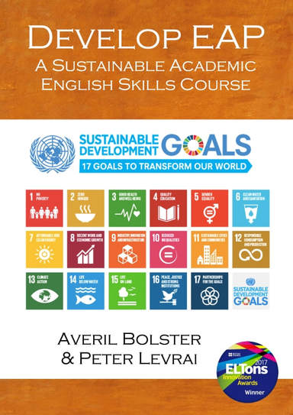 | Develop EAP is an award-winning core course solution for University students, which is designed to help students succeed in their academic studies and beyond. It engages students with the UN’s Sustainable Development Goals and has a focus on developing their academic and collaborative skills.

The resource page for Develop EAP contains the link to the downloadable materials course (course booklet and PPTs, an accompanying VLE and a comprehensive suite of assessment tools).

The research page for Develop EAP contains links to our research, papers and conference presentations into course development, collaborative learning and academic presentations.

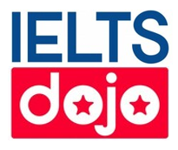 | IELTS dojo gives tips and advice to help students succeed in the IELTS exam. Understanding the exam in the first step and IELTS dojo provides guidance on the different papers, particularly the writing and speaking papers.

