Examining Student Perceptions of the Effectiveness of Safe Spaces in Secondary Religious Education

BY

A dissertation submitted in part requirement for
the degree of
MEd Professional Practice

August 2022

Total Word Count

15643

Examining Student Perceptions of Effectiveness of Safe Spaces in Secondary Religious Education

Acknowledgments P.4
Abstract P.5
Permission to Consult P.6
Abbreviations P.7

Chapter 1 - Introduction
  - Practitioner enquiry P. 9
  - Safe spaces P. 9
  - Research rationale P. 10
  - Research aim P. 11
  - Intervention structure P. 12

Chapter 2 Literature review
2.1 Background to the concept of safe spaces P. 14
2.2 Brave and Civil spaces P. 16
2.3 The role of religious education P. 18
2.4 Safe spaces in religious education P. 21
2.5 Student mental health and wellbeing P. 22
2.6 Student engagement in RE P. 24

Chapter 3 Research Design and Methodology
3.1 Introduction P. 26
3.2 Study context P. 27
3.3 Analysis of data collection methods P. 28
Questionnaires P. 28
Observations P. 30
Case studies P. 30
3.4 Data Analysis P. 31
Quantitative data analysis P. 31
Qualitative data analysis P. 32
Data Triangulation P. 33
Data Coding P. 34

Chapter 4 - Ethical Considerations P. 35
4.1 Responsibilities and obligations P. 35
4.2 Considerations of teacher as researcher P. 37
4.3 Ethical issues arising from data collection P. 38

Chapter 5 Discussion of Findings, Conclusions and Recommendations
5.0. Discussions and findings P. 39
5.1 Data Analysis from questionnaires P. 39
5.2 Thematic analysis and discussions P. 43
Comfort P. 44
Confidence P. 46
Relationships P. 47
Classroom Environment P. 49
5.3 Case study – the views of individual students P. 50
Pupil Profile P. 50
“Emma” P. 51
Emma's views on safe, brave, civil and respectful spaces P. 52
“Matthew” P. 52
Matthews views on safe, brave, civil and respectful spaces P. 53
5.4 Dissemination Strategies P. 55
5.5 Limitations P. 56
5.6 Recommendations moving forward P. 57

Appendix

Appendix 1 Pre-Intervention Questionnaire P. 60
Appendix 2 Post intervention Questionnaire P. 61
Appendix 3 Planning stage for plenary activities P. 62
Appendix 4 Safe spaces plenary P. 64
Appendix 5 Brave spaces plenary P. 65
Appendix 6 Civil spaces plenary P. 66
Appendix 7 Respectful spaces plenary P. 67
Appendix 8 Literary review search strategy P. 68
Appendix 9 Ethical approval form P. 69
Appendix 10 Plain Language statement – Parents P. 70
Appendix 11 Consent form – Parents P. 72
Appendix 12 Plain Language Statement – Student P. 74
Appendix 13 Consent form – Student P. 76
Appendix 14 Pre intervention Questionnaire Data Analysis (Full) P. 77
Appendix 15 – Post intervention Questionnaire Data Analysis (Full) P. 78
Appendix 16 – Thematic Analysis Data Analysis (Full) P. 79

References P.82

ACKNOWLEDGEMENTS

I would like to thank my supervisor, Julie Shaunessy, for all her help and support over the course of this dissertation.

Also, to my lovely three girls for their patience, my supportive partner, and my family who all helped with supporting me throughout this process.

ABSTRACT

The long-term effects of Covid 19 on Scottish students are still unknown, however what has become clear post lockdown is the detrimental effect it has had on the mental health of young people. Anxiety and depression are at an all-time high, school non-attendance rates have increased, and young people are struggling with the readjustment back to fulltime education.
The question of how we can ensure young people feel safe, confident, and included in our classrooms is a challenge faced by teachers across all curricular areas, and at all stages of the Scottish Curriculum for Excellency. By considering how we do this and why it is important for young people to be involved in this dialogue is an area vital to Covid recovery.
This research examines the perceived need for and importance of students to be in a ‘safe space’ to be able to learn and examines the terminology of ‘brave’ ‘civil’ and ‘respectful’ spaces to look at what effect this has on learners in a secondary RE environment. The intervention involved using explicit teaching and understanding of these vocabulary, student discussion and debate, and questionnaires ranking the importance of each of these methods by the students.
Data collection was collected in a mixed method approach, using pre and post intervention questionnaires, starters and plenaries embedded into lessons, observations, and case studies and final thematic analysis were conducted.
This study concluded that students show preferences away from ‘safe’ spaces and aim to create a classroom environment in which civility and respect are central.

PERMISSION TO CONSULT

This dissertation is available for any individual(s) who may wish to access it.

ABBREVIATIONS

ABLe (plan) - Additional Barriers to Learning Evaluation
ACEs – Adverse Childhood Experiences
ADD – Attention Deficit Disorder
ADHD - Attention Deficit Hyperactivity Disorder
AiFL – Assessment is For Learning
BERA – British Educational Research Association
CFE – Curriculum for Excellence
GDPR – General Data Protection Regulation
GTCS – General Teaching Council for Scotland
RE / RME – Religious Education / Religious and Moral Education
RERC – Religious Education in Roman Catholic Schools
SEEMIS – Secondary Educational Management Information Systems
SIMD – Scottish Index of Multiple Deprivation
SQA – Scottish Qualifications Authority

CHAPTER 1
INTRODUCTION

Religious Education is an area in which extensive debate and misconception surrounds the curriculum in Scotland. The Education (Scotland) Act 1980 imposes a statutory duty on local authorities to provide religious education in Scottish schools, both in non-denominational schools (RME) and Roman Catholic schools (RERC). This is a mandatory curricular requirement until the final year of secondary education, and dictates that ‘Children and young people deserve the opportunity to have this taught in a meaningful and progressive way’ (section 2.9) with a focus on ‘high quality learning experiences and meeting principles such as depth and progression’ (section 2.10)

Although often confused with ‘Religious Instruction’ (in which the teaching of a particular religious position is conducted, usually by a member of clergy) Religious education in non-denominational schools’ places emphasis on the study of a range of World Religions, Philosophical thinking, and Moral and ethical topics which are uniquely discussed in the Religious Education classroom.
Due to the local flexibility of the Religious Education curriculum, themes of Terrorism, Hate Crime, Medical ethics such as euthanasia or abortion, and human ultimate philosophical questions such as ‘why are we here?’ or ‘what happens when we die?’ are all commonplace, leading to an important place where we address difficult topics and consider our own views on complex moral issues.

The skills of investigation, interpretation and reflection are commonly used within RE, and the emphasis of learning includes the development of higher order thinking skills, analysis, and synthesis skills, and those of application of knowledge and expression of thought, creating an environment in which frequent class discussions and debates can be cultivated, and students are able argue and share their opinions.

However, accessing these divisive, complex, and sensitive topics requires a classroom environment conductive to do so. Although much research has been conducted into positive teacher student relationships in the Religious Education Classroom (Golby, 2012; Gorski, 2012, Gorski & Parekh, 2020) research into the post Covid classroom, the students perceived safety, and their willingness and freedom to express their opinion is lacking. From the standpoint of a classroom teacher younger students are reluctant to speak out, anxious about giving their opinions and unwilling to participate in classroom activities discussions in numbers higher than in previous years. In preparation for my own research, I examined data from my own schools SEEMIS network, and discovered that students with the term's ‘anxiety’ ‘social communication issues’ and ‘shyness’ listed in their confidential notes and ABLe plans had increased 17% in the S1 cohort for 2021-22. Although aware that these conditions cannot be managed by a single positive classroom environment or teacher relationship, I hoped to investigate what effect a positive environment may have on these students, and their impression of learning.

1.1 PRACTITIONER ENQUIRY

The GTCS Standards for professional Registration 3.1.1 (Engage critically with literature, research, and policy) and 3.2.2 (Engage in reflective practice to develop and advance career-long professional learning and expertise) place emphasis on the importance of practitioner enquiry for educational practitioners. Through engagement with research, educational beliefs, values, and norms can be challenged, and education can be further developed.
The GTCS place ‘Enquiry and Research’ as a Key Area outlined in the Standards for Career Long Professional Learning. Promotion of the engagement in practitioner enquiry is a crucial element of improving professional practice for teachers. At the time of undertaking my Practitioner Enquiry I was a Newly Qualified Teacher (NQT) and therefore this is important in developing my own professional practice. My own academic interests lie around Health and Wellbeing, which was the reason for the focus of this topic.

1.2 SAFE SPACES

The term ‘safe space’ has been widely used in various stages of education in a variety of different ways, although the origin of the term is unclear.
Holley and Steiner (2005, p4) propose a definition of safe spaces as follows; “The metaphor of the classroom as a ‘safe space’ has emerged as a description of a classroom climate that allows students to feel secure enough to take risks, honestly express their views and share and explore their knowledge, attitudes and behaviours.’’ In this example, physical safety is not the concern, however classroom safety is removing perceived psychological or emotional harm or risk of micro aggressive behaviour from their peers or teachers and to develop a sense of support and community.
The reason the author chose this area, is that in daily interactions in the post Covid classrooms students express that they are not currently feeling ‘safe,’ manifesting itself in low attainment, low confidence, and low participation. Student willingness to engage in classroom discussions is low and these can be categorised into three main groups, with significant overlaps between the students within each cohort. Firstly the ‘silent middle’ – those academically capable of engaging but who, for a variety of reasons, choose not to. (Jaworski and Sachdev,1998). The previously aforementioned group of students with anxiety, social and communication challenges of students with shyness were a second group who struggled with classroom interactions (Spyrou, 2011, 2016; Mazzei & Jackson, 2012) and finally those with other barriers to learning, such as students with dyslexia, SEBN, ADHD or general additional support needs. There are also a small but significant group of students who are active and eager in classroom discussions, but tend to monopolize the discussion, and addressing the balance of achieving inclusion for all these students is an important aspect of classroom management.

1.3 RESEARCH RATIONALE

Although the author advocates for students to feel safe, respected and supported in all areas across the secondary area, this study will focus on safe spaces in the Religious Education classroom for a variety of reasons.
Firstly, the author is a Religious Education specialist whose GTCS Registered area is Religious Education, and who teaches Religious Education full time in a Scottish public school.
Secondly, the explicit research of safe spaces in conjunction with discussion-based subjects is under researched. Although the concept of ‘safe spaces’ is academically dated, how we view student mental health in the classroom and their perceived safety in their environment to learning is an issue which we must re-evaluate post Covid. In January 2022 the Center for Social Justice reported an estimated 100,000 students in England became school non-attenders as a result of Covid, and in Scottish schools we are seeing similar patterns in our students.
Thirdly, due to the difficult topics we cover in RE, students with strong opinions are often the most widely heard. In looking how we balance these viewpoints and ensure a sense of academic safety to all will benefit not just RE, but all subject across the Curriculum. The investigation seeks to contribute to this significantly under researched discourse.
In conducting this research, I hoped it would have both a local impact in my own school and a wider impact in the area of health and wellbeing generally. In examining the notion and development of safe spaces in RE, one of the most ethically complex areas in the Scottish Curriculum, the knock-on effects to other subjects such as PSE could be significant.

1.4 RESEARCH AIM

Three research questions will be addressed as part of this enquiry:
1. What do students consider to be a safe space in RE?
2. Does the terminology of ‘safe’ ‘brave’ ‘civil’ or ‘respectful’ space make a difference to the learners?
3. Can student engagement be improved through directly addressing the classroom environment?

1.5 INTERVENTION STRUCTURE

The first phase of the research will involve pre-intervention data collection from the participants in the form of individual questionnaires (see Appendix 1), assessing their own personal opinions of the importance of feeling safe in the learning environment.
My intention to use quantitative data (Punch and Oancea 2012) involving questionnaires to gauge baseline individual views will be complimented with small group activities in the main body of the intervention.
As Kreuger and Casey (2000) and Biddulph and Adey (2003) advocate, small groups will be used for group discussions to help identify trends in a straightforward and concise way. Although small groups will be used in order to promote discussion, the individual plenary activities gauging students' perception to each of the four terms will be completed individually.

These data collection methods will be completed during the pupils’ timetabled weekly Religious Education lessons.

Following the questionnaire, students will participate in standard S1 lessons based around Refugees and Asylum seekers. The main body of the lesson will remain the same for all classes, however the intervention classes will have alternative starter and plenary activities based specifically around the idea of ‘safe’ ‘brave’ civil’ and ‘respectful’ spaces on a rotating weekly basis (See Appendix 4-7). Observations will take place regarding the student's engagement in these topics and noted in an ongoing professional log.

Once the intervention is completed, pupils will take part in the second phase of research, a questionnaire designed to collect data and assess changes in students' opinion of these terms, and their own perceived engagement with the subject (Appendix 2).
Pupils will be required to a similar questionnaire and case studies will be selected for discussion.

The class chosen for this intervention initially consisted of 20 participants from a single first year class at the authors current school of employment. The size of this class is unusual in a public secondary school, however, presents a rare opportunity for researchers to be able to focus on research findings without the behavioural concerns which occur in larger classes. Students were given child appropriate plain language statements and consent forms prior to the research commencing, and parents and guardians were also given plain language statements and consent forms. Although all students were able to access the learning in the mainstream classroom, only data was used from students who had returned both sets of permission forms.

Of this class of twenty students, one was consistently absent due to long term sick leave, and another student was a school refuser. During my research, during scheduled timetable change, one student was removed from the class and placed within another due to ongoing behavioural issues with another student. Therefore, I made the decision to remove this student from the data. Due to the limited time scheduled for core RME in secondary, if students were absent during this time, I made the decision to exclude their data from that week.

CHAPTER 2
LITERATURE REVIEW

In consideration of the questions selected for research, I have highlighted the following areas for literature study, however it should be noted that these themes are by no means exhaustive. Due to the many overlapping areas in the field of health and wellbeing, some areas I have had to selectively omit, such as the issue of childhood resilience, the impact of adverse childhood experiences (ACEs) research into conditions such as attention hyperactivity deficit disorder (ADHD) childhood depression and anxiety disorders and the reasons and impact of school refusal. All of these factors are relevant to students perceived safety within the school environment, and more research is required to determine how these factors link with the feeling of safety in school generally, and particularly in the Religious Education classroom.

2.1 BACKGROUND TO THE CONCEPT OF SAFE SPACES

Although the origins of the term ‘safe spaces’ are unknown, the term has been widely associated with the aim of safety for vulnerable members of education and society. Traditionally used in feminist referral of both physical and metaphorical safety, over the past twenty years a variety of authors have promoted the idea of the classroom as a ‘safe space’ (Boostrom 1998; Holley and Steiner 2005; Hunter 2008, Poynter and Tubbs 2008; Roux 2012). This has emerged to become an essential aspect of the classroom community, in which safety is an essential component of learning and now seems standard part of classroom practise.
Hunter (2008) places four conditions on the term ‘Safe Space’ and its practical uses within the classroom environment. Firstly, physical qualities (considerations of immediate personal safety) secondly metaphorical safety (a place in which inequalities and injustices are removed). Thirdly a physical place of comfort and relaxation and finally an experimental place of encouraging risk or danger. Hardiman, Jackson and Griffin (2007) also place emphasis on the solid creation of rules and guidelines by the classroom facilitator to ‘develop trust and safety’ (p54) Although these four conditions are a good start in recognising the environment necessary to create a safe space, a criticism of Hunters safe space may be that it is largely focused on the utilitarian group environment, and neglects to provide individualised consideration for students who may be struggling within the environment, which is the problem currently being experienced in Secondary schools in Scotland.

Various other authors question the concept of safe space, citing several pedagogical and psychological reasons and concerns. Iversan (2019) in regard to the terminology surrounding safe spaces, suggests that the ambiguity and controversy surrounding safe spaces call for a renewal of the term and its definition, from ‘safe spaces’ to ‘communities of disagreement’, in which disagreement is accepted as a natural part of everyday classroom discussion and dialogue. Communities of disagreement may be preferable to safe spaces, due to the emphasis placed away from the individual requirement for safety and protection, and a move towards an environment in which disagreement is celebrated and seen as a normal aspect of classroom and human behaviour.

Concerns due to the overuse of ‘Safe Spaces’ as a metaphor has raised concerns of its ‘unintended outcomes’ as outlines in Boostrom (1998, 404) claiming that metaphoric safe spaces have led to a lack of criticality and a culture in which conflict is discouraged.

“The tendency of ‘safe space’ talk to censor critical reflection turns sympathy into
sentimentality, open-mindedness into empty headedness. That we need to hear other
voices in order to grow is certainly true, but we also need to be able respond to those
voices, to criticize them, to challenge them, to sharpen our own perspectives through the
friction of dialogue. (Boostrom 1998, 407)”

The consideration of marginalisation minorities and the balance of equality and power in the classroom is a further concern raised by Ellsworth (1992, 2002, 2013). Ellsworth places emphasis on readdressing power dynamics over terminology, claiming:

Acting as if our classroom were a safe space in which democratic dialogue was possible and happening did not make it so. If we were to respond to our context and the social identities of the people in our classroom in ways that did not reproduce the oppressive formations we were trying to work against, we needed classroom practices that confronted the power dynamics inside and outside our classroom that made democratic dialogue impossible” (2013, 107).

Ellsworth raises questions regarding the use of terminology. If the essential components which make a classroom ‘unsafe’ are yet to be addressed, then surely the arguments regarding the adequate terminology are all purely semantic and provide little real-life change or support to students in the modern classroom.

In agreement with Ellsworth, Law (1993) states that “we need to create an environment that allows people to interact with equal power and therefore redistributes power evenly” (1993, 35). Law advocates for “monocultural’ or ‘affinity grouping, in which commonalities between a group are emphasised over difference.

Other concerns are raised by Welch (1999), noting that by claiming ‘safe spaces’ we are implying that difference is to be avoided and is therefore our differences are of no value. By learning from painful and tricky situations we can achieve true teaching moments, which mirror real life.

2.2 BRAVE AND CIVIL SPACES

Brian Arao and Kristi Clemens (2013) in their publication “From safe spaces to brave spaces,” explain the process of creating a workshop around diversity led to a realisation of the problem of ‘safe’ spaces. Their implementation of a visual activity called “One Step Forward, One Step Backwards” illustrates the effects of social classification and injustice and the knock-on effect on participants lives and the effectiveness of perceived safety within the classroom environment. Arao and Clemens (2013) and Atiya et al (2013) argue that perceived ‘safe spaces’ often resulted in marginalisation for certain groups of students, and this was an unhelpful classroom environment generally, whilst acknowledging that some degree of perceived safety is required.

Arao and Clemens (2013) examine the terminology behind the commonly used 'safe space' approach and argue that by making the linguistic switch to 'Brave Space' it can challenge common misconceptions and encourage positive psychological change, leading to practical changes in the modern classroom. They advocate setting down ground rules at the beginning of discussion and (where possible) to allow all members to become involved in the rule making process. They are in favour of the change to brave space and feel this psychological jump can alter the way we think about 'safe' places - making the switch away from safety and danger towards bravery through voicing and defending one's opinion. Although both Iversen and Arao and Clemens would agree that the social wellbeing is mitigated by the use of ‘safe spaces’ and the unrealistic claims of perceived safety, the move to ‘brave’ seems to offer similar concerns, however with emphasis on the victims perceived resilience or strength increasing, not as a method to prevent hate speech or offensive and disrespectful comments.

Moving away from the notion of both safe and brave spaces, Barrett (2010) and Callan (2016) ￼against the use of the term safe space and argue for a replacement term of civility, and developing responsible discussion skills within the classroom. In his argument against the use of Safe Space terminology Barrett claims that safe space concepts, although relevant in literacy, are problematic in the learning and teaching context, and that the social responsibility of education must be centred around and promote human values, both in and outside the classroom.

Providing false promise of uncritical acceptance in the classroom environment would be irresponsible, and therefore a notion of student civility is one which should be adapted. Moving away from safety towards civility does not directly oppose the goals of a safe classroom, instead, Barrett argues, moves towards the goals of citizenship and responsibility. Callan (2010) also draws links between intellectual and personal safety and argues that if dignity safety is maintained then challenging intellectual safety is acceptable academically.

Although all three main arguments surrounding the terminology of safe spaces are valid, they place expectations on learners in regard to their resilience, and coping ability within the classroom. Tso et al (2021) in a large-scale study of childhood resilience during Covid, found long term increased levels of depression and anxiety in young children as a result of the Covid pandemics, leading to higher levels of vulnerability in otherwise normal children. Sanders (2022) identifies the possibility of categorising Covid 19 and subsequent school closures as an Adverse Childhood Experience (ACE) acknowledging the level of trauma that Covid has caused on the lives of many young people. In education also we must recognise that the former benchmarks of concepts such as resilience has been lowered, and as a result students are more sensitive and easily upset that in previous years.

In examining students' own perceptions to safe spaces as a general concept, Holley and Steiner (2005) found that 97% of students rate safe spaces as ‘very or extremely important’ to their education, with 97% rating that a safe environment has potential to change the content of their learning. 84% of students estimated that they learned more in a safe environment, with 12% arguing that they learned less.
In definition of an unsafe learning environment, the overarching characteristic that defined an unsafe learning environment was that the teacher was perceived by students to be “critical towards students, biased, opinionated, or judgmental” (p. 58)

Flenser and Der Lippe (2019) examine the concept of safe space and its impact on higher education. In response to Barretts (2010) views on classroom civility over safe space, and that of Boostrom (1998) who argues that education should not be safe and comfortable, in order to prepare students for real life situations.
Arao and Clemens also examine the possibility of 'Brave space' as opposed to 'safe space' leading to an environment in which putting one's opinion forward is seen as an act of bravery. This linguistic shift may be useful, as may Iversen's (2018) approach of 'communities of disagreement'. Flensner concludes that fear or insecurity is a bad place for learning to begin, and as a result the term 'classroom of disagreement' may be useful.
The terminology of ‘respectful’ space has not yet been widely academically researched, however in line with the values of the authors school of employment, ‘Respectful’ spaces is a term I am trialling.

2.3 THE ROLE OF RELIGIOUS EDUCATION

The issue of the role and purpose of Religious Education is fundamental in understanding how its content and delivery is an area of importance for students growing up in modern Scotland. The Education (Scotland) Act of 1980 imposes a statutory duty on local authorities to provide religious education in Scottish schools, and as a result Basic General Educational (BGE) level RME is taught actively until age 16, with opportunities of further study available until the end of School. The Scottish Government (2021) states that ‘In secondary schools, the role of qualified teachers of religious and moral education and religious education is therefore very much an important one particularly when aiming to deliver high quality learning experiences and meeting principles such as depth and progression’, however the way that this ‘depth’ and ‘progression’ is met is up to individual practitioners and departments to achieve.
RE should, according to the Scottish Curriculum for Excellence (CFE), include ‘well planned experiences and outcomes across Christianity, world religions and developing beliefs and values’, however, it is unusual in that there is freedom by each local authority to decide their own curriculum based on the needs of the wider community, which ensures a community-based approach.

Due to the nature of the subject, a high amount of classroom discussion is commonplace in the religious education classroom in Scotland. Despite the CFE requiring that Literacy, Numeracy and Health and wellbeing are the responsibility of all staff, many practitioners find that literacy is a universally used skill in RME, as with many other social science subjects. However, working in the secondary environment daily reveals gaps in the literacy of young people, particularly in S1 and S2, and some significant reluctance around engaging in literacy, which seems to have worsened post-Covid.

Clayton and Stevens (2018) examined the role of Religious Education in state-maintained schools, and what the content and purpose of that should be. The commonly cited reason of teaching RE revolves around tolerance and respect, and question whether the religious education classroom is the best place to learn about this. They raise issues around religious intolerance and intolerance generally, and where, when and who should be teaching these complex issues.

Grimmitt (2000) argues that modern RE attempts to secularise modern education through secular bias and concludes that criticism in this area is justified. Copley (2005) Jackson (2005) and Hayward (2006) have also criticised the modern RE curriculum on the grounds of stereotyping or oversimplification of religions, and as a result having a detrimental effect on individuals who may practise those religions.

Estrada (2019) directly examined the link between adolescent mental health and Religious Education and concludes that RE can be responsible for helping develop coping mechanisms (religious and non-religious) and a sense of 'connectedness' to aid self-esteem and boost confidence. Estrada et al also draw links between the importance of good RE in schools and issues which may cause mental disorders, such as depression, stigmatisation, bullying or discrimination, and again this links back to the subject content. In the examination of unsatisfactory RE, Moulin (2011) identifies links between simplification and stereotypes in RE, and a feeling of pressure for students to be ‘representatives’ of their own religion, noting that religious intolerance was common.

Within Secondary Religious Education in Scotland, the difficulty in freedom of speech is frequently debated. This controversial issue, which was addressed in the Equality and Human Rights Commission for Scotland document ‘Freedom of Expression’ emphasises that everyone has the right to free speech, and education should work to widen debate and challenge. They also recognise that everyone has the ‘right to express and receive views and opinions, including those that may ‘offend shock or disturb others.’’

In March 2021 the Scottish Government incorporated the United Nations Convention on the Rights of the Child (UNCRC) into Scottish Law, making it unlawful for public authorities to act in a way which is incompatible with the CRC.
The UNCRC Article 13 specifies that

- “The child shall have the right to freedom of expression; this right shall include freedom to seek, receive and impart information and ideas of all kinds, regardless of frontiers, either orally, in writing or in print, in the form of art, or through any other media of the child's choice.
- The exercise of this right may be subject to certain restrictions, but these shall only be such as are provided by law and are necessary:
  - (a) For respect of the rights or reputations of others; or
  - (b) For the protection of national security or of public order (ordre public), or of public health or morals.

The consideration of how we teach cultural and religio-cultural understanding and empathy, whilst also allowing for free speech and ensures that a ‘safe’ environment is maintained in which student engagement is accessible, is an issue which requires further research.

As Gutmann (1987) Suggests, “The most distinctive feature of a democratic theory of education is that it makes a democratic virtue out of our inevitable disagreement over educational problems” (p. 5), however this offers little individual insight into the difficulties students face in our modern classrooms.

2.4 SAFE SPACES IN RE
The explicit development of safe spaces within RE has been widely discussed, yet rarely agreed upon (Geiger 2016; Osbeck, Sporre, and Skeie 2017). Within safe spaces specifically in RE, the concern of ambiguity (both within risk seeking and risk averse classroom dialogue) is an issue which Iversen (2018) frequently criticises, arguing that representation of religion is a relevant factor which makes safe spaces difficult to create. Although Eriksen (2008) and Iversen (2012, 2016) endorse the description ‘communities of disagreement’ as an alternative to ‘safe spaces’, placing emphasis on the educator's ability to define and decide how these disagreements should be dealt with, criticisms may fall in difficulty of this in the practical RE classroom. With most BGE RE consisting of only one period a week, how to create this community with students is a concern.

Osbeck, Sporre, and Skeie (2017, 56, 57) raise the concerns of difficulty achieving control of safety from the perspective of a teacher, using the case study of a lesson in which safety was not achieved for two Muslim students in their care. This study has ethical implications for my own research, in the examination of how I answer my first and second research questions while maintaining an environment of safety and protection for the students in my care,

It has been widely argued against safe spaces in RE in the respect that it is impossible to guarantee safety (Barrett 2010; Arao and Clemens 2013; Atiya et al. 2013; Hodkinson 2015, Iversan 2018) which may result in unrealistic expectations for learners and further disappointment when safety cannot be guaranteed, either in the classroom or outside situations. The promise of a safe space may create a false sense of security for students, ultimately leading to unmet expectations and potential for harm. Iversen (2018) and Atiya et al (2013) therefore argue that RE does not benefit from using ‘safe space’ language, however that does not mitigate the social and emotional wellbeing which comes from the subject.

A potential criticism of Iversen (2019) Barret (2010) and Boostrom (1998) in post Covid classrooms may be that students are no longer mentally equipped to handle an environment which does not guarantee safety. The Covid Pandemic in which students engaged in learning from their own homes online without confrontation or difficult interactions of classroom debates has left children at a significant social and linguistic disadvantage, and without the promise of a safe space (or at least the attempt to try to make one) engagement would be non-existent. To attempt to link student engagement with perceived notions of safety implies a classroom environment which students feel both respected by their peers and teachers whilst also maintaining a sense of civility and free speech, however the long-term implications of this in real life situations are yet to be fully understood.

2.5 STUDENT MENTAL HEALTH AND WELLBEING IN THE POST COVID CLASSROOM
The long-term effects of students who have experienced gaps in learning due to Covid is still an area undergoing research, and although a wealth of literature exists in the area of safe, brave and civil spaces, limited research has been conducted to look at the need for perceived safety by students returning to the school environment. Russell, Hutchison, and Tambling (2020) note the increase of mental health problems following local and community-wide catastrophic events, however, admit the long-term effects of Covid are as yet, unknown. While the effects of negative mental health over students of all ages are well documented post Covid (Zheng et al 2019, Qin et al 2021, Zhang et al 2021) little specific research has been conducted on students in the transition between primary and secondary – a group of students vital to this research.

UNESCO (2020) reports the closing of schools in over 200 countries from December 2019, with 90% of learners across these countries facing educational disruption. Cohen & Kupferschmidt (2020) report over half a billion students aged 4 – 18 studying in an online capacity. Within the UK, a survey ‘Coronavirus: the consequences for mental health’ conducted by the mental health charity MIND report one in three young people (34%) reporting their mental health has decreased over the coronavirus pandemic.
Naidu (2021) examines the issue of student resilience post Covid in students within higher education, concluding that resilience is formed due to a complex range of factors including ‘grit’ ‘perseverance’ determination’ and ‘motivation’ (pg. 3). Duckworth (2016) also assigns ‘passion and perseverance’ as factors to develop resilience in students. Looking at students in our everyday classroom, these semantical terms seem fairly unhelpful. As an educational practitioner, resilience appears to be more fluid than these terms suggest, and the idea of a fixed mindset to resilience may not be appropriate for every child.

Lee et al (2020) in a small-scale study conducted amongst primary age children across the UK and Korea, conclude that the Covid-19 pandemic, despite the disruption caused to learners and their education has not been as bad for learners as one might have been initially predicted, suggesting a capacity for resilience beyond what may be initially expected. This is not to suggest that there will be individual learners who struggle with the classroom environment and its social and environmental factors, and these students certainly cannot be overlooked. As classroom teachers are aware, the students who face these complex issues often take time, effort and additional support.

A study by Meine et al (2021) concluded that participants with consistently high levels of resilience (including factors of optimism, selfcare, social-support, and perceived self-efficacy) scored highest on tests assessing how they coped during Covid 19, while participants with markedly lower levels of resilient functioning scored lowest. Although conducted on older students, this study suggests that resilience can be promoted through routine and support and is not as fixed to factors like ‘perseverance’ or ‘determination’ as other authors have suggested.

2.6 STUDENT ENGAGEMENT IN RE

My final research question examines the link between a perceived ‘safe’ classroom environment and engagement, and in order to examine this link I feel it necessary to examine what engagement is and how it can affect students.

The Student Engagement Framework Scotland (2011) identifies five elements of student engagement, the two most important for this study being that students feeling part of a supportive institution and that students engage in their own learning, The SEF explains that through removing barriers to participation and increasing support, students will have more opportunities to engage. By engaging students in their own learning and promoting responsibility of learning, students will naturally engage with both the lesson content and classroom environment.

The vagueness of the term ‘engagement’ has led to criticisms of its use in modern education, with accusations of its use as being uncritical (Coates and McCormick 2014, Trowler 2010) and as a term used to mask inclusion and equity (Trowler 2014) while Kahn (2014) argues that the concept of student engagement has not been strongly theorised.

Student engagement is also commonly left undefined in many contexts. ‘What students are engaging with’ (Healey et al. 2014) and why (Healey et al. 2014, Trowler 2010) and why (Trowler 2014).

Ashwin and McVitty (2015, p4) advocate for focusing on an examination of what is ‘being formed’ through student engagement, leading to a categorisation of three objectives of engagement – engagement for individual understanding; engagement for curricula and engagement for formation of communities, and in attempting to answer my own research questions I will be examine this within the context of forming communities, in particular the small classroom community.

The reading around these issues presents three main issues from which I shaped my research questions. Firstly, the role of Religious Education in the lives in young people and how practitioners can create an environment of safety and trust. Secondly, the way young people feel about their own engagement in Religious Education, and the environment which is beneficial for their own learning. Finally, how this engagement in Religious Education can be possible for young people who have faced the trauma of Covid.

CHAPTER 3
RESEARCH DESIGN AND METHODOLOGY

In examining what methodology is and its importance in developing research, Punch and Oancea, (2014) define Methodology as the theory behind the methods and approaches used in a professional enquiry and methods used by the researcher to identify, select, process and analyse data and information.

To actively assess student views on the importance of space spaces and their impact on their learning, in this study I chose to focus on the terminology surrounding safe spaces in RE and examining student perceptions of the effects of these terms. The study was broken up into three fundamental areas.
- Pre and Post intervention questionnaires designed to gauge students' attitudes to school, learning, RE and their own individual perceived opinions about what constitutes a ‘safe’ environment for learning.
- Starter and Plenary activities which were focused on the topic of the week – safe, brave, civil or respectful spaces. In groups, students were presented with a starter question and given 10 minutes to discuss before feeding back to the class. An individual plenary worksheet was also distributed to gain individual thoughts and opinions on the weekly topic
- Finally, two students with very strong opinions were carefully selected as ‘case studies’, based on their responses in the group discussion phases.

3.1 INTRODUCTION

My topic of research is driven by my research question (Punch and Oancea, 2014) and initially in forming my research questions, I considered “What am I trying to do in this research?” as advocated by Menter et al 2011; Punch and Oancea 2014. In developing my research questions, I was careful to avoid judgement, predisposition or pre-existing relationship (Punch and Oancea 2014; Scott 2012) with a focus on developing research questions which can be answered by collected data (Punch and Oancea 2014:99)

Kubota and Lin (2006, 245) argue towards development of inclusive pedagogies creating an environment in which “students and teachers confront racism and other kinds of social injustice” and is with this in mind that I focused my research questions to examine student health and wellbeing – an area extremely relevant in the post Covid classroom.

3.2 STUDY CONTEXT

The environment in which I will conduct my research is a large comprehensive secondary school in Dundee City Council. The school is situated in an urban setting and serves a catchment area that is both socially and economically diverse. Despite being in the least deprived areas in the locale, according to the Scottish Index of Multiple Deprivation (SIMD), the school accommodates approximately 18% of students from out with the catchment area, from some of the most deprived areas surrounding the school. Due to the statistically relatively affluent nature of the catchment area, the school receives less funding for support for learning and additional support needs students that any other school in the city, leading to practical difficulties supporting individual students.

The Scottish Government (2012) and Scott (2012) advise that any experimental research would require the researcher to exercise maximum possible control over variables in the research and incorporate “pre- and post-tests” (p.110), pre- and post- intervention questionnaires, “experimental and control groups” (p.110) and observations. As a result, I will aim to use questionnaires to collect pre and post intervention questionnaires (Punch and Oancea 2012) starter and plenary activities used to gather thematic data and pre- and post-intervention feedback (Scott 2012) to gauge student response to my intervention. The issue of low literacy levels was a barrier to research in my intervention, so as a result I decided to offer the option of writing or sketching responses in the starter and plenary activities in order to develop an environment in which all students could participate.

3.3. ANALYSIS OF DATA COLLECTION METHODS

To answer my research questions a number of data collection strategies will be employed that provide both quantitative and qualitative data, which in turn will provide accurate and relevant data to be analysed. Following data collection over a period of four weeks, analysis will take place to attempt to answer my research questions and allow for further discussion. In examining how my own research questions could be answered, I decided to approach data analysis using a mixed method research system, to fully encompass the range of student responses elicited within this research.

Questionnaires

The use of questionnaires in academic research has long been one of the simplest methods of data collection. Questionnaires, as defined by Anderson and Arsenault (2005) are low cost, quick and simple, and be an excellent means of gathering data research in a small-scale enquiry as my own, however offer caution surrounding ‘overcomplication’ (p26) which can potentially lead to unreliable data, which was a concern due to the small-scale nature of the study.
Spencer et al (2003) argue that despite the fact questionnaires have historically been considered quantitative as a method of data collection, they can also form qualitative data collection method and provide useful information in particular contexts, and as a result I decided that questionnaires would be an appropriate method of data collection pre and post intervention. Check and Schutt (2012) also agree that questionnaires are valuable in developing an overall picture of a group, and despite the fact that my own students are not a large group this information is also important in considering how this research may be useful moving forward.

There is debate around the best kind of questions to ask, with Anderson and Arsenault (1998) advocating for multiple choice questions, arguing that the ‘most straightforward multiple- choice questions are answered consistently’ (1998: p.173) while Menter et al. (2011) suggest using open-ended questions to gain more in-depth qualitative data. Gilchrist (2018) argues that both types of questions should be used to complement the collection of both qualitative and quantitative data. In consideration of my research questions, I concluded that both questions one and two would be appropriate for questionnaires.

The use of questionnaires can, however, pose many limitations. Respondents may not be aware of the point of the questions and these questions cannot be followed up unlike focus groups or interviews (Menter et al., 2011). Also Due to the early age of the participants and the link between complicated questions and reduced rate of return for complicated questionnaires (Anderson, G. & Arsenault, N. 2005) I also am aware that several of my students face literacy difficulties, such as global developmental delays or additional support needs such as dyslexia, and therefore a paper and virtual version of the questionnaire will be accessible for these students.

In the design of my questionnaire, I examined a range of methods aimed to extract maximum data in a straightforward way and opted to use a wide range of open and closed questioning techniques, incorporating both multiple choice and open ended in order to extract maximum qualitative and quantitative data.

In order to extract data in an age-appropriate way, I chose simple, opinion-based questions on a Likert scale in Q1-10, with only the final, open ended question requiring significant amounts of writing. In the administration of the questionnaires Punch (2009) and Menter et al (2011) advise that brevity and a deadline or telling the students the length of time required to complete a survey will increase response rate (Punch, 2009, p293; Menter et al 2011) and this was a consideration for my class, and I gave clear instructions at the beginning of the questionnaire regarding timing, content, and instructions in how to complete the materials. The mixed abilities of the participants means that some students required additional support, so I explicitly explained any less familiar vocabulary and terminology prior to the questionnaires being executed. A timer was placed on the whiteboard, and despite the fact most students finished quickly, those who needed a bit more time seemed grateful of this. All students were able to complete the questionnaire.

Observations

As “observation is a valuable data source collected simultaneously with the occurrence of the event, without interfering with the occurrence of the event” (Queirós, Faria & Almeida, 2017: 376) I will also use observation to triangulate my evidence from other methodology and data which has been collected throughout the course of this intervention.
As this is part of my usual routine within the class it should not be intrusive or unusual to the students, however consideration needs to be given to what exactly is being observed. Sharp (2009) argues that the action of being watched may change the participants behaviour, and due to my position. as their current class teacher cognisance of my familiarity with the participants is required.
Verbatim quotes and discussion notes will record key interactions between the students under development of the tasks (Menter et al. 2011) and notes taken on pupil engagement and work completed.
The ‘observation’ in my own research took place in the time following the starter task in which students were asked to discuss the term of the week in the form of a starter question.

An ongoing professional diary will be kept throughout this study, to help record and provide reflection on the intervention and log any issues which emerge throughout this enquiry.
Linberg (1987:119-128) endorses a double column approach to professional record keeping – with the left column for a ‘descriptive commentary’ and the right for ‘emergent themes; over the course of the intervention. These themes will help in my analysis of qualitive data following the final questionnaire and help analyse which terminology in my intervention was most useful and effective. I also used my ongoing observation diary as a method of recording my case study observations, which proved extremely helpful and removed the need for formal interviewing of my selected case study participants.

Case Studies

The term ‘case study’ is varied in its meanings and context, however useful in research environments in which more in-depth exploration is needed than questionnaires and interviews.
Crowe et al (2011) argue that case studies allow for ‘in-depth, multi-faceted explorations of complex issues in their real-life settings’ (p3) and combine a variety of qualitative research methods, such as observations and interviews, to provide rich detail about the perceptions of individuals in each situation. Merriam (1985) argues that the case study is useful in questions of meaning and process, which can be answered only through understanding the context in which they exist and not through standard data collection.
In order to answer my own research questions, I will conduct an in-class case study with selected members of my targeted research group. Through observation during plenary activities, I examined the work of specific students and their follow up comments within the context of the class we have been conducting research on. Due to the nature of my research, I will incorporate case studies and student accounts to further support my qualitive and quantitative data and examine individual student perceptions of the research subject.

3.4 DATA ANALYSIS
In examining how we are best to understand data analysis, first an understanding and clarification of what the data means is important. Simply speaking, quantitative data analysis involves looking at hard numerical data, whilst qualitative data analysis concerns subjectivity and opinions which are more difficult to measure in a numerical way. Due to the mixed method approach of my research, I opted to extract a range of both numerical data in the form of questionnaires and qualitative data in the form of plenary feedback and case study analysis.

Quantitative data analysis

In examining an effective method of data preparation and analysis Menter et al. (2011) suggest that five main stages of data preparation need to be followed. Menter claims that doing this will result in a numerical database which will result in usable research data.
Firstly, a Comprehensive record keeping system must be established and regularly and systematically updated, preferably during ongoing research collection.
Secondly, data checking for accuracy and to remove errors prior to data cleansing.
Thirdly Constructing an organised database in which ongoing data can be logged and compared.
Fourthly Data cleansing, and removing data which may be incomplete, inaccurate or irrelevant and finally transformation of the data into a useful numeric analytic tool. In my own study, this would be possible in the case of my questionnaire, however only the multiple-choice questions would be suitable foruantitative analysis. In doing this I will use I will use a Likert scale to reflect those categories in order to turn my pupils’ responses into quantitative data (Likert, 1932)
Nemoto and Beglar (2014: 8) suggest, “the Likert-scale questionnaires should ideally be administered in conjunction with other data-gathering approaches in order to produce a more well-rounded understanding of the construct under investigation and to overcome the inherent limitations of numerical Likert-scale data, namely that numerical data cannot provide a complete picture of educational phenomena "and therefore I will also use a range of qualitative data to provide this.

Qualitative data analysis
The analysis of data of a qualitative nature is far more complex, due to the nature of data, which is verbal, written, or collected in a non-numerical way. Although Punch and Oancea (2014) argue for three main components of qualitative data analysis: data reduction, data display and drawing and verifying conclusions, in reality the analysis of qualitative data is much less clear.
In the consideration of analysing various sources of data, Flick (2014) argues for diverse types of data analysis, reflective of the various approaches of gathering data.
Braun and Clarke (2006) describe thematic analysis as an approach to qualitative analysis that enables researchers to generate new insights based on commonly emerging themes from data of a qualitative nature, which they recommend being particularly accessible in a small-scale research project or for inexperienced researchers. It is not frequently used across all areas of research, being described as a ‘distinctive method with a clearly outlined set of procedures in social science” (Braun & Clarke, 2013, p. 178)

Stewart et al (2011) argue that in analysing data from interviews or focus groups can be complicated due to the open-ended nature of responses, however thematic analysis would be a method to aid this. Using a seven-step process of transcription, reading and familiarization, coding, searching for themes, reviewing themes, defining and naming themes, and finalizing the analysis, thematic analysis method can be used to analyse almost any qualitative data such as interviews, focus groups, and qualitative surveys (Attride-Stirling 2001) and focuses on relationships and patterns between data. Menter et al highlight the importance of transcribing and recording observations of individuals or focus groups, however this can be time consuming, therefore I will also transcribe relevant observations (p217). Potential Limitations of thematic analysis include the loss of individual accounts, due to searching for themes across data, however I feel that there is potential to counteract this with case studies in my own enquiry in order to answer research question 2.

Data triangulation

Denzin (1970) identifies four main types of data triangulation which may be effective in analysing research. Firstly, methodological triangulation, which combines qualitative with quantitative data before, during and after research. By using qualitative research prior to quantitative research, a hypothesis can be generated, and terminology and concepts defined. By using quantitative research alongside quantitative methods, ongoing issues and concerns can be measured. And by using qualitative after quantitative research, further clarification can be offered.
Downward and Mearman (2007) define data triangulation as the process of ‘combining data from more than one method within the qualitative research approaches, or from more than one source or population’.
Investigator triangulation, in which multiple researchers examine various interpretations and analysis of the research, resulting in further perspective to the data.
Theoretical triangulation involves the use of various theoretical assumptions or theories to analyse data from an alternative theoretical perspective.
Due to the size of this study, data triangulation and investigator triangulation will be unrealistic, and I feel theoretical triangulation will be unhelpful due to my subject content, so I aim to use methodological triangulation to attempt to analyse the collected data from my research in order to best answer my research questions.

Data coding
Following the collection of data, whether qualitative or quantitative, the process of coding is crucial to help understand the numerical value of a piece of data. Menter et al (2011) and Punch and Oancea (2014) state the importance of helping analyse and interpret findings, and also identifying patterns within the texts. I will use open coding and memoing to separate the data into emerging themes where I can then analyse the meaning and attribute codes (Campbell, McNamara & Gilroy, P. 2004) Therefore I will use data coding throughout my analysis process for both my data collected from questionnaires and student discussion observations.

CHAPTER 4
ETHICAL CONSIDERATIONS
In conducting research with young participants, a variety of concerns emerge regarding the most ethical way to execute and deliver this research. When these participants are your current students further ethical dilemmas emerge. The issues of safe spaces can be immensely upsetting or triggering to young people, and this was a further concern I faced daily. The British Educational Research Association (2004, p. 4) highlights the fact that “The research ethic of respect for truth, or academic integrity, requires researchers to be scrupulous in avoiding distortion of evidence and weakly supported assertions in the reporting of findings” and therefore I thought deeply surrounding the ethical concerns of my enquiry throughout the planning and execution stage.

4.1 RESPONSIBILITIES AND OBLIGATIONS

In designing and conducting my research, I was aware of my own ethical responsibilities and obligations, due to the problematic role of me being both their class teacher and conducting research. Zeni (2001) argues that if social research in a real-world context involves human participants, then ethical considerations are essential, and therefore I addressed ethical concerns as paramount throughout this intervention. The guidelines from the University of Glasgow, GDPR and BERA were all adhered to in the design of this intervention,

From early on in my research design I concluded that the wellbeing of my pupils must be the guiding principle, keeping in mind the principles of GIRFEC (Scottish Government, 2012). Hubbard & Power (1999: 64) conclude that teachers must “respect those with whom they work, openly sharing information about their research” and from early on I examined which research and dissemination strategies I could use which would be fair and honest while also maintaining integrity and confidentiality.

As my data will be a mix of quantitative and qualitative data, I will record my observations in a reflective diary which will be ongoing throughout the data collection period. However, a concern is that pupils may notice this action and alter their behaviour or attitude.
Alternatively, observations could have been documented after the event at the risk of less accurate reporting.

It was also particularly important for me to consider the views of my students who would participate in this research – before, during and after the data collection period. I was aware students may feel pressure to participate, and I emphasised throughout that no student would face negative consequences for withdrawing (Felzmann, 2009, Punch 2009, BERA 2019) and that their own physical and mental wellbeing was paramount. Punch (2009) argues that the learning and welfare of the student must take priority, so if this was to occur, individual pupils should be removed from the research or the study suspended, and therefore I conducted my research with these considerations in mind.

The concept and discussion of safe spaces could potentially be triggering to students who, in other classrooms or social environments have felt unsafe, and consideration of these students was given from the planning stage. A time out option was given to students at the beginning of each lesson in which, if they felt they need a break from the issues we discussed, they were free to take a short break in a designated partner room. Also, in line with the school pastoral care and guidance policy, all students were reminded that counselling services were available should they require them.

Prior to commencing this research, an application for ethical approval was submittedfirstly to my supervisor, and then to the University of Glasgow’s School of Education Ethics Committee (Appendix 4) Furthermore secondary consent to conduct the research was obtained following this from the headteacher of the school, and guidance teachers made aware of the research taking place.
Both parental and student consent forms and plain language statements were issued using simple language and informing them of the methods of research (Appendix 10-13), the reason why the research is being conducted and the use and implications of any collected data, including storage I was particularly careful to avoid pressuring or coercion of the parents (Bournot-Trites and Belanger, 2005, p205) and therefore decided that should a parental permission form not be returned to accept this as withholding of consent. I was fortunate that only one parent was in this category and the majority of my students, and their parents consented to the research taking place.

4.2 -CONSIDERATION OF TEACHER AS RESEARCHER

The pre-existing relationship I held with my participants was a concern I held from the initial design of my research, and one I was aware of throughout the data collection and analysis period.
My initial ethical concern was the perceived obligation faced by the students and the possible pressure to do what their teacher tells them.
Cohen, Manion and Morrison (2013) argue that students should be given opportunities to refuse to participate and withdraw at any time, safe in the knowledge that if they do this no negative consequences will occur. In order to counteract this, prior to the first session, and at every session moving forwards in the data research, students were reminded that they were free to withdraw at any time without judgement, and a copy of the plain language statements students signed also stated this clearly.

A second ethical problem was concerning the power balance and dynamics within the classroom, in which students had viewed me as a teacher and not a researcher.
‘Hopefully, as an action researcher, I can engage them as co-researchers where we learn together for their benefit rather than them feel that the research is being “done “to them (Anderson, Herr, Nihlen, 2007).
Considering how to overcome this was an area in which I gave careful consideration and concluded that it would be impossible to gain the impartiality of outside researcher, however this would not necessarily be a negative thing. The pre-existing positive relationship, combined with a positive atmosphere in which students felt comfortable sharing their opinions would result in more forthcoming opinions and discussions by the class.

A third ethical consideration was that two students in the classroom were classified as vulnerable, defined as being “individuals or categories of individuals who may not have the required degree of understanding (for whatever reason) to give their informed consent to participation in research.” Oliver (2003: 55-56).
Although the practical problems with this were solved by obtaining parental consent, I was acutely aware that my own knowledge of these students and their personal vulnerabilities stemmed from being their classroom teacher, with a relationship developed over the previous year. This power balance needed to be addressed prior to beginning the research and considering whether these students should be included in this. After discussion with these students and confirmation that they wished to be, the importance surrounding confidentiality and safeguarding these vulnerable pupils was of high consideration (Forster 2017)

I will also need to consider the political element of my research (Anderson, Herr, Nihlen, 2007) and in doing this consider the local, school based and wider effects of its findings.

4.3 ETHICAL ISSUES ARISING FROM DATA COLLECTION

Tilley and Woodthorpe (2011) argue that anonymity conflicts with the demands to disseminate and the current thinking needs to be reassessed to reflect the age of the internet so I will also remove any identifying markers of when the study was conducted, which students were selected as case studies, and of the work selected as exemplars.

One other ethical consideration I have is how I will disseminate this data in an ethical way which provides anonymity to the class. Initially local distribution to my own department and those of social sciences would be relevant, ensuring that the results are anonymised.
Further to this I would present the same information to our schools learning and teaching group

In our student plain language statement, I made it clear that any information disclosed which may be harmful to the students would result in reporting. During the course of my research there were several instances where students disclosed information that, although not harmful enough to warrant suspension of the project, needed to be reported to a child protection officer and member of the pastoral care team. Examples of this included students revealing use of vaping or alcohol as a means of stress relief, and one implication of an eating disorder. All of these incidents were reported to the relevant guidance teacher and child protection staff, and the student's data was removed for that stage of the research.

CHAPTER 5
DISCUSSIONS AND FINDINGS

The analysis of the data presented an opportunity to revisit my initial research questions and consider the range of responses presented by students. Due to the mixed methods of this research, I initially examined the questionnaires provided by the students to extract numerical data regarding their own opinions on RE. In my exploration of this issue, I felt that while data extraction was important as a tool to gauge the whole class perception of these issues, individual student voice was also crucial in understanding the complex range of opinions towards students' perception of safety. Therefore, in this chapter I will examine the range of data extracted from my research then examine the views of two specific students in the form of a case study in order achieve the greatest possible understanding of the perceptions of students within this research.

5.1 DATA ANALYSIS FROM QUESTIONNAIRES

The questionnaire was based around four areas of opinion – 1. I agree, 2. I kind of agree, 3. I kind of disagree and 4. I disagree.

The 15 questions provided to the students were analysed post intervention, and responses coded and collaborated (Appendix 8 and 9).

Generally, students showed mixed attitudes towards attending school, with 10% agreeing and 37% moderately agreeing with the statement ‘I enjoy coming to school’ in the pre-intervention questionnaire and 15% agreeing and 57% moderately agreeing post intervention.

Pre intervention data | Post intervention data
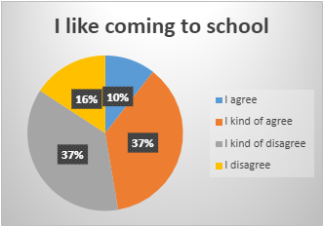 | 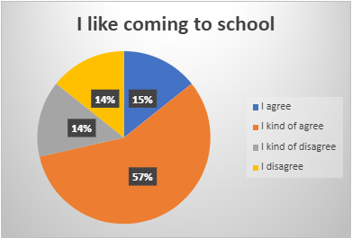

Students showed positive views towards religious education, with 65% and 87% agreeing to the statement that ‘I like coming to RE’. Students also strongly agreed with the idea that ‘some subjects are safer than others (25% agreeing and 69% expressing moderate agreement). In examining perceived safety in RE, students strongly agreed with 65% opting for the ‘agree’ option, whilst 29% showed moderate agreement.

RE engagement Pre / Post | Perceived safety Pre / Post
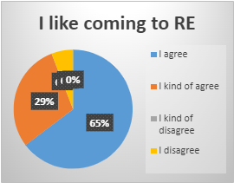 | 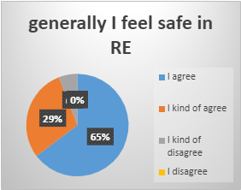

One of the most divisive questions was ‘I think it sometimes can be hard to speak out in class discussions’ with 29% agreement, 35% moderate agreement, 18% moderate disagreement and 18% strong agreement. This number remained unchanged throughout the pre and post questionnaire analysis.

Speaking out in class discussions Pre / Post
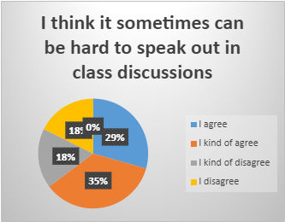

The question 'Respect is something that’s important in our school’ was met with 65% agreement and 29% moderate agreement, rising to 82% agreement and 18% moderate agreement in the post intervention questionnaire.

The final question in the post intervention questionnaire was ‘Which of these four spaces did you find to be the most useful?’
Results were divided, with equal weight given to ‘Civil’ and ‘Respectful’ spaces (36%) retrospectively with ‘Brave’ at 21%. Despite the relative wide knowledge surrounding safe spaces (56% agreement and 22% moderate agree with the statement ‘I have heard about safe spaces before’) only one student opted for this as their preferred classroom environment.

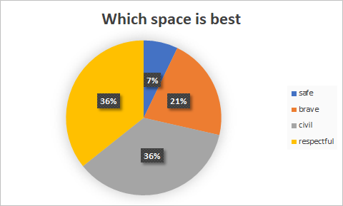

Following selection of preference of classroom space, students were asked to comment on why they selected their preference.

For the student who selected ‘Safe Spaces’ the reasoning ‘It's good to have a safe space’ was given as justification, however no further explanation was expanded on.

The students who selected ‘Brave Spaces’ as their preference commented that ‘bravery helps you develop’, ‘being brave is a big thing’ and ‘I chosed (sic) brave because it is good to brave something.’

The comments surrounding civil spaces were of a more varied range, with respondents stating that ‘it just feels right to be civil’
‘I chose civil spaces because I just feel like everyone should always be civil’
‘it's hard to be brave and not everyone is respectful all the time, so I think civil is the best’
‘I think being civil is more important than being brave’
‘I feel it's important to be civil especially in RE’.

Finally in the examination of ‘Respectful Spaces’ (in line with one of the core values of the school) students responded that

‘I chose respect because we should always be respectful to one another ‘
‘I think it's important to respect other opinions’
‘I'm not sure why but it’s the best one’
‘We need to be nice and respectful to everyone’
‘I think respect is the best because it tells people you respect people's cultures and people's voices’

Although all students were able to identify preferred terminology, the depth in which they were able to evaluate their reasoning was varied.

5.2 THEMATIC ANALYSIS AND DISCUSSION

Eight over-arching themes which were further reduced to five key terms emerged from the questionnaires, plenary activities and interviews conducted from the range of students in my class.
These themes were physical comfort, emotional comfort, safety, freedom of speech, confidence, trust (and perceived trust) relationships and academic and social ability, however this list is not exhaustive (see Appendix 16).

Total response numbers | 15 | 16 | 14 | 16
Terms used | week 1 - safe | week 2 - brave | week 3 -civil | week 4 - respectful
‘Comfort’ | 12 |  |  |  | 12
‘Friends’ | 4 | 1 | 2 | 2 | 9
‘Respectful’ |  |  | 4 | 6 | 10
‘Home’ | 5 | 3 |  | 4 | 12
‘Teacher’ (relationship with) | 3 | 4 |  | 5 | 12

The terms which occurred most frequently (through both written and sketched work) were ‘comfort’ ‘friends’ ‘home’ ‘respectful’ and ‘teacher’ (focusing on relationships with the teacher.) The below table represents the instances of each terminology use, and in which week they featured prominently.

Frequently emerging terminological themes by week
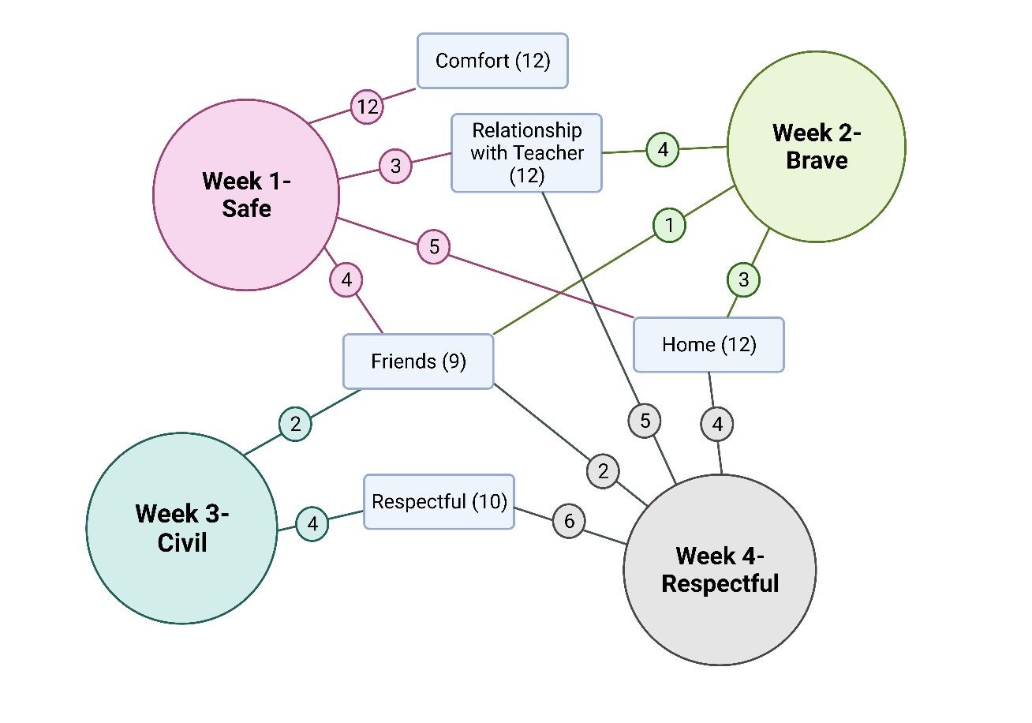

Following the data analysis, the author felt it necessary to be more selective in the themes to be the focus for this paper, and as a result I chose four themes which best represented the experiences of the students' questionnaires, interviews and plenary activities.

These four themes are comfort, confidence, relationships and classroom environment.

Comfort

Strong themes of physical, emotional and academic comfort and discomfort were apparent from the initial questionnaire and became evident throughout the study. In our initial ‘safe spaces’ discussion activity and plenary activity, 9 out of the 17 students who completed the activity referred to some form of physical place as places of safety, including beds, bedrooms and a recliner with a trusted animal. Hobbies and interests (dance, sports and physical activities) were also a commonly emerging theme, with four students referencing these in their idea of physical safety.

Student comments obtained during the plenary activity sheet included:

‘I feel comfortable in my class

‘My Home – my safe space. My belongings are here, my family lives here, I've grown up here.’

Due to the wide range of student ability in the class, students were also given the opportunity to sketch or draw their own opinions to help increase engagement without the need for literacy-based competency.

Examples of student-based artwork on the theme of ‘comfort’
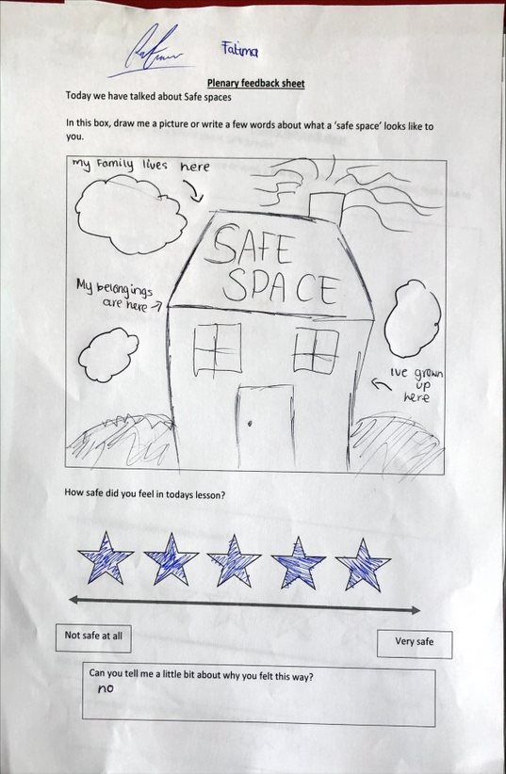
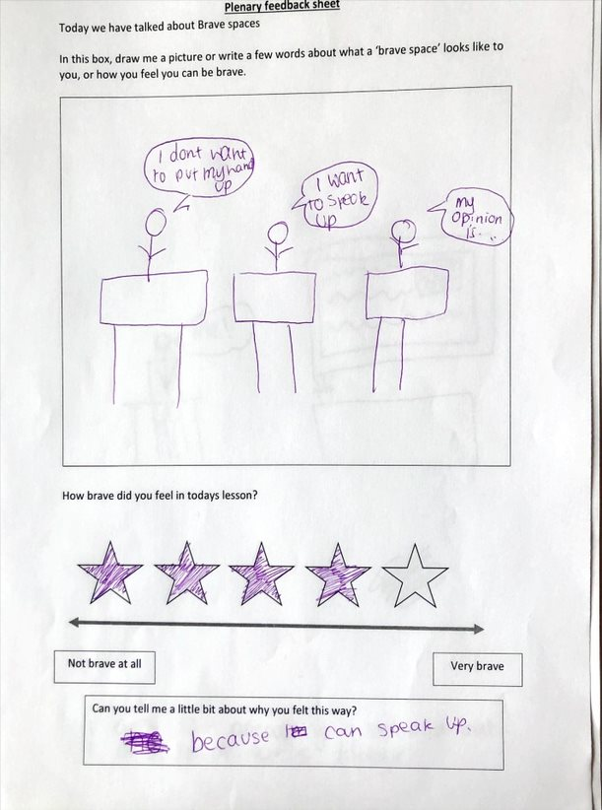

In examining the idea of brave spaces, similar themes of comfort were apparent, however students were more fluid in the ideas of overcoming fears and pushing themselves out with their comfort zone.

‘I don’t like answering questions, but I was able to today’
‘I'm really shy and I don’t like speaking in class, but I think it's important to try.’

Confidence

Student confidence, or perceived lack of confidence, was a second theme emerging throughout this study, especially among the safe and brave sections of this research.
Phrases such as ‘confidence’ ‘shy’ and ‘embarrassed’ emerged a total of 27 times through this study in written ,verbal and sketched themes, whilst negative statements such as ‘I don’t want to look stupid’, ‘I don’t want people to know what I think’ or ‘I am worried people will laugh at me’ appeared in every plenary activity across all four weeks.

Student examples of ‘Confidence’ in plenary activities

In our classroom discussions, I surveyed an average of 6 pupils per lesson who were voluntary participants raising their hands independently in response to questions, whilst other students had to be persuaded to participate, however all but two students (13) were able to answer when asked by the teach, either in the whole group or individually, suggesting that these students are able, however for whatever reason somewhat unwilling.
Despite low voluntary engagement and perceived low confidence, there were positive attitudes in the class as well, with several students looking towards overcoming their own fears, particularly in the brave space's plenary.

Relationships

The importance of positive friendship, familial and teacher relationships was highlighted by student feedback at every stage of this study, with students caring deeply about the relationships in their life and an acute awareness of their own safety within this. Frequently occurring terminology included ‘family’ (5 total responses) ‘friends’ (9) ‘pets’ (5) and relationship with teacher. (12)

In our discussion of safe spaces, family and home was a commonly listed factor, with family, friends, grandparents, teachers and pets being listed as a crucial element of safe space for the students within the research. In classroom discussion, when asked about whether they feel safe in school post Covid, the majority of the class answered negatively, with statements such as …

‘We missed a lot of primary school (due to Covid), but I felt safer there.’
‘High school is quite noisy and there's a lot of people’
‘I feel like people judge you more if you get an answer wrong in high school than primary.’

In researcher led questioning in class, students also highlighted the problems faced by themselves and their peers on social media, with an acute awareness of the fact that social media is a very ‘un-safe space’. The heightened awareness of the dangers of technology was highlighted by a range of real-life examples, such as cyberbullying of themselves or others, the use of inappropriate or unwanted photographs, and the dangers of false of duplicated accounts.

In considering relationships between themselves and their teachers, students placed immense importance on having positive relationships with teachers they liked, and a strong link between how much they enjoyed the subject based on the teacher.

Student examples of ‘relationships’ emerging from plenary activities

Classroom Environment

Finally, classroom and school environment were an area in which students highlighted as a key area, based on the frequently emerging terms ‘school’ (5 total responses) ‘kindness’ (9) ‘respect’ (10) and ‘speaking/talking out’ (5). From comments given both in questionnaires and in plenary activities, we see students have mixed feelings about the classroom environment, with comments including;

‘I am too shy to speak up in class because I'm embarrassed if I get it wrong.’
‘The same people always talk and sometimes I feel there's no point in trying’
‘I don’t like speaking in most classes, but I like it in RE.’

Student plenary and sketch work also reflected concerns about classroom environment and their engagement within this however, stemmed frequently from their own concerns regarding their abilities and their perceptions of peer judgement, as opposed to criticism of the teaching and learning of the subject matter.

Student examples of ‘environment’ emerging from plenary activities

The four themes discussed above are by no means exhaustive, and also notably overlapping in content, however, give good insight into the views and concerns of the class in regard to how they feel their own learning is progressing in post Covid RE classrooms. The following two case studies give further detail into individual opinions from the perspective of two young people in the research cohort.

5.3 CASE STUDY – STUDENTS AND THEIR OPINIONS OF THE ROLE OF SAFETY WITHIN THE CLASSROOM

The data collected my pre and post intervention questionnaires was useful in revealing the thought process of the entire class, however less in regarding individual students views on safety, free speech and their role within the classroom environment. It is important to recognize that student engagement within the classroom is dependent on a range of factors, and in order to consider what a ‘safe’ classroom environment looks like to students within the RE specific classroom environment.

Pupil Profile
In selecting students for my case study, I initially used pre and post questionnaire data to find an example of one student who showed commonality in opinion with the remainder of the group, and one student whose opinions differed widely to the opinions of others. Matthew and Emma (both pseudo names) were selected for case studies of this study, due to this criterion, and also in their own individual needs which required additional support within the classroom.

‘Emma’
At the time of this study Emma was a first-year high school student of age 12, who presented with anxiety and a host of individual learning difficulties. Emma had an ABLe (Additional Barriers to Learning) plan which had been developed through primary school, low self-confidence and displayed as a very shy and nervous pupil who struggled to develop and maintain friendships or speak out in the classroom environment. On top of Emma’s social difficulties, she also has a dyslexia diagnosis, extremely poor levels of literacy and numeracy and SNSA levels well below the average for S1.
In learning about Emma’s individual needs to support her learning, I was aware that Emma struggled in speaking out in the classroom and creating an environment in which she would be able to feel safe, supported and included was an important part of my classroom management.
Although quiet in the classroom environment, Emma had strong opinions in our pre and post intervention questionnaires, which surprised me as a researcher due to her frequently quiet and withdrawn nature. In consultation with Emma individually during the plenary weekly activities, she voiced that she had very precise views on what a classroom should look like, how her learning should be supported and how she could be encouraged to participate more independently. Emma's questionnaire results painted a strong picture of her intense dislike of school and her lack of perceived safety within the school environment, whilst also highlighting RE as a class which she both enjoyed and felt safe in. I felt this would be an opportunity to develop further and used the time conducting this research to further develop my academic relationship with Emma, in the hope that she would allow insight into how best support her.
Although Emma's plenary activities were of low literacy level, I gave her the opportunity to expand on her opinions verbally, which she did enthusiastically.

(From my notes)
“Emma enjoyed todays introductory questionnaire and told me after class that she is glad we are having these conversations. She is excited to be a participant in research and interested in how we can make the RE classroom, and the school, a better place. She confided in me that she finds speaking up in class extremely hard, however wants to get better at this. Emma really enjoys RE and told me that she finds it a really safe space for her. She particularly is pleased that we explore LGBTQ+ issues in RE and told me that she feels I am an ally for her within the school. “

Emma's views on Safe, Brave, Civil and Respectful Spaces
During each plenary activity I verbally checked in with Emma, ensuring that she understood the task or if she had any questions about it. Following the activity I had a short individual chat with her regarding the material, and her opinions about the content.
Emma had a strong preference for the term ‘respectful’ spaces, feeling that a culture of respect in which everyone is listened to, appreciated and included wholeheartedly was important. Her preference for this term stemmed from her intense dislike of ‘civil’ and ‘brave’ space terminology.
For Emma, civility had undertones of politeness, whilst not fully being appreciated, understood or included. She expressed that she felt that civil was linked to simply being tolerated publicly, whilst perhaps laughed at or shunned privately by her classmates – an experience which had occurred frequently for Emma at primary school.
She also rejected the term brave spaces, although expressing admiration for her classmates who were able to be brave. Emma felt, as a young person who identified as LGBTQ+ and struggled widely with the academic nature of school, she was already extremely brave. She confided in me that she has had periods of school refusal in primary, so the challenge of pushing herself further in the classroom to be brave seemed impossible.
(From my notes) “Emma was ambivalent about the term ‘Safe’ spaces, and she expressed that she felt that physical safe spaces were important to her but struggled to see the connection between the classroom and an emotionally safe space due to her previous difficulties within the classroom environment. “

‘Matthew’
In this study Matthew was in the same year group as Emma, and generally a friendly and enthusiastic member of the class. Matthew is diagnosed with ADHD which is controlled by medication at home, and generally does not display excessive hyperactive or negative behaviours in class. Academically Matthew tends to do fairly well, although expresses preference in certain subject areas. He is an eager participant, always willing to share his opinion, and like Emma was a very eager participant to the study from the outset.

(From my notes)
“Matthew approached me after class today to discuss the research we are conducting. He said he found it interesting and really likes to participate in research. Matthew told me that he had heard of safe spaces before, as a youth group he is a member of promotes safe spaces for young people facing trauma. He asked me if safe spaces in RE are the same thing, and we discussed what he felt they should be – he responded that safe spaces are somewhere where kids can be themselves and feel safe and happy.”

Although willing to engage with the research, Matthew was chosen as a case study subject because his views on questionnaires and plenary activities generally represented the majority view of the classroom. Matthew put tremendous thought into his activities and gave detailed and well thought out answers. Although Matthew had fewer extreme views than Emma, he was thoughtful and considered in his opinion, and enjoyed engaging in dialogue about the themes we covered.
Matthew was particularly interested in the issues surrounding free speech and the RE classroom, and how we can reconcile free speech without hurting other people’s feelings.

Matthews views on Safe, Brave, Civil and Respectful Spaces
As with Emma, I checked in regularly with Matthew during the plenary activities, however rather than checking for understanding it was to encourage wider thinking around the issues at hand.
On the final questionnaire Matthew identified Civil spaces as the best all round option for him, however found this process difficult.
(From my notes) “Matthew was struggling to complete the final activity in selecting which terminology he preferred, so I asked him about what he was finding difficult. ‘I agree with all of them a little bit’ he responded. In discussion he noted that he likes the idea of safety, but acknowledges an inability to be emotionally safe, yet have free speech. He also liked the idea of bravery but understands not all students have the capacity for this. He believed there was significant overlap between respect and civil, however ultimately chose civil as his choice due to the fact that civil spaces have the greatest capacity for people both expressing their own views while understanding the views of others.”

Student views on the implications of this research
Both Emma and Matthew were students directly impacted by the 2019 Covid pandemic, and both missed significant school time as a result. I was curious to know about their own feelings regarding their perceived safety of their learning, and whether discussions around their feelings and safety were helpful going forward.
Both students agreed they were, however acknowledged these dialogues were rare.

(From my notes)
“Emma was very vocal about the fact that these conversations were important to her, and an area in which she felt she would benefit from. ‘We do kind of talk about these things sometimes in PSE I suppose but that’s the only other place, except here.’ I asked Emma where she felt she would benefit from these conversations and immediately she replied ‘Maths. The teacher is so nice, but it (the subject) just makes me feel stressed.”

Matthew agreed that he had not commonly engaged in these kinds of discussions regarding how students feel but admitted that he did enjoy the process of thinking about his own feelings towards the classroom environment. He was unsure about how it could be used in other subjects, claiming that he felt it may work for social subjects, but he wasn’t sure about how it might work in practical or scientific subjects.
Both students had commonality in their positive views towards this research, and wider classroom data suggested that this was in line with the wider views of the class.

In discussion around engagement in lessons as a result of addressing the classroom environment, Matthew and Emma were divided in their opinions. Matthew felt confident that if we address the classroom environment then engagement would increase but claimed peer perception to be an essential element to this. ‘I think my friends would talk more (in RE) if they knew no one would laugh at them or joke about it later. Sometimes things you say in a class can end up on a story (on snapchat) or something and I don’t like it when that happens. ‘

Emma also highlighted concerns over teasing and bullying as a factor which prevented engagement, however focused more on her role in the school as an issue which affected her in class. ‘Sometimes people say things in class which I think are kind of to try to upset me – like they don’t believe in trans people using the bathroom they identify with. It's just easier to ignore it than fight with them because they want to get a reaction.’ In further discussion with Emma regarding how we should deal with these kinds of comments, Emma was unsure about whether classroom environment could realistically have an effect on school wide bullying culture. ‘I can be brave and argue with them (other students) and I know the teacher will help me and tell them they need to be respectful but maybe at break or lunch then they will just make fun of me again.’

Emma's concerns raise valid problems in my own research. If we develop a safe, brave, civil or respectful classroom environment, it can only protect the students in the classroom at that time, if supported by the class teacher, individual departments and the school management team as a whole. A whole school policy, in conjunction with a local and city-wide Bullying policy, is necessary to support students like Emma who are the targets of victimisation and bullying. More research is needed into how this is best put into practise.

5.4 - DISSEMINATION STRATEGIES

The GTCS standards for professional registration (GTCS 3.2.2 and 3.2.3) promote practitioner enquiry as a tool for continuing professional development, however how we use this research to advance educational practice is an area which is debated. Menter et al (2011: p229) claims dissemination of Practitioner Enquiry helps to ‘address the deficit of studies that connect strongly with teachers’ classroom practice’ leading to a more balanced body of research relating to everyday educational practise.

Taber (2013) identifies a key difference between professional educational researchers and classroom teachers undertaking Professional Enquiry, in that funding for submission to research journals and conferences, and that classroom teachers are more likely to report at a local level, to their immediate schools or boards of education, and that classroom research is often ‘not ideally suited to formal reporting.’ (p139)
Cook and Landrum (2013) recognise that those involved in educational research tend to share with those in similar educational environments, and this was a consideration for myself as a secondary RE teacher. I feel that the implications of this research could affect both the subject of Religious Education, and the area of health and wellbeing generally, both within the primary, secondary and additional support needs environments. Cohen et al. (2018: p.139 cited from Lockwood, 2020) also claim that the results need to be in a format that the relevant audience can ‘access and understand’, so making the results simple and relevant to students and parents is also of utmost importance in considering dissemination.

I initially hope to use the data from my practitioner enquiry to develop understanding of using health and wellbeing within Religious Education, not only in my own school but on a local and national scale. My immediate target audience will be my tutors at the university of Glasgow, and on a level local to the school (in line with my Plain Language Statement issued at the beginning of the study (See Appendix I) will share the findings of my enquiry with the participants involved in the research. For the students involved this will be conducted during lesson time, and the parents or guardians would also be given a copy of the findings at parent's evenings. Baumfield et al. (2017) recommend starting locally before gradually disseminating to a wider community, and I will follow this advice in own research.
In considering the confidentiality of students, especially when circulated in a local environment,

In consideration of dissemination to the Religious Education and Health and Wellbeing communities, I will use social media to reach the widest sector possible, by publishing my results on twitter, and attempting to gain publication in academic educational journals, such as NATRE (National Association of Teachers of Religious Education) and The SAGE Journal of Pastoral Care.

5.5 LIMITATIONS

Despite my efforts to ensure this research was fair, ethical and methodologically sound, due to the small-scale nature of this study there were several limitations which were addressed at the planning, research execution, data analysis and dissemination stages. The identification of these limitations was important from an initial stage, however several unprecedented limitations emerged over the course of my research.

In the initial planning and execution stages, I had practical concerns and limitations due to ongoing Covid mitigations, which restricted group work, co-operative learning opportunities and seating arrangements, and also meant several students were absent while testing positive or isolating throughout the research duration. At the time of planning, it was unsure just how long the mitigations would last, and therefore I had to conduct my research without the use of small group interactions, which would have been preferrable in exploring the issues above. The decision to ultimately use seating arrangement-based pairs was successful, however I feel that the variety of responses may have increased in small groups.

A small sample bias was a difficulty this research, however due to the highly personalised nature of the study and the fact that RE is only executed once a week, data analysis over two or more classes would have been time consuming and unhelpful.

The methodology of my research was also constrained by Covid mitigations, and at one point the possibility of further lockdowns. Had these not been a consideration then intergroup interviews and co-operative research opportunities would have been possible.

5.5 CONCLUSIONS AND MOVING FORWARD

This professional enquiry aimed to examine three main questions regarding students' perceptions about their own perceived safety in the Religious Education Classroom.
Firstly, what do students consider to be a safe space in RE?
From the initial questionnaire we had mixed feelings about what safety meant to students in RE, hence the need for an exploration of the various terminologies used in the search for a space in which meaningful and considerate dialogue can be explored.
Statistically our study showed that students find school to be safe, and the RE classroom to be a place where they enjoy coming and feel protected. Whilst safety is important to young learners, they also largely expressed a desire to be challenged in the classroom environment and engage in meaningful interactions with their peers and teachers. Although students recognise their own limitations, with acknowledgement that a ‘nice class makes engagement easier, and that it can be challenging to speak out in a classroom environment, students agreed that monopolization of the classroom dialogue by a few overenthusiastic members was a negative thing, and engagement from all should be encouraged. Safety also took priority for members of minority groups, such as those identifying as LGBTQ+, who felt that RE was a space in which their own views could be respected and unique opportunities for dialogue between students exist.
Does the terminology of ‘safe’ ‘brave’ ‘civil’ or ‘respectful’ space make a difference to the learners?
Although there was division about which terminology was preferred by learners, students agreed that the terminology was important to them, and understood the differences, benefits and weaknesses between each of the terms. Students were divided between the terms civil and respectful as the ‘best’ environment for the Religious Education class, acknowledging that a ‘safe’ environment limits free speech and opinion, whilst ‘brave’ puts overemphasis on the individual experiencing anxiety or nervousness. A culture of civility and respect places individuals at the centre, whilst also promoting a classroom where people can be listened to without expectation of agreement (civil) or listened to without fear of judgement (respect.) Although arguably purely semantic, students are engaged with this discussion, and our research data shows that they are more interested in creating an environment in which students are respected by one another than one of purely safety where opinions can not be shared.

Finally, can student engagement be improved through directly addressing the classroom environment?

The data in this study, collected both through questionnaires, interviews and observations, show that although there is not a direct correlation between classroom environment and engagement, there was increased positivity (as evidenced in the differences between pre and post questionnaires) when students were engaged in discussions about the kind of environment students felt benefits their own learning. Although we saw both positive and negative trends in students' perception of the classroom environment, from my interactions with the whole group and the case studies, I feel this may be a potential way of raising engagement in the post Covid classroom, and an area which may assist in Covid recovery.

Moving forward, further research is needed to examine the ongoing long-term effects of the Covid pandemic and subsequent school closures, and the effect on young learners in Scotland. Although many learners have returned seamlessly to education, for some students social and educational anxiety continue to act as barriers to learning. Continuing this research in an environment out with the RE classroom would be a natural next step, and by combining student voice and opinion regarding their own learning environments in a subject such as Maths or Science would give insight into student's importance of learning environment across the Curriculum for Excellency.

Appendix 1
Pre-Intervention Questionnaire

Appendix 2
Post Intervention Questionnaire

Appendix 3
Planning Stage for plenary activities

 | Starter activities | Plenary activities
Introduction Questionnaire | NA | NA
Week 1 | Safe spaces  Using an image prompt and an ‘I see I think I wonder’ Students will be invited to discuss what the term  - Makes them feel  - Makes them think about  - What questions it raises  They will be asked to consider a time in the lesson today when they felt that RE was a ‘safe space’ or they felt unsafe. | Safe spaces  In the final 5 minutes of class students will be given a blank piece of paper on which they will be invited to  - Sketch or write an example of what a safe space means to them and how they have felt safe.  - Give a rating out of 5 for how safe they felt today.
Week 2 | Brave spaces  Using an image prompt with the title ‘what is bravery’ Students will be invited to discuss what the term  - Makes them feel  - Makes them think about  - What questions it raises  They will be asked to consider a time in the lesson today when they felt brave in RE, or any other feelings surrounding this. | Brave Spaces  In the final 5 minutes of class students will be given a blank piece of paper on which they will be invited to  - Sketch or write an example of what they think brave spaces are and how today they have felt brave.  - Give a rating out of 5 for how brave they felt today.
Week 3 | Civil spaces  Starter question on board  “We have already discussed brave and safe spaces; how do you think civil spaces are different to these?”  Class discussion and feedback. | Civil spaces  In the final 5 minutes of class students will be given a blank piece of paper on which they will be invited to  - Sketch or write an example of what they think civil spaces are.  - Give a rating out of 5 for how civil they felt the class was today. What could be improved?
Week 4 | Respectful spaces  “Respect is one of our core schools' values – do you think it is important in RE? How about in other subjects?”  Class discussion and feedback | Respectful spaces  In the final 5 minutes of class students will be given a blank piece of paper on which they will be invited to  - Sketch or write an example of what they think respectful spaces are and how today they have felt respected and respectful towards their classmates.  - Give a rating out of 5 for how respectful they felt the classroom was today.
Final Questionnaire | NA | NA

Appendix 4
Safe Spaces Plenary

Appendix 5
Brave Spaces Plenary

Appendix 6
Civil Spaces Plenary

Appendix 7
Respectful Spaces Plenary

Appendix 8
Systematic Diagram of Literature Review
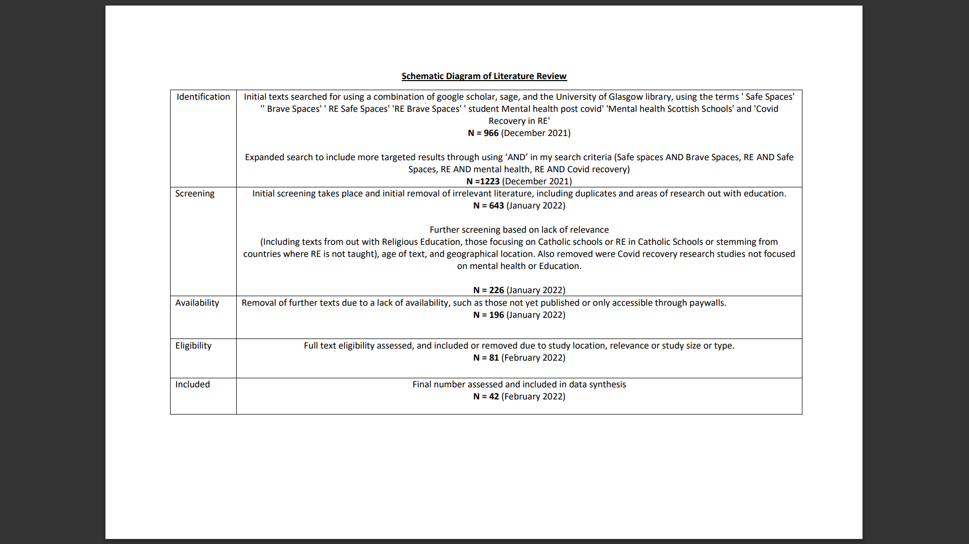

Appendix 9
Ethical Approval Consent Form

Appendix 10 – Plain Language statement – Parents and Carers

Appendix 11 – Parental Consent

Appendix 12 – Plain language statement Children

Appendix 14 Pre-Intervention Questionnaire data analysis (Full)

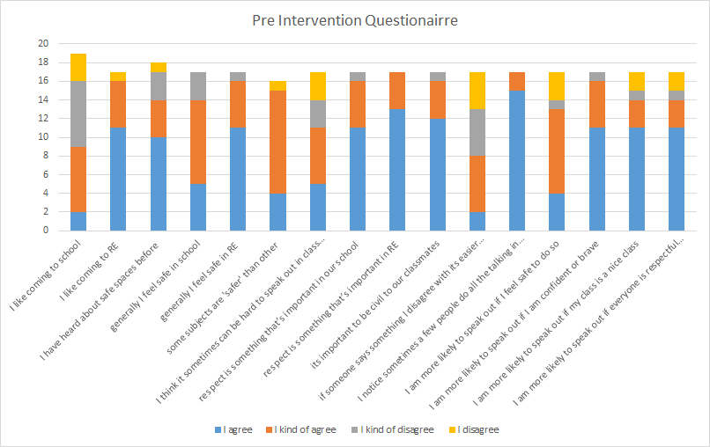

Appendix 15 – Post Intervention Questionnaire Data Analysis (Full)

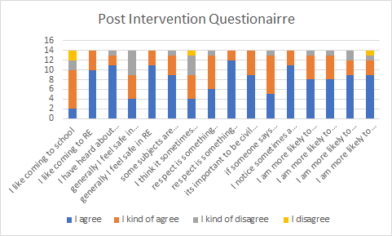

Appendix 16
Thematic Analysis Data (Full)

response numbers | 15 | 16 | 14 | 16 | total
Terms used | week 1 - safe | week 2 - brave | week 3 -civil | week 4 - respectful
Themes emerging
annoyance |  | 2 |  |  | 2
arguments |  |  | 3 |  | 3
body language |  |  |  | 1 | 1
bravery |  | 2 |  |  | 2
calm |  |  | 2 |  | 2
civil |  |  | 3 |  | 3
comfort | 12 |  |  |  | 12
confidence |  | 1 |  |  | 1
equality |  |  |  | 1 | 1
embarrassment |  | 1 |  | 2 | 2
family | 3 | 2 |  |  | 5
fear |  | 3 |  |  | 3
friends | 4 | 1 | 2 | 2 | 9
hobbies | 4 |  |  |  | 4
judgement |  |  |  | 3 | 3
kindness |  | 1 | 4 | 4 | 9
home | 5 | 3 |  | 4 | 12
listening |  | 1 | 2 | 3 | 6
pets | 5 |  |  |  | 5
religion / religious places |  |  |  | 1 | 1
respectful |  |  | 4 | 6 | 10
speaking / talking out |  | 4 |  | 5 | 9
school |  | 3 |  | 2 | 5
teacher (relationship with) | 3 | 4 |  | 5 | 12
social media / phones | 3 | 1 |  |  | 4
trust | 2 | 1 |  | 2 | 5
violence |  |  | 1 |  | 1

REFERENCES

Ashwin, P., McVitty, D. (2015). The Meanings of Student Engagement: Implications for Policies and Practices. In: Curaj, A., Matei, L., Pricopie, R., Salmi, J., Scott, P. (eds) The European Higher Education Area. Springer, Cham. https://doi.org/10.1007/978-3-319-20877-0_2

Arao, B., & Clemens, K. (2013). From Safe Spaces to Brave Spaces: a new way to frame dialogue around diversity and social justice. In Landreman, L. (Ed.), The Art of Effective Facilitation: Reflections from Social Justice Educators (pp. 135-150). Sterling, VA: Stylus Publishing.

Barnes, L. P. (2020). Crisis, Controversy and the Future of Religious Education. Abingdon: Routledge.

Barnett, T (1985) Pupil Personality and Styles of Teaching, Pastoral Care in Education, 3:3, 207-215, DOI: 10.1080/02643948509470519

Barrett, B J. 2010. “Is ‘Safety’ Dangerous? A Critical Examination of the Classroom as a Safe Space.” The Canadian Journal for the Scholarship of Teaching and Learning 1 (1): article 9.

Baer, U. (2019). What snowflakes get right: Free speech, truth, and equality on campus. Oxford University Press.

Baumfield, V. (2017). Changing Minds. The Professional Learning of Teachers in a Classroom Community of Inquiry. In M. Gregory, J. Haynes, & K. Murris (Eds.), The Routledge International Handbook of Philosophy for Children (pp. 119-126). London and New York Routledge.

Bland, D (2015) Using drawing in research with children: Lessons from practice. In AARE Annual Conference 2015, 2015-11-29 - 2015-12-03. (Unpublished)

British Educational Research Association (2000) Good practice in educational research writing (Southwell, Notts, British Educational Research Association).

Boostrom, R. 1998. “‘Safe Spaces’: Reflections on an Educational Metaphor.” Journal of Curriculum Studies 30: 397–408.

Braun, V., Clarke, V. (2006). Using thematic analysis in psychology. Qualitative Research in Psychology, 3, 77–101. https://doi.org/10.1191/1478088706qp063oa
Callan, Eamonn. 2016. “Education in Safe and Unsafe Spaces.” Philosophical Inquiry in Education 24 (1): 64–78.

Carlsson, D (2020) Representation and safe space: conflicting discourses
in RE teacher education supervision, British Journal of Religious Education, 42:1, 36-44, DOI:
10.1080/01416200.2018.1556600

Clayton, M & Stevens, D (2018) 'What is the point of Religious Education' - Journal of Theory and Research in Education - SAGE

Copley, T. 2005. Indoctrination, education and God, London: SPCK.

Crowe, S., Cresswell, K., Robertson, A., Huby, G., Avery, A., & Sheikh, A. (2011). The case study approach. BMC medical research methodology, 11, 100. https://doi.org/10.1186/1471-2288-11-100

Denzin, N. K. (1970) The Research Act in Sociology. Chicago: Aldine.

Downward, P & Mearman, A (2007) ‘Retroduction as mixed-methods triangulation in economic research: reorienting economics into social science’
Cambridge Journal of Economics
Vol. 31, No. 1 pp. 77-99 (23 pages)

Duckworth, A. L. (2016). Grit: The power of passion and perseverance. Scribner. https://doi.org/10.1111/peps.12198

Estrada, C.A.M., Lomboy, M.F.T.C., Gregorio, E.R. et al. religious education can contribute to adolescent mental health in school settings. Int J Ment Health Syst 13, 28 (2019). https://doi.org/10.1186/s13033-019-0286-7

Ellsworth, E. 1992. “Why doesn’t this feel empowering? Working through the repressive myths of critical pedagogy.” In Feminisms and critical pedagogy, eds. C. Luke and J. Gore, 90–119. New York: Routledge.

Flensner, K. K& Von der Lippe, M (2019) Being safe from what and safe
for whom? A critical discussion of the conceptual metaphor of ‘safe space’, Intercultural Education,
30:3, 275-288, DOI: 10.1080/14675986.2019.1540102

Freedom of Expression Legal Framework, Equality and Human Rights Commission: https://www.equalityhumanrights.com/en/publication-download/freedom-expression-legal-framework

Gibson, A., (2017), ‘Safe spaces & Free speech: Effects of moderation policy on structures of online forum discussions’. In Proceedings of the 50th Hawaii International Conference on System Sciences.

Gorski, P. (2012). Equity and social justice from the inside-out: Ten commitments for intercultural educators. In N. Palaiologou & G. Dietz (Eds.), Mapping the broad field of multicultural and intercultural education worldwide: Towards the development of a new citizen (pp. 388–401). Cambridge Scholars Publisher.
Gorski, P., & Parekh, G. (2020). Supporting critical multicultural teacher educators: Transformative teaching, social justice education, and perceptions of institutional support. Intercultural Education, 31(3), 265–285.
Grimmitt, M., ed. 2000. Pedagogies of religious education, Great Wakering: McCrimmons. Google Scholar

Hayward, M. 2006. Curriculum Christianity. British Journal of Religious Education, 28(2): 153–171. [Taylor & Francis Online]

Holley, L, C., and Steiner, S. 2005. “Safe Space: Student Perspectives on Classroom Environment.” Journal of Social Work Education 41 (1): 49–64
Hunter, Mary Ann. 2008. “Cultivating the Art of Safe Space.” Research in Drama Education 13 (1): 5–21

Hunter, M. A. 2008. “Cultivating the Art of Safe Space.” Research in Drama Education 13 (1): 5–21

Iversen, L. L (2019) From safe spaces to communities of disagreement, British Journal of Religious Education, 41:3, 315-326, DOI: 10.1080/01416200.2018.1445617

Jackson, R. 2004b. Rethinking religious education and plurality, Abingdon: Routledge Falmer.

Jaworski, A. & Sachdev, I. (1998) Beliefs about silence in the classroom, Language and Education, 12(4), 273– 292.

Kahu, E. (2013). Framing student engagement. Studies in Higher Education, 38(5), 758–773.

Law, E. H. F. 1993. The wolf shall dwell with the lamb: A spirituality for leadership in a multicultural community. St. Louis, MI: Chalice Press.

Lockwood, H (2020) Can S2 pupils 'motivation in learning History be improved by using Virtual Reality? [University of Glasgow MEd].

Ludlow, J. (2004). From safe space to contested space in the feminist classroom. Transformations, 15(1), 40–56.

Mazzei, L. & Jackson, A. (2012) Complicating voice in a refusal to ‘let participants speak for themselves’, Qualitative Inquiry, 18(9), 745– 751.

Meine, LE, Strömer E, Schönfelder, S, Eckhardt EI, Bergmann, AK and Wessa1, M (2021) ‘Look After Yourself: Students Consistently Showing High Resilience Engaged in More Self-Care and Proved More Resilient During the COVID-19 Pandemic’ In Frontiers of Psychiatry ‘The Consequences of COVID-19 on the Mental Health of Students’ series

Merriam S. B, (1985) ‘THE CASE STUDY IN EDUCATIONAL RESEARCH: A REVIEW OF SELECTED LITERATURE ‘in The Journal of Educational Thought (JET) / Revue de la Pensée Éducative Vol. 19, No. 3 pp. 204-217

McKay C & Macomber G. The Importance of Relationships in Education: Reflections of Current Educators. Journal of Education. December 2021.

Naidu, S (2021) Building resilience in education systems post-COVID-19, Distance Education, 42:1, 1-4, DOI: 10.1080/01587919.2021.1885092
O’Brien, J. (2016). Debating abortion on campus: Let both the pro and anti-sides speak. In T. Slater (Ed.), Unsafe space (pp. 81–92).

Osbeck, C, Sporre. K, and Skeie. G. (2017). “The RE Classroom as a Safe Public Space. Critical Perspectives on Dialogue, Demands for Respect, and Nuanced Religious Education.” In Location, Space and Place in Religious Education, edited by Martin Rothgangel, Kerstin von Brömssen, Hans-Günter Heimbrock, and Geir Skeie, 49–66. Münster: Waxmann.

Palfrey, J. (2017). Safe spaces, brave spaces: Diversity and free expression in education. MIT Press Open. https://bravespaces.org/

Poynter, K. J, and Tubbs, N J. (2008) “Safe Zones.” Journal of LGBT Youth 5 (1): 121–132.
Roux, Cornelia. 2012. Safe Spaces: Human Rights Education in Diverse Contexts. Rotterdam: Sense Publishers.

Qin, J, Ding, Y, Gao, J, Wu, Y, Lv, H and Wu, J. (2021) “Effects of COVID-19 on Mental Health and Anxiety of Adolescents Aged 13–16 Years: A Comparative Analysis of Longitudinal Data from China
“Frontiers in Psychology

Queirós, A., Faria, D., & Almeida, F. (2017). Strengths and limitations of qualitative and quantitative research methods. European Journal of Education Studies.

Rudge, L. (1998). ‘I am nothing’ – Does it matter? A critique of current religious education policy and practice in England on behalf of the silent majority. British Journal of Religious Education, 20(3): 155–165.

Sanders LM (2020) Is COVID-19 an adverse childhood experience (ACE): Implications for screening for primary care. J Pediatr. 2020; 222:4-6. doi: 10.1016/j.jpeds.2020.05.064

Sell, A. P. F (1973) THE BACKGROUND TO THE CURRENT RE/ME DEBATE IN BRITAIN: AN HISTORICAL SKETCH, Religious Education, 68:1, 42-56, DOI: 10.1080/0034408730680104

Spyrou, S. (2011) The limits of children’s voices: From authenticity to critical, reflexive representation, Childhood, 18(2), 151– 165.

Stern, J. (2010) Research as pedagogy: building learning communities and religious understanding in RE, British Journal of Religious Education, 32:2, 133-146

Scottish Government - Religious and moral Education 3-18 Curriculum Impact statement (2014)

Sue, D. W. 2015. Race talk and the conspiracy of silence: Understanding and facilitating difficult dialogues on race. Hoboken, NJ: Wiley.

Taber K.S (2013) Classroom based research and evidence-based practise: An introduction (2nd Ed) London SAGE

Tatum, B. D. (1992). “Talking about race, learning about racism: The application of racial identity development theory in the classroom.” Harvard Educational Review 62 (1):1–24.

Taylor, E. (2000). “Analysing research on transformative learning theory.” In Learning as transformation: Critical perspectives on a theory in progress, ed. J. Mezirow, 285–328. San Francisco, CA: Jossey-Bass.

Teece, G. (2017). ‘Religious education needs a rebrand – it should be fascinating, challenging and hard.’ Times Educational Supplement. 20 September 2017. Available online at: https://www.tes.com/news/religious-education-needs-rebrand-it-should-befascinating-challenging-and-hard

Trowler, V. (2010). Student engagement literature review. York: Higher Education Academy.

Trowler, V. (2014). Negotiating Contestations and Chaotic Conceptions: Close-up Research into Engaging “Non-Traditional” Students. Paper presented at the Higher Education Close Up 7 Lancaster.

Tso, W.W.Y., Wong, R.S., Tung, K.T.S. et al. (2022) Vulnerability and resilience in children during the COVID-19 pandemic. Eur Child Adolesc Psychiatry 31, 161–176

Welch, S. D. (1999) Sweet dreams in America: Making ethics and spirituality work. New York: Routledge.

Ward, T.N., (2017). Protecting the silence of speech: Academic safe spaces, the free speech critique, and the solution of free association. Wm. & Mary Bill Rts. J., 26, p.557.

Yin, R. K. (2014). Case study research: Design and methods. London, UK: SAGE.

Zeni, J. (2001) Ethical Issues in Practitioner Research. London: Teachers College Press.

