The Impact of Motor-Development Approaches to Teaching Physical Education upon the Self-Regulation of Primary 1 and 2 Pupils within the Scottish Education System

BY
Marco Sisi Marco.Sisi@south-ayrshire.gov.uk

A dissertation submitted in part requirement for the degree of
MEd Professional Practice

AUGUST 2022

Dissertation Word Count:
16,382

Table of Contents
Contents Page
Abstract 1
Permission to Consult 2
Abbreviations 3
Chapter 1- Introduction 4
1.1 Background 4
1.2 Personal Rationale 5
1.3 Research Question 6
1.3.1 Secondary Questions 6
Chapter 2 - Literature Review 7
2.1 Introduction 7
2.2 Systematic Search 7
2.3 Self-Regulation 8
2.3.1 Theoretical and Conceptual Framework 8
2.3.2 Models of Self-Regulation 8
2.3.3 Self-Regulation and School Readiness 10
2.3.4 Self-Regulation and Academic Success 11
2.3.5 Risk Factors for Self-Regulation 12
2.3.6 Interventions for Self-Regulation 12
2.4 Physical Education 13
2.4.1 PE in Schools 13
2.4.2 The Importance of PE 14
2.4.3 PE as an Intervention for Self-Regulation 15
2.5 Motor Skills 15
2.5.1 Gross Motor Skills 16
2.5.2 Fine Motor Skills 17
2.5.3 Relationship Between Motor Skills and Cognitive Development 17
2.5.4 Motor-Development Approaches in PE 18
2.6 BMT 20
2.7 Conclusion of Literature 21

Chapter 3- Methodology 23
3.1 Primary Research Questions 23
3.2 Participants and Setting 23
3.3 The Intervention: BMT 24
3.4 Research Design 24
3.5 Paradigm 25
3.6 Action Research 26
3.7 Methods 27
3.7.1 Response to Challenge Scale 28
3.7.2 Reflective Journals 30
3.7.3 Focus Groups 31
3.8 Data Analysis 32
3.8.1 Qualitative Data Analysis 32
3.8.2 Quantitative Data Analysis 33
3.9 Ethical Considerations 34
3.9.1 Relationships 34
3.9.2 Informed Consent 35
3.9.3 Anonymity and Confidentiality 35
Chapter 4- Results 37
4.1 Quantitative Data 37
4.1.1 Sample Characteristics 37
4.1.2 Cognitive Regulation 38
4.1.2.i. Box Plot Analysis 38
4.1.2.ii. Hypotheses 38
4.1.2.iii. Wilcoxon Signed-Rank Test 39
4.1.3 Affective-Regulation 40
4.1.3.i. Box Plot Analysis 40
4.1.3.ii. Hypotheses 41
4.1.3.iii. Paired T-Test 41

4.1.4 Motor-Regulation 42
4.1.4.i. Box Plot Analysis 42
4.1.4.ii. Hypotheses 43
4.1.4.iii. Wilcoxon Signed-Rank Test 43
4.2 Qualitative Analysis 44
4.2.1 Perceived Skill Levels 44
4.2.2 Readiness to Learn 44
4.2.3 Wellbeing 45
Chapter 5- Discussion 47
5.1 Cognitive-Regulation 47
5.1.1 Readiness to Learn 48
5.2 Affective-Regulation 49
5.2.1 Wellbeing 49
5.3 Motor-Regulation 51
5.3.1 Perceived Motor Competence 51
5.4 Regression 52
5.5 Conclusion 53
Chapter 6- Conclusion and Recommendations 54
6.1 Limitations 54
6.2 Dissemination 55
6.3 Conclusions 56
6.4 Recommendations 57
6.4.1 Investigating Long-Term Effects 57
6.4.2 Integrating BMT as a Widespread Approach 58
6.4.2 A Tool for COVID Recovery 58

Appendices 59
Reference List 79

List of Accompanying Material
Tables and Figures
Figure 1 – O’Leary’s (2017) Action Research Cycle 26
Figure 2.1 – RCS 8-Challenging Tasks 28
Figure 2.2 – RCS 16-Item Rating-Scale 29
Figure 3 – 6-Phases of Thematic Analysis 32
Table 1 – Descriptive Statistics of Overall Sample 37
Figure 4 –Cognitive-Regulation Box Plot 38
Table 2 – Results of quantitative evaluation of the Cognitive Subscale 39
Figure 5 –Affective-Regulation Box Plot 40
Table 3 – Results of quantitative evaluation of the Affective Subscale 41
Figure 6 –Motor-Regulation Box Plot 42
Table 4 – Results of quantitative evaluation of the Motor Subscale 43
Figure 7- Thematic Map 46
Appendices
Appendix A – Systematic Search Strategy Model 59
Appendix B – BMT Intervention Process 60
Appendix C – Teacher Intervention Plan 61
Appendix D – Reflective Journal Framework 62
Appendix E – Pupil Focus Group Questions 63
Appendix F – Teacher PLS 64
Appendix G – Parents PLS 67
Appendix H – Pupil PLS 70
Appendix I – Teacher Consent Form 72
Appendix J – Parental Consent Form 74
Appendix K –Normality Test of Cognitive-Regulation Data 76
Appendix L –Normality Test of Affective-Regulation Data 77
Appendix M –Normality Test of Motor-Regulation Data 78

ABSTRACT
Throughout Scotland, self-regulation has been acknowledged as a fundamental function, critical to school transition, social interaction, and success within education (Education Scotland, 2020b). Yet despite this, many children begin school lacking self-regulation skills, impacting upon their development and engagement in classroom tasks (Cadima et al., 2016). Therefore, in an attempt to support the self-regulatory capacities of children across Scottish schools, Education Scotland (2020a) has launched Better Movers and Thinkers (BMT)- a motor-development approach to teaching physical education (PE) which aims to develop the cognitive domain and foster self-regulation skills among children. However, despite such well-intended endorsements, there remains a lack of evidence surrounding the true effectiveness of motor-development approaches to PE upon self-regulation. Therefore, in acknowledgement of this void, this study aimed to explore the impact of motor-development approaches to teaching PE amongst primary 1 and 2 school pupils within the Scottish education system.
The following study implemented BMT as a motor-development intervention across an 8-week period, amongst 30 pupils within primary 1-2 in a school in South Ayrshire. Framed through a mixed-methods design, the study involved pre and post-intervention testing of three quantitative outcome measures- cognitive-regulation, affective-regulation, and motor-regulation- assessed through the Response to Challenge Scale (RCS). In order to examine the perceptions of teachers and pupils upon the implementation of BMT, qualitative data was gathered via three, pupil focus group interviews and through the reflective journals of four classroom teachers- assuming the role of reflective observers throughout the study.
Quantitative data revealed an effect between pre and post-test conditions in the domains of cognitive-regulation (p=0.000) and affective-regulation (p=0.042) however, displayed no significance within the domain of motor-regulation (p=0.067). Analysis of qualitative data through both reflective journals and pupil focus groups revealed that as well as enjoying BMT as an intervention, pupils experienced further benefits such as improved wellbeing, confidence, and concentration within class.
Moving forward, the potential that BMT holds to develop both cognitive and affective-regulation amongst children is encouraging, and must be further pursued in order to promote motor-development approaches to PE throughout the mainstream curriculum.

PERMISSION TO CONSULT

The author gives permission for this dissertation to be made available by the University of Glasgow to anyone who wishes to consult it or knows of its existence.

AR | Action Research
BMT | Better Movers and Thinkers
BERA | British Educational Research Association
CfE | Curriculum for Excellence
EBSCO | Elton B. Stephens Company
EF | Executive Functions
ERIC | Education Resources Information Centre
FMS | Fine Motor Skills
GMS | Gross Motor Skills
IQR | Interquartile Range
PA | Physical Activity
PE | Physical Education
PLS | Plain Language Statement
RCS | Response to Challenge Scale
SKIP | Successful Kinaesthetic Instruction for Pre-schoolers
SRL | Self-Regulated Learning
SRLs | Self-Regulated Learners
ABBREVIATIONS
CHAPTER 1: INTRODUCTION
1.1 Background
From early childhood, individuals must navigate through complex physical, social, and cultural realms, making decisions upon how to act in ways that satisfy personal needs and environmental demands (Lerner et al., 2011). An essential tool in achieving this feat is that of self-regulation. Self-regulatory capacity has been shown to positively impact upon a multitude of outcomes across the life course including health trajectories and wellbeing (Diamond, 2016). Moreover, research has linked self-regulation to child development and more specifically, school success- predictive of several outcomes including reading competence, mathematical thinking, and academic achievement (De Greef et al., 2018).
The nature of education demands the constant application of learners’ self-regulatory abilities to follow instructions, adhere to expectations, develop relationships, and solve problems (Wagner et al., 2020). Yet as Cadima et al. (2016) emphasise, many children begin school lacking self-regulation skills, impacting upon their development. Indeed, in a study of 3595 teachers, Curby et al. (2018) discovered that 46% of teachers reported at least half of their students to have self-regulatory based difficulties- raising a cause for concern.
In acknowledging the evident criticality of self-regulation among children, Education Scotland’s (2017) ‘Teaching and Learning Toolkit’, regards self-regulatory development as one of the most effective approaches to supporting learners. Such recognition is further echoed by the Joseph Rowntree Foundation’s (2014) ‘Closing the Attainment Gap in Scotland’ report, advising that teachers should implement effective evidence-based self-regulation strategies as a means to raise attainment. Therefore, in an attempt to support the self-regulatory capacities of young people across Scotland, Education Scotland (2020a) has launched the implementation of BMT; a motor-development approach to teaching PE designed to develop and foster self-regulation skills. However, as Diamond (2016) asserts, what constitutes as ‘effective’ in improving self-regulation skills among children remains an issue of debate.

Although a small number of interventions have displayed initial signs of promise upon self-regulatory improvements, there remains a distinct lack of intervention-based evidence surrounding the impact of PE-based motor-development interventions, with such deficiencies becoming further evident in a Scottish context. Therefore, acknowledging this literature void, the conducted study has aimed to investigate how the implementation of motor-development approaches to teaching PE impacts upon self-regulation amongst primary 1 and 2 school pupils within the Scottish education system.
1.2 Personal Rationale
It is in combination with both the aforementioned policy and literature, and the issues identified within my own teaching practice, that my interest upon how one can develop self-regulatory capacity among children has arisen. This intersecting matter, recognised both throughout literature and within personal practice, is deemed a valid impetus from which to begin an enquiry (Gilchrist, 2018).
Self-regulation is an apparent issue amongst many learners in my current school. I have observed within my classroom, that pupils often struggle to calm themselves following periods of excitement or anger. This issue has been further highlighted across the school, with the general consensus among staff being that pupils struggle to control their emotional impulses when in the classroom- in turn, impacting upon behaviour, engagement, and learner resilience throughout lessons.
Situated within a rural setting, there exists little opportunity for pupils within my current school to engage in any physical activity (PA) out with the school grounds. This was echoed within the 2021 pupil voice survey, with students highlighting the desire to gain access to further PA opportunities out with their 2-hours of weekly curricular PE. Interestingly, there exists evidence to suggest that a lack of engagement within PE can indeed negatively impact upon self-regulation (Bai et al., 2021). Therefore, in response to such conclusions, the school has prioritised the improvement of self-regulation as a central focus throughout their 2021-2022 school improvement plan. In order to effectively fulfil this aim, a BMT staff training programme has been implemented- equipping all teaching staff with the appropriate skills required to deliver BMT as a PE-based intervention with the aim of promoting self-regulation skills among learners.
From the viewpoint of the literature on professional enquiry, Nichols and Cormack (2017) affirm that this is a sound basis upon which to examine an issue as it has emerged from what Forde et al. (2009) term ‘collective rumination’- where, as a staff-base, an issue has been acknowledged and as a result, an intervention has been implemented.
Equally relevant when engaging within enquiry, is the aim of improving an aspect of a practitioner’s skillset (Nichols and Cormack, 2017). In undertaking this enquiry, not only will I develop my pedagogical knowledge of BMT, but simultaneously, as Taber (2013) advocates, I will both advance my understanding and collate tangible evidence upon how to employ BMT most effectively as an intervention toward improving self-regulation skills among learners.
1.3 Research Question
Formulated through the researcher’s first-hand experiences as a practitioner and in line with the main intentions of the study, the following question will shape this practitioner enquiry:
- To what extent can motor-development approaches to teaching PE impact upon self-regulation among primary 1 and 2 school pupils within the Scottish Education System?

1.3.1 Secondary Questions
In order to effectively answer the main research question within the context of the study, the following secondary questions were formulated:
- What is self-regulation and why could it be important in primary school?

- What are motor-development approaches within PE?

- What impact has the implementation of motor-development approaches to PE had upon pupils’ self-regulatory domains?

CHAPTER 2: LITERATURE REVIEW
2.1 Introduction
The following review of literature aims to discuss and critically analyse the various themes arising from literature, which have contributed to answering the overarching research question: To what extent can motor-development approaches to teaching PE impact upon self-regulation among primary 1 and 2 school pupils within the Scottish Education System? In attempt to answer sub-question 1, the first section will review self-regulation and its role within education. The second section analyses PE as a tool for both physical and cognitive development before progressing towards motor skills, where their relationship with cognitive development is analysed and utility as a component of PE programmes is discussed- contributing to sub-question 2. To conclude, the final section reviews ‘BMT’- the study intervention- and its potential to incite developmental outcomes.
2.2 Systematic Search
Formulating an effective search strategy is a recursive process which is vital throughout research, allowing one to locate appropriate literature and to identify ‘what works’ (Boudah, 2010). However, in order to navigate the myriad of publications available, one must select the appropriate databases (Morrell and Carroll, 2010). Therefore, considering this logic, the databases included were: ERIC, EBSCO, and the University of Glasgow’s online database of articles.
Primarily, to collate topic-appropriate literature, when searching databases, it was crucial to only include key search terms pertinent to the research (Zawacki-Richter et al., 2020). Therefore, four different search concepts were identified: ‘self-regulation,’ ‘motor-development,’ ‘primary school’ and ‘PE.’ To refine the results further, the researcher utilised Boolean operators to associate the identified key terms- “self-regulation and motor-development,” “self-regulation and primary school,” and “self-regulation and PE”- in order to effectively filter down the results of each database and refine the focus of each search (Ary et al., 2018). The aforesaid terms were then modified to capture the various interchangeable terminology used across the literature (Rossi et al., 2016). This process was repeated for the search concepts ‘motor-development,’ ‘primary school’ and ‘PE’. Following this, the literature was then screened for relevant articles, excluding duplicates and non-applicable papers. Appendix A displays this procedure utilising ERIC as the focus.
Furthermore, to obtain location-specific literature, the researcher included the additional search terms of: “self-regulation and Scotland” and “motor-development and Scotland”. However, there appears to be an evident lack of Scottish-specific research across all three databases, which is a notable limitation of this review.
2.3 Self-Regulation
2.3.1 Theoretical and Conceptual Framework
In recent years, the concept of self-regulation has been viewed through a diverse set of lenses- studied within a sports science context, in education and from a psychological perspective (Millar, 2017; Nicholls et al., 2016; Ursache et al., 2012). Yet, despite these various viewpoints, it nonetheless remains apparent that throughout literature, there is a consensus that self-regulation has vital implications for developmental outcomes across the life course (McClelland et al., 2018). Indeed, in their seminal work, Posner and Rothbart (2000, p.427) assert that “understanding self-regulation is the single most crucial goal for advancing the understanding of development”.
2.3.2 Models of Self-Regulation
In the context of this paper, viewing self-regulation from an educational perspective, widespread viewpoints across literature tend to fall into two distinct groups, each of which address fundamental educational matters. In one camp, are those who study self-regulated learning (SRL), which broadly speaking, can be conceptualised as the self-directive process whereby individuals channel and sustain behaviours, emotions and cognitions that are focused on the accomplishment of a set goal (Panadero, 2017). As Alexander and Greene (2017) posit, self-regulated learners (SRLs) have the ‘will’ to learn, possessing elevated levels of motivation and self-discipline which enables them to engage and persevere with learning tasks regardless of difficulty (Nilson, 2013). SRLs direct and control their thought processes in line with their environment, in turn, maximising their learning efforts (Stoeger et al., 2015). Yet, Alexander and Greene (2017) argue that the notion of development spans far beyond simply possessing the motivation to achieve a set goal.
Indeed, there exists a divergent cohort of scholars, who examine self-regulation more broadly, across numerous contexts. From this lens, self-regulation becomes a multi-faceted construct, involving how one monitors, adapts, and sustains their cognitive, behavioural, and emotional state in accordance with the environment in which they exist (Vohs and Baumeister, 2004). From this perspective, self-regulation spans far beyond simply engaging in learning. In fact, according to Duckworth and Carlson (2013), within an educational setting, self-regulation permits children to navigate their school environment more effectively, enabling one to interact with teachers and peers, adhere to classroom rules, manage emotions, and focus on tasks. All of which, according to Tranter and Kerr (2016), permit one to become ‘ready to learn’.
Given the well-informed theories of both SRL and self-regulation, to solely consider either self-regulation or SRL research without the other would render an incomplete depiction of how learners self-regulate within an educational setting (Alexander and Greene, 2017). In analysis of both perspectives, it appears evident that effective self-regulation can engender both social development and educational success. Firstly, through interaction with the school environment and developing social and emotional competence, one becomes ‘ready to learn’ (Tranter and Kerr, 2016), from at which point their self-regulatory efforts can be directed towards achieving explicit learning goals. Moreover, although there exists variances across both perspectives, the essence of each theory remains the same. Whether it be for academic gain or broader social development, there exists convergence across both theories in that to successfully achieve their desired outcome, one must regulate their behaviours, emotions, and cognitive processes (Duckworth and Carlson, 2013).
Therefore, as Alexander and Greene (2017) assert, within an educational realm, one should simply adopt the term ‘self-regulation in education’- encompassing both the SRL and self-regulatory challenges that learners are faced with throughout education.

2.3.3 Self-Regulation and School Readiness
As a cognitive component enabling one to navigate their own behaviours and actions, it is no surprise that self-regulation has been strongly associated with school readiness (Duncan et al., 2018b). Defining school readiness as the means by which children are both socially, physically, and intellectually ready to begin formal schooling, Reardon and Portilla (2016) emphasise that many children begin school lacking such rudimentary skills, adversely impacting upon their ability to adjust to the formal school environment. Therefore, assuming the mediating role, in recent times, scholars have suggested that improving self-regulatory capacity among children can act as a bridge between preschool and primary school- improving school readiness (Vitiello and Greenfield, 2017).
From an educational perspective, self-regulation skills are continuously employed within the classroom setting, as learners must seamlessly coordinate multiple self-regulatory aspects: maintaining concentration, following instructions, and employing both motor and verbal functions in order to produce overt behaviours- all amidst the distractions of an active classroom environment (Duncan et al., 2018b). Therefore, holding such self-regulatory skills enables one to interpret, observe and control their own reactions to the environment in which they are situated- providing the foundations for school adjustment (Schmitt et al., 2015).
Indeed, targeting pupils’ school readiness through the mechanism of a self-regulation intervention, a study by Raver et al. (2011) provided teachers across 35 classrooms with training strategies designed to provide their pupils (n= 602) with more effective self-regulatory support. The results of this study displayed that children who were part of the intervention demonstrated significantly higher levels of both school readiness and self-regulation in comparison to the control group. Another primary discovery throughout the research outlined that self-regulation skills are equally as important to early success within school as general intelligence. However, despite this, and as Blair and Raver (2015) emphasise, it is important to acknowledge that developing self-regulatory skills does not supplant interest in the development of fundamental learning milestones such as the acquirement of early knowledge of letters and numbers; it simply sets the stage for it.

2.3.4 Self-Regulation and Academic Success
With an array of evidence displaying the link between self-regulation and school readiness, scholars have begun to research its correlation with academic success. According to Savina (2021), self-regulatory components such as working memory, focus of attention and inhibitory control permit children to develop adaptive strategies which enable them to utilise their learning environment- paying attention to teachers, persisting with learning activities and following instructions, all of which influence future educational trajectories. Analysing this correlation, Gestsdottir et al. (2014) conducted a longitudinal study of children with an average age of 6 years old, across a two-year span, in order to explore the links between self-regulation and academic achievement among young children in Europe. Multilevel analysis discovered that amongst the 260 children studied, those who demonstrated greater levels of self-regulation, displayed higher levels of academic success. Whilst this research yields promising results, the recent work of Quis et al. (2021) suggests otherwise. In their study, analysing academic success within maths, it was discovered that there existed no relationship between self-regulation and academic success amongst 6 and 7-year-old pupils. However, in this study, ‘academic success’ was measured through the means of mathematical competence and therefore, one cannot consider it to be entirely representative of academic success.
Presenting a more encompassing perspective on the correlation between self-regulation and academic success, a longitudinal study following 1000 participants from birth to age 32 years, displayed that those with poor self-regulatory skills, detected at the initial stages of life, were indeed less likely to persist with formal education and progress towards higher education than their well-regulated peers (Moffit et al., 2011). However, although this study attempted to ‘disentangle’ self-regulation from social class and adverse childhood experiences to obtain reliable results, Lackner et al. (2018) recognise the inevitability of adverse childhood experiences in reducing self-regulatory capacity.

2.3.5 Risk Factors for Self-Regulation
Despite evidence linking self-regulation to both educational success and school readiness, it is important to acknowledge that many children remain at a critical disadvantage in acquiring such vital, life-long skills (Zakszeski et al., 2020). Disparities within self-regulatory development among children are broadly associated with demographic factors and early childhood experiences (Allee-Herndon and Roberts, 2019). Research suggests that stressful early childhood experiences may influence particular patterns of brain activation and behaviour (Palacios-Barrios and Hanson, 2019). Indeed, traumatic experiences require continuous attention to, and the maintenance of heightened emotional information, which leaves little opportunity for the intellectual discovery and educational experiences that a stimuli-rich environment provides (Zakszeski et al., 2020). Well documented throughout literature, childhood poverty not only intensifies stress levels, but inhibits the self-regulatory systems that children require to manage the numerous environmental factors often associated with poverty (Allee-Herndon and Roberts, 2019). Moreover, children situated in poverty are significantly less likely to experience family, home and social environments which promote the optimal development of self-regulation, and consequently, the provision of available learning opportunities becomes limited (Yu et al., 2020). As such, in recent years, there has been a surge in interest within childhood interventions as a means to specifically target and develop self-regulation (Viglas and Perlman, 2018).
2.3.6 Interventions for Self-Regulation
Due to the expanding body of empirical evidence, there now exists a consensus upon the potential impacts that the acquisition self-regulatory skills can engender across the life course. Moreover, in considering the aforementioned benefits that self-regulation can generate, the value of self-regulatory interventions becomes apparent (Dignath et al., 2008). Therefore, one would expect to experience a well-informed and practical application of this research knowledge in the classroom. Yet, whilst teachers have the potential to play a key role in the development of self-regulation, achieving this remains a ‘fuzzy concept’ for most practitioners (Dignath et al., 2008). Thus, there exists the opportunity to further train teachers in order that they can play a significant role in the promotion of self-regulation within the classroom.
Of the interventions that do exist, in their meta-analysis of self-regulatory interventions, Pandey et al. (2018) revealed that amongst 21 curriculum-based interventions, the most common strategies involved circle-time, self-talk, and role-play- all inciting improvements within self-regulatory capacities. However, revisiting the viewpoint of Dignath et al. (2008), despite the multitude of existing self-regulatory interventions within education, due to the apparent lack of teacher expertise in this domain, a consistent classroom-based intervention compromising optimal self-regulatory improvement remains difficult to locate. Therefore, as an alternative approach, various scholars advocate the promotion of PE within a school setting, as a facilitator of self-regulation, suggesting further research should be conducted in this area (Vasilopoulos and Ellefson, 2021).
2.4 Physical Education
2.4.1 PE in Schools
PE is “education through the physical” (Papacharisis et al., 2007, p.68), which is described by Hills et al. (2015) as the planned, progressive learning experiences through PA which take place across the preschool, primary and secondary school curriculum. Although most research surrounding PE has been based within a secondary school environment, in recent times, PE has emerged as a prominent topic within the primary school curricula, receiving increased political, professional, and academic attention (Powell et al., 2016). As such, in 2011, it was made a mandatory requirement in Scotland that all children in primary schools are entitled to at least 2 hours of PE per week (Scottish Parliament, 2011). This apparent shift in educational priority is due to growing evidence displaying that PE during the formative years holds the potential to incite developmental progression, associated with growth in motor competence, social skills, mental health, executive functioning, and various other areas- as will be examined below.

2.4.2 The Importance of PE
In review of literature across the field of education, the significance of PE and its developmental capacities becomes clear. Primarily, and most apparent, PE is positively associated with a multitude of health-related benefits; recognised for its capacity to improve cardiovascular health, body composition, bone health and mental health (Lynch, 2019). Emphasising its importance, with rates of inactivity at an all-time high amongst children in the UK, Jenny and Rhodes (2017) assert that accessing PE within school is pivotal to the wellbeing of young people and may be the only opportunity for many to engage in PA.
Not only does it hold the potential to engender positive health benefits, but evidence also suggests a favourable relationship between PE and a host of additional developmental factors (Opstoel et al., 2020). In a recent review of research by Opstoel et al. (2020), examining 88 studies, it was implied that in fact, engagement in PE can develop a range of 11 key life skills including decision making, responsibility and cooperation. However, despite this research, Bailey et al. (2009) argue that simply ‘doing’ PE is not sufficient enough to incite such developmental progression. Instead, to engender any form of development beyond that of physical improvements, PE must be delivered via the correct pedagogical circumstances (Bailey et al., 2009).
Illustrating successful pedagogical approaches in the implementation of PE, in their study, Dyson (2001) determined that utilising co-operative learning structures in PE positively influenced the ability of students to collaborate effectively while taking responsibility for their own learning. Likewise, Hellison’s (2010) model of Teaching Personal and Social Responsibility through PE, originally created to effectively integrate disengaged young people back within society, has been proven successful in developing students’ goal setting, leadership, teamwork, and social skills- and is now widely implemented in curriculums of PE across the globe (Escartí et al., 2010). Through analysing such pedagogies, what remains clear is that, to be effective beyond a health-related sense, PE must align with, and be purposely ‘fitted’ to its context and appropriate goals. This feat, according to Jung et al. (2021), although time-consuming in design, if executed correctly has the potential to incite impactful effects. As such, over the years, an increasing number of purposely designed PE interventions have been developed.
2.4.3 PE as an Intervention for Self-Regulation
In viewing literature upon PE as an intervention for self-regulation, two elements become clear; there exists a lack of specific literature upon PE as an intervention for self-regulation and there exists debate upon its effectiveness. Indeed, in their study of the FunAction Intervention, delivering PE to a cohort of 302 pupils aged 12-14 over a 16-week period, Laberge et al. (2012) determined that PE had no impact upon the self-regulation of participants post-intervention. Beyond this research, only a few other key studies have measured the impact of a PE upon self-regulation- amongst those, is the seminal work of Lakes and Hoyt (2004). Their study provides evidence to suggest that a three-month intervention of taekwondo instruction, combined with instruction in specific self-regulation techniques generated greater improvement in the self-regulation of 6-11-year-old participants in comparison to a traditional PE curriculum. Such evidence suggests that standard PE alone may not possess the capacity to significantly alter self-regulatory capacity, indicating that a more integrated approach may be necessary (Diamond and Ling, 2016). This perspective is further echoed by Chatzipanteli et al. (2015) who state that the greatest improvements within self-regulation seem to occur when interventions are extended beyond that of orthodox PE, incorporating cognitive engagement.
The role of cognitive engagement as a tool to improve self-regulatory capacity has directly emerged from ‘brain training’ programmes, which incorporate no elements of PE (Berkman et al., 2012). However, the notion that the combination of cognitive and physical engagement are components of effectual self-regulatory intervention has recently been exhibited through motor-development approaches.
2.5 Motor Skills
Broadly defining motor skills, Libertus and Hauf (2017) conceptualise these as the body’s ability to manage the process of movement through the coordinated function of nerve centres, nerves, and muscles. It is widely accepted across literature that there exist two categories of motor skills: gross motor and fine motor.

2.5.1 Gross Motor Skills
Gross motor skills (GMS) are often considered to be the ‘basic vocabulary’ of motor skills, providing the basis from which all future motor behaviours are founded (Mamani-Ramos et al., 2021). Involving the coordination of an individual’s arms, legs and other body parts, GMS are an essential component, enabling one to carry out fundamental movements (Duncombe, 2019). Many scholars suggest that GMS can be segmented into two categories; locomotor skills, which propel the body through space (running, jumping, and skipping); and object control skills, which propel an object through space (throwing, kicking, and striking) (Cook et al., 2019). According to Favazza and Siperstein (2016), the attainment of such motor skills ‘develops naturally’ amongst the majority of children through engaging in their environment. However, Logan et al. (2012) convey an alternative view, expressing that such motor skills do not arise naturally and must be taught correctly and continuously through ‘planned’ gross-movement programmes. Therefore, whilst GMS may arise inherently through natural exploration, it appears essential to reinforce such development with intentional gross-motor activities to attain optimal outcomes.
Recent reviews highlight the criticality of GMS in fostering and sustaining healthy developmental trajectories. Indeed, literature from Robinson et al. (2015), highlights that GMS are positively correlated with PA engagement and fitness, whilst appearing to be inversely related to weight gain. Furthermore, from a cognitive perspective, in their study of 4-11-year-olds, Davis et al. (2011), discovered that there exists a relationship between GMS and components of higher order cognition. However, viewing this premise from a wider standpoint, in their systematic review of over 20 studies (of which 12 were gross-motor specific), Van Der Fels et al. (2015) found that correlations between GMS and cognitive development were deemed as ‘weak’. Therefore, whilst indefinitely correlated to physical development amongst children, further research is required to fully determine the relationship, if any, between GMS and cognitive development.

2.5.2 Fine Motor Skills
Throughout literature, fine-motor skills (FMS) have been the focus of diverse research fields, studied across occupational therapy, educational psychology, and sports science. Hence inevitably, several definitions of FMS exist. However, succinctly conceptualising them within a generalised context, Bruininks (2005, p.2) asserts that FMS “encompass control and coordination of the distal musculature of the hands and fingers”. Requiring synchronised hand-eye movements, as Matheis and Estabillo (2018) posit, developing FMS are essential for actions such as picking up items and grasping small objects- enabling precision and dexterity of movement. Moreover, in addition to their critical function in performing everyday tasks, there exists evidence to suggest that FMS can incite a host of additional developmental benefits.
Indeed, across literature, there exists a strong correlation linking FMS development to academic achievement across the curriculum (Syväoja et al., 2019). In their analysis, exploring the relationship between FMS and academic achievement across 96 primary school pupils within the UK, Pitchford et al. (2016) uncovered that FMS appeared to be a significant predictor of mathematical competence. Additionally, the research of Roebers and Jäger (2014) suggests that across all motor departments, FMS proved to be the most significant predictor of reading ability and writing competence amongst 129 preschool participants. However, as Martzog et al. (2019) postulate, the link between FMS and academic success is founded upon the reality that throughout early education, FMS facilitate fuller participation across learning tasks- enabling those competent, to engage further within the learning process whilst those who struggle fall further behind. Therefore, there lies a critical responsibility amongst educators to develop the FMS of all children in the attempt to reduce the attainment gap (Pitchford et al., 2019).
2.5.3 Relationship Between Motor Skills and Cognitive-Development
The notion that there exists an association between motor skills and cognitive development is by no means new. For example, pioneering research from Piaget (1953), proposed that both activity and sensorimotor engagement are vital for the emergence of cognitive ability. Yet, despite this, historically, there exist differing views upon this relationship, particularly among children (Michel and Moore, 1995). On one hand, although acknowledging the importance of motor skills, early research considers that motor skills and cognitive skills are entirely distinct processes, developing separately and involving different brain regions (Connolly, 1986). Moreover, literature from Tomporowski et al. (2008), asserts that no existing theory has been proposed that effectively addresses the relationship between motor skills and cognitive development.
However, despite past views, more recent research has demonstrated that in fact both motor skills and cognitive skills have numerous interrelated processes. Indeed, research from Leisman et al. (2014) has displayed co-activations between the prefrontal cortex, cerebellum and ganglia throughout various motor and cognitive development tasks. This is particularly evident when the specified task utilises both sides of the body in a coordinated manner- a cognitive process known as bilateral-integration (Van Der Fels, 2020). According to Rudd et al. (2019), motor-development programmes, which focus upon the development of bilateral-integration, have been found to incite a stronger impact upon cognitive functions than traditional ‘brain training’ programmes. For instance, Moreau et al. (2015) discovered that engagement in complex bilateral physical movements facilitates greater cognitive engagement than that of non-PA-based cognitive training programmes.
However, despite its potential to incite developmental outcomes, there exists a common misconception that children ‘naturally’ acquire motor skills (Robinson et al., 2016). Therefore, revisiting the literature of Logan et al. (2012), motor skills amongst children is a proficiency that must be purposely implemented and taught. Thus, as research into motor skills has progressed, highlighting both the physical and cognitive processes involved in the advancement of movement competence, there exists an opportunity to design a sound theoretically underpinned PA curriculum that will enable children to not only develop motor skills, but grow holistically through movement (Rudd et al., 2019).
2.5.4 Motor-Development Approaches in PE
As previously outlined, there has been a surge of interventions investigating the impact of traditional PE upon cognitive development. However, within the field of motor-development, various scholars have moved beyond simply engaging in sport, towards actively seeking to improve bimanual-integration, eye-hand coordination, and motor skills (Dalziell et al., 2015a).
Adopting this approach, Mulvey et al. (2018) evaluated the ‘Successful Kinaesthetic Instruction for Pre-schoolers’ (SKIP) intervention- an evidence-based motor-development PE intervention- across 50 preschool participants over a 6-week period in order to ascertain whether a proven motor-development intervention also improves EF skills. Following twice-weekly, 30-minute sessions, where participants engaged in motor-development activities, it was concluded that participants involved in the SKIP intervention had improved not only their basic motor skills, but significantly improved their EF skills when compared to the control group. Whilst these findings shed initial light upon the relationship between motor and cognitive skills, and display that targeted interventions can affect both domains in unison amongst the pre-school population, there appears to be a lack of empirical data evidencing such results within the primary school population.
Coincidently, one of the few studies that does in fact examine the relationship between motor-development approaches and cognitive development amongst a primary school population, is one which evaluates the intervention of BMT. Dalziell et al. (2015a) conducted an empirical study amongst 9-10-year-old pupils in Scotland, in order to investigate the impact of a BMT intervention upon EF skills. Here, two groups received two PE lessons per week over a 16-week period. The control condition (n= 21) received a traditional PE provision, whereas, the intervention condition (n= 25) received BMT. Following quantitative analysis, the findings from the study revealed statistically significant improvements in the particular cognitive domain of working memory for participants recruited to the BMT intervention condition- suggesting that BMT does positively impact upon EF skills.
Given the evidence that links the early development of motor skills to the development of cognitive EF (Dalziell et al., 2015a), one would assume that research examining motor-development in relation to the cognitive domain of self-regulation would exist in the same vein. However, this is not the case, as remarkably there exists a vast literature void in the study of the relationship between motor-development and self-regulation.

2.6 BMT
Key findings from research emphasise the significance of PA, integration of cognitive skills, and the need for movement tasks to be multifaceted in enhancing one’s learning (Rudd et al., 2019). Therefore, considering such research, this presents a compelling case for the employment of BMT as an approach to PE, as this specific initiative incorporates all three of these components (Dalziell, 2016).
Collaboratively developed within Scotland across education, sports performance, and cognitive neuroscience, BMT is a novel approach which represents an evolution in PE- combining pedagogical development and innovative content with current good practice (Dalziell et al., 2015a). Concerned with the development and provision of quality PE for children aged 3-18 years, BMT is “an approach to learning and teaching in PE designed to develop the ability of all children and young people to move and think in a more cohesive way” (Education Scotland, 2015, p.2).
A key element of PE is that learners are motivated to purposefully participate in practical activity, however, in comparison to traditional PE, BMT uniquely facilitates this through assisting in the development of cognitive skills (Dalziell et al., 2015b). Indeed, BMT, achieves this objective through enabling pupils to engage in a multifaceted learning process where “movement is exciting, thinking is interesting and participating is enjoyable” (Dalziell, 2016, p.22). Whilst literature maintains that BMT is an ‘enjoyable’ means of PE, a study by Papla et al. (2019) discovered that whilst attitudes towards PE are generally positive throughout primary school, these attitudes become increasingly negative as children age. Therefore, discovering the perceptions of pupils towards BMT as a vehicle for PE is an element that the current research will seek to discover.
PE lessons which are delivered through the BMT framework enable pupils to take responsibility for their learning, where a number of increasingly intricate routines, stimulating both physical and cognitive components, are provided for the learner to engage in. These synergistic exchanges between both physical and cognitive activity provide pupils with the physical and cognitive capacities that are required to effectively engage in PA across the life course (Dalziell et al., 2015b). Moreover, not only does BMT foster a foundation wherein one can develop their PA-related proficiencies, Education Scotland (2015) claims that resultantly, incorporating such an approach throughout PE creates learners who are ‘switched on’, ‘industrious’ and can make stronger connections across the wider school curriculum.
Supporting such claims, is Dalziell et al. (2019), whose empirical study employed a 16-week BMT intervention, where 2-hours of BMT was delivered to 65 children aged 9-10 years across 6 schools. Following analysis, it was established that, when compared to the control group (n = 78) who received 2-hours of traditional PE across the 16-week period, pupils who received BMT displayed significant improvements within both cognitive capacities and gross motor coordination.
Yet, whilst this study, amongst others within BMT, displays encouraging results, all current research within the field of BMT to date is restricted to the 9-11 years age group. Therefore, one cannot assume that the data is representative of all ages (Kukull and Ganguli, 2012). More significantly, in analysis of the literature upon BMT, one element that remains consistent across all papers is the involvement of the same scholar- the co-author of BMT. As such, it appears that there indeed exists an opportunity to further explore BMT as an intervention.
2.7 Conclusion of Literature
In summary, the intention of this literature review was to examine the various themes posed in the research question: To what extent can motor-development approaches to teaching PE impact upon self-regulation among primary 1 and 2 school pupils within the Scottish education system?
As demonstrated throughout this chapter, and answering sub-question 1, self-regulation is a key skill for pupils within primary school which if developed can enable one to succeed within education (Duncan et al., 2018b). Moreover, highlighted as a further tool, the discussed literature has examined motor skills and their relationship with cognitive development- allowing pupils to ‘grow holistically through movement’ (Rudd et al., 2019). Additionally, the literature illustrated that whilst typically, PE is intended to improve physical aspects, when extended beyond that of orthodox PE and towards a motor-development approach, it can incite benefits within the cognitive domain- contributing towards sub-question 2. However, whilst evidence clearly links the early development of motor skills development to a range of cognitive domains, there exists a vast literature void in the study of the relationship between motor-development incorporated PE and its impact upon self-regulatory domains. Therefore, such acknowledgements exemplify that there exists a gap within the literature and in order to answer sub-question three, primary research is essential- justifying the requirement of this study.

CHAPTER 3: METHODOLOGY
This chapter sets out to address the research plan of enquiry that was utilised to discover to what extent motor-development approaches to teaching PE can impact upon self-regulation among primary 1 and 2 pupils. Here, in order to effectively direct and explore the research aim, the research process is detailed in its entirety, outlining the intervention, research design and data collection methods and analysis, before detailing any considerations that were made. Appendix B visually outlines this process.
3.1 Primary Research Questions
As identified throughout the review of literature, it was essential to conduct primary research in order to answer sub-question three: what impact has the implementation of motor-development approaches to PE had upon pupils’ self-regulatory domains? As a means to direct the research most effectively towards answering this, the researcher formulated a further three primary research-specific questions which will be answered through the methods detailed within this chapter.
- What is the direct impact of motor-development approaches to PE upon the cognitive, affective, and motor self-regulatory-domains?

- What is the opinion of teachers upon the impact of motor-development approaches to PE on the self-regulation of their primary 1-2 pupils?

- What is the opinion of pupils upon the impact of motor-development approaches to PE on their self-regulatory capacity?

3.2 Participants and Setting
The conducted research took place within a primary school in South Ayrshire, Scotland. The participants who took part in the study were aged between 5-6 years old and were all situated across primary 1 and primary 2 (n=30). Moreover, within this study, four consenting classroom teachers assumed the dual-role of ‘observers’- gathering naturally occurring classroom data- and ‘implementers’- delivering the BMT intervention. It is imperative to outline that I, the researcher, also took part in the research (as one of the four teachers involved in the study).
3.3 The Intervention: BMT
Firstly, it is important to acknowledge that all teachers, prior to the study, have received training within BMT and have an understanding upon how to deliver the intervention. Throughout the intervention phase, all teachers, including the researcher (n=4), began delivering BMT within their classrooms for an 8-week period. BMT was delivered to all 30 pupils for 30-minutes, five times per week (20-hours total). As primary 1 and primary 2 are split across two classrooms, taught by four different teachers across the course of the week, to ensure consistency across classrooms, teachers were instructed to follow their provided BMT intervention plan- detailing which routine to teach each week (see appendix C). When delivering the 30-minute intervention, all four members of teaching staff firstly displayed a BMT instructional video (demonstrating the routine), before breaking down the routine and teaching this to learners. All pupils worked on the same routine each week, practising this every day before starting a new routine the following week. Across the course of the 8-week intervention, all 30 pupils engaged in 8 different BMT routines.
3.4 Research Design
In order to effectively answer the primary research questions, a mixed-methods design was adopted. Defining mixed-methods research, Clark and Ivankova (2015) describe this as a procedure of data collation which combines both qualitative and quantitative methods within a single study such that a deeper understanding of phenomena can be acquired. Whilst traditionally, the employment of qualitative methods have been the predominant approach across educational research, Riazi (2017) posits that due to the increasing complexities within education, many researchers have come to acknowledge the true efficacy of mixed-methods research in their pursuit to decipher educational phenomena. Indeed, through the combination of qualitative and quantitative approaches, the researcher was able to explore the phenomena under examination from multiple perspectives- utilising RCS, reflective journal and focus group data in an interconnected fashion (Ivankova, 2014).

However, despite its notable utility, Malina et al. (2011) posit that its multifaceted structure can often present challenges. Indeed, Tashakkori and Teddlie (2003, p.45) refer to the need for mixed-method researchers to be “methodologically bilingual”, possessing high levels of knowledge in both qualitative and quantitative research methods. Without such methodological proficiency, researchers can often encounter inconsistencies within both the interpretation and synthesis of qualitative and quantitative data- subsequently, producing ambiguous results (Creswell and Clark, 2011). Therefore, it became the responsibility of the researcher, through engagement in wider academic literature, to develop a sound knowledge across both quantitative and qualitative domains.
3.5 Paradigm
Throughout the research, the overarching paradigm applied was structured through a pragmatist lens. Epistemologically, pragmatism is premised on the idea that academics can apply the:
“methodological approach that works best for the particular research problem that is being investigated” (Tashakkori and Teddlie, 1998: 20).
Indeed, in conducting research within the domain of education, the researcher sought to steer clear of the ‘forced dichotomy’ of positivism or interpretivism, due to their rigidity in method selection (Patton, 2014), instead, choosing to conduct the research through a pragmatist framework- providing the freedom to utilise any such method or technique associated with qualitative or quantitative research (Kelly and Cordeiro, 2020). However, despite its utility as a framework wherein one can achieve practical results, the pragmatist orientation to reality is contested by Giladi (2015), who questions its validity as it ignores dominant philosophy and theories, rejecting to view phenomena through a monistic, prescribed meta-theoretical lens. Yet, whilst many view pragmatism as ‘chaotic and messy’ (Mitchell, 2018), it is the open and exploratory nature of pragmatism which allows educators to truly comprehend reality and understand the connection between knowledge and action- permitting the researcher to holistically analyse the collated RCS, reflective journal and focus group data through an unrestricted means (Biesta, 2010).

3.6 Action Research
As Hammond (2013) asserts, due to its introspective design, pragmatism provides an action-orientated framework for research which lends itself most adequately to that of action research. Conceptualising action research from an educational standpoint, Efron and Ravid (2013, p.2) define this research approach as “an inquiry conducted by educators in their own settings in order to advance their practice and improve their students’ learning”. Indeed, in assuming the role of teacher-researcher and engaging in what Burrows (2019, p.86) describes as “taking action and doing research”, the researcher was presented with the opportunity to develop a deeper understanding of his own students, solve classroom-based problems, and implement transformational change within his establishment.
Often, academic research within education and its derived recommendations have been viewed as “out of touch” (Hammond and Wellington, 2020, p.141)- detached from the reality of bona fide classroom practice. However, action research provided the researcher with a framework for authentic change and encouraged him to ‘take ownership’ in discovering the impact of motor-development approaches upon self-regulation, through recognising practical issues and then devising a self-directed and systematic plan to take action (Efron and Ravid, 2013).
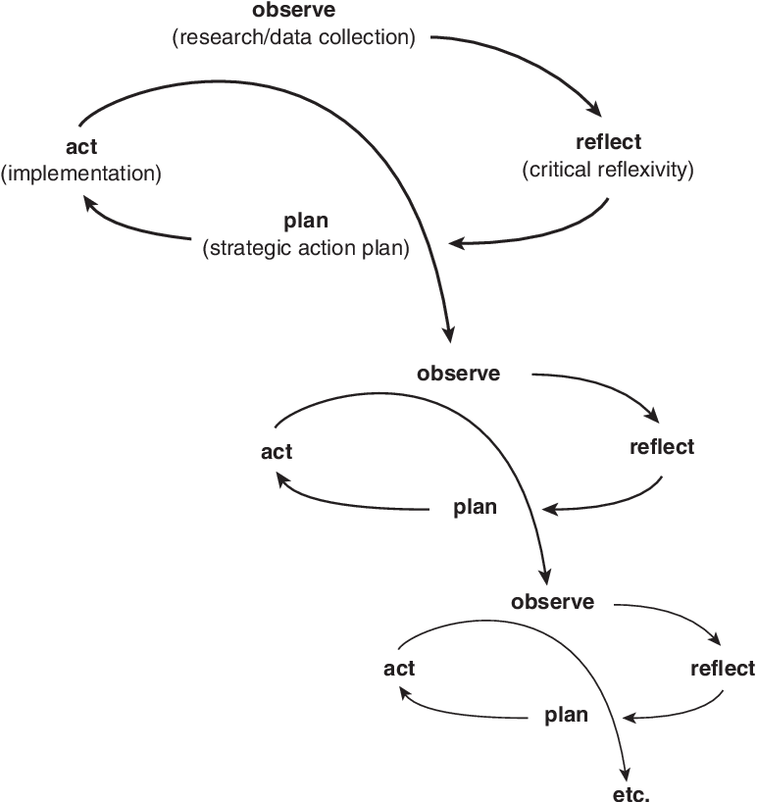
Figure 1: O’Leary’s (2017) Action Research Cycle

The Action Research Cycle (O’Leary, 2017) displayed above in figure 1, indicates the four cyclical steps that the researcher followed in conducting the enquiry, consisting of: (1) observation- identifying self-regulation as an issue amongst primary 1-2 pupils; (2) critical reflection- considering how to best tackle the issue; (3) purposeful planning- planning the 8-week BMT intervention, and (4) arguably the most important phase, ‘acting’, where the researcher acted upon their research methodology, carrying out the conducted study in attempt to improve self-regulation amongst primary 1-2 pupils, before arriving once more at the observation stage to re-evaluate.
Whilst many advocate this cyclical research-style, Zuber-Skerritt (2011), argues that refining such a methodology can become ‘time exhaustive’ and complex. Moreover, Baumfield et al. (2008) question the iterative nature of action research, highlighting that one cannot arrive at a definitive end-point when conducting such research as, fundamentally, the research process only reaches its natural conclusion at an endpoint of full understanding. Yet, according to Mertler (2017), this particular criticism is what makes action research an invaluable tool for the teacher-researcher. Comparable to the cyclical nature of action research, is the occupation of a teacher, who may opt to implement their action research year upon year with new students- where their revisions would be monitored and evaluated, developing new improvements for the next stage of implementation. Indeed, due to the time constraints involved within this enquiry, the Action Research cycle was only conducted once. However, as Parsons and Brown (2002) posit, the end point of one enquiry is the starting point of the next. Therefore, the conducted enquiry holds the potential to be reviewed and adapted accordingly in future as a basis for another study.
3.7 Methods
Throughout the data collection process, the researcher employed a purposeful mix of methods, incorporating both qualitative and quantitative techniques. In order to obtain quantitative data upon the self-regulation of pupils, the RCS was utilised. Moreover, as a means to gain a panoramic view of the opinions of both teachers and pupils upon the implementation of motor-development approaches to teaching PE, both teacher reflective journals and pupil focus groups were employed.

3.7.1 Response to Challenge Scale
In order to collate quantitative data relevant to primary research question 1- what is the direct impact of motor-development approaches to PE upon the cognitive, affective, and motor self-regulatory-domains?- Lakes and Hoyt’s (2004) RCS was utilised both pre and post-intervention as a means to measure any differences within levels of self-regulatory domains amongst pupil participants. Used across multiple studies involving PA and self-regulation (Lakes, 2013; Lakes et al., 2019), literature suggests that the RCS is the first published observer-rated measure of self-regulation for school-aged children, designed to measure children’s cognitive, affective and motor-regulation in response to a physical challenge (Lakes, 2013).
The RCS was administered within the school gym hall, where, prior to the explanation and demonstration of all tasks, one at a time, 30 pupil participants individually undertook a physical challenge course, consisting of 8 tasks of increasing difficulty. Each of the 8 tasks involved within the challenge course varied in the demands that they placed on pupils cognitively, affectively, and physically- see figure 2.1 below for details.
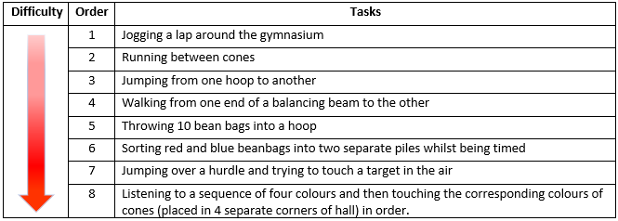
Figure 2.1: RCS 8-Challenging Tasks- Adapted from Lakes (2012)

As Lakes (2012) asserts, due to its multiple tasks and assessment scale, gathering reliable data through the RCS is by no means a simple task. Therefore, to create a robust self-regulatory index on the RCS, Howard et al. (2019) recommend that multiple live observers are required. Thus, whilst pupils completed the challenge course, two observers independently measured the self-regulatory capacities of each participant based upon the 7-point RCS scale which consists of 16 bipolar adjectives; allowing researchers to measure self-regulation via three dimensions: motor control (co-ordination required to carry out each activity), emotional control (perseverance in the face of increasingly difficult tasks) and cognitive control (attentiveness required to observe and complete all activities accurately). Possible scores across all 16 items ranged from 1-7, with larger scores indicative of higher self-regulatory capacity- this is detailed below in figure 2.2. Moreover, following data collation, all scores were aggregated across both observers, achieving both consistency and reliability throughout the results (Lakes et al., 2019). However, although providing a robust assessment, Lakes (2012) asserts that to gain a broader depiction of self-regulatory capacity amongst children, researchers should combine the RCS as part of a multi-method approach, utilising it in combination with other measures- as will be discussed below.
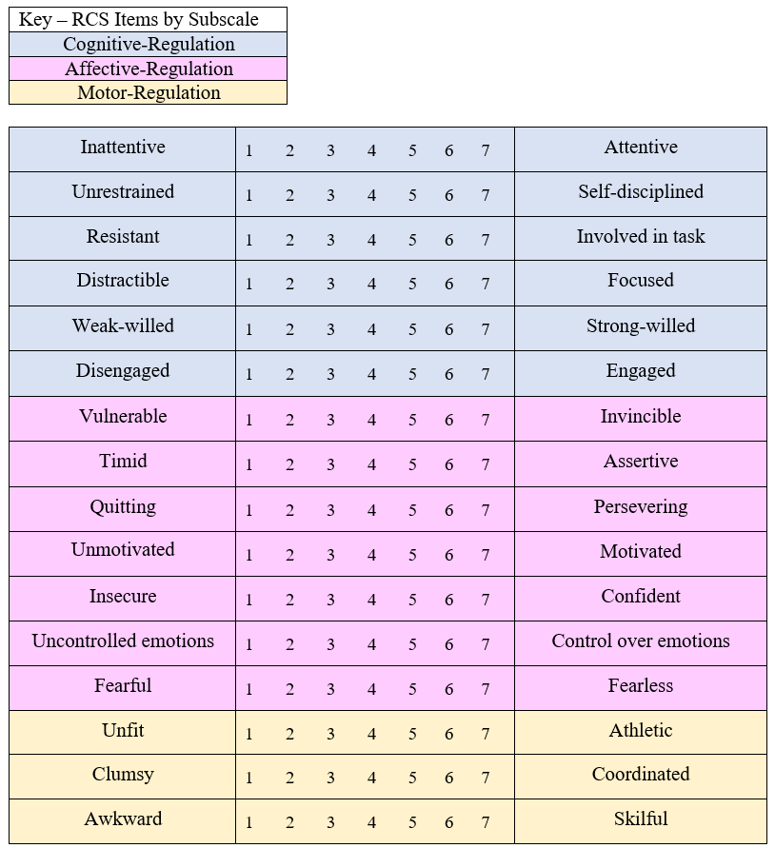
Figure 2.2: RCS 16-Item Rating-Scale- Adapted from Lakes (2012)

3.7.2 Reflective Journals
Differing from the quantitative data gathered through the RCS, qualitative data collection methods are exploratory in nature, permitting the researcher to reflect upon the ‘how’ and the ‘why’ (Miles et al., 2014). In utilising such methods throughout mixed-methods research, the researcher may not only quantify the problem, but can acquire an understanding of context-specific experiences and phenomena that otherwise could not be obtained (Richards, 2020).
One method of qualitative data collation which was employed throughout the research was that of reflective journals, defined as an ongoing, self-reporting account of experiences documented throughout the research process, “but more essentially an opportunity for reflection” (Bloomberg, 2021, p.204). Indeed, collating reflective journal data enabled the researcher to gain real-life, reflective data from all teacher-observers (n=4), allowing phenomena to be viewed through the professional gaze of practitioners and thus, aiding the research process (Bashan and Holsblat, 2017).
Herein, all 4 teachers completed two reflective journals- one on week 4 (halfway through the intervention) and once again on week 8 (at the end of the intervention). This resulted in a total of 8 reflective journals being collated. The journals were intended to serve as a valuable tool for the researcher, creating the scope to answer primary research question 2: exploring the opinions of teachers upon the impact of motor-development approaches to PE on the self-regulation of their primary 1-2 pupils, through a purposeful framework- establishing observable connections between theory and practice (Bashan and Holsblat, 2017).
In order that reliable and consistent data was gathered, the framework of each journal followed Kirkpatrick’s (1994) ‘Four Levels of Evaluation’ model- widely employed throughout reflective evaluation. Each journal was based upon the same format, segmented into four sections: reaction- measuring if practitioners have found BMT to be a relevant classroom tool; learning- formatively measuring whether learners had acquired the knowledge and skills that the intervention targeted; behaviour- measuring behavioural changes after learning to see if learners were taking skills acquired within the intervention and applying this across the curriculum; results- formatively assessing whether or not the targeted outcome was achieved (see appendix D).
3.7.3 Focus Groups
Focus groups are one of the most widely utilised qualitative means of data collection across educational research due to their capacity to draw upon the feelings, experiences, and reactions of participants in a way in which other methods simply cannot (Lambert, 2019). Kamberelis and Dimitriadis (2013) assert that whilst other methods of interviewing, such as individual interviews, can engender rich data, focus group interviews are particularly effective in this regard. This is due to their interactive nature, permitting participants to engage with, and build upon each other’s responses, hence, generating more comprehensive data. Moreover, as Stewart and Shamdasani (2014) assert, not only do focus groups provide a platform from where rich data can be gathered, they allow the researcher to access such data from large groups of people through a flexible means. In spite of this, Krueger and Casey (2000) warn that despite its benefits, conducting focus groups- if not executed with care- can become a time-exhaustive and unproductive process. Therefore, in line with the literature of Guest et al. (2017), the study was limited to three focus groups. Here, the researcher applied stratified random sampling, randomly selecting 6 pupils, 3 male and 3 female (n= 18)- permitting an ample amount of data to be collated, whilst remaining time-effective.
A pivotal factor of consideration was whether to conduct the focus group interviews through a structured or semi-structured format. The inclusion of structured focus group interviews were considered- proposing closed-ended questions to participants in a standardised and methodical fashion (Leavy, 2014)- due to the age of participants. Indeed, O’Reilly and Dogra (2016) assert that young children often respond most effectively to direct questions and such questions often elicit more reliable information. However, conversely, Lyon (2014) claims that the attempt to over-structure focus group interviews can often lead to short, unelaborated responses amongst young children- simply scratching the surface. Therefore, instead, focus group interviews were conducted through a semi-structured nature, which provided a platform for both the researcher and participants to communicate freely and created the opportunity to explore set themes- whilst simultaneously enabling new ideas to be introduced (Punch and Oancea, 2014).
In order that both accurate and relevant information was collated, the focus group questions (Appendix E) posed to participants were based upon the literature review findings- generating appropriate and specific data relevant to answering primary research question 3: what is the opinion of pupils upon the impact of motor-development approaches to PE on their self-regulatory capacity? Furthermore, the focus group interview design was critically considered. All three focus groups answered 6 questions- a number which O’Reilly and Dogra (2016) deem appropriate when interviewing younger participants, ensuring to maintain their attention while allowing for adequate data to be collated. Moreover, the language used throughout the focus groups was considered, ensuring it was basic, relatable, and appropriate to the age group of all participants.
3.8 Data Analysis
As O’Neil and Schutt (2013, p.25) posit, “data doesn’t speak for itself”. Therefore, the process of data analysis plays an essential role within any form of research. As the collated data was of a mixed-methods nature, it was imperative that the researcher thought about how to examine the data sets most appropriately whilst also considering, “how can the analysis do justice to the participants and their perspectives?” (Flick, 2014: p.15). The latter must be a major priority for any researcher (Brooks et al., 2014).
3.8.1 Qualitative Data Analysis
Following the completion of all pupil focus groups and reflective journal logs, all collated qualitative data was subject to Braun and Clarke’s (2006) recursive ‘six phases of thematic analysis’ (figure 3)- a methodical process which facilitates the researcher to establish, examine and interpret relationships within a data set.
As Richards (2020, p.8) asserts, when handling qualitative data, researchers can often become “overwhelmed by rich, messy data” due to its initial lack of order and transparency. Therefore, it was essential that the researcher followed a clear and systematic process. Here, Braun and Clarke’s (2006) six phases of data analysis were adhered to:
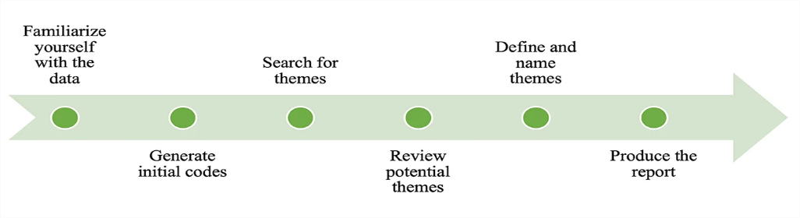
Figure 3: 6-Phases of Thematic Analysis- Braun and Clarke (2006)

- Familiarisation: Initially, reflective journals and recorded focus group interviews were transcribed verbatim via a word processing programme, before reading and re-reading such data to develop an overall comprehension of the data.
- Generating Initial Codes: Moving forwards, initial codes were established through categorising keywords and phrases across the data set, and collating data relevant to each code.
- Searching for Themes: Following the process of coding, the identified codes were then categorised into potential themes relating to the phenomena under examination.
- Reviewing Themes: In order to further refine such themes, a thematic map was formulated to visually observe the established themes and relating codes- clearly articulating their relationships.
- Defining and Naming Themes: Emphasising its recursive nature, ongoing analysis of each theme was continued to eliminate irrelevant data, adjust concepts, and revise details until the conclusive themes of: Perceived Skill Level, Readiness to Learn and Wellbeing were constructed.
- Producing the Report: Finally, the analysis of data was related back to the research question as a series of vivid, compelling extract samples were selected to reinforce findings.
3.8.2 Quantitative Data Analysis
In order to effectively analyse the results of the pre and post-intervention RCS data, the data was divided into three sub-scales: cognitive-regulation, affective-regulation, and motor-regulation. This permitted the researcher to target and analyse specific domains of self-regulation, making results more meaningful and aligning with primary research question 1 (Lakes, 2012). Initially, it was essential to utilise descriptive statistics in order to summarise the characteristics of each data set across each sub-scale through a visual lens, permitting a simplified interpretation to be made (Hoy and Adams, 2016). However, as Roni et al. (2020) assert, when testing for normality, simply relying upon a visual summary of a data set is not enough to make any firm assumptions. Therefore, Anderson-Darling Tests were employed as a further mechanism in testing the normality of the data through a rigorous statistical means (appendix K-M).

As the data sets were of a paired nature, analysing 30 participants pre and post-intervention, statistical tests which appropriately analyse paired and repeated data were utilised. For data sets with normal distribution (Affective-Regulation Subscale), a paired t-test was utilised. Whereas, a Wilcoxon Signed Rank Test was employed for not normally distributed data (Cognitive-Regulation and Motor-Regulation Subscales). Throughout all tests, a significance level of p<0.05 was considered to be statistically significant and all data was analysed using the statistical software Minitab.
3.9 Ethical Considerations
As defined within the University of Glasgow’s Risk Guidance document and as outlined by BERA (2018), working with vulnerable groups such as children poses a high-risk scenario in any instance- requiring ethical scrutiny. Moreover, in consideration of the aforementioned methodological discussion, the posed research questions, and the methods of data collection utilised, indeed hold the potential to raise ethical issues (Robson, 2002). Therefore, it becomes apparent that there exists numerous ethical considerations which must be addressed. In order to uphold good ethical practice, in line with the General Teaching Council for Scotland’s Code of Professionalism and Conduct, ethical approval was sought and granted by the University of Glasgow Ethics Committee and the head teacher at the school wherein the research took place as it was deemed that, through the following actions, the research project was ethically sound.
3.9.1 Relationships
As Graham et al. (2013, p.13) posit, “relationships are at the core of ethical research”. Whilst this statement rings true across all research, it is particularly relevant for teachers conducting research in their own classrooms (Robson, 2002). This is due to the fact that teacher-researchers are in a dependent relationship with their participants (Baguley et al., 2013). As Campbell and Groundwater-Smith (2010) suggest, this dynamic can often be advantageous, as pre-existing teacher-pupil trust often allows a researcher-participant relationship to naturally form. However, whilst acknowledging established relationships as a strength, Blaxter et al. (2001, p.158), assert that it is because of the very nature of such teacher-pupil relationships that “most commonly, ethical issues are thought to arise”. This is often due to the position of power that teachers possess over their pupils, or in this case, participants, which can cause pupils to feel the need to comply with any classroom-based research in fear of negative consequences which may impact their lives in the classroom (Cohen et al., 2017). Therefore, in assuming the role of teacher-researcher, it was essential to clearly communicate to all participants, both verbally and in written form, that the choice to participate in the study was truly free, involving no consequences, and that they could exercise their right to opt-out of the data collection process at any time (BERA, 2018).
3.9.2 Informed Consent
The dual role of a teacher-researcher requires one to ethically obtain informed consent from their participants prior to commencing an enquiry (BERA, 2018). Therefore, to adhere to such ethical procedures, several measures were implemented.
All teachers, pupils and parents of pupils were provided with a plain language statement (PLS) (Appendix F-H), informing them upon the entirety of the study prior to signing their consent forms (Appendix I-J). Here, it was ensured that the language utilised throughout the PLS, and consent forms was both basic, relatable, and appropriate to the age group of all participants. However, as Wiles (2012) asserts, the consent process should not be considered as a ‘one-off’. Instead, teacher-researchers must consider the concept of ‘ongoing consent’, ensuring that participant approval is continually negotiated throughout the research process (Salkind, 2010). Therefore, whilst detailed on the PLS and consent forms, it was re-emphasised that all participants involved in the study were free to remove themselves from the process at any time without providing reason.
3.9.3 Anonymity and Confidentiality
As BERA (2018, p.21) outline, “the confidential and anonymous treatment of participants' data is considered the norm for the conduct of research”. Yet, whilst a necessity across all research fields, within education, the teacher-researcher has multiple considerations to make (Brooks et al., 2014). Firstly, to protect the identity of all participants, gathered reflective journals, RCS and focus group data remained entirely anonymous through the use of pseudonyms. This ensured that any disseminated data was untraceable to the participants or their school. However, as Macleod et al. (2018) outline, when researching vulnerable groups, due to child protection measures, anonymity can never be entirely promised. Therefore, it was emphasised to both participants and parents that although where possible, all data collected would remain entirely anonymous, total confidentiality may be impossible to guarantee in the event of disclosure of harm or danger to participants. Moreover, as an additional layer of risk management, all collated data throughout the study was stored within a locked cabinet within the school that only the researcher had access to. Furthermore, in line with the literature of Brooks et al. (2014), following the collation and data analysis of such data, all data was destroyed.

CHAPTER 4: RESULTS
To develop a holistic understanding upon the impact of the BMT intervention process, data collected using mixed methods were compared, related, and integrated. The results are reported in the following order: (1) quantitative analysis, (2) qualitative results, before (3) the integration and comparison of mixed method findings within chapter 5.
4.1 Quantitative Data
In order to analyse the pre and post-results of the RCS following an 8-week BMT intervention, self-regulation was measured across three sub-scales: (1) cognitive-regulation, (2) affective-regulation and (3) motor-regulation. To define the relationship between pre and post-intervention across all three subscales, three separate hypotheses were formulated. In analysing the data, all three sets of data endured normality testing via the Anderson-Darling Normality Test (appendix K-M) to determine their distribution. Following this, dependent upon the data distribution, a paired T-Test or Wilcoxon signed rank test was employed to test the hypotheses. Moreover, box plots were considered to be the most appropriate tool to present and assist in the interpretation of the results. Here, it is important to note that whilst some data sets were symmetrical, for matter of effective comparison, the median and interquartile range (IQR) have been utilised in analysis of the data.
4.1.1 Sample Characteristics
Descriptive statistics for the sample are displayed within Table 1. In total, 30 children participated in the study, 43.3% of which were female (n=13) and 56.7% of which were male (n=17) with a mean age of 5.46 (SD = 0.50), ranging from 5-6 years.

Table 1. Descriptive Statistics of Overall Sample
Characteristics | N (30) | %/Mean (SD)
Sex

Female | 13 | 43.3%
Male | 17 | 56.7%
Age |  | 5.46 (0.50)
5 | 16 | 53.3
6 | 14 | 46.6
4.1.2 Cognitive-Regulation
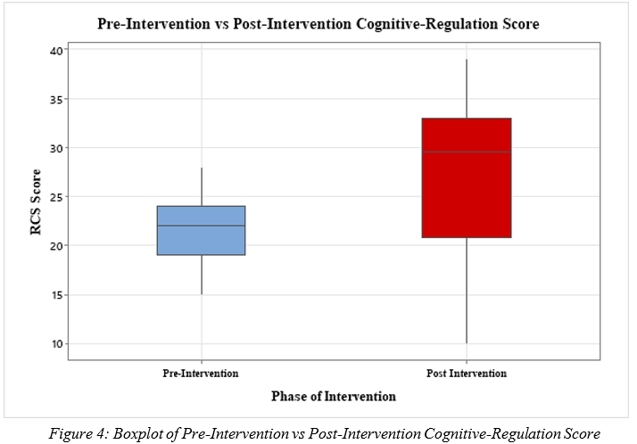
4.1.2.i. Box Plot Analysis

Figure 4: Boxplot of Pre-Intervention vs Post-Intervention Cognitive-Regulation Score

Through analysis of the box plots (figure 4), both data sets appear to be negatively skewed. This was confirmed through the Anderson-Darling Normality test as p=0.030 (appendix K). Moreover, it is apparent that a difference appears to exist between the pre and post-intervention scores within the cognitive domain. This is further exemplified when the median values are examined: Pre-Intervention = 22; Post-Intervention = 29.5.

4.1.2.ii. Hypotheses
H₀ – There is no significant difference between pre and post-intervention Cognitive-regulation scores.
H₁- There is a significant difference between pre and post-intervention Cognitive-regulation scores.

4.1.2.iii. Wilcoxon Signed-Rank Test
A Wilcoxon test was used to analyse the paired pre and post-results as the distribution of the data are skewed. The cognitive subscale was tested and found to be highly significant (p=0.000) meaning that the null hypothesis was rejected, and it can be accepted that there exists a significant difference between pre and post-intervention cognitive-regulation scores. Providing further evidence for the acceptance of the alternate hypothesis, Table 2 displays both the pre (22) and post (29.5) median values and the pre (13) and post (29) IQR.

Table 2: Results of quantitative evaluation of the Cognitive Subscale via Wilcoxon Test
Subscale |  | Median (SD) | Min | Max | IQR | p-Value
Cognitive-regulation | Pre | 22.00 (3.39) | 15 | 28 | 13 | 0.000
 | Post | 29.50 (6.94) | 10 | 39 | 29
* p ≤ 0.05; 1 significance of absolute value of T statistic (Wilcoxon test)

4.1.3 Affective-Regulation
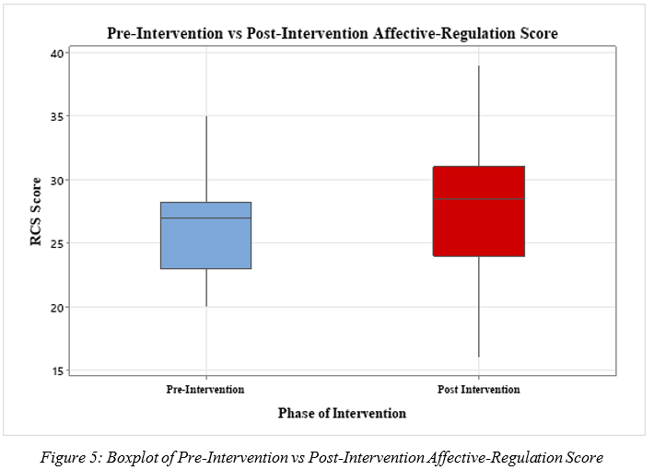
4.1.3.i. Box Plot Analysis

Figure 5: Boxplot of Pre-Intervention vs Post-Intervention Affective-Regulation Score

Through analysis of the box plots (figure 5), pre-intervention data appears to be negatively skewed, whereas post-intervention data appears to be evenly distributed. The normality of the data sets was further investigated via an Anderson-Darling test (appendix L) and found to be normally distributed (p=0.100). Moreover, the post-intervention box appears higher than the pre-intervention box, indicating that the post-intervention IQR is higher than pre-intervention scores. However, when comparing median values, it becomes apparent that there exists only a marginal difference between pre (median = 26.23) and post-intervention (median = 27.5) scores. It was therefore vital to conduct further statistical tests.

4.1.3.ii. Hypotheses
H₀ – There is no significant difference between pre and post-intervention Affective-regulation scores.
H₁- There is a significant difference between pre and post-intervention Affective-regulation scores.
4.1.3.iii. Paired T-Test
A paired t-test was employed to analyse the affective Subscale, proving the results of the BMT intervention to be statistically significant (p=0.042) and therefore rejecting the null hypothesis. Moreover, Table 3 displays the difference in pre (26.23) and post-intervention (27.5) median values and the pre (15) and post (23) IQR.

Table 3. Results of quantitative evaluation of the Affective Subscale via paired t-test
Subscale |  | Median (SD) | Min | Max | IQR | p-Value
Affective-regulation | Pre | 26.23 (3.83) | 20 | 35 | 15 | 0.042
 | Post | 27.50 (4.71) | 16 | 39 | 23
* p ≤ 0.05; 1 significance of absolute value of T statistic (paired t-test)

4.1.4 Motor-Regulation
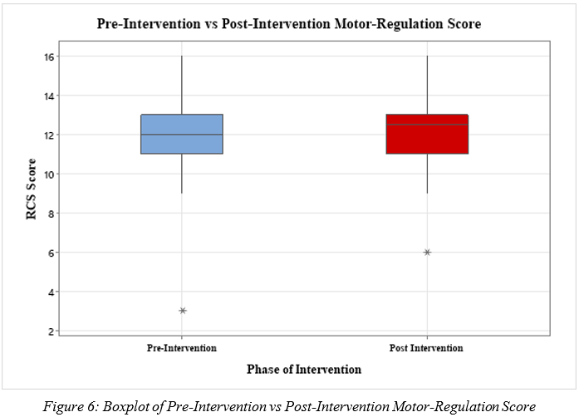
4.1.4.i. Box Plot Analysis

Figure 6: Boxplot of Pre-Intervention vs Post-Intervention Motor-Regulation Score

Through analysis of the box plots (figure 6), the pre-intervention data appears normally distributed, whereas the post-intervention data appears negatively skewed. The normality of the data sets was further investigated via an Anderson-Darling test (appendix M) and was found to be not normally distributed (p=<0.005). In analysis of both box plots, there appear to be no significant visual differences between pre and post-intervention motor-regulation scores. Moreover, in analysing the median line, although a marginal difference exists between pre-intervention (median = 12) and post-intervention (median = 12.5), this difference is negligible.
Moreover, within both data sets, there exists an outlier- marked by the asterisk in figure 6- which has been taken into consideration outside of the group. This particular individual has been excluded from the data set as they require more specific analysis which will be included within chapter 5.

4.1.4.ii Hypotheses
H₀ – There is no significant difference between pre and post-intervention Motor-regulation scores.
H₁- There is a significant difference between pre and post-intervention Motor-regulation scores.

4.1.4.iii. Wilcoxon Signed-Rank Test
A Wilcoxon test was utilised to analyse the paired pre and post-results. The motor Subscale was tested and produced a p-value of 0.067 meaning that the null hypothesis was accepted- confirming that no significant difference exists between pre and post-intervention motor-regulation scores.
Providing further evidence for the acceptance of the null hypothesis, Table 4 displays that pre-intervention, participants produced a median value of 12, in similar comparison to a median of 12.5 post-intervention. No change was found within the IQR.

Table 4. Results of quantitative evaluation of the Motor Subscale via paired t-test
Subscale |  | Median (SD) | Min | Max | IQR | p-Value
Motor  Regulation | Pre | 12.00 (2.27) | 16 | 20 | 4 | 0.067
 | Post | 12.50 (2.19) | 16 | 20 | 4
* p ≤ 0.05; 1 significance of absolute value of T statistic (Wilcoxon Test)

4.2 Qualitative Analysis
The integrated thematic analysis of both participant focus groups and teacher reflective journals revealed three emergent master themes; perceived skill development, readiness to learn, and wellbeing. The thematic map displayed at the end of this chapter (figure 7) is intended to clearly demonstrate the correlation between each master theme and their respective sub-themes. It includes a range of quotes, demonstrating the perceptions of teachers and pupils upon the employment of motor-development approaches within the classroom. Whilst these quotes are clearly indicative of each theme and provide a detailed insight, further quotes will be analysed throughout chapter 5.
4.2.1 Perceived Skill Levels
Within this overarching theme, three emergent sub-themes became apparent: self-regulation skills, motor skills, and skill regression. Overall, there was a general consensus amongst teachers and pupils that the BMT intervention was inciting a positive impact upon the self-regulation of learners. Moreover, building upon perceived skill development, it was reported by pupils that the implementation of BMT seemed to have a perceptible impact upon their motor skills. Such perceived improvements within motor skills were also thought to have a resultantly positive impact within PE.
The positive impact that BMT induced upon the motor skills of the pupils was also corroborated through the observation of teachers. However, whilst numerous perceived impacts were both experienced and observed across teachers and pupils throughout the 8-week intervention, all four teachers observed a distinct regression in pupil progress on week 4 of the intervention- which incidentally occurred following a 2-week school holiday.
4.2.2 Readiness to Learn
In further dissecting the responses of both teachers and pupils within this master theme, two recurring and associated sub-themes were extracted: pupil engagement and timing of implementation. It was well established, through analysis of both student and teacher responses, that the employment of BMT appeared to improve student engagement when in the classroom. Moreover, a recurring theme prevalent across both teachers’ and pupils’ responses was regarding the time in which it is best to implement BMT. Both teachers and pupils commented upon the notion that BMT functioned as a particularly engaging tool within the morning period- promoting pupils’ readiness to learn. However, whilst many teachers and pupils enjoyed the perceived benefits of BMT implemented within the morning period, others viewed it as a ‘brain break’ and as a means to provide pupils with respite from their regular classroom activities.
4.2.3 Wellbeing
In analysing ‘Wellbeing’ as an overarching theme amongst both teacher and pupil responses, a further two sub-themes emerged: enjoyment and confidence. Through analysing the quotes from the thematic map in figure 7, it becomes apparent across both pupils and teachers, that the implementation of BMT was enjoyable.
As well as enjoying the experience, both teachers and students mentioned that BMT has improved pupil confidence levels. This improved confidence was particularly prevalent amongst pupils who do not enjoy traditional PE and do not view themselves as ‘sporty’.

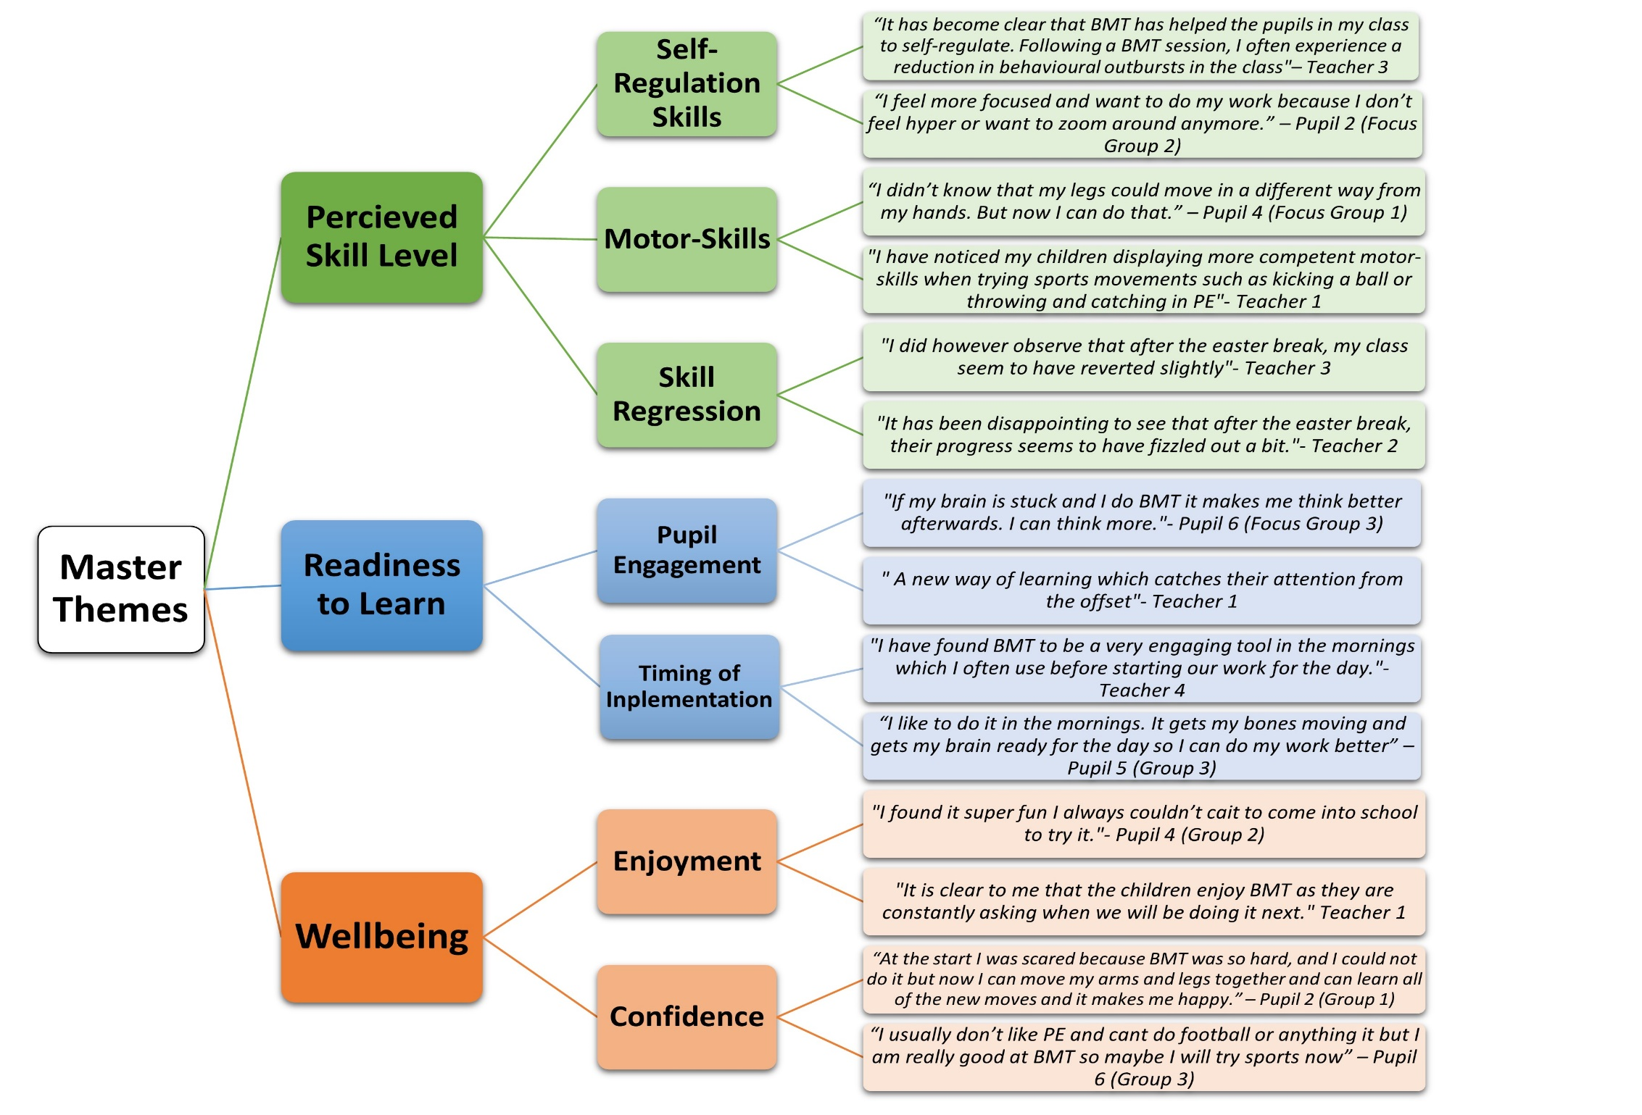
Timing of Implementation
Perceived Skill Level
Figure 7: Thematic Map of Pupil Focus Groups and Teacher Reflective Journal Data
CHAPTER 5: DISCUSSION
This study aimed to determine the impact of motor-development approaches to PE upon the self-regulation of primary 1-2 pupils within the Scottish education system. In order to achieve this, BMT was delivered by four teachers across two separate classrooms over an 8-week period. The results from this study revealed statistically significant improved overall score changes across the domains of cognitive and affective self-regulation, indicating that motor-development approaches to PE have the potential to positively impact specific domains of self-regulation amongst primary 1-2 pupils.
5.1 Cognitive-Regulation
Most evidently, there were substantial improvements across cognitive self-regulation, which Lakes (2013, p192) asserts is the “control over mental processes, including attention and concentration”. Following the 8-week intervention, the quantitative analysis, conducted via a Wilcoxon test, revealed that there was a significant difference between pre and post cognitive-regulation scores (p= 0.000). This compelling result was also corroborated by the pupils involved in the study, one of which stated, “Sometimes I can’t focus in class well but after BMT I always feel like I can concentrate and learn even more”. Indeed, this fundamental component of self-regulation, according to Duckworth and Carlson (2013), holds specific significance to learning and academic progression as focus and attentional span play an essential role in the acquisition of knowledge. Reflective journal findings also support this belief as numerous class teachers made specific references throughout the 8-week programme suggesting that cognitive self-regulation components support the learning of their pupils. To substantiate such statements, one class teacher highlighted the “clear link between BMT, improved focus, and better learning outcomes”. Therefore, whilst not a primary outcome of the study, preliminary evidence suggests that the findings from this research indicate that BMT has incited the development of cognitive self-regulation with a concomitant impact upon educational progress. However, whilst this notion is indeed thought-provoking, it is largely a postulation, and further research must be conducted to substantiate such a claim.

5.1.1 Readiness to Learn
Furthermore, interrelated with the domain of Cognitive-Regulation and its features of focus and attentional span is the theme of ‘Readiness to Learn’ which was identified as a master theme throughout qualitative analysis and was encapsulated by one pupil as feeling like you are “just ready to learn new things because my body and my mind is switched on”. Throughout the thematic analysis of this master theme, many teachers commented upon the utility of BMT, with one describing it as an “engaging tool that has provided my learners with mental and physical stimulation”. Making sense of such remarks is the literature of Hilferty et al. (2010), who posit that being ‘ready to learn’ is an ongoing and multidimensional process which incorporates cognitive development, motor-development, and social and emotional wellbeing. As one pupil commented, “After BMT I feel happy and ready to focus”. In developing these multidimensional areas, Goldstein and Naglieri (2010) assert that over a period of time, children will begin to demonstrate observable traits, such as concentration and focus of attention, which indicate that they are ready to receive early academic instruction. Therefore, the fact that BMT is specifically designed to target such developmental domains, provides evidence to suggest that it can improve a child’s ‘readiness to learn’.
Interestingly, qualitative analysis reveals that both teachers and pupils found BMT to be most effective in promoting readiness to learn when used within the morning period. The teachers within the study viewed it as an opportunity for their pupils to “wake up and shake-up” and “engage their brains from the offset”. This intuitive belief held by the teachers involved within the research runs parallel with empirical studies. Indeed, Tilp et al. (2020) discovered that the employment of motor-cognitive exercises within the morning period positively promoted an enduring impact upon cognitive functions such as concentration and thought-processing. Yet, whilst inciting a positive impact during the morning period, there was no direct comparison between the employment of BMT during the morning period against an alternative time of day. Therefore, one cannot explicitly claim that the morning period is the optimal time to engage in BMT.

5.2 Affective-Regulation
A further key component of self-regulation is the means by which a child can maintain control over their emotional state and mood (Baumeister et al. (1997), and Lakes (2012), terms this particular domain ‘Affective Self-Regulation’. As children enter primary school, they are faced with an array of mental and emotional challenges which initiate their affective self-regulation (Merritt et al., 2012). Therefore, many believe that one spontaneously develops their affective self-regulation and ability to control emotions through everyday interactions (Bronson, 2000). Thus, one may pose the question; to what extent is one responsible for developing their own means for development, and to what extent is such development the product of purposeful intervention? Somewhat responding to this question is the data collated from the teachers in the study, wherein one asserted, “My class are generally good with their emotions, but it is clear to me that BMT has helped my students to control and understand these even more effectively over the past eight weeks”. Indeed, not only was this difference observed in a qualitative sense, but the paired t-test conducted to compare pre and post-intervention RCS scores within the affective domain discovered that there was a significant difference between pre and post-intervention affective-regulation scores (p= 0.042). Therefore, similarly to the research of Flook et al. (2015), this study provides evidence to suggest that purposeful intervention, even over a short duration, can incite a positive impact upon affective-regulation.
5.2.1 Wellbeing
Inextricably linked to the emotional domain of affective-regulation is the notion of wellbeing, as Kraiss et al. (2020) assert that both affective-regulation and wellbeing have a co-dependent relationship wherein for one to be fulfilled, so must the other. Throughout the conducted qualitative analysis, wellbeing was identified as a prominent master theme, with pupil feedback indicating that BMT was enjoyed by students. Supporting such analysis was one pupil who expressed “I can’t wait to do BMT every day! It is more fun than reward play”. Whilst it is widely recognised that pupil enjoyment in school promotes general wellbeing (Papadopoulos et al., 2022), previous studies have established that school-based interventions which can incite positive emotions, such as enjoyment, hold the potential to engender long-term opportunities for improving educational outcomes amongst children (Roth et al., 2017). Therefore, as one teacher asserted, “At the heart of it all, BMT is something that my pupils enjoy, and that is what makes it successful”.
A further significant finding within the overarching theme of wellbeing was that the implementation of BMT improved pupil confidence. As one pupil expressed, “I am good at BMT, and I keep getting better”. There is an evident correlation between progression and self-confidence across any realm (Wentzel and Brophy, 2014), and the progressive nature of BMT across this 8-week intervention clearly enabled pupils to perceive that they were making progress. This increase in confidence was also recognised by the classroom teachers: “I have loved to see even my less coordinated learners blossom and become confident individuals”. Indeed, in a Scottish context, to enable all young people to become ‘confident individuals’ is one of the ‘four capacities’ of the Curriculum for Excellence (CfE) (Scottish Government, 2009). Furthermore, developing ‘confidence and self-esteem amongst learners is outlined as a major objective within the CfE PE-specific benchmarks (Education Scotland, 2017) and moreover, is a key aim of the Scottish Government’s (2021) ‘Education Recovery’ policy- suggesting that BMT may hold the potential to contribute to Covid-Recovery throughout primary schools, supporting the wellbeing of all students.
As Mitchell et al. (2015) assert, pupils often become disengaged in PE, losing confidence due to low perceptions of competence. This was exemplified within the pupil focus groups: “I hate normal PE like tennis because I am rubbish at it and am not sporty”. According to Gray et al. (2019), practitioners should move away from the direct teaching of sport-specific skills, towards a broader approach- particularly amongst younger learners. In line with such advice, the BMT intervention focused on building upon the broad-spectrum motor-skills in order that pupils could build stronger physical foundations. This clearly had a positive impact, as pupils who classified themselves as ‘non-sporty,’ began to show an increasing confidence: “I am not good at football and tennis, but I am really good at BMT so maybe I will get better at sports too”.

5.3 Motor-Regulation
Lakes and Hoyt’s (2004) model of the various manifestations of self-regulation also includes that of motor-regulation- the extent to which one exhibits athleticism, coordination, and motor control. Naturally, on a basic level, BMT is a motor-development approach to PE, therefore, alongside cognitive development, its core aim is to develop motor skills (Education Scotland, 2015). However, following the 8-week intervention, the quantitative statistical analysis conducted via a Wilcoxon test, revealed that no significant difference existed between pre and post motor-regulation scores (p= 0.067).
Here it is also important to highlight the outlying data, wherein one participant’s RCS score was excluded from the data set (figure 6). This participant, who has difficulty with motor skills and coordination scored 3, pre-intervention and a total score of 6, post-intervention. Whilst these scores are below the median post-intervention score of 12.5, what remains significant is that this participant improved their score by 100%, suggesting that BMT could potentially have a stronger impact upon improving motor-regulation within those who have impaired motor skills. This supposition is aligned with wider literature from Jane et al. (2018), whose meta-analysis concluded that short-term motor-skill interventions are effective in improving motor competence in children with developmental coordination difficulties. With regards to the remaining majority, whose median scores displayed no significant improvement in motor-regulation, this may be due to the fact that the duration of the 8-week intervention phase was not sufficient enough to allow for the development of motor-regulation skills.
5.3.1 Perceived Motor Competence
Contrastingly, although robust statistical analysis provides evidence to suggest that overall, participants did not improve their motor-regulation skills, qualitative data from the participants of the study suggests otherwise. A reoccurring theme identified throughout pupil focus groups was that of perceived improvements in motor-skills: “I can move my arms and legs better now and it helps me to do things like running and skipping in sports day”. However, literature from Washburn and Kolen (2018) elucidates that the majority of children are unable to accurately perceive their motor abilities. In their study of 127 third-grade students, it was discovered that 67.7% of pupils overestimated their motor abilities (Washburn and Kolen, 2018). Therefore, it is likely that the pupils within the current study perceived their motor-regulation skills to be higher than their actual level. However, despite this, Duncan et al. (2018a) assert that in fact, the development of elevated levels of perceived motor competence within children may actually play a vital role in ensuring that children remain sufficiently active and moreover, improving a child’s perception of their own motor competence is often the first step towards developing their actual motor competence. Therefore, despite failing to improve the motor-regulation skills of the students in the intervention, BMT has certainly proven to enhance one’s confidence with regards to their motor skill perception- an encouraging sign.
5.4 Regression
Spanning across all three domains of self-regulation, throughout the week four reflective journal entries, at the halfway phase of the intervention, teacher feedback highlighted that there had been a decrease in pupil progress with regards to their self-regulation. Encapsulating this observation, one teacher commented, “My learners seem to have reverted back to their initial behaviours and their focus during the morning period has also reduced. We will need to re-learn the BMT routines again I think”. There was no RCS conducted at the halfway point of the study, which makes it difficult to ascertain whether there was indeed a regression in pupil self-regulation- and to what extent across each domain. However, the teachers who observed this perceived regression considered the 2-week Easter Holiday to have incited this negative impact: “It was interesting to see that pupils had regressed following the Easter break”. Viewing such observations through the seminal lens of Ebbinghaus’ (1880) theory of ‘the forgetting curve’, learned behaviours and skills reduce over time if no attempt is made to re-learn these. Therefore, what the pupils may have experienced, is a reduction in self-regulatory skills due to not having engaged in BMT over the 2-week Easter period. However, in line with Ebbinghaus’ (1880) theory, Murre and Dros (2015) highlight that previously absorbed information or learned behaviours can be re-learned within quick succession. This proved true following the Easter break as teachers observed that “My class seemed to bounce back well after the easter break, albeit took a week or so”.

5.5 Conclusion
In an attempt to effectively answer all three primary research questions, this chapter has presented the findings of this practitioner enquiry, wherein four main observations have been presented. As reflected through the gathered data, BMT has proved effective in developing pupils’ cognitive-regulation (p=0.000), improving their concentration and readiness to learn. Moreover, a further self-regulatory improvement was observed in affective-regulation (p=0.042), as children displayed an improvement in emotional control and confidence. The BMT intervention evoked no impact upon the participants’ motor-regulation (p=0.067), however, the study revealed that pupils developed an elevated perception of their motor-regulation- the first step towards developing actual motor competence (Duncan et al., 2018a). Finally, whilst experiencing a regression in progress during a 2-week break, in line with the research of Ebbinghaus (1880), the study proved that children have the ability to ‘bounce back’. Whilst recommendations can certainly be derived from the results of this research, the study also had a range of limitations- both of which will be outlined in chapter 6.

CHAPTER 6: CONCLUSIONS AND RECOMMENDATIONS
6.1 Limitations
Prior to progressing further in this chapter, it is important to recognise the limitations of this research. Acknowledging limitations is an essential component throughout any study, permitting the researcher to both understand and contextualise potential research findings whilst also informing and directing future research (Conrad and Serlin, 2005).
Firstly, the research investigates a small quantity of pupils (n = 30) all placed within the same establishment. Therefore, the results of this study should be treated with caution and cannot be generalised to all lower primary school pupils. Moreover, due to constraints within the study design, a single-arm study was employed, which does not allow comparisons to be made to a control group. Therefore, to inform future research, this study could be replicated across a larger participant base, analysing both a control and test group. This would permit a broader range of findings to be discovered and would allow the researcher to generate a more representative collation of results.
Furthermore, an additional limitation of this study identified is due to the time constraints of the academic year, confining the intervention to an 8-week period. If this study is to be replicated, it would be advisable to extend this period of time, allowing for more accurate findings to be discovered upon the impact of motor-development approaches to PE upon self-regulation. Moreover, relating to the boundaries of the academic year, on week four of the BMT intervention, the school Easter Holidays commenced. This two-week break could have potentially impacted upon the results of the study- as reviewed within chapter 4.
A further noteworthy limitation of this study pertains to the particular approaches adopted in collating data. A component of the qualitative research was gathered via self-reporting teacher reflective journals, thus, the data may be subject to risks of biases, such as exaggeration and recall bias (Leavy, 2014). Finally, whilst there are numerous benefits of assuming a teacher-researcher role, this dual role may have also served as a limitation, as participants could potentially have acted out of character in the knowledge that they were being observed- impacting upon the data gathered.

6.2 Dissemination
Throughout all realms of research, it is vital to consider how one shares their findings with a wider audience and this is particularly a matter to consider for the teacher-researcher (Baumfield et al., 2017). Each year, countless teachers conduct ‘professional enquiries’ within their own establishment, gathering valuable data upon how to improve and refine current teaching pedagogy. However, those who do, often hold the perception that their findings may only be of relevance to their own practice, leading to an apparent underrepresentation of teacher-researchers within the academic field (Menter et al., 2011). Yet, there are in fact an array of advantages to data dissemination. One being that sharing research has an ‘educative’ impact, informing the teaching community about ‘best practice’ and how to attain this, from a practical, real-life perspective (Baumfield et al., 2017).
Indeed, this study sought to investigate the impact of motor-development approaches to teaching PE upon self-regulation within primary 1 and 2 school pupils within the Scottish education system, and moreover discovered that such approaches can yield positive outcomes. Therefore, this action research study not only seeks to enhance the researcher’s practice, but to contribute to the improvement of motor-development approaches to PE across all primary schools. As such, the key audience of this research spans far beyond simply the researcher, but extends nationally to all educators, governing bodies, and those within the wider academic community in the attempt to communicate effectual approaches to teaching and to contribute to research within the academic field- highlighting the value of the teacher-researcher role and its potential to incite bottom-up change within educational policy and practice.
Beyond the University of Glasgow tutors, first and foremost, this research will be shared with the teachers in the school in which the research took place. Here, the research will be formally communicated via a PowerPoint presentation during a staff meeting, allowing for quick dissemination of findings (Menter et al., 2011).
Furthermore, as promised within the pupil/parental consent forms (appendix G-H), the results of the study will be shared with all pupil participants and their parents/guardians. From a pupil perspective, the findings of the study will be communicated within the classroom. As Cohen et al. (2017, p.139) assert, any communication of research results must be delivered to the respective audience through a means in which they can “access and understand”, therefore, here it will be ensured that the information is shared in a digestible manner and that age-appropriate language is utilised. With regards to parents, an abbreviated report of the findings will be shared with them, and they will be provided with access to an online PowerPoint voiceover of the study and its findings.
Finally, reaching beyond simply those connected to the study, the researcher intends to share the key outcomes, alongside a copy of this paper, with Education Scotland. As an advocate of BMT, Education Scotland could benefit from the opportunity to access real-life, practical data upon BMT in the primary classroom. As a further means of widespread dissemination, the researcher will engage in an ‘Enlighten Talk’ in the National Teaching Repository, verbally discussing the project and summarising it via an infographic- this will be made publicly accessible. Moreover, the researcher will also endeavour to submit this paper for publication in an appropriate journal to expand the potential regional, national, and international reach- truly raising awareness of the potential that BMT can engender.
6.3 Conclusions
The conducted practitioner enquiry sought to develop an understanding of motor-development approaches within PE and their impacts upon the self-regulatory domain. The overarching aim of which was to explore to what extent motor-development approaches to teaching PE can impact on self-regulation among primary 1 and 2 pupils within the Scottish education system. Critically analysing teacher responses and studying a cohort of 30 pupils, a combination of both qualitative and quantitative data gathering methods permitted a wealth of information to be collated and an understanding to be developed upon the impacts that motor-development approaches to PE can truly incite through the BMT approach.
Summarising the main findings, the implementation of BMT proved effective in developing pupils’ cognitive-regulation (p=0.000). Both teachers observed, and pupils experienced, an improvement in focus and concentration as a result of the intervention, positively impacting pupils’ readiness to learn. A further significant finding was that BMT improved pupil wellbeing. Here, statistical analysis displayed an improvement in pupils’ affective-regulation (p=0.042) resulting in increased control over their emotions. Moreover, qualitative analysis revealed that participants experienced an improvement in confidence, as their perceptions towards PE became more positive. Finally, whilst fundamentally designed with the intention to improve motor-skills, pre and post-RCS analysis revealed that the 8-week BMT intervention induced no significant improvements within the domain of motor-regulation (p=0.067). However, qualitative analysis identified that whilst not improving the motor-regulation domain, BMT encouraged learners to develop elevated self-perceptions of their motor-regulation, which Duncan et al. (2018a) assert is often the first step towards developing actual motor competence.
To conclude, firstly, on a basic level, the findings identified within this study provide evidence to prove that motor-development approaches - namely BMT- are indeed feasible to deliver as a PE curriculum within education. However, more significantly, the correlations between BMT and its potential to develop both cognitive and affective-regulation amongst children reveals promising initial results which must be further pursued. Such evidence may help to encourage policymakers to rethink traditional approaches to PE, substantiating BMT as an integral element of the mainstream PE curriculum and as a tool for Covid-Recovery. Such forward thinking has the potential to develop key skills, improve well-being and provide children with the foundations to engage in a lifelong relationship with PA.
6.4 Recommendations
6.4.1 Investigating Long-Term Effects
The BMT approach produced a range of promising results amongst a cohort of 30 pupils aged 5-6 years– as addressed within the discussion chapter- over the 8-week intervention period. It would be of great interest to monitor a similar demographic of participants undertaking the BMT intervention as part of a longitudinal study. This would contribute to research in ascertaining whether the effects of the BMT programme persist into upper primary school and beyond, and whether sustained exposure would result in more significant improvements within self-regulation. Moreover, a long-term process evaluation of the programme would effectively strengthen the justification for employing BMT as a widespread approach to PE within the primary school setting.

6.4.2 Integrating BMT as a Widespread Approach
Following the introduction of the Scottish Government’s mandatory policy for all children in schools to engage in at least 2 hours of PE per week, practitioners and policymakers have realised the potential of PE to incite developmental progression, associated with growth in motor competence, social skills, mental health, and executive functioning. However, this research has highlighted that not all children can access the benefits of this due to negative perceptions towards sports and a lack of both self-confidence and feelings of incompetence. Therefore, as opposed to a ‘novel’ approach to PE, BMT should be considered as a more widespread and preliminary approach to PE in primary schools, focusing less upon sport-specific skills in order to build learner confidence, and acting as an eventual pathway towards encouraging a fuller engagement in traditional PE and PA throughout the life-course.
6.4.3 A Tool for COVID Recovery
Following the series of national lockdowns within Scotland, as a practitioner in the field of education, it has become apparent that due to the absence of school-routine and social interactions, young children have suffered both mentally and physically. As a result, health and wellbeing has become a national priority within Scottish schools. The findings derived from the conducted study have revealed that BMT can serve as an effective tool in improving pupil wellbeing. Therefore, naturally, BMT could potentially function as a strategy towards Covid-recovery, developing emotional-regulation, learner confidence and promoting PA amongst children as part of an integrated process towards enhancing pupil wellbeing.

APPENDICES
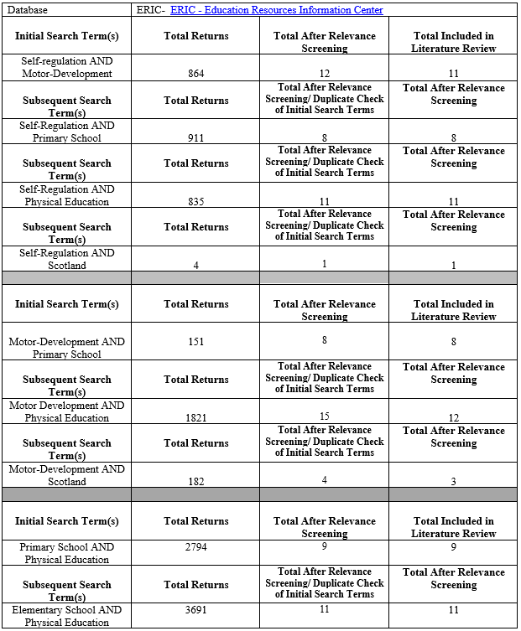
Appendix A: ERIC Systematic Search Strategy Model

Appendix B: BMT Intervention Process
 | Intervention Phase = Green
 | Data Collection Phase = Orange
Pre- Intervention |  | Week 1 | Week 2 | Week 3 | Week 4 | E  A  S  T  E  R  B  R  E  A  K | Week 5 | Week 6 | Week 7 | Week 8 | Post-Intervention
 |  | BMT in Class Intervention (30 minute session) | BMT in Class Intervention (30 minute session) | BMT in Class Intervention (30 minute session) | BMT in Class Intervention (30 minute session) |  | BMT in Class Intervention (30 minute session) | BMT in Class Intervention (30 minute session) | BMT in Class Intervention (30 minute session) | BMT in Class Intervention (30 minute session)
Pre-Intervention RCS Data Collection |  |  |  |  | Reflective Journal 1 |  |  | Pupil Focus Group Interviews (6 pupils) | Pupil Focus Group Interviews (6 Pupils) | Reflective Journal 2 | Post-Intervention RCS Data Collection

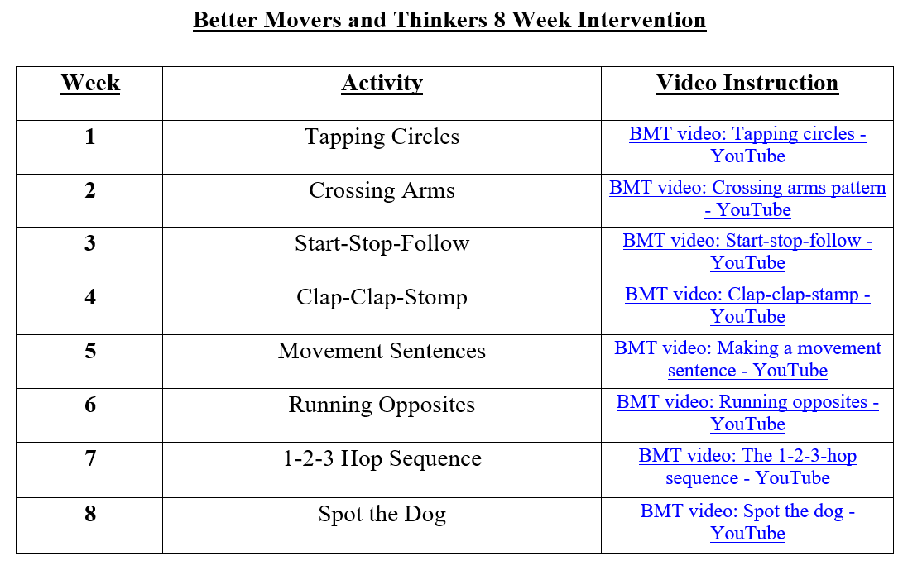
Appendix C: BMT Teacher Intervention Plan

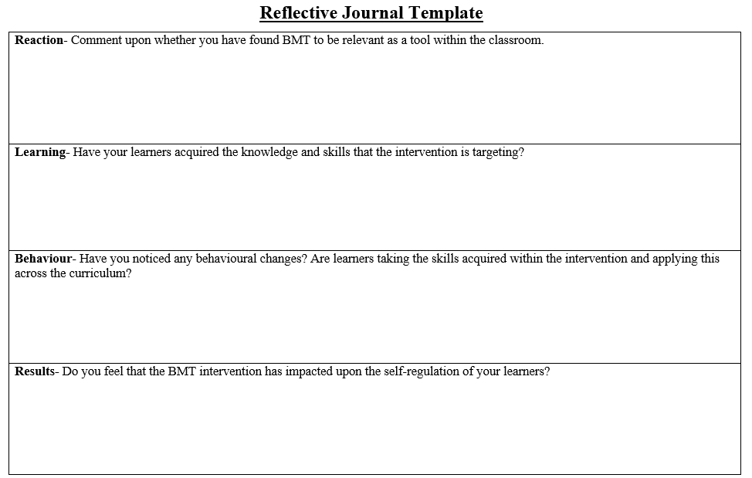
Appendix D: Reflective Journal Framework

Appendix E: Pupil Focus Group Questions

The enjoyment levels of students throughout the physical education intervention
- What is it you like most about BMT?

- Is BMT something that you look forward to doing each day?
Pupil perceptions upon what they have learned throughout the intervention
- What do you think you learn during BMT?

- Has BMT taught you anything that you did not know before?
Transferable skills from the intervention to classroom-based learning
- Do you think that practicing BMT every day helps you in class?

- How do you feel when you have returned to class after practicing your BMT routine?

Appendix F: Teacher Plain Language Statement

Plain Language Statement - Teachers

Title of project and researcher details
Project Title: To what extend can motor-development approaches to teaching PE impact upon self-regulation among primary 1 and 2 school pupils within the Scottish Education System?
Researcher Name: Marco Sisi (student)
Researcher Email: 2272269S@student.gla.ac.uk
Supervisor: Gabriella Rodolico (Lecturer in Science Education)
Supervisor Email: Gabriella.rodolico@glasgow.ac.uk
Course: MEd in Professional Practice

You are being invited to take part in a research project exploring the extent to which motor development approaches to teaching physical education impact on self-regulation among primary 1-2 pupils.

Before you decide if you want to take part, it is important for you to understand why the research is being done and what it will involve. Please take time to read the information on this page carefully and discuss it with others if you wish. Ask me if there is anything that is not clear or if you would like more information. Take time to decide whether or not you wish to take part.

I hope that this sheet will answer any questions you have about the study.

1. What is the purpose of the study?
The purpose of this study is to evaluate the impact of motor-development approaches (Better Movers and Thinkers) to teaching physical education upon the self-regulation of primary 1-2 pupils.
Self-regulation is the ability to control one’s impulses, behaviours, and emotions within social situations and within our school, a core element of the school improvement plan is to improve this developmental skill among all children.
In order to achieve this, as a school, we are implementing Better Movers and Thinkers within all classrooms- a method of teaching physical education which is focused upon improving self-regulation skills among children which involves a series of co-ordination and motor-development exercises- see link for more info (Better movers and thinkers | Learning resources | National Improvement Hub (education.gov.scot)).
Therefore, so that as a school we can properly evaluate this programme, this research will be conducted.
2. Why have I been chosen?
You are being asked to take part because as a teacher in our school, delivering motor-development approaches to Physical Education (BMT) within class, you views and reflections upon the intervention will provide a valuable insight.

3. Do I have to take part?
You do not have to take part in this study. If you decide not to take part, as previously explained, as Better Movers and Thinkers is part of the School Improvement Plan, you will still deliver the same BMT intervention in class as per normal, however, no specific data will be collected upon you.
Throughout the research process, your name will never be used in any of the studies documents. If, after you have begun to take part, and then decide that you no longer want to take part in the study, it is important that you let me know as I am the only person, as the researcher, who will be able to retrieve your data allowing the withdraw to take place.
Please note that both participation or non-participation in the study will in no way impact your salary or the way in which you are treated in the workplace.

4. What will happen to me if I take part?
As delivering the Better Thinkers and Movers intervention is already part of your in-class teaching commitments there will be no extra work involved in this regard. For the purpose of the study, you will deliver an 8 week Better Movers and Thinkers intervention to your class and in order to effectively collate data, will be asked to provide two reflective journal entries- voicing your thoughts on the intervention. Again, there is no obligation to complete the reflective journals. The entire intervention process will take 8 weeks and reflective journal entries will not take long to complete. Once all of your reflective responses have been collected, I will then analyse these. Please note, up until the point of data analysis, you are entitled to remove these reflective journal entries from the study at any point.
I will be finished gathering data by 25/06/22.

5. Will the information that I give you in this study be kept confidential?
I will keep all the data I collect about your reflections in a locked cabinet within the school that only I have access to. When I write about what I have found, your name will not be mentioned- instead, I will assign either Teacher 1, Teacher 2 etc to each member of teaching staff in order that your identity is never implicated.
However, if during our conversation I hear anything which makes me worried that you might be in danger of harm, I might have to inform the year head of this, who will pass any relevant information on to the head teacher.

6. What will happen to the results of this study

I will analyse the data I collect from participants and present this in the dissertation which I am writing for my qualification, MEd of Professional Practice. All participants will receive a written summary of the findings and I will also present the information to colleagues and potentially share this information with Education Scotland in order that they can receive some real life practical data upon Better Movers and Thinkers. I will destroy the data at the end of the project. Copies of the final paper will be available to access on request.

7. Who has reviewed the study?
This study has been reviewed and agreed by the School of Education Ethics Forum, University of Glasgow.

8. Who can I contact for further Information?
If you have any questions about this study, you can ask me,
Marco Sisi: 2262279S@student.glasgow.ac.uk
or my supervisor, Gabriella Rodolico: Gabriella.Rodolico@glasgow.ac.uk

Thank you for reading this.

Appendix G: Parents Plain Language Statement

Plain Language Statement- Parents/Guardians

Project Title: To what extend can motor-development approaches to teaching PE impact upon self-regulation among primary 1 and 2 school pupils within the Scottish Education System?
Researcher Name: Marco Sisi (student)
Researcher Email: 2272269S@student.gla.ac.uk
Supervisor: Gabriella Rodolico (Lecturer in Science Education)
Supervisor Email: Gabriella.rodolico@glasgow.ac.uk
Course: MEd in Professional Practice

You child is being invited to take part in a research project exploring the extent to which motor development approaches to teaching physical education impact on self-regulation among primary 1-2 pupils.
Before you decide if you want your child to take part, it is important for you to understand why the research is being done and what it will involve. Please take time to read the information on this page carefully and discuss it with others if you wish. Ask me if there is anything that is not clear or if you would like more information. Take time to decide whether or not you wish your child to take part.
I hope that this sheet will answer any questions you have about the study.

1. What is the purpose of the study?
The purpose of this study is to evaluate the impact of motor-development approaches (Better Movers and Thinkers) to teaching physical education upon the self-regulation of primary 1-2 pupils.
Self-regulation is the ability to control one’s impulses, behaviours, and emotions within social situations and within our school, a core element of the school improvement plan is to improve this developmental skill among all children.
In order to achieve this, as a school, we are implementing Better Movers and Thinkers within all classrooms- a method of teaching physical education which is focused upon improving self-regulation skills among children which involves a series of co-ordination and motor-development exercises- see link for more info (Better movers and thinkers | Learning resources | National Improvement Hub (education.gov.scot)).
Therefore, so that as a school we can properly evaluate this programme, this research will be conducted.

2. Why has my child been chosen?
As previously discussed, here at our school, we wish to find out if our Better Movers and Thinkers programme has any true impact on the self-regulation of the pupils within the school.
Developing self-regulation skills is particularly important among young children at within early years and those who have just began school, allowing them to acclimatise to the classroom environment and cope with all the social situations that school life poses.
Therefore, as your child is in the primary 1 or 2 classroom, there exists a particular interest in discovering whether Better Movers and Thinkers has made any impact upon their self-regulation.

3. Does my child have to take part?
Your child does not have to take part in this study. If you decide that they should not take part, or if your child does not want to take part, as previously explained, as Better Movers and Thinkers is part of the School Improvement Plan, they will still receive the same BMT intervention as all other pupils, however, no data will be collected.
Throughout the research process, your child’s name will never be used in any of the studies documents. If, after your child has started to take part, they decide they no longer want to take part in the study, it is important that you let me know as I am the only person, as the researcher, who will be able to retrieve your child’s data allowing the withdraw to take place.
Please note that both participation or non-participation in the study will in no way impact your child’s grades or the way in which they are treated in the school.

4. What will happen to my child if they take part?
If your child takes part, they will firstly take part in a series of 8 exercises in the school gym hall, aimed at measuring their self-regulation. Following this, your child will be part of an 8 week teaching programme of Better Movers and Thinkers- a motor development approach to teaching physical education aimed at improving self-regulation among learners. This will be part of the school day routine and will be taught for 30 minutes per day. After 8 weeks, your child will complete all 8 exercises again in the school gym hall in order to re-assess their self-regulation.

On top of this, your child will also take part in a focus group interview- a conversational group interview involving a small number of participants wherein the researcher poses questions to the participants and helps to facilitate discussion. Here, your child will be asked some questions about what they think about Better Movers and Thinkers as part of 30 minute focus group interviews. The interviews will be held in an area of the school which is familiar to all children. The focus group will be kept as relaxing and informal as possible and to ensure that all children are properly supported, as well as the researcher, the head of pupil health and wellbeing will sit in on all focus group interviews in order to monitor their wellbeing. All children will have access to water and there will be a toilet nearby. On top of this, it will be explained clearly to all pupils that they do not have to answer any questions that they do not want to. I will record the answers on a voice recorder so that afterwards I can listen carefully to what was said. All voice recordings will be destroyed immediately after transcription and no identities will be implicated.

I will be finished gathering data by 25/06/22.

5. Will the information that my child gives you in this study be kept confidential?
I will keep all the data I collect about pupil self-regulation will be stored in a locked cabinet which only I have access to. All focus group responses will be kept on a private and encrypted voice recording device. When I write about what I have found, your child’s name will not be mentioned. Instead, I will assign either Pupil 1, Pupil 2 etc to each pupil in order that their identity is never implicated.
However, if during our conversation I hear anything which makes me worried that your child might be in danger of harm, I will have to follow the set school procedures; informing the head of pupil wellbeing of this who will relay this information to the head teacher if necessary.
6. What will happen to the results of this study
I will analyse the data I collect from the children and present this in the dissertation which I am writing for my qualification, MEd of Professional Practice. Children who have participated, and their parents, will receive a written summary of the findings and I will also present the information to colleagues and potentially share this information with Education Scotland in order that they can receive some real life practical data upon Better Movers and Thinkers. I will destroy the data at the end of the project. Copies of the final paper will be available for you and your child on request.

7. Who has reviewed the study?
This study has been reviewed and agreed by the School of Education Ethics Forum, University of Glasgow

8. Who can I contact for further Information?
If you have any questions about this study, you can ask me, Marco Sisi: 2262279S@student.glasgow.ac.uk
or my supervisor, Gabriella Rodolico: gabriella.rodolico@glasgow.ac.uk)
The Ethics officer for the School of Education (COSS) Paul Lynch paul.lynch@glasgow.ac.uk
Thank you for reading this.
Appendix H: Pupil Plain Language Statement

Pupil Plain Language Statement
Project Title: To what extend can motor-development approaches to teaching PE impact upon self-regulation among primary 1 and 2 school pupils within the Scottish Education System?

Please Note: It is essential that Parents/Guardians read this plain language statement through with their child.
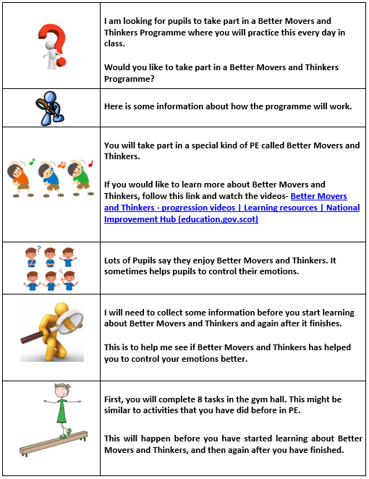

Appendix I: Teacher Consent Form

Teacher Consent Form
Project Title: To what extend can motor-development approaches to teaching PE impact upon self-regulation among primary 1 and 2 school pupils within the Scottish Education System?

Researcher Name: Marco Sisi (student)
Researcher Email: 2272269S@student.gla.ac.uk
Supervisor: Gabriella Rodolico (Lecturer in Science Education)
Supervisor Email: Gabriella.rodolico@glasgow.ac.uk
Course: MEd in Professional Practice

Before beginning this consent form, it is important that the following are understood:
I confirm that I have read and understood the Plain Language Statement for the above study and have had the opportunity to ask questions.
I understand that my participation is voluntary and that I am free to withdraw at any time, without giving any reason.

My Confidentiality
I acknowledge that participants will be referred to by pseudonym.
I acknowledge that all collated data will be kept anonymous.

Dependent Relationships
I acknowledge that there will be no effect on my professional life or treatment within the school arising from my participation or non-participation in this research.

Data Usage and Storage
I understand that all names and other material likely to identify individuals will be anonymised.
I understand that the material gathered will be treated as confidential and kept in secure storage at all times.
I acknowledge that the material gathered will be destroyed once the project is complete.
I agree to waive my copyright to any data collected as part of this project.
I acknowledge the provision of a Privacy Notice in relation to this research project.

Research Methods
I am happy and willing to take part in the completion of 2 reflective journals.
I understand what the 8-week BMT intervention consists of.

I agree / do not agree (delete as applicable) to take part in the above study.

Name of Participant ………………………… Signature ……………………………

Date ……………………………………

Name of Researcher …………………………Signature ………………………………

Date ……………………………………

Appendix J: Parental Consent Form

Parental/Guardian Consent Form
Project Title: To what extend can motor-development approaches to teaching PE impact upon self-regulation among primary 1 and 2 school pupils within the Scottish Education System?

Researcher Name: Marco Sisi (student)
Researcher Email: 2272269S@student.gla.ac.uk
Supervisor: Gabriella Rodolico (Lecturer in Science Education)
Supervisor Email: Gabriella.rodolico@glasgow.ac.uk
Course: MEd in Professional Practice

Before beginning this consent form, it is important that the following are understood:
I understand that, as a parent/guardian, it is important that this consent form is read and thoroughly explained to my child
I confirm that I have read and understood the Plain Language Statement for the above study and have had the opportunity to ask questions.
I understand that my participation is voluntary and that I am free to withdraw at any time, without giving any reason.

My Confidentiality

I acknowledge that participants will be referred to using a false name.
I fully understand that all collated data will be kept anonymous.

Dependent Relationships

I acknowledge that there will be no effect on my grades or treatment within school arising from my participation or non-participation in this research.

Data Usage and Storage
I understand that all names and other material likely to identify individuals will be anonymised.
I understand that the material gathered will be treated as confidential and kept in secure storage at all times.
I acknowledge that the material gathered will be destroyed once the project is complete.
I agree to waive my copyright to any data collected as part of this project.
I acknowledge the provision of a Privacy Notice in relation to this research project.

Research Methods
I am happy and willing to take part in focus group interviews.
I consent to focus-group interviews being audio-recorded.
I understand what the 8-week BMT intervention consists of.
I am happy to complete the 8 challenging physical tasks both before and after the intervention.

I agree / do not agree (delete as applicable) to take part in the above study.

Name of Participant ………………………… Signature ……………………………
Date ………………………

Name of Parent/guardian ……………………………………
Signature ………………………………………….. Date ………………

Name of Researcher …………………………Signature ………………………………
Date ……………………………………
Appendix K: Anderson-Darling Normality Test of Cognitive-Regulation Data

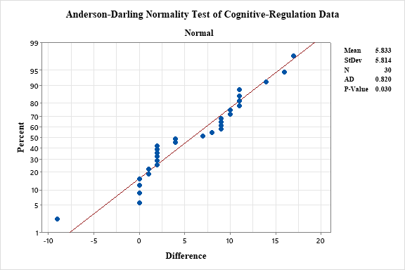

Appendix L: Anderson-Darling Normality Test of Affective-Regulation Data

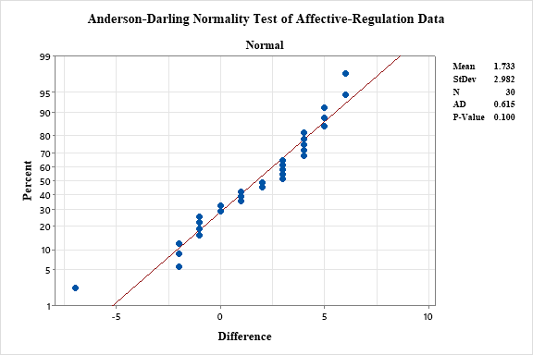

Appendix M: Anderson-Darling Normality Test of Motor-Regulation Data

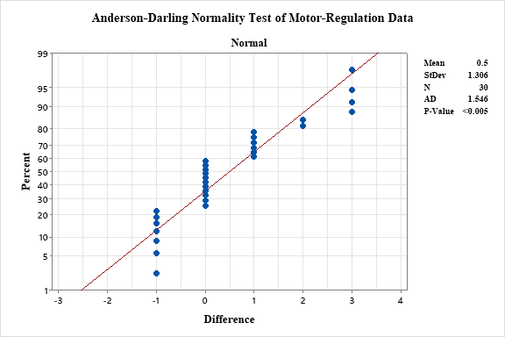

Reference List
Alexander, P.A. and Greene, J.A. (2017) Self-regulation in education. Oxon: Routledge.
Allee-Herndon, K.A. and Roberts, S.K. (2019) ‘Poverty, self-regulation and executive function, and learning in K-2 classrooms: A systematic literature review of current empirical research.’ Journal of Research in Childhood Education, 33(3): 345-362.
Ary, D., Jacobs, L.C., Irvine, C.K.S. and Walker, D. (2018) Introduction to Research in Education. Boston: Cengage Learning.
Baguley, M., Danaher, A.D. and Midgely, W. (2013) The Role of Participants in Education Research: Ethics, Epistemologies, and Methods. Oxon: Routledge.
Bai, P., Johnson, S., Trost, S.G., Lester, L., Nathan, A. and Christian, H. (2021) ‘The relationship between physical activity, self-regulation and cognitive school readiness in preschool children.’ International Journal of Environmental Research and Public Health, 18(22): 11-21.
Bailey, R., Armour, K., Kirk, D., Jess, M., Pickup, I., Sandford, R. and Education, B.P. (2009) ‘The educational benefits claimed for physical education and school sport: an academic review.’ Research papers in education, 24(1): 1-27.
Bashan, B. and Holsblat, R. (2017) ‘Reflective journals as a research tool: The case of student teachers’ development of teamwork.’ Cogent Education, 4(1): 1-15.
Baumeister, R.F. (1997) ‘Esteem threat, self-regulatory breakdown, and emotional distress as factors in self-defeating behavior.’ Review of general psychology, 1(2): 145-174.
Baumfield, V., Hall, E. and Wall, K. (2008) Action Research in the Classroom. London: Sage Publications.
Baumfield, V., Hall, E. and Wall, K. (2017) Action Research in Education: Learning Through Practitioner Enquiry. London: Sage Publications.
BERA (2018) Ethical Guidelines for Educational Research. Available from: Ethical Guidelines for Educational Research, fourth edition (2018) | BERA (Last Accessed 27th May 2022)
Berkman, E.T., Graham, A.M. and Fisher, P.A. (2012) ‘Training self‐control: A domain‐general translational neuroscience approach.’ Child Development Perspectives, 6(4): 374-384.
Biesta, G. (2010) ‘This is My Truth, Tell Me Yours’. Deconstructive pragmatism as a philosophy for education.’ Educational Philosophy and Theory, 42(7): 710-727.
Blair, C. and Raver, C.C. (2015) ‘School readiness and self-regulation: A developmental psychobiological approach.’ Annual review of psychology, 66: 711-731.
Blaxter, L, Hughes, C. and Tight, M. (2001) How to Research. Buckingham: Open University Press.
Bloomberg, L.D. (2021) Designing and Delivering Effective Online Instruction. New York: Teachers College Press.
Boudah, D.J. (2010) Conducting educational research: Guide to completing a major project. London: Sage Publications.
Braun, V. and Clarke, V. (2006) ‘Using thematic analysis in psychology.’ Qualitative research in psychology, 3(2): 77-101.
Bronson, M. (2000) Self-Regulation in Early Childhood: Nature and Nurture. London: Guilford Press.
Brooks, K., Te Riele, K. and Maguire (2014) Ethics and Education Research. London: Sage Publications.
Bruininks, R.H. (2005) Bruininks-Oseretsky test of motor proficiency: BOT-2. Minneapolis: Pearson.
Burrows, A.C. (2019) ‘US Perspectives on Active Research in Education.’ In: Mertler, C.A. (ed) The Wiley handbook of action research in education. New Jersey: John Wiley and Sons. pp. 75-96.
Cadima, J., Verschueren, K., Leal, T. and Guedes, C. (2016) ‘Classroom interactions, dyadic teacher–child relationships, and self–regulation in socially disadvantaged young children.’ Journal of abnormal child psychology, 44(1): 7-17.
Campbell, A. and Groundwater-Smith, S. (2010) Connecting inquiry and professional learning in education. Oxon: Routledge.
Chatzipanteli, A., Digelidis, N. and Papaioannou, A.G. (2015) ‘Self-regulation, motivation and teaching styles in physical education classes: An intervention study.’ Journal of Teaching in Physical Education, 34(2): 333-344.
Clark, V.L.P. and Ivankova, N.V. (2015) Mixed methods research: A guide to the field. London: Sage Publications.
Cohen, L., Manion, L. and Morrison, K. (2017) Research methods in education. Oxon: Routledge.
Connolly, K. J. (1986) ‘A perspective on motor-development.’ In M.G. Wade and H.T.A. Whiting (Eds) Motor-development in children: Aspects of coordination and control. Boston: Martinus Nijhoff. pp.3-21.
Conrad, C.F. and Serlin, R.C. (2005) The Sage Handbook for Research in Education. London: Sage Publications.
Cook, C.J., Howard, S.J., Scerif, G., Twine, R., Kahn, K., Norris, S.A. and Draper, C.E. (2019) ‘Associations of physical activity and gross motor skills with executive function in preschool children from low‐income South African settings.’ Developmental science, 22(5): 1-13.
Creswell, J.W. and Clark, V.L. (2011) Designing and conducting mixed methods research. London: Sage publications.
Curby, T.W., Berke, E., Alfonso, V.C., Blake, J.J., Demarie, D., Dupaul, G.J., Flores, R., Hess, R.S., Howard, K.A., Lepore, J.C. and Subotnik, R.F. (2018) ‘Transition practices into kindergarten and the barriers teachers encounter.’ Kindergarten transition and readiness, 1(1); 249-264.
Dalziell, A., Booth, J.N., Boyle, J. and Mutrie, N. (2019) ‘Better Movers and Thinkers: An evaluation of how a novel approach to teaching physical education can impact children's physical activity, coordination and cognition.’ British Educational Research Journal, 45(3): 576-591.
Dalziell, A., Boyle, J. and Mutrie, N. (2015a) ‘Better movers and thinkers (BMT): An exploratory study of an innovative approach to physical education’ Europe's Journal of Psychology, 11(4): 722-741.
Dalziell, A., Boyle, J. and Mutrie, N. (2015b) ‘Better movers and thinkers (BMT): A quasi-experimental study into the impact of physical education on children's cognition—A study protocol.’ Preventive Medicine Reports, 2(2015): 935-940.
Dalziell, A.G. (2016) Exploration of an innovative approach to physical education (Better Movers and Thinkers) on children’s coordination and cognition. PhD Thesis, University of Edinburgh, Edinburgh.
Davis, E.E., Pitchford, N.J. and Limback, E. (2011) ‘The interrelation between cognitive and motor-development in typically developing children aged 4–11 years is underpinned by visual processing and fine manual control.’ British Journal of Psychology, 102(3): 569-584.
De Greeff, J.W., Bosker, R.J., Oosterlaan, J., Visscher, C. and Hartman, E. (2018) ‘Effects of physical activity on executive functions, attention and academic performance in preadolescent children: a meta-analysis.’ Journal of science and medicine in sport, 21(5): 501-507.
Diamond, A. (2016) ‘Why improving and assessing executive functions in early life is critical.’ In Griffin, J.A., McCardle, P. and Freund, L.S. (eds) Executive function in pre-school aged children: Integrating measurement, neurodevelopment, and translational research. Washington: American Psychological Association. pp.11-43.
Diamond, A. and Ling, D.S. (2016) ‘Conclusions about interventions, programs, and approaches for improving executive functions that appear justified and those that, despite much hype, do not.’ Developmental cognitive neuroscience, 18(1): 34-48.
Dignath, C., Buettner, G. and Langfeldt, H.P. (2008) ‘How can primary school students learn self-regulated learning strategies most effectively?: A meta-analysis on self-regulation training programmes.’ Educational Research Review, 3(2): 101-129.
Duckworth, A.L. and Carlson, S.M. (2013) ‘Self-regulation and school success.’ Self-regulation and autonomy: Social and developmental dimensions of human conduct, 40(1): 208-230.
Duncan, M.J., Jones, V., O’Brien, W., Barnett, L.M. and Eyre, E.L. (2018a) ‘Self-perceived and actual motor competence in young British children.’ Perceptual and motor skills, 125(2): 251-264.
Duncan, R.J., Schmitt, S.A., Burke, M. and McClelland, M.M. (2018b) ‘Combining a kindergarten readiness summer program with a self-regulation intervention improves school readiness.’ Early Childhood Research Quarterly, 42: 291-300.
Duncombe, R. (2019) The Physical Development Needs of Young Children. Oxon: Routledge.
Dyson, B. (2001) ‘Cooperative learning in an elementary physical education program.’ Journal of teaching in Physical Education, 20(3): 264-281.
Ebbinghaus, H. (1880) About the Memory. Passua: Passavia University Press.
Education Scotland (2015) Better Movers and Thinkers: Resource Package. Available from: https://education.gov.scot/improvement/Documents/hwb9-better-mover-and-thinkers.pdf (Last Accessed 4th April 2022).
Education Scotland (2017) Transform Toolkit. Available from: Transform Toolkit | Learning resources | National Improvement Hub (education.gov.scot) (Last Accessed 23rd December 2021).
Education Scotland (2020a) Better Movers and Thinkers. Available from: Better movers and Thinkers (education.gov.scot) (Last Accessed 23rd December 2021).
Education Scotland (2020b) Realising the Ambition: Being Me. Available from: realisingtheambition.pdf (education.gov.scot) (Last Accessed 6th July 2022).
Efron, S.E. and Ravid. R. (2013) Action Research in Education: A Practical Guide. New York: Guilford Press.
Escartí, A., Gutiérrez, M., Pascual, C. and Marín, D. (2010) ‘Application of Hellison's teaching personal and social responsibility model in physical education to improve self-efficacy for adolescents at risk of dropping-out of school.’ The Spanish journal of psychology, 13(2): 667-676.
Favazza, P.C. and Siperstein, G.N (2016) ‘Motor Skill Acquisition for Young Children with Disabilities.’ In: B. Reichow, B.A. Boyd, E.E. Barton and S.L. Odom (eds) Handbook of Early Childhood Special Education. New York: Springer. pp.225-245.
Flick, U. (2014) The Sage Handbook of Qualitative Data Analysis. London: Sage Publications.
Flook, L., Goldberg, S.B., Pinger, L. and Davidson, R.J. (2015) ‘Promoting prosocial behavior and self-regulatory skills in preschool children through a mindfulness-based Kindness Curriculum.’ Developmental psychology, 51(1): 44-51.
Forde, C., McMahon, M. and Reeves, J. (2009) Putting together professional portfolios. London: Sage Publications.
Gestsdottir, S., von Suchodoletz, A., Wanless, S.B., Hubert, B., Guimard, P., Birgisdottir, F., Gunzenhauser, C. and McClelland, M. (2014) ‘Early behavioral self-regulation, academic achievement, and gender: Longitudinal findings from France, Germany, and Iceland.’ Applied Developmental Science, 18(2): 90-109.
Giladi, P. (2015) ‘A Critique of Rorty’s Conception of Pragmatism.’ European Journal of Pragmatism and American Philosophy, 7(2): 1-32.
Gilchrist, G. (2018) Practitioner enquiry: professional development with impact for teachers, schools and systems. Oxon: Routledge.
Goldstein, S. and Naglieri, J.A. (2010) Encyclopedia of child behavior and development. New York: Springer.
Graham, A., Powell, M., Taylor, N., Anderson, D. and Fitzgerald R. (2013) ‘Ethical Research Involving Children.’ UNICEF Office of Research. Innocenti: Florence.
Gray, S., Treacy, J. and Hall, E.T. (2019) ‘Re-engaging disengaged pupils in physical education: an appreciative inquiry perspective.’ Sport, Education and Society, 24(3): 241-255.
Guest, G., Namey, E. and McKenna, K. (2017) ‘How many focus groups are enough? Building an evidence base for nonprobability sample sizes.’ Field methods, 29(1): 3-22.
Hammond, M. (2013) ‘The contribution of pragmatism to understanding educational action research: value and consequences.’ Educational Action Research, 21(4): 603-618.
Hammond, M. and Wellington, J. (2020) Research methods: The key concepts. Oxon: Routledge.
Hellison, D. (2010) Teaching personal and social responsibility through physical activity. Illinois: Human Kinetics.
Hilferty, F., Redmond, G. and Katz, I. (2010) ‘The implications of poverty on children's readiness to learn.’ Australasian Journal of Early Childhood, 35(4): 63-71.
Hills, A.P., Dengel, D.R. and Lubans, D.R. (2015) ‘Supporting public health priorities: recommendations for physical education and physical activity promotion in schools.’ Progress in cardiovascular diseases, 57(4): 368-374.
Howard, S.J., Neilsen-Hewett, C., de Rosnay, M., Vasseleu, E. and Melhuish, E. (2019) ‘Evaluating the viability of a structured observational approach to assessing early self-regulation.’ Early Childhood Research Quarterly, 48: 186-197.
Hoy, W.K. and Adams, C.M. (2016) Quantitative Research in Education: A Primer. London: Sage Publications.
Invernizzi, P.L., Signorini, G., Colella, D., Raiola, G., Bosio, A. and Scurati, R. (2020) ‘Assessing rolling abilities in primary school children: Physical education specialists vs. generalists.’ International Journal of Environmental Research and Public Health, 17(23): 1-19.
Ivankova, N.V. (2014) Mixed methods applications in action research. London: Sage Publications.
Jane, J.Y., Burnett, A.F. and Sit, C.H. (2018) ‘Motor skill interventions in children with developmental coordination disorder: a systematic review and meta-analysis.’ Archives of physical medicine and rehabilitation, 99(10): 2076-2099.
Jenny, S.E. and Rhodes, S. (2017) ‘Physical education professionals developing life skills in children affected by poverty.’ Physical Educator, 74(4): 653-671.
Joseph Rowntree Foundation (2014) Closing the Attainment Gap in Scottish Education. Available from: Closing the attainment gap in Scottish education | JRF (Last Accessed 23rd December 2021).
Jung, Y., Burson, S.L., Julien, C., Bray, D.F. and Castelli, D.M. (2021) ‘Development of a school-based physical activity intervention using an integrated approach: project SMART.’ Frontiers in Psychology, 12(1): 1-14.
Kamberelis, G. and Dimitriadis, G. (2013) Focus Groups: From Structured Interviews to Collective Conversations. Oxon: Routledge.
Kelly, L.M. and Cordeiro, M. (2020) ‘Three principles of pragmatism for research on organizational processes.’ Methodological innovations, 13(2): 1-10.
Kirkpatrick, D. L. (1994) Evaluating training programs: the four levels. San Francisco: Berrett-Koehler.
Kraiss, J.T., Peter, M., Moskowitz, J.T. and Bohlmeijer, E.T. (2020) ‘The relationship between emotion regulation and well-being in patients with mental disorders: A meta-analysis.’ Comprehensive psychiatry, 102(1): 1-14.
Krueger, R.A. and Casey, M.A. (2014) Focus groups: A Practical Guide for Applied Research. London: Sage Publications.
Kukull, W.A. and Ganguli, M. (2012) ‘Generalizability: the trees, the forest, and the low-hanging fruit.’ Neurology, 78(23): 1886-1891.
Laberge, S., Bush, P.L. and Chagnon, M. (2012) ‘Effects of a culturally tailored physical activity promotion program on selected self-regulation skills and attitudes in adolescents of an underserved, multiethnic milieu.’ American journal of health promotion, 26(4):105-115.
Lackner, C.L., Santesso, D.L., Dywan, J., O’Leary, D.D., Wade, T.J. and Segalowitz, S.J. (2018) ‘Adverse childhood experiences are associated with self-regulation and the magnitude of the error-related negativity difference.’ Biological Psychology, 132(1): 244-251.
Lakes, K.D. (2012) ‘The Response to Challenge Scale (RCS): the development and construct validity of an observer-rated measure of children’s self-regulation.’ The International journal of educational and psychological assessment, 10(1): 83-96.
Lakes, K.D. (2013) ‘Measuring self-regulation in a physically active context: Psychometric analyses of scores derived from an observer-rated measure of self-regulation.’ Mental health and physical activity, 6(3): 189-196.
Lakes, K.D. and Hoyt, W.T. (2004) ‘Promoting self-regulation through school-based martial arts training.’ Journal of Applied Developmental Psychology, 25(3): 283-302.
Lakes, K.D., Neville, R., Vazou, S., Schuck, S.E., Stavropoulos, K., Krishnan, K., Gonzalez, I., Guzman, K., Tavakoulnia, A., Stehli, A. and Palermo, A. (2019) ‘Beyond broadway: analysis of qualitative characteristics of and individual responses to creatively able, a music and movement intervention for children with Autism.’ International journal of environmental research and public health, 16(8): 1377-1391.
Lambert. M. (2019) Practical Research Methods in Education: An Early Researcher’s Critical Guide. London: Taylor and Francis.
Leavy, P. (2014) The Oxford Handbook of Qualitative Research. Oxford: Oxford University Press.
Leisman, G., Braun-Benjamin, O. and Melillo, R. (2014) ‘Cognitive-motor interactions of the basal ganglia in development.’ Frontiers in systems neuroscience, 8(16): 1-18.
Lerner, R.M., Lerner, J.V., Bowers, E.P., Lewin‐Bizan, S., Gestsdottir, S. and Urban, J.B. (2011) ‘Self‐regulation processes and thriving in childhood and adolescence: A view of the issues.’ New Directions for Child and Adolescent Development, 2011(133): 1-9.
Libertus K. and Hauf, P. (2017) Motor Skills and Their Foundational Role for Perceptual, Social, and Cognitive Development. Lausanne: Frontiers Media SA.
Logan, S.W., Robinson, L.E., Wilson, A.E. and Lucas, W.A. (2012) ‘Getting the fundamentals of movement: a meta‐analysis of the effectiveness of motor skill interventions in children.’ Child: care, health and development, 38(3): 305-315.
Lynch, T. (2019) Physical education and wellbeing: Global and holistic approaches to child health. London: Palgrave Macmillan
Lyon, T.D. (2014) ‘Interviewing children.’ Annual review of law and social science, 10(1): 73-89.
Macleod, C.I., Marx, J., Mnyaka, P. and Treharne, G.J. (2018) The Palgrave handbook of ethics in critical research. London: Palgrave Macmillan.
Malina, M.A., Nørreklit, H.S. and Selto, F.H. (2011) ‘Lessons learned: advantages and disadvantages of mixed method research.’ Qualitative Research in Accounting & Management, 8(1): 59-71.
Mamani-Ramos, A.A., Dextre-Mendoza, C.W., Gálvez, J.J.L. and Flores, G.T. (2021) ‘Gross motor-development in preschoolers on the islands of Lake Titicaca’. Retos, 39(1), pp.592-597.
Martzog, P., Stoeger, H. and Suggate, S. (2019) ‘Relations between preschool children’s fine motor skills and general cognitive abilities.’ Journal of Cognition and Development, 20(4): 443-465.
Matheis, M. and Estabillo, J.A. (2018) ‘Assessment of fine and gross motor skills in children. In J.L. Matson (ed) Handbook of Childhood Psychopathology and Developmental Disabilities Assessment. New York: Springer. pp.467-484.
McClelland, M., Geldhof, J., Morrison, F., Gestsdóttir, S., Cameron, C., Bowers, E., Duckworth, A., Little, T. and Grammer, J. (2018) ‘Self-regulation.’ In Halfon, N., Forrest, C.B., Lerner, R.M. and Faustman, E.M. (eds) Handbook of life course health development. New York: Springer. pp.275-298.
Menter, J., Elliot, D., Hulme, M., Lewin, J., Lowden, K. and Hall, J. (2011). A Guide to Practitioner Research in Education. London: Sage Publications.
Merritt, E.G., Wanless, S.B., Rimm-Kaufman, S.E., Cameron, C. and Peugh, J.L. (2012) ‘The contribution of teachers' emotional support to children's social behaviors and self-regulatory skills in first grade.’ School psychology review, 41(2): 141-159.
Mertler, A. (2017) Action Research: Improving Schools and Empowering Educators. London: Sage Publications.
Michel, F.G. and Moore, C.L. (1995) Developmental psychobiology: an interdisciplinary science. Massachusetts: MIT Press.
Miles, M.B., Huberman, A.M. and Saldana, J. (2014) Qualitative Data Analysis: A Methods Sourcebook. London: Sage Publications.
Millar, B.M. (2017) ‘Clocking self-regulation: Why time of day matters for health psychology.’ Health Psychology Review, 11(4): 345-357.
Mitchell, A. (2018) ‘A review of mixed methods, pragmatism and abduction techniques’. ‘Proceedings of the European Conference on Research Methods for Business & Management Studies’ 1(1): 269-277.
Mitchell, F., Gray, S. and Inchley, J. (2015) ‘This choice thing really works…’Changes in experiences and engagement of adolescent girls in physical education classes, during a school-based physical activity programme.’ Physical Education and Sport Pedagogy, 20(6): 593-611.
Moffitt, T.E., Arseneault, L., Belsky, D., Dickson, N., Hancox, R.J., Harrington, H., Houts, R., Poulton, R., Roberts, B.W., Ross, S. and Sears, M.R. (2011) ‘A gradient of childhood self-control predicts health, wealth, and public safety.’ Proceedings of the national Academy of Sciences, 108(7): 2693-2698.
Moreau, D., Morrison, A.B. and Conway, A.R. (2015) ‘An ecological approach to cognitive enhancement: complex motor training.’ Acta psychologica, 157(2015): 44-55.
Morrell, P.D. and Carroll, J.B. (2010) Conducting educational research: A primer for teachers and administrators. Rotterdam: Sense Publishers.
Mulvey, K.L., Taunton, S., Pennell, A. and Brian, A. (2018) ‘Head, toes, knees, SKIP! Improving preschool children’s executive function through a motor competence intervention.’ Journal of Sport and Exercise Psychology, 40(5): 233-239.
Murre, J.M. and Dros, J. (2015) ‘Replication and analysis of Ebbinghaus’ forgetting curve.’ Plos One, 10(7): 1-23.

Nicholls, A.R., Levy, A.R., Carson, F., Thompson, M.A. and Perry, J.L. (2016) ‘The applicability of self-regulation theories in sport: goal adjustment capacities, stress appraisals, coping, and well-being among athletes.’ Psychology of Sport and Exercise, 27: 47-55.
Nichols, S. and Cormack, P. (2017) Impactful practitioner inquiry: The ripple effect on classrooms, schools, and teacher professionalism. New Nork: Teachers College Press.
Nilson, L. (2013) Creating self-regulated learners: Strategies to strengthen students? self-awareness and learning skills. Virginia: Stylus Publishing LLC.
O’Neil, C. and Schutt, R. (2013) Doing Data Science. Cambridge: O’Reilly.
O’Reilly, M. and Dogra, N. (2016) Interviewing Children and Young People for Research. London: Sage Publications.
O'Leary, Z. (2017) The essential guide to doing research. 3rd Edition. London: Sage Publications.
Opstoel, K., Chapelle, L., Prins, F.J., De Meester, A., Haerens, L., van Tartwijk, J. and De Martelaer, K. (2020) ‘Personal and social development in physical education and sports: A review study.’ European Physical Education Review, 26(4): 797-813.
Palacios-Barrios, E.E. and Hanson, J.L. (2019) ‘Poverty and self-regulation: Connecting psychosocial processes, neurobiology, and the risk for psychopathology.’ Comprehensive psychiatry, 90(1): 52-64.
Panadero, E. (2017) ‘A review of self-regulated learning: Six models and four directions for research.’ Frontiers in psychology, 8: 422.
Pandey, A., Hale, D., Das, S., Goddings, A.L., Blakemore, S.J. and Viner, R.M. (2018) ‘Effectiveness of universal self-regulation–based interventions in children and adolescents: A systematic review and meta-analysis. JAMA paediatrics. 6(2018): 556-575.
Papacharisis, V., Theofanidis, G. and Danish, S. (2007) ‘Education through the physical: The effectiveness of teaching life skills program in physical education.’ In L.A. Chiang (ed) Motivation of exercise and physical activity. New York: Nova Science Publishers. pp.67-77.
Papadopoulos, N., Mantilla, A., Bussey, K., Emonson, C., Olive, L., McGillivray, J., Pesce, C., Lewis, S. and Rinehart, N. (2022) ‘Understanding the Benefits of Brief Classroom‐Based Physical Activity Interventions on Primary School‐Aged Children's Enjoyment and Subjective Wellbeing: A Systematic Review.’ Journal of School Health. (2022): 1-16.
Papla, M., Wojdała, G., Rasek, J., Królikowska, P., Starzak, J. and Górna-Łukasik, K. (2019) ‘Attitudes towards physical education lessons in students at different levels of education.’ Journal of Education, Health and Sport, 9(4): 301-316.
Parsons, R.D. and Brown, K.S. (2002) Teacher as Reflective Practitioner and Action Researcher. California: Wadsworth Publishing.
Patton, M.Q. (2014) Qualitative research & evaluation methods: Integrating theory and practice. London: Sage publications.
Piaget, J. (1953) ‘How children form mathematical concepts.’ Scientific American, 189(5): 74-79.
Pitchford, N.J., Papini, C., Outhwaite, L.A. and Gulliford, A. (2016) ‘Fine motor skills predict maths ability better than they predict reading ability in the early primary school years.’ Frontiers in psychology, 7(783): 1-17.
Posner, M.I. and Rothbart, M.K. (2000) ‘Developing mechanisms of self-regulation.’ Development and psychopathology, 12(3): 427-441.
Powell, E., Woodfield, L.A. and Nevill, A.M. (2016) ‘Increasing physical activity levels in primary school physical education: The SHARP Principles Model.’ Preventive medicine reports, 3: 7-13.
Punch, K. and Oancea, A. (2014) Introduction to Research Methods in Education. 2nd Edition. London: Sage Publications.
Quis, J.S. Bela, A., and Heineck, G. (2021) ‘Preschoolers' self-regulation and early mathematical skill differentials.’ Education Economics, 29(2): 173-193
Raver, C.C, Jones, S.M., Li-Grining, C., Zhai, F., Bub. K., and Pressier E. (2011) ‘CSRP’s Impact on Low-Income Preschoolers’ Preacademic Skills: Self-Regulation as a Mediating Mechanism.’ Child Development, 82(1), 362-378.
Reardon, S.F. and Portilla, X.A (2016) ‘Recent trends in income, racial, and ethnic school readiness gaps at kindergarten entry.’ Aera Open, 2(3): 1-18.
Riazi, A.M. (2017) Mixed methods research in language teaching and learning. Sheffield: Equinox Publishing.
Richards, L. (2020) Handling Qualitative Data: A Practical Guide. London: Sage Publications.
Robinson, L.E., Palmer, K.K. and Bub, K.L. (2016) ‘Effect of the children’s health activity motor program on motor skills and self-regulation in head start preschoolers: an efficacy trial.’ Frontiers in public health, 4(173): 1-9.
Robinson, L.E., Stodden, D.F., Barnett, L.M., Lopes, V.P., Logan, S.W., Rodrigues, L.P. and D’Hondt, E. (2015) ‘Motor competence and its effect on positive developmental trajectories of health.’ Sports medicine, 45(9): 1273-1284.
Robson, C. (2002) Real World Research. Oxford: Blackwell.
Roebers, C.M. and Jäger, K. (2014) ‘The relative importance of fine motor skills, intelligence, and executive functions for first graders’ reading and spelling skills.’ Perspectives on Language and Literacy, 40(2): 13-17.
Roni, S.M., Merga, M.K. and Morris, J.E. (2020) Conducting quantitative research in education. New York: Springer.
Rossi, D., Gacenga, F. and Danaher, P.A. (2016) Navigating the education research maze: contextual, conceptual, methodological and transformational challenges and opportunities for researchers. New York: Springer.
Roth, R.A., Suldo, S.M. and Ferron, J.M. (2017) ‘Improving middle school students' subjective well-being: Efficacy of a multicomponent positive psychology intervention targeting small groups of youth.’ School Psychology Review, 46(1): 21-41.
Rudd, J.R., O’Callaghan, L. and Williams, J. (2019) ‘Physical education pedagogies built upon theories of movement learning: How can environmental constraints be manipulated to improve children’s executive function and self-regulation skills?.’ International journal of environmental research and public health, 16(9): 1904-1916.
Salkind, N.J. (2010) Encyclopedia of research design. London: Sage Publications.
Savina, E. (2021) ‘Self-regulation in preschool and early elementary classrooms: Why it is important and how to promote it.’ Early Childhood Education Journal, 49(3): 493-501.
Schmitt, S.A., McClelland, M.M., Tominey, S.L. and Acock, A.C. (2015) ‘Strengthening school readiness for Head Start children: Evaluation of a self-regulation intervention.’ Early Childhood Research Quarterly, 30: 20-31.
Scottish Government (2009) Curriculum for Excellence: Building the Curriculum 4. Available from: Building the Curriculum 4: Skills for learning, skills for life and skills for work (education.gov.scot) (Last Accessed 1st July 2022).
Scottish Government (2021) Education Recovery: Key Actions and Next Steps. Available from: Education Recovery: Key Actions and Next Steps (www.gov.scot) (Last Accessed 3rd August 2022).
Scottish Parliament (2011) Meeting of the Parliament 02 June 2011. Available from: Meeting of the Parliament: 02/06/2011 | Scottish Parliament Website (Last Accessed 27th February 2022).
Stewart, D.W. and Shamdasani, P.N. (2014) Focus Groups: Theory and Practice. London: Sage Publications.
Stoeger, H., Fleischmann, S. and Obergriesser, S. (2015) ‘Self-regulated learning (SRL) and the gifted learner in primary school: The theoretical basis and empirical findings on a research program dedicated to ensuring that all students learn to regulate their own learning.’ Asia Pacific Education Review, 16(2): 257-267.
Syväoja, H.J., Kankaanpää, A., Joensuu, L., Kallio, J., Hakonen, H., Hillman, C.H. and Tammelin, T.H. (2019) ‘The longitudinal associations of fitness and motor skills with academic achievement.’ Medicine and science in sports and exercise, 51(10): 2050-2057.
Taber, K.S. (2013) Classroom-based Research and Evidence-based Practice: An Introduction. London: Sage Publications.
Tashakkori, A. and Teddlie, C. (1998) Mixed methodology: Combining qualitative and quantitative approaches. London: Sage Publications.
Tashakkori, A. and Teddlie, C. (2003) Handbook of Mixed Methods in Social and Behavioral Research. London: Sage Publications.
Tilp, M., Scharf, C., Payer, G., Presker, M. and Fink, A. (2020) ‘Physical exercise during the morning school‐break improves basic cognitive functions.’ Mind, Brain, and Education, 14(1): 24-31.
Tomporowski, P.D., Davis, C.L., Miller, P.H. and Naglieri, J.A. (2008) ‘Exercise and children’s intelligence, cognition, and academic achievement.’ Educational psychology review, 20(2): 111-131.
Tranter, D. and Kerr, D. (2016) Understanding self-regulation: Why stressed students struggle to learn. Newzealand: Ontario University.
Ursache, A., Blair, C. and Raver, C.C. (2012) ‘The promotion of self‐regulation as a means of enhancing school readiness and early achievement in children at risk for school failure.’ Child development perspectives, 6(2): 122-128.
Van Der Fels, I. (2020) Movement, cognition and underlying brain functioning in children. PhD Thesis, Rijksuniversiteit Groningen.
Van der Fels, I.M., Te Wierike, S.C., Hartman, E., Elferink-Gemser, M.T., Smith, J. and Visscher, C. (2015) ‘The relationship between motor skills and cognitive skills in 4–16 year old typically developing children: A systematic review.’ Journal of science and medicine in sport, 18(6): 697-703.
Vasilopoulos, F. and Ellefson, M.R. (2021) ‘Investigation of the associations between physical activity, self-regulation and educational outcomes in childhood.’ Plos one, 16(5): 94-98.
Viglas, M. and Perlman, M. (2018) ‘Effects of a mindfulness-based program on young children’s self-regulation, prosocial behavior and hyperactivity.’ Journal of Child and Family Studies, 27(4): 1150-1161.
Vitiello, V.E. and Greenfield, D.B. (2017) ‘Executive functions and approaches to learning in predicting school readiness.’ Journal of Applied Developmental Psychology, 53(1): 1-9.
Vohs, K.D. and Baumeister, R.F. (2004) Handbook of self-regulation: Research, Theory and Applications. New York: Guilford Press
Wagner, B., Latimer, J., Adams, E., Carmichael Olson, H., Symons, M., Mazzucchelli, T.G., Jirikowic, T., Watkins, R., Cross, D., Carapetis, J. and Boulton, J. (2020) ‘School-based intervention to address self-regulation and executive functioning in children attending primary schools in remote Australian Aboriginal communities.’ Plos one, 15(6): 2-9.
Washburn, R. and Kolen, A. (2018) ‘Children’s self-perceived and actual motor competence in relation to their peers.’ Children, 5(6): 72-79.
Wentzel, K. and Brophy, J.E. (2014) Motivating Students to Learn. London: Taylor and Francis.
Wiles, R. (2012) What are qualitative research ethics?. London: A&C Black.
Yu, D., Caughy, M.O.B., Smith, E.P., Oshri, A. and Owen, M.T. (2020) ‘Severe poverty and growth in behavioral self-regulation: The mediating role of parenting.’ Journal of applied developmental psychology, 68: 1-27.
Zakszeski, B., Hojnoski, R.L., Dever, B.V., DuPaul, G.J. and McClelland, M.M. (2020) ‘Early elementary trajectories of classroom behavior self-regulation: Prediction by student characteristics and malleable contextual factors.’ School Psychology Review, 49(2): 161-177.
Zawacki-Richter, O., Kerres, M., Bedenlier, S., Bond, M. and Buntins, K. (2020) Systematic reviews in educational research: Methodology, perspectives and application. New York: Springer.

