Zettelkasten—Messy Notes

Dr Nathalie Tasler, 21/04/2020
First published online Zettelkasten–Messy Notes – Adventures in Academic Development (acdevadventures.blog)
Over the last years I have experimented with numerous apps, techniques and approaches of organising my notes. The last two months--which feel more like two years--have been challenging to say the least and resulted in a significant increase of note dumping. During times of poor focus I work in small bouts of sorting my way through the mess of notes, and saved resources. In the midst of all of this, Google algorithms for once worked, and suggested an article about the Zettelkasten method.
For the time being I would ignore the productivity spin in some of the articles when you are searching for Zettelkasten but focus on what the method can do to sort a messy head and messy notes. For me it is a survival tool, rather than a productivity thing:
https://writingcooperative.com/zettelkasten-how-one-german-scholar-was-so-freakishly-productive-997e4e0ca125
https://zettelkasten.de/posts/zettelkasten-improves-thinking-writing/
I am not reinventing the wheel and explain what Zettelkasten method is about in great detail. However, the principle is simple. Ideas are written on cards (physically or digitally) and labeled with a number, no two ideas go on one card to ensure most flexibility, this way old ideas and notes, can be mixed and matched, categorized and re-categories, almost like a living physical mindmap. There are a couple of plugins and apps you can use as Zettelkasten some people recommend to use Trello for instance.

My Go To Apps
Now I have started using PowerPoint to do this as I can also make the Zettel (pieces of paper) pretty and this helps me remember and categorise. Also I can use visual tools to highlight cross references to something else. So far I have only began using PowerPoint as Zettelkasten to organize note taking from reading.

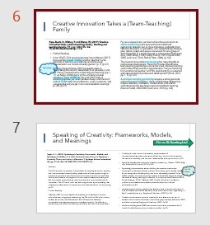
For everything else I am using Google Keep as it offers voice notes, voice typing, lists, and doodles, and it can be edited in a web browser, including drag-and-drop a note in a different place. You can also add tags to each note so you can collate notes under various tags and thus it enables moving one note into various topics. You can add images, and colour-code the various notes. So far it is the best quick note taking app I now.

