Team A
Lula
The arm-wrestling tournament is an annual event run as a straight knockout. This means that participants play matches, the winner of a given match progresses, the loser is knocked out of the competition, and this continues until a winner is found. (Think of it like a tennis tournament or the FA cup.) There were 140 entrants. How many matches needed to be played to find a winner?
The entire town was at the arm-wrestling tournament. The sheriff kept guard outside the saloon and but was still able to watch events proceed through the window. The six suspects were the only people to leave while the competition took place.
The crime was captured on some very grainy CCTV footage. We cannot see who the perpetrator was, but we do know the time. Thanks to the strict timings of competitive arm-wrestling, we know that the catnapping happened during the 136th match of the tournament. The sheriff reports that 10 more matches happened after Lula left the saloon but lost count of how many had already happened. If Lula left after match 136, she can be eliminated from our enquiries.
Is Lula still a suspect?

Floyd
The CCTV footage captured the perpetrator picking up some rope before leaving the crime scene. The rope was hanging between two 1m high posts and was seen to be touching the ground. The posts are 1m apart. See Figure 1 overleaf.
Floyd was found with rope exactly 2m long. Could that have been the rope from the crime scene? If not, we must eliminate him form our enquiries.
Is Floyd still a suspect?
Hint: Think about the 2m rope and what would need to happen for it to touch the ground rather than trying to calculate the length of the rope at the scene.

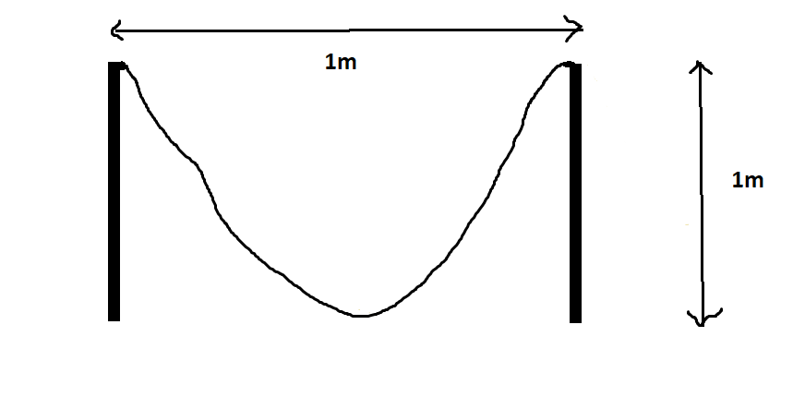
Figure 1: Visual representation of the rope problem
Vinnie
The suspect must have ridden their getaway horse through the speed trap on the road out of town. The speed trap will record anything going past at 50mph or more but did not record anything on the day of the catnapping.
Vinnie’s horse usually gallops at a speed 10% slower than 50mph. However, Vinnie rightly claims that, in this situation, he could push the horse to go 10% quicker than its usual top speed. Could Vinnie’s horse achieve a top speed of 50mph or quicker? If so, we must eliminate him from our enquiries.
Is Vinnie still a suspect?
Hint: Don’t take this problem at face value. Do the maths of taking 10% off and adding 10% back on.

