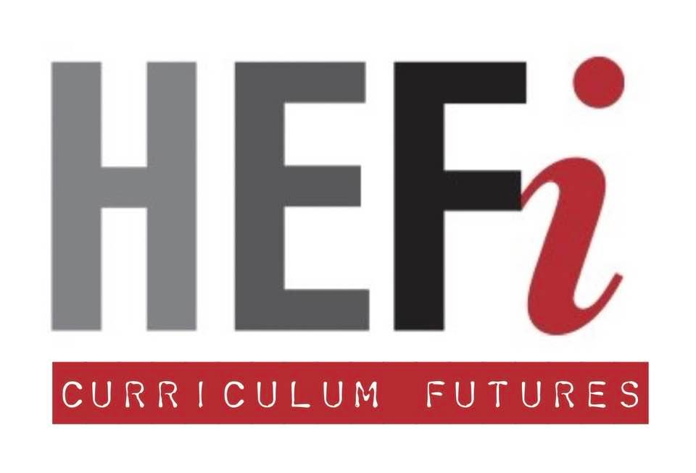
Situational Factors
in Learning Design Framework
Workbook

Tweet size description of your module / programme

Table of Contents
Situational Factors in Learning Design 4
Overview 5
Situational Lens 1. Students 7
Overall Student Characteristics 7
Pen Portraits 8
Key Links to the UKPSF 15
References 15
Situational Lens 2. Staffing 16
Who 16
Implications 16
Looking Within: What is My Teaching Philosophy? 17
Key Links to the UKPSF 19
References 19
Situational Lens 3. Subject 20
Introduction 20
Thinking Like A… 21
Departmental / Programme Norms and Culture 22
Learning Outcomes Alignment Mapping 24
Graduate Attributes Mapping 31
Key Links to the UKPSF 33
References 33
Situational Lens 4. Sequencing 34
Introduction 34
Characteristics: Where are we now / where do we want to be? 34
Storyboarding 36
Storyboard Basic Tools 36
Storyboard Method 36
Key Links to UKPSF 37
Situational Lens 5. Space 38
A. Group Physical Space 38
B. Group Virtual Space 39
C. Individual Space 39
Key Links to UKPSF 40
Further Reading 40
Situational Lens 6. Scene 41
A. Teacher's Academic Context (overlap with the Staff lens) 41
B. Student's Academic Context (overlap with the Student lens) 41
C. Departmental Context 41
D. Institutional Context 42
Key Links to UKPSF 42
Situational Lens 7. Standards 43
Regulations 43
University Codes of Practice, Policies and Guidance 44
Learning Outcomes 45
QAA Subject Benchmarks 45
Subject level descriptors 46
Professional Statutory and Regulatory Bodies (PSRBs) 47
Key Links to the UKPSF 48
References 48
Situational Lens 8. Scholarship 49
Exploring the Rich Evidence Base for Teaching in Higher Education 49
A Scholarly Approach to Teaching .49
Key Links to the UKPSF 51
Backwards Learning Design 52
Overview 53
Benefits of Using Backwards Learning Design 53
Stage 1: Identify Desired Response (Outcomes) 54
Stage 2 – Determine Acceptable Evidence (Assessment) 54
Stage 3 – Plan Learning Experiences & Instruction 54
Stage 1: Learning Outcomes Creation / Review 55
Learning Outcomes Process 55
Task 1. Clarifying Content Priorities 56
Level Descriptors 58
Task 2. Getting Level 59
Task 3. Construction Guide 60
Reality Checking: Are My LOs VASCULAR? 63
Stage 2 – Determine Acceptable Evidence (Assessment) 64
Task: Learning Goals Inventory 64
References 67
Further Reading 67

Situational Factors in Learning Design

Overview

When designing or redesigning learning, whether small scale (course sections), medium (a course, module or MOOC) or large scale (programme or MOOC) the first step needs to be a careful review of the situational factors that may affect your key decisions. The situational lenses include:
- Students
- Staffing
- Subject
- Sequencing
- Space
- Scene
- Standards
- Scholarship
These all sit within the wider University of Birmingham priorities including
- University Education Strategy priorities,
- Research-Intensive Learning,
- Programme Framework for the Future (ProFF)
- Birmingham Academic Career Framework (BACF),
- Birmingham Graduate Attributes.
You may find some lenses to be more important than others. By exploring them all you will identify the factors that are important to creating a robust learning design.
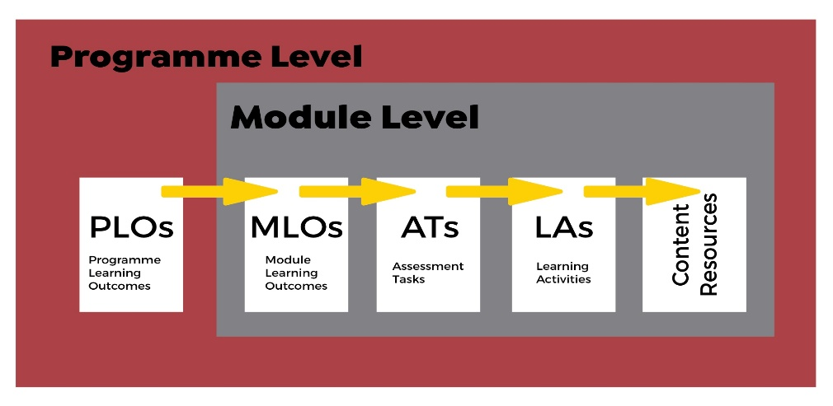
Situational Factors Lenses
Situational Factors Lenses
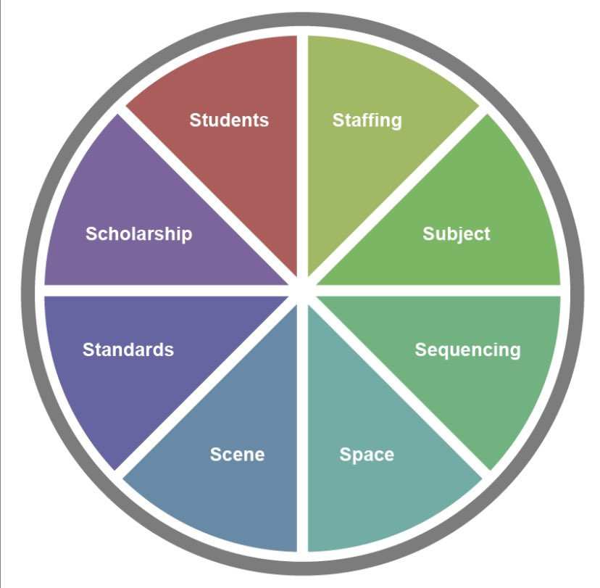
Eight Situational Lenses Framework

Situational Lens 1. Students

Overall Student Characteristics
Start by summarising the characteristics of your module, course or workshop learners.
- Numbers (average or expected) for cohort as a whole, plus any subdivisions (eg. for seminars)
- Level of study – will issues of transition (UG / PG) impact?
- Mode of study – are students full-time, part-time, working, dealing with additional responsibilities (family, caring & working)

Pen Portraits
It is worthwhile creating a number of pen portraits giving you an opportunity to sketch out the various types of students you normally enrol, expect to enrol or aspire to enrol. You might want to consider some or all of the following:
- Range of experience, knowledge, capabilities and skills
- Particular motivations, needs and preferences
- Life situation or world that the student brings into the classroom (including social, political, cultural, historical and economic)
  - Students social location, defined / informed by their gender, race, social class, age, ability, religion, sexual orientation, and geographic location
  - Life or professional goals students bring with them
  - Reasons for enrolling, including the impact of compulsory enrolment
  - Knowledge including preconceptions
  - Expectations of what is learning, university, the discipline, the classroom, career trajectory
- What prior experiences, knowledge, skills, and attitudes do students bring with them

Summary

Pen Portrait of …

Age and demographic
full-time / part-time, working student, family / work responsibilities, international student…

Educational experiences

Study Motivations / Life and Profession Goals

What prior experiences, knowledge, skills and attitudes do these students have regarding your discipline and subject?

Learning assumptions, perceptions, likes and dislikes

Skills strengths and weaknesses (study, literacy, language, soft skills etc)

Technology use and expertise

Pen Portrait of …

Age and demographic
full-time / part-time, working student, family / work responsibilities, international student…

Educational experiences

Study Motivations / Life and Profession Goals

What prior experiences, knowledge, skills and attitudes do these students have regarding your discipline and subject?

Learning assumptions, perceptions, likes and dislikes

Skills strengths and weaknesses (study, literacy, language, soft skills etc)

Technology use and expertise

Pen Portrait of …

Age and demographic
full-time / part-time, working student, family / work responsibilities, international student…

Educational experiences

Study Motivations / Life and Profession Goals

What prior experiences, knowledge, skills and attitudes do these students have regarding your discipline and subject?

Learning assumptions, perceptions, likes and dislikes

Skills strengths and weaknesses (study, literacy, language, soft skills etc)

Technology use and expertise

Pen Portrait of …

Age and demographic
full-time / part-time, working student, family / work responsibilities, international student…

Educational experiences

Study Motivations / Life and Profession Goals

What prior experiences, knowledge, skills and attitudes do these students have regarding your discipline and subject?

Learning assumptions, perceptions, likes and dislikes

Skills strengths and weaknesses (study, literacy, language, soft skills etc)

Technology use and expertise

Pen Portrait of …

Age and demographic
full-time / part-time, working student, family / work responsibilities, international student…

Educational experiences

Study Motivations / Life and Profession Goals

What prior experiences, knowledge, skills and attitudes do these students have regarding your discipline and subject?

Learning assumptions, perceptions, likes and dislikes

Skills strengths and weaknesses (study, literacy, language, soft skills etc)

Technology use and expertise

Pen Portrait of …

Age and demographic
full-time / part-time, working student, family / work responsibilities, international student…

Educational experiences

Study Motivations / Life and Profession Goals

What prior experiences, knowledge, skills and attitudes do these students have regarding your discipline and subject?

Learning assumptions, perceptions, likes and dislikes

Skills strengths and weaknesses (study, literacy, language, soft skills etc)

Technology use and expertise

Key Links to the UKPSF
V1 Respect individual learners and diverse learning communities
V2 Promote participation in higher education and equality of opportunity for learners
V3 Use evidence-informed approaches and the outcomes from research, scholarship and continuing professional development
V4 Acknowledge the wider context in which higher education operates recognising the implications for professional practice

References
Diamond, R.M., (1998) Designing and Assessing Courses and Curricula: A Practical Guide. The Jossey-Bass Higher and Adult Education Series. Jossey-Bass: San Francisco
Fink, L.D., (2013) Creating significant learning experiences: An integrated approach to designing college courses. John Wiley & Sons. Higher Education Academy
(2011) The UK Professional Standards Framework for teaching and supporting learning in higher education https://www.heacademy.ac.uk/system/files/downloads/UK%20Professional%20Standards%20Framework.pdf

Situational Lens 2. Staffing

Who
Who is involved in the teaching (yourself, colleagues, PGTAs, associates, careers, library, student peers etc) and supporting learning (admin team, eLearning, etc)?

Implications
How might each team member's confidence levels, interests, skills and experience impact:
- particular pedagogies, subject topics or techniques utilised
- situations encountered
- technologies used or considered for use
- their developmental needs

Looking Within: What is My Teaching Philosophy?

What is your teaching philosophy? You may find it valuable to spend some time thinking about this. The following questions may help trigger your thoughts:
What do you think is the purpose of teaching?
Information focused (tell them what they need to know) or Process focused (create an environment in which the students can learn

What do you think are the characteristics of an effective teacher in your disciplinary and departmental context?

What are your aspirations for your students?

In the context of teaching, how do you hope you are seen by your students and / or your colleagues?

What personal values and beliefs underpin your practice?

Sample Teaching Philosophy’s

Professor Tina Overton (Chemistry)
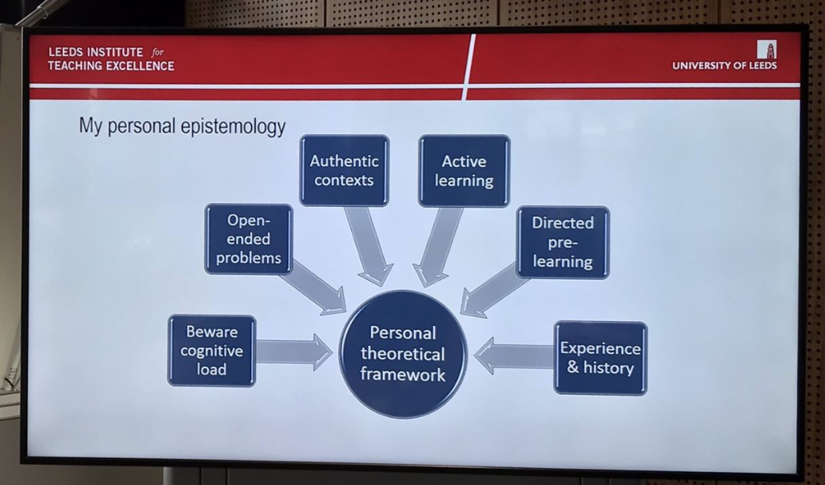
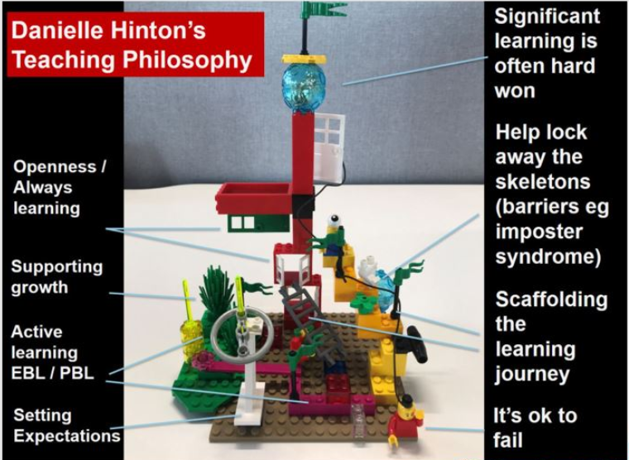

Key Links to the UKPSF

A4 Develop effective learning environments and approaches to student support and guidance
K2 Appropriate methods for teaching, learning and assessing in the subject area and at the level of the academic programme
V1 Respect individual learners and diverse learning communities
V2 Promote participation in higher education and equality of opportunity for learners

References

Hinton, D. (2019) Teaching Philosophy Twitter Thread, Twitter, [Online] https://twitter.com/hintondm/status/1159132559210684421

Hinton, D. (2021) Getting Started with your Teaching Philosophy. National Teaching Repository. Presentation. [Online] https://doi.org/10.25416/NTR.14420804.v1
Humphrey, P. (2019) Engage, Empower, Evolve: Using a Teaching Philosophy to Engage Staff, Presentation. Macquarie University: Sydney {Online] https://www.englishaustralia.com.au/documents/item/762
Palmer, P.J., (2017) The courage to teach: Exploring the inner landscape of a teacher's life. John Wiley & Sons.

Situational Lens 3. Subject

Introduction
One of your most important Situational Lenses, here are some question to ask yourself and have the opportunity to reflect on.
- Do you have clear learning outcomes that align to the materials, activities and assessment?
- What areas and/or threshold concepts that students struggle with?
- What aspects of the curriculum are becoming stale / must keep?
- Where does research-intensive learning feature in the curriculum?
- How do you embed opportunities to develop aspects of the Birmingham Graduate or Disciplinary Graduate?
- How does disciplinary culture impact teaching, assessment and feedback/forward?​​​​​​​

Thinking Like A…
“Disciplines have their own ways of working, habits of thought and characteristic approaches to ideas. They are made up of particular people and given forms of organisation. When you are teaching, though, it’s not just your own mastery of the processes that are inherent to your discipline that matters. Your awareness of these processes and your capacity to introduce them to others are also important. What does it take then to draw students in to the heart of a discipline? How can you learn to do this more effectively?”
Kahn, Peter, and Lorraine Anderson. Developing Your Teaching : Towards Excellence, Routledge, 2019. ProQuest Ebook Central, http://ebookcentral.proquest.com/lib/bham/
detail.action?docID=5724697

Basic Patterns of Thinking
Identify some of the basic patterns of thinking that students need to master within your own discipline

Departmental / Programme Norms and Culture

Departments often share attitudes, beliefs, expectations and behaviours around student learning.
- How does disciplinary culture impact teaching, assessment and feedback/forward?
- What departmental norms do your students need explicit induction into?
- How might you incorporate the scaffolding of this hidden curriculum?
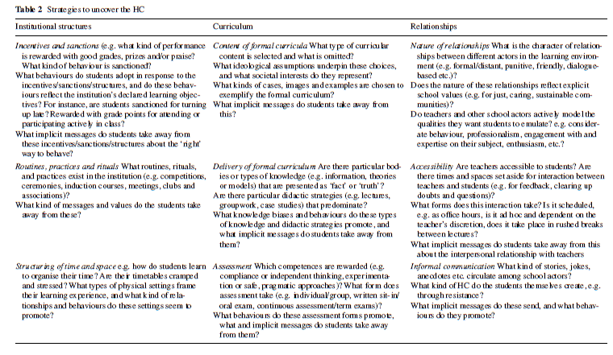
Semper, J.V.O. and Blasco, M., 2018. Revealing the hidden curriculum in higher education. Studies in Philosophy and Education, 37(5), pp.481-498.

Learning Outcomes Alignment Mapping

Introduction
Module learning outcomes should detail the knowledge, skills and related attributes that a student will be required to demonstrate on the successful completion of each module. This differs from aims which reflect the intention of the teacher.
All learning outcomes must be assessed by means of a summative assessment – failure to achieve all stated learning outcomes results in a student’s failure of the module.
Module outcomes must map onto the
- programme of study outcomes of which it belongs
- module assessment
- module learning activities
Well written learning outcomes contain three parts:
(1) action verb – (2) what – (3) nature, context or standard of performance
In regards to the action verb it is important that you avoid:
- the use of word and phrases such as understand, know, be aware of..., appreciate, become familiar with..., interest in..., feeling for...
- any verbs and phrases that are not observable, measurable or universally understood.

Are My Learning Outcomes Written at a Pass or Threshold Level
What is the pass / threshold level for each of my learning outcomes?
LO1.
Pass / Threshold level is:
I can provide a definition of achievement required for each of the grade bands use: Y / N

LO2.
Pass / Threshold level is:
I can provide a definition of achievement required for each of the grade bands use: Y / N

LO3.
Pass / Threshold level is:
I can provide a definition of achievement required for each of the grade bands use: Y / N

Lo4.
Pass / Threshold level is:
I can provide a definition of achievement required for each of the grade bands use: Y / N

LO5.
Pass / Threshold level is:
I can provide a definition of achievement required for each of the grade bands use: Y / N

Do my Learning Outcomes reflect the current needs of my discipline / profession?

Mapping of Alignment to Module Assessment
- Do my summative assessments examine / measure all my Learning Outcomes?
- How do I signal this to my students (eg. assignment instructions, marking criteria etc)?

Summative Assessment 1:

Aligned to LOS:
How do the students know the pass / threshold level required?
a) I provide
b) I don’t provide anything currently

Summative Assessment 2:

Aligned to LOS:
How do the students know the pass / threshold level required?
a) I provide
b) I don’t provide anything currently

Action Planning
Including notes of any Learning Outcomes not yet aligned

Alignment to my module learning activities
Note down where there is alignment within the planned learning activities and your module Learning Outcomes.
Week | Theme | LOs
1
2
3
4
5
6
7
8
9
10
11
12

Threshold Concepts
What are threshold concepts appear in my curriculum?
Threshold concepts (a term coined by Meyer and Land) describes core, foundational or gateway concepts, ways of thinking and practising that once understood transform understanding and permit a learner to progress in a discipline. They are:
- Transformative
- Irreversible
- Integrative
- Conceptually bound
- Can involve troublesome knowledge (Perkins, 1999)
  - conceptually difficult
  - counter-intuitive or ‘alien’

Pinch Points / Stale Curriculum Elements

The following triggers might help you to identify pinch points and/or stale elements and areas within the curriculum:
- Is there repetition internally or externally within the programme?
- Where do students struggle? Drop / Change
- Do our students their see current / future selves in the module (including identity and current / desired employment)?
- What isn’t working as well as it could be?
- What aspects of the curriculum are becoming stale / must keep?

Research-intensive learning
Where does research-intensive learning feature in the curriculum?

Graduate Attributes Mapping
How do you embed opportunities to develop aspects of the Birmingham Graduate or Disciplinary Graduate currently (red) and plan to post the end of the workshop (blue)?

Academic Excellence
Graduates with outstanding specific and cross-disciplinary skills, knowledge and expertise that they can apply in practice.
- Subject specialists – experts in discipline-specific theories, knowledge, research methods skills and enquiry-informed practices
- Intellectually curious and confident – nurtured by engagement in cutting edge academic disciplines
- Independent critical thinkers – challenging, discerning, analytical and autonomous thinkers
- Cross-disciplinary expertise – open-minded and having a depth and breadth of knowledge about concepts, ideas, theories and methods beyond a specialist subject

Local and Global Leaders
Graduates with the skills and human qualities to be confident trailblazers for positive change.
- Creative – able to think imaginatively and purposefully, to recognise opportunities and to come up with original ideas
- Intercultural – able to work collaboratively, and communicate complex ideas to and with different and diverse audiences
- Inclusive – actively listen to and consider different views, lead with humility and empathy, and remove barriers for people who are different from themselves
- Resilient – agile, respond positively to change and uncertainty, act consistently with their values, and support the well-being of themselves and others

Future-Minded
Informed graduates who can adapt in order to navigate, thrive and lead in the information/digital age of the 4th IR .
- Digitally literate – with the skills and knowledge of finding, using, managing, critically evaluating, designing and developing digital resources and/or technologies, as appropriate
- Sustainability-engaged: adopt values and behaviours that demonstrate an understanding of and commitment to the global principles of sustainable development
- Lifelong learner – take responsibility for ongoing personal learning; monitor progress; evaluate personal growth
- Entrepreneurial – proactive, flexible, ability to generate and realise ideas, and benefit others by adding value (social, cultural, environmental, technological, operational, economical)

Ethical and Active Citizens
Graduates with the character and values to make a meaningful and sustainable contribution in local, national and global contexts.
- Socially responsible – civic minded and emotionally intelligent, with a desire to help others and the wider community to flourish
- Practical wisdom – can respond constructively to ethical challenges; able to identify and enact the best options at the most appropriate time at work and in aspects of wider life
- Reflective – committed to evaluating personal ethical thoughts and civic actions

1
1

2
1
8
1

4
1
5
1
6
1
7
1
3
1

Key Links to the UKPSF
A1 Design and plan learning activities and/or programmes of study
A4 Develop effective learning environments and approaches to student support and guidance
K1 The subject material
K2 Appropriate methods for teaching, learning and assessing in the subject area and at the level of the academic programme
K3 How students learn, both generally and within their subject/ disciplinary area(s)

References

Advanced HE (2017) Flipped learning, https://www.heacademy.ac.uk/knowledge-hub/flipped-learning-0
Diamond, R.M., (1998) Designing and Assessing Courses and Curricula: A Practical Guide. The Jossey-Bass Higher and Adult Education Series. Jossey-Bass, Inc., Publishers: San Francisco.
Fink, L.D., (2013) Creating significant learning experiences: An integrated approach to designing college courses. John Wiley & Sons: San Francisco
Meyer, J. and Land, R., (2006) Overcoming barriers to student understanding: Threshold concepts and troublesome knowledge. Routledge: Oxford.

Situational Lens 4. Sequencing

Introduction
This situational lens encourages you to think through the time available for learning. Time for learning should include consideration of both time "in class" (group) and "out of class" (individual). The lens offers an opportunity to undertake some storyboarding - creating a birds eye view of your current and/or planned curriculum.
This Lens is best explored:
- in a group with at least one academic colleague and input from professional services colleagues including HEFi (Educational Development and Digital Education teams), Careers and the Library
- once you have reviewed / created your learning outcomes and aligned assessments

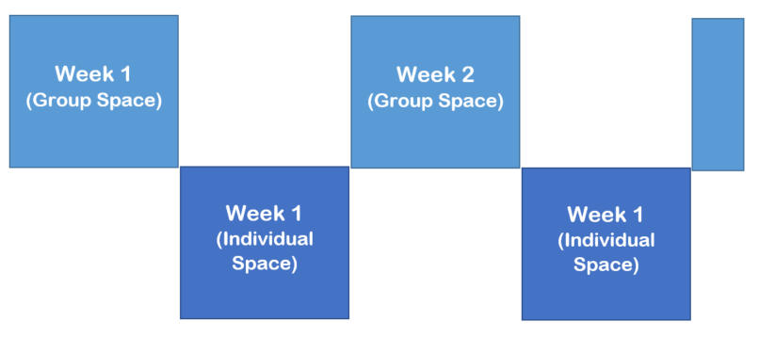

Characteristics: Where are we now / where do we want to be?

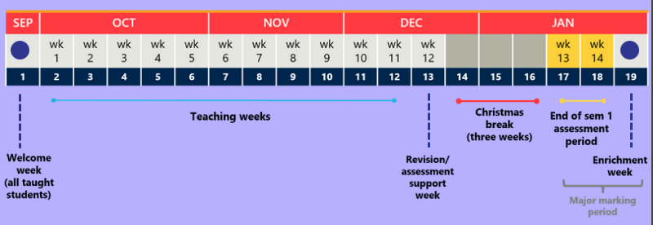
1
1
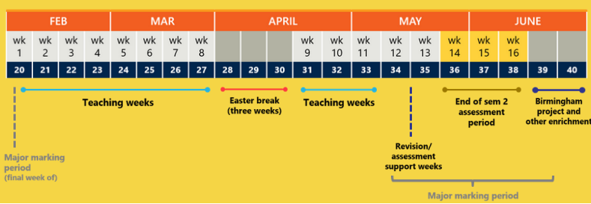
2
1

Storyboarding

Storyboarding essentially is creating a birds eye view of your current and/or planned curriculum. It comes from a well established tradition in animation (think Disney) and more recently elearning design processes> The following are three well developed Higher Education focused storyboarding designs that you might wish to partake in:

- Carpe Diem (Gilly Salmon and the University of Leicester)
https://www.gillysalmon.com/carpe-diem.html
- ‘7Cs of Learning Design‘ (Grainne Conole)
https://www.slideshare.net/GrainneConole/conole-learning-designworkshop
- ABC (UCL)
https://www.ucl.ac.uk/teaching-learning/case-studies/2018/jun/designing-programmes-and-modules-abc-curriculum-design

Storyboard Basic Tools
- Paper-based:
  - ​​​​​​​​​​​​​​Pack of four coloured Post-Its, pens and Flip Chart paper
  - ABC method cards https://cpb-eu-w2.wpmucdn.com/blogs.ucl.ac.uk/dist/3/513/files/2018/05/ABC_cards_learning_types.pdf
  - Pens and Flip Chart paper
- Web-based: a tool such as
  - Padlet https://en-gb.padlet.com/dashboard
  - Linoit https://en.linoit.com/
  - Popplet https://www.popplet.com/
- Computer: PowerPoint

Storyboard Method
A. If you're using Post-Its or Linoit Sticky Notes or the like allocate colours for each of the following
- Time / Theme / Subject
- Learning Outcomes
- Assessment / Demonstration of Learning
- Learning Activities
- Learning Resources
B. Divide your Flip Chart paper or Linoit screen in half horizontally - allocate the top half to in class / group time and the bottom half to out of class / individual time.
C. For an idea of how to use Linoit to create a Storyboard
- watch this video from Gabi Witthaus and
- browse this partial UoB PGCHE learning design (see below)
Time / Theme / Subject [Yellow], Learning Outcomes [green], Assessment / Demonstration of Learning [Purple], Learning Activities [Red] and Learning Resources [Orange]
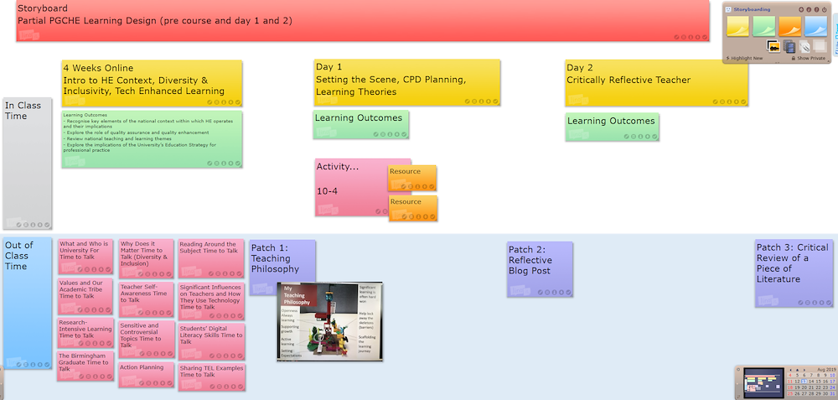

Key Links to UKPSF

A1 Design and plan learning activities and/or programmes of study
A4 Develop effective learning environments and approaches to student support and guidance
K2 Appropriate methods for teaching, learning and assessing in the subject area and at the level of the academic programme
K3 How students learn, both generally and within their subject/ disciplinary area(s)

Situational Lens 5. Space

The Space Situational Lens is an important one that will affect your learning design. Linking closely to the Sequencing Lens, it is important to reflect on and examine the In Class or Group Physical and Virtual space as well as the Out of Class or Individual space. Reflecting on what currently is and isn't working and future learning spaces in the light of research and scholarship is key.

A. Group Physical Space
Where are you normally or likely to be timetabled?
Being aware of the physical affordances of space can help inform you of what additional technologies you might wish to explore to encourage active learning for instance.

B. Group Virtual Space
Everyone has virtual space with Canvas, our virtual learning environment as well as many other virtual spaces (depending on your needs and availability). Good practice, techniques and activities in traditional teaching can also be mediated by technology, opening up learning opportunities.
Have a look at the
- Canvas Guide (https://canvas-guide.bham.ac.uk/) and the
- Learning and Teaching Gateway (https://www.birmingham.ac.uk/university/hefi/learning-teaching-gateway/index.aspx) for more ideas and support.
What do you use now? What is / not working? What do you want to know more about?

C. Individual Space
The individual space of the student (part of the 200 hours of student effort per 20 credits) is also available and can be utilised through ideas such as the Flipped Classroom.
How do you currently utilise individual student space? What is / not working?

Key Links to UKPSF

A1 Design and plan learning activities and/or programmes of study
A4 Develop effective learning environments and approaches to student support and guidance
K2 Appropriate methods for teaching, learning and assessing in the subject area and at the level of the academic programme
K3 How students learn, both generally and within their subject/ disciplinary area(s)

Further Reading

Elkington, S and Bligh, B. (2019) Future Learning Spaces Space, Technology and Pedagogy, AdvanceHE, https://www.heacademy.ac.uk/system/files/downloads/Future%20Learning%20Spaces_0.pdf

JISC (2018) UK Higher Education Learning Space Toolkit: case studies, https://www.jisc.ac.uk/guides/learning-space-toolkit-case-studies
Snakes and Ladders- UK HE Learning Space Toolkit edition

Situational Lens 6. Scene
A wide range of contextual factors impact on teaching and supporting learning that can't be ignored. It is important to be aware of how they do or can impact. If you're not aware now, talk to a colleague, your School Director of Education or departmental Teaching and Learning Manager. Themes and factors might include:

A. Teacher's Academic Context (overlap with the Staff lens)

B. Student's Academic Context (overlap with the Student lens)

C. Departmental Context
- Departmental interpretation of institutional conditions
- Departmental and disciplinary philosophy
- Departmental disciplinary discourse and policies
- Environmental factors (eg NSS)

D. Institutional Context
- Physical and organisational structures
- Institutional philosophy
- External / internal political environment
(Higher Education Surveys – national (NSS) and institutional; TEF, REF and KEF; Society and Higher Education more specifically)
- Institutional policies and strategies (eg. Birmingham Education
Strategy and Birmingham Academic / Graduate profiles)
- Management approach

Key Links to UKPSF

A1 Design and plan learning activities and/or programmes of study
V4 Acknowledge the wider context in which higher education operates recognising the implications for professional practice

Situational Lens 7. Standards
As part of the local and national quality assurance process within Higher Education there are a number of standards related factors to be aware of and aware of how they impact our teaching and supporting learning.
They include:

Regulations
The Regulations contain principles and standards designed to control or govern conduct or provide direction at a more detailed level than Ordinances. The are split into three:
- University Regulations
- Library Regulations
- Cohort Regulations*
*The Cohort Regulations are year specific and you should consult the ones that align with the first year of study for the students on the modules you’re teaching.
https://intranet.birmingham.ac.uk/as/registry/legislation/regulations/index.aspx

University Codes of Practice, Policies and Guidance
Codes of practice, policies and guidance are supplementary to Regulations, setting out the procedures to be followed in specific areas. These are mandatory and apply to all staff and students and are cohort specific (aligning to the entry cohort of the programme of study within which your modules operates).
https://intranet.birmingham.ac.uk/as/registry/legislation/codesofpractice/index.aspx
They include:
- Admissions & Alternate Modes of Delivery*
- Conduct (incl. Misconduct), Complaints and Appeals
- Health and Wellbeing, Leave of Absence & Extension to Study Periods
- Research Ethics, Research Programmes & Research Related
- Student Support & Student Related (incl. Immigration)*
- Taught Programmes and Modules*
- General / Other
You are encouraged to review the starred categories and make notes in regards to your teaching and supporting learning needs:

Learning Outcomes

For guidance to support reviewing or creating robust Learning Outcomes and to review the alignment between your module learning outcomes with assessments and learning activities please see the Backwards Learning Design section at the back of this guide.

QAA Subject Benchmarks
Benchmark statements describe the attributes, skills and capabilities that a graduate with an honours degree in a specific subject might be expected to have. Compiled by academics and other specialists (such as representatives from professional bodies, industry and commerce) from the subject area, the benchmark statements help to ensure that the standards of degree programmes across the UK meet an agreed level.
https://www.qaa.ac.uk/quality-code/subject-benchmark-statements
Benchmark Statement review notes

Subject level descriptors
Credit level descriptors define the level of challenge, complexity, and autonomy expected of a learner on completion of a defined and bounded learning activity such as a module or programme of learning.
http://www.seec.org.uk/wp-content/uploads/2016/07/SEEC-descriptors-2016.pdf
You are encouraged to review Level Descriptors that align to your teaching load.

Professional Statutory and Regulatory Bodies (PSRBs)
Many programmes of study are accredited, recognised or approved by any one of the numerous Professional Statutory and Regulatory Bodies (PSRBs). Accreditation may require some kind of inspection, visit and/or scrutiny of the programme documentation and award of approval normally is given for a specific time period..
Professional bodies are dedicated to the advancement of the knowledge and practice of professions through developing, supporting, regulating and promoting professional standards for technical and ethical competence. There are approximately 400 professional bodies in the UK, together they represent 13 million professionals.
If you work within some kind of PSRB accreditation processes you might wish to note key dates and action planning notes:

Key Links to the UKPSF

A1 Design and plan learning activities and/or programmes of study
A4 Develop effective learning environments and approaches to student support and guidance
K2 Appropriate methods for teaching, learning and assessing in the subject area and at the level of the academic programme
K3 How students learn, both generally and within their subject/ disciplinary area(s)
K6 The implications of quality assurance and quality enhancement for academic and professional practice with a particular focus on teaching

References
SEEC (2016) Credit Level Descriptors for Higher Education, SEEC, http://www.seec.org.uk/wp-content/uploads/2016/07/SEEC-descriptors-2016.pdf
QAA (20??) Subject Benchmark Statements, http://www.qaa.ac.uk/quality-code/subject-benchmark-statements
University of Birmingham Codes of Practice https://intranet.birmingham.ac.uk/as/registry/legislation/codesofpractice/index.aspx
University of Birmingham Regulations https://intranet.birmingham.ac.uk/as/registry/legislation/regulations.aspx

Situational Lens 8. Scholarship

Exploring the Rich Evidence Base for Teaching in Higher Education
It is important that teachers and those who support learning engage with and where possible contribute to the research informed evidence base for teaching in Higher Education. A great deal of evidence and practice is published in Higher Education focused books, journals, newsletters, blogs and social media focused on Higher Education in general or more specifically via the discipline and/or technology. As professionals taking part in teaching, continued professional development is also key.

Getting Started: Two ResourceLists
- Disciplinary Higher Education and Related Journals
https://rl.talis.com/3/bham/lists/8089C70D-E8BE-2803-9968-03B386E4B63D.html
- Academic Practice Reading List
https://rl.talis.com/3/bham/lists/23316621-58AF-69CB-D28E-F2171DF92AC8.html

A Scholarly Approach to Teaching
The scholarship of teaching and learning (SoTL, pronounced “sō-tul” in the US) is a synthesis of teaching, learning, and research in higher education that aims to bring a scholarly lens—the curiosity, the inquiry, the rigor, the disciplinary variety—to what happens in the classroom (brick-and-mortar, virtual, co-curricular, et al.).
SoTL involves
- asking meaningful questions about student learning and about the teaching activities designed to facilitate student learning,
- answering those questions by first making relevant student learning visible as evidence of thinking and learning (or mis-learning), and then systematically analyzing this evidence, and
- sharing the results of that analysis publicly to invite review and to contribute to the body of knowledge on student learning in a variety of contexts, and
- aiming to improve student learning by strengthening the practice of teaching (one’s own and others’).
We say that SoTL brings a scholarly approach because it begins with intellectual curiosity, is conducted deliberately and systematically, is grounded in an analysis of some evidence, and results in findings shared with peers to be reviewed and to expand a knowledge base.
The formal origins of SoTL begin in 1990. In an effort to define the scholarship performed by professors in academia as more than just “teaching versus research,” Ernest L. Boyer, in his influential book Scholarship Reconsidered: Priorities of the Professoriate (1990), concluded that “the work of the professoriate might be thought of as having four separate, yet overlapping, functions. These are: the scholarship of discovery; the scholarship of integration; the scholarship of application; and the scholarship of teaching” (p. 16).

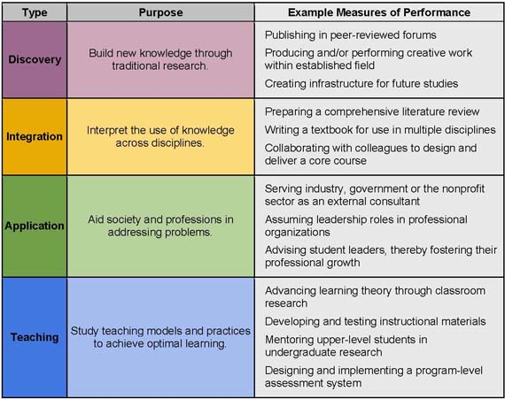
Fig. Boyer’s Scholarship of Teaching and Learning (SOTL)
From https://sites.stedwards.edu/innovationfellowship/2014/05/28/scholarship-of-teaching-learning-sotl/
Building on Boyer’s work, Charles E. Glassick, Mary Taylor Huber, and Gene I. Maeroff, in their book Scholarship Assessed: Evaluation of the Professoriate (1997), identified six markers of scholarly work, including the scholarship of teaching (p. 25). Scholarly work should have
- Clear goals
- Adequate preparation
- Appropriate methods
- Significant results
- Effective presentation
- Reflective critique
Lee. S. Shulman, president emeritus of the Carnegie Foundation for the Advancement of Teaching, writes:
“Scholarly teaching is what every one of us should be engaged in every day that we are in a classroom, in our office with students, tutoring, lecturing, conducting discussions, all the roles we play pedagogically. Our work as teachers should meet the highest scholarly standards of groundedness, of openness, of clarity and complexity. But it is only when we step back and reflect systematically on the teaching we have done, in a form that can be publicly reviewed and built upon by our peers, that we have moved from scholarly teaching to the scholarship of teaching.” (2004, p. 166).
This subsection was created by https://my.vanderbilt.edu/sotl/ and is reused under a Creative Commons Attribution-NonCommercial 4.0 International License

Key Links to the UKPSF

A5 Engage in continuing professional development in subject/disciplines and their pedagogy, incorporating research, scholarship and the evaluation of professional practices
V3 Use evidence-informed approaches and the outcomes from research, scholarship and continuing professional development

Further Reading
Binns, C., (2017) Module design in a changing era of higher education: Academic identity, cognitive dissonance and institutional barriers. Basingstoke: Palgrave Macmillan.
Ciccone, A.A., (2012) Exploring more signature pedagogies: Approaches to teaching disciplinary habits of mind. Stylus Publishing, LLC..
Diamond, R.M., (1998) Designing and Assessing Courses and Curricula: A Practical Guide. The Jossey-Bass Higher and Adult Education Series. Jossey-Bass, Inc., Publishers, 350 Sansome St., San Francisco, CA.
Fink, L.D., (2013) Creating significant learning experiences: An integrated approach to designing college courses. John Wiley & Sons.
Gurung, R.A., Chick, N.L. and Haynie, A., (2009) Exploring signature pedagogies: Approaches to teaching disciplinary habits of mind. Stylus Publishing, LLC..
Huber, Mary Taylor and Sherwyn P. Morreale, eds. (2002) Disciplinary Styles in the Scholarship of Teaching and Learning: Exploring Common Ground. Washington, DC: American Association for Higher Education and The Carnegie Foundation for the Advancement of Teaching.
Hutchings, P., (2000) Opening Lines: Approaches to the Scholarship of Teaching and Learning. Carnegie Publications, the Carnegie Foundation for the Advancement of Teaching, 555 Middlefield Road, Menlo Park, CA 94025. https://files.eric.ed.gov/fulltext/ED449157.pdf
McKinney, Kathleen, ed. (2013) The Scholarship of Teaching and Learning In and Across the Disciplines. Bloomington: Indiana University Press.
Semper, J.V.O. and Blasco, M., 2018. Revealing the hidden curriculum in higher education. Studies in Philosophy and Education, 37(5), pp.481-498.
Shulman, L., (2005) February. The signature pedagogies of the professions of law, medicine, engineering, and the clergy: Potential lessons for the education of teachers. In Talk Delivered at the Math Science Partnerships (MSP) Workshop:“Teacher Education for Effective Teaching and Learning” Hosted by the National Research Council’s Center for Education February (pp. 6-8).

Backwards Learning Design

Overview
Teachers typically approach module design in a “forward design” manner, meaning they consider the learning activities (how to teach the content), develop assessments around their learning activities, then attempt to draw connections to the learning outcomes of the module.
In contrast, the backward design (Wiggins and McTighe) or constructive alignment (Biggs and Tang) approaches has teachers consider the learning outcomes of the module first. These learning outcomes embody the knowledge and skills teachers want their students to have learned when they leave the module.
Once the learning outcomes have been established, the second stage involves consideration of assessment. The approach suggests that teachers should consider these overarching learning outcomes and how students will be assessed prior to consideration of how to teach the content. For this reason, backward design is considered a much more intentional approach to module design than traditional methods of design.
“In teaching students for understanding, we must grasp the key idea that we are coaches of their ability to play the ‘game’ of performing with understanding, not tellers of our understanding to them on the sidelines.”

Benefits of Using Backwards Learning Design
“Our sessions, modules, and programmes should be logically inferred from the results sought, not derived from the methods, books, and activities with which we are most comfortable. Curriculum should lay out the most effective ways of achieving specific results… in short, the best designs derive backward from the learnings sought.”
Backward design is beneficial to teachers because it innately encourages intentionality during the design process. It continually encourages the teacher to establish the purpose of doing something before implementing it into the curriculum. Therefore, backward design is an effective way of providing guidance for instruction and designing sessions, modules, and programmes. Once the learning outcomes, have been identified, teachers will have an easier time developing assessments and instruction.
The incorporation of backward design also lends itself to transparent and explicit instruction. If the teacher has explicitly defined the learning outcomes of the module, then they have a better idea of what they want the students to get out of learning activities. Furthermore, if done thoroughly, it eliminates the possibility of doing certain activities and tasks for the sake of doing them. Every task and piece of instruction has a purpose that fits in with the overarching outcomes and outcomes of the module.

Constructive alignment diagram, Beale Gurney & Nell Rundle, CC BY-SA

Stage 1: Identify Desired Response (Outcomes)
In the first stage, the teacher must consider the learning outcomes of the session, module or programme. Wiggins and McTighe provide a useful process for establishing curricular priorities. They suggest that the teacher ask themselves the following three questions as they progressively focus in on the most valuable content:
- What should participants hear, read, view, explore or otherwise encounter?
- What knowledge and skills should participants master?
- What are big ideas and important understandings participants should retain?

Stage 2 – Determine Acceptable Evidence (Assessment)
The second stage of backward design has teachers consider the assessments and performance tasks students will complete in order to demonstrate evidence of understanding and learning. In the previous stage, the teacher pinpointed the learning outcomes of the module. Therefore, they will have a clearer vision of what evidence students can provide to show they have achieved or have started to attain the outcomes of the course. Consider the following two questions at this stage:
- How will I know if students have achieved the desired results?
- What will I accept as evidence of student understanding and proficiency?
At this stage it is important to consider a wide range of assessment methods in order to ensure that students are being assess over the goals the instructor wants students to attain. Sometimes, the assessments do not match the learning outcomes, and it becomes a frustrating experience for students and teachers.

Stage 3 – Plan Learning Experiences & Instruction
The final stage of backward design is when teachers begin to consider how they will teach. This is when instructional strategies and learning activities should be created. With the learning outcomes and assessment methods established, the teacher will have a clearer vision of which strategies would work best to provide students with the resources and information necessary to attain the outcomes of the module. Consider the questions below:
- What enabling knowledge (facts, concepts, principles) and skills (processes, procedures, strategies) will students need in order to perform effectively and achieve desired results?
- What activities will equip students with the needed knowledge and skills?
- What will need to be taught and coached, and how should it best be taught, in light of performance outcomes?
- What materials and resources are best suited to accomplish these outcomes?

Stage 1: Learning Outcomes Creation / Review
Module learning outcomes should detail the knowledge, skills and related attributes that a student will be required to demonstrate on the successful completion of each module. This differs from aims which reflect the intention of the teacher. Module outcomes should map onto the programme of study outcomes of which it belongs.
Module learning outcomes should be written at a pass or threshold level. It is important that you do not include module outcomes that only the highest achieving students have the ability to achieve.
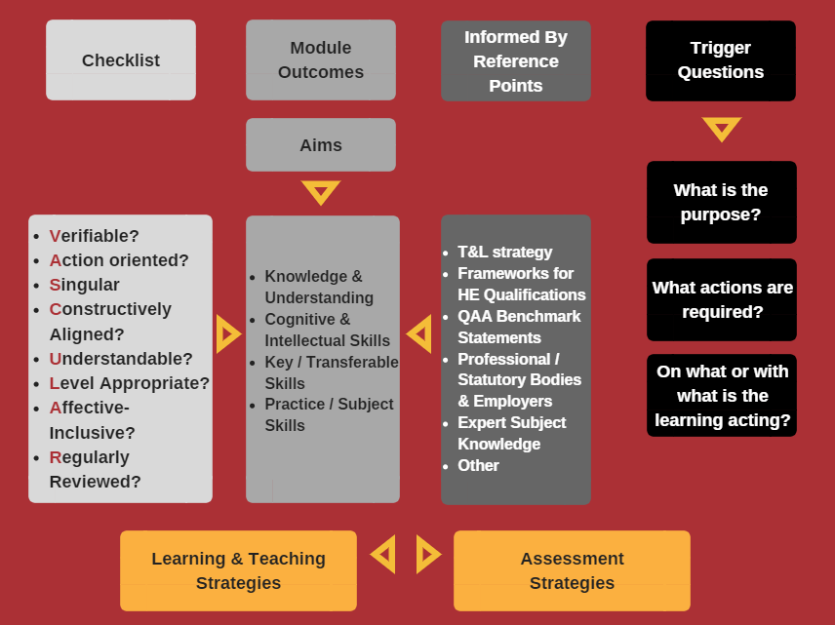
It generally is recommended that a 20 credit module (11 weeks) has between 3 and 7 learning outcomes.

Learning Outcomes Process

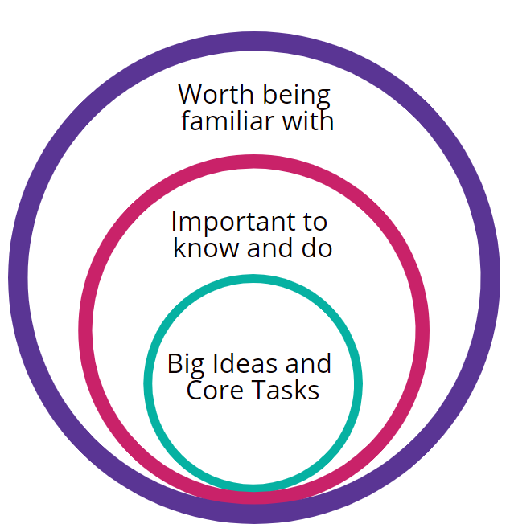
Task 1. Clarifying Content Priorities

Big ideas – include in LOs (Why and What)
These anchor the unit or module – might include concepts, themes, ongoing debates, paradoxes, theory, underlying assumption, recurring questions, understanding or principle

A big idea is described by a number of authors along these lines:
- Is both “central to coherent connections in a field of study and a conceptual anchor for making facts more understandable and useful, …provides a focusing conceptual lens for any study, provides breadth of meaning by connecting and organising, pointing to ideas at the heart of expert understanding, requiring “uncoverage” because its meaning or value is rarely obvious to the learner, is counterintuitive or prone to misunderstanding, has transfer value – “horizontally” (across subjects) and ”vertically” (through the years in later modules) and outside of university (Wiggins and McTighe, 2005, p 68-69)
- They “generate new knowledge in the field while also being helpful to novice learners” (Phenix, 1964, p. 323)

Important to know and do – include in LOs (How and What)
Important knowledge, skills and concepts that have connective and transfer power within this and related units of study eg. disciplinary threshold concepts (knowledge and practical application)

Worth Being Familiar With (Why Not)
Identify knowledge that students might benefit from or find interesting being familiar with (eg main figures in discipline, non-essential terminology)

Level Descriptors
One of the most common reasons for modules to be referred for further development is that their learning outcomes are not appropriate for the level of study, especially between level H and M.
Credit level descriptors
- “define the level of challenge, complexity, and autonomy expected of a learner” (SEEC: 1)
- provide a “statement of the generic characteristics of outcomes of learning at specific levels” (QAA: 1-2)
- should be a starting point in regards to the creation of learning outcomes

Levels
L4: 1st year Undergraduate (eg. CertHE, HNC)
L5: 2nd year Undergraduate (eg. DipHE, DipHE)
L6: 3rd year Undergraduate (eg. BA/BSc Hons, PGCE)
L7: Masters (eg. MPhil, MLitt, MRes, MA, MSc, MB ChB, PGDips)
L8: Doctoral (eg. PhD/DPhil, EdD, DBA, DClinPsy)

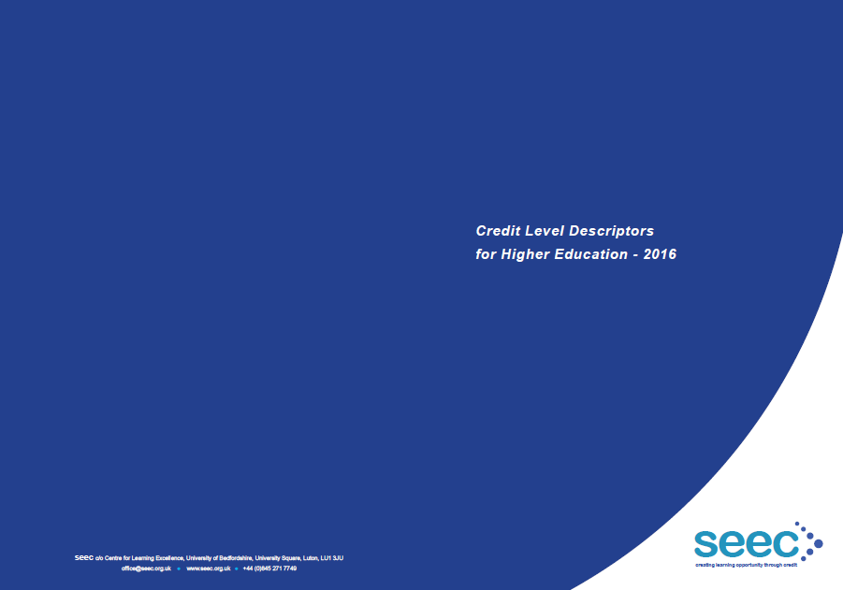

Task 2. Getting Level
Review the SEEC descriptors at your level in conjunction with the QAA Subject Benchmarks for your Discipline (if available) and make any appropriate notes.

Task 3. Construction Guide
Learning outcomes are commonly categorized into the general characteristics of learning such as (1) Knowledge & Understanding, (2) Cognitive & Intellectual Skills, (3) Key / Transferable Skills and (4) Practical / Subject Skills.

Part One: Action Verb
The first portion of a module learning outcome is the verb indicating what a learner is expected to be able to do. Benjamin Bloom (1956) published a classification exploring learning behaviours. As part of his framework he developed a number of "measurable verbs" that have been subsequently added to that are useful place to start when composing learning outcomes for modules.
It is important that you avoid the use of word and phrases such as:
understand, know, be aware of..., appreciate, become familiar with..., interest in..., feeling for...
These and many other verbs and phrases are not observable, measurable or universally understood.
Gronlund (1991) and others provides lists of measurable and observable terms (for the Cognitive Domain) that can be used in module learning outcomes which are based on Bloom's taxonomy. Verbs for the Affective and Psychomotor domains are also available.

Part Two: Object (‘What’?)
The second part of any good module learning outcome details the all-important ‘what’ - a phrase that indicates on what or with what the learner is acting.
- ...a constructively aligned approach to programme and module design...
- ...bonding schemes...
- ...common lawyer...
- ...the relationship...
- ...some simple search algorithms...
- ...as a member of a project team to...

Part Three: Nature, Context or Standard
Lastly a module learning outcome should finish with a phrase that indicates the nature (context or standard) of performance required. Attach the "nature" phrase to parts one and two of your outcome with some connecting words or phrases, eg.
- ...using Eurocode
- ...informed by the 6 UoB reference points
- ...to the analysis of a range of spoken and/or written texts
- ...to a standard commensurate with Level I
- ...in improved golf performance
- ...made by the body in response to exercise
- ...to simple organic molecules
- ...then use them to represent an arbitrary function as a Fourier series

Cognitive Domain Active Verbs
- Remembering
Define, describe, identify, label, list, match, name, outline, reproduce, select, state, recall, record, recognise, repeat, draw on, or recount.
- Understanding
Convert, defend, distinguish, estimate, explain, extend, generalise, give examples, infer, paraphrase, predict, rewrite, summarise, clarify, restate, locate, recognise, express, review, or discuss, locate, report, express, identify, describe how, infer, illustrate, interpret, draw, represent, differentiate.
- Applying
Apply, change, compute, calculate, demonstrate, discover, manipulate, modify, operate, predict, prepare, produce, relate, show, solve, use, schedule, employ, sketch, intervene, practise, or illustrate.
- Analysing cc
Analyse, break down, make a diagram, classify, contrast, categorise, differentiate, discriminate, distinguish, appraise, test, inspect, illustrate, infer, outline, relate, select, survey, investigate, make an inventory, calculate, question, contrast, debate, compare, or criticise.
- Evaluating
Appraise, assess, argue, compare, conclude, contrast, criticise, discriminate, judge, evaluate, choose, rate, revise, select, estimate, measure, justify, interpret, relate, value, measure the extent, validate, summarise.
- Creating
Compose, design, plan, assemble, prepare, construct, propose, formulate, set up, predict, deriver, elaborate, invent, develop, devise, rearrange, summarise, tell, revise, rewrite, write, modify, organise, produce, or synthesise.

Affective Domain Active Verbs
- This domain includes the manner in which we deal with things emotionally, such as feelings, values, appreciation, enthusiasms, motivations, and attitudes.
- Receiving phenomena
asks, chooses, describes, follows, gives, holds, identifies, locates, names, points to, selects, sits, erects, replies, uses.
- Responding to phenomena
answers, assists, aids, complies, conforms, discusses, greets, helps, labels, performs, practices, presents, reads, recites, reports, selects, tells, writes.
- Valuing
completes, demonstrates, differentiates, explains, follows, forms, initiates, invites, joins, justifies, proposes, reads, reports, selects, shares, studies, works.
- Organisation of Values into Priorities
adheres, alters, arranges, combines, compares, completes, defends, explains, formulates, generalizes, identifies, integrates, modifies, orders, organizes, prepares, relates, synthesizes.
- Internalizing values (characterization)
acts, discriminates, displays, influences, listens, modifies, performs, practices, proposes, qualifies, questions, revises, serves, solves, verifies.

Reality Checking: Are My LOs VASCULAR?
Sally Brown (2019) proposes putting the life-blood back into learning by using VASCULAR learning outcomes which are:
Verifiable? Can we tell when they’ve been achieved? And can students?

Action orientated? Do they lead to real and useful activity?

Singular? Avoid portmanteau outcomes combining two or more into one – these are difficult to assess if differently achieved. Outcomes should readily be matchable to student work produced.

Constructively aligned? so that there is clear alignment between aims (what do students need to be able to know and do?), what is taught/ learned, how these are assessed and evaluated.

Understandable? Are the language codes used meaningful to all stakeholders?

Level-appropriate? Suitable and differentiable between 1st year, 2nd year, 3rd year, Masters, other PG?

Affective-inclusive? Outcomes should not just covering actions but include capabilities in the affective domain (values, organisation, responding and receiving phenomena).

Regularly reviewed? It is important that outcomes are fit-for-purpose and therefore should not be stuck in history.

Read the whole blog piece here: https://thesedablog.wordpress.com/2019/03/07/sally-brown/

Stage 2 – Determine Acceptable Evidence (Assessment)
The second stage of backward design has teachers consider the assessments and performance tasks students will complete in order to demonstrate evidence of understanding and learning. In the previous stage, the teacher pinpointed the learning outcomes of the module. Therefore, they will have a clearer vision of what evidence students can provide to show they have achieved or have started to attain the outcomes of the course. Consider the following two questions at this stage:
- How will I know if students have achieved the desired results?
- What will I accept as evidence of student understanding and proficiency?
At this stage it is important to consider a wide range of assessment methods in order to ensure that students are being assess over the outcomes you want students to attain. Sometimes, the assessments do not match the learning outcomes, and it becomes a frustrating experience for students and teachers.

Task: Learning Goals Inventory
Complete the Learning Goals Inventory to help you explore / locate appropriate Learning Assessment techniques that you can use to help teach and assess how well students have achieved the learning outcomes.
Once you have your scores please review the Assessment Methods Mapping document and take an opportunity to explore and discuss methods.

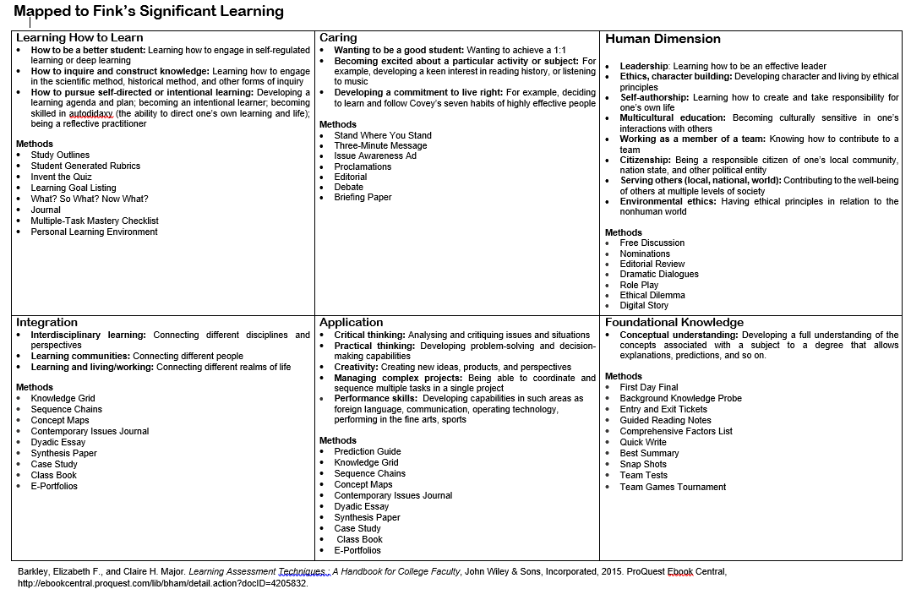
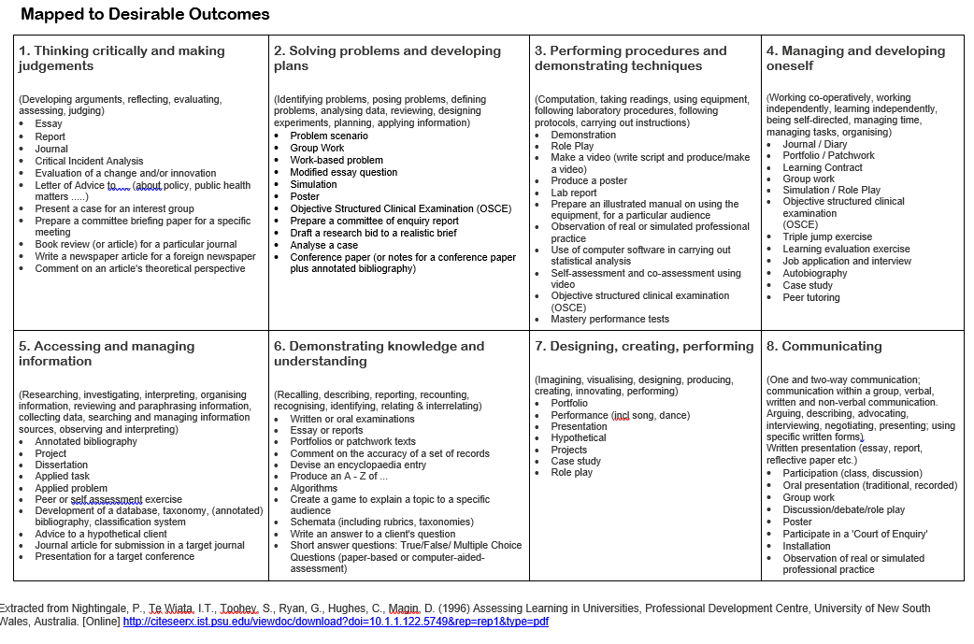

References
Anderson, L. W. and D. R. Krathwohl, Eds. (2001) A Taxonomy for Learning, Teaching, and Assessing: A Revision of Bloom's Taxonomy of Educational Objectives, New York: London Longman.
Bloom, B (1956) Taxonomy of Educational Objectives: The Classification of Educational Goals, New York: David McKay Co.
Clark, D (unknown) Bloom’s Taxonomy: Affective Domain, [Online] https://warwick.ac.uk/fac/soc/ces/news/mathematicsresilience/proceedings/bloomaffect_taxonomy.pdf
Gronlund, N.E. (1991) How to Write and Use Instructional Objectives. New York: Macmillan Publishing Co.

Further Reading
Baume, D (2009) Writing and using good learning outcomes, Leeds: Leeds Metropolitan University. [Online] http://eprints.leedsbeckett.ac.uk/2837/1/Learning_Outcomes.pdf

Author: Danielle M. Hinton, SFHEA
This framework was a key resource created as part of the “The Curriculum Futures Retreat”
a University Educational Enhancement Funded (EEF) project (Oct 18 - Jul 19)
Higher Education Futures institute
University of Birmingham

CC BY-NC 4.0: Attribution-NonCommercial 4.0 International

