Enhancing internationalisation and understanding of sustainability through a remotely delivered hands-on STEM challenge. Social Media as medium of Participatory pedagogy.

Gabriella Rodolico, Neeraja Dashaputre, Shanti Pise, Asim M. Auti, Juliana D’souza, Deborah Simpson, Shubhashree Madhavan, Victoria Doak, Vasundhara Patade, Darshana Kamat, Jennifer Lammey, Aimee Gallagher, Hermant Ghorpade, Vaishali Kamat, Shubhashree Madhavan, Tanali Bhattacharyay, Shirish Sant and Manisha Nahar

Introduction
STEM Education poses many challenges for teachers. Research shows that teachers are concerned about pedagogical challenges and lack of teacher support which could be overcome by promoting collaboration with peers, and effective professional development (Margot & Kettler, 2019).

An example of such collaboration in STEM Education is a sustainability project- STEM challenge called “Build your own sustainable house” (Rodolico, 2021a). This contribution is based on the STEM challenge model and on the international model recently developed by Dr Rodolico (Rodolico, Breslin and Mariani 2021b). It has been conducted in collaboration between the School of Education (SoE), University of Glasgow (UoG) and the Indian Institute of Science Education and Research (IISER) Pune. Participants’ experience on using social media, is clearly explained by their reflections.

STEM challenge participants’ reflections: Using social media to build professional conversation and knowledge exchange.

Positive considerations:

Social media like WhatsApp, blogs, Twitter, YouTube are part of the day-to-day life of learners, and this makes their use for active learning, knowledge exchange and collaborations quick and effective, allowing learners to express themselves, enhancing their learning experience (Natarajan, M., 2017). It can be intended as a participatory pedagogy where knowledge is co-constructed by participating in the learning processes and learners begin to see themselves as authentic producers of knowledge, sharing their student voice and representing their world view.( de Sousa, J., Loizou, E. and Fochi, P., 2019).

For example, we think that the STEM challenge workshops have been enriched by the creation of a large WhatsApp group and subgroups with tutors and participant teachers from both countries. This allowed to break the political and geographical barriers and brought teachers and instructors together, all sharing their research and finding in an ethos of equity and collaboration. We were able to instantly share pictures, videos , voice recordings even when we were in a hurry. The best feature was the recording function which facilitated instant communication, although every member would have the chance to work in their own time zone and regions (India and UK), by accessing the files at their own convenient time and still preserving the ethos of all professional discussion we engaged in.

We also exchanged knowledge not necessarily directly related to the workshops’ tasks, but still very precious source of cultural exchange, such as the Diwali celebration uses and Guy Fawkes Night fireworks which happen at similar times of the year and, although very different, they both are celebrated with lights and fireworks.

Negative considerations:
There are several limitations to be considered, WhatsApp might have data protection issues which are handled in a different way by different governments which react to changes in information by introducing data privacy regulations or laws. A clear example has been the different approach to the recent change in WhatsApp and Facebook data handling which affected EU/UK and non-European users in a different way (Lorico, 2021).

Zoom meetings generated a different opinion for different participants. For Indian partners for example Zoom meetings had a time limit of 45 minutes causing the disadvantage to have to re-join again every time. This was not the case for Scottish participants. On the other hand, Indian teachers had a more direct positive experience with Google meet while Scottish teachers can use TEAMS through their UoG account as well as Glow account.

Conclusions
Engaging in professional dialogue and practice via social media with international partners, as well as with colleagues from other local authorities’ schools has been considered hugely beneficial to the professional development of all teachers involved, with a focus on expanding knowledge and practice from other schools, institutions, curriculums and countries. This has raised awareness of positive learning experiences as well as barriers and challenges faced by children in other parts of the world. Furthermore, as most of the contact is done via social media allowed all participants the time to read, comprehend and respond to questions, queries and suggestions at times that were more convenient. Indian tutors commented that WhatsApp helped in maintaining day-to-day interaction with the participants towards building a relationship with them during and beyond the Covid-19 pandemic. Teachers in remote villages who might not have access to high bandwidth/ internet data, find it easier to communicate using WhatsApp. Very often, a WhatsApp video call is given preference over zoom call for smaller groups and to avoid video call fatigue. YouTube on the other side has been largely used not only for the STEM challenge video demonstrations, but also for other courses organised at the IISER Pune which gathered more than 1.5 million views and several projects-based collaboration opportunities with state government.

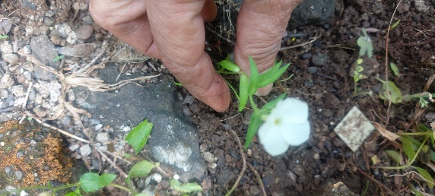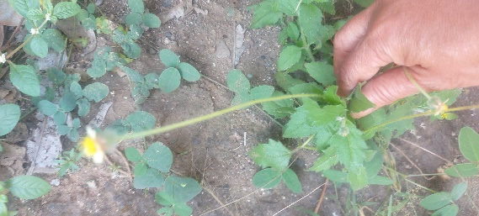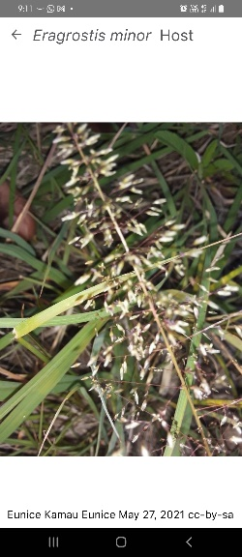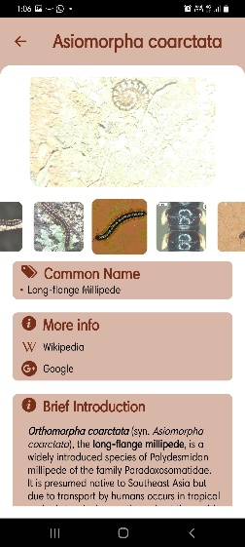
Figure 1. Example of pictures shared on WhatsApp while carrying out the biodiversity survey to design a sustainable house and discussing the Diwali.

References
de Sousa, J., Loizou, E. and Fochi, P., 2019. Participatory pedagogies: Instituting children’s rights in day to day pedagogic development.

Lorico,S., (2021). WhatsApp And the Question of Data-Privacy Models. The McKenzie Institute Canadian Security matters Accessed 04/11/2021 Available at : https://mackenzieinstitute.com/2021/01/whatsapp-and-the-difference-between-privacy-laws-in-the-world/

Natarajan, M., 2017. Exploring Knowledge Sharing over Social Media. In Harnessing Social Media as a Knowledge Management Tool (pp. 55-73). IGI Global.

Rodolico, Gabriella, (2021a), Bringing STEM and the Social Sciences Together, GTCS Magazine, April, Pg. 50-51. Avalable at https://edition.pagesuite.com/html5/reader/production/default.aspx?pubname=&edid=4125fc39-1e18-4e91-b9de-03ee94430da2

Rodolico, Gabriella; Breslin, Mark; Mariani, Annamaria (2021b): Social & Digital Change Symposium. An internationalisation experience via digital platforms. Edge Hill University. Media. https://doi.org/10.25416/NTR.16606220

Sharma, Jyoti & Yarlagadda, Prasad KDV (2018) “Perspectives of ‘STEM education and policies’ for the development of a skilled workforce in Australia and India”, International Journal of Science Education: Vol. 40 (16), 1999-2022, 2018.
Available at: https://doi.org/10.1080/09500693.2018.1517239

Srikoom, W., Faikhamta, C., & Hanuscin, D. (2018). Dimensions of effective STEM integrated teaching practice. K-12 STEM Education, 4(2), 313-330.

Available at: https://nsuworks.nova.edu/transformations/vol3/iss1/4

