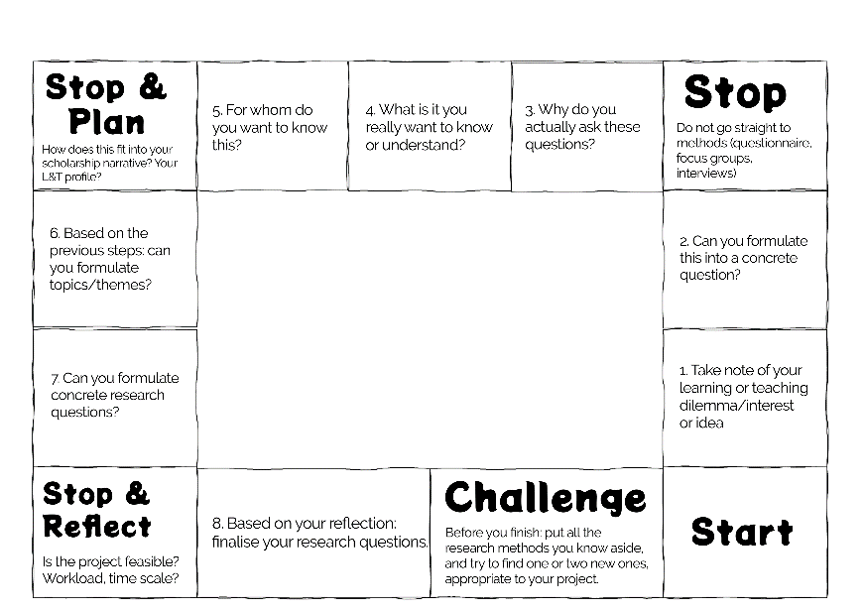

Questionopoly Instructions

Welcome to Questionopoly.
  - Aim
The aim of the game is to help you develop and finalise your research question. You are encouraged to keep notes while you go through the game which will help future you to write up the project for publication and fill in the ethics forms.
How to play
You can use this for self-reflection or get together with your peer group, research collaborators, Scholarship of Teaching and Learning colleagues, and go through it together.
As you move through the game you can drag and drop (online) or place (print version) one of the motivational cards over each section you have addressed.

  - Play time (still have to experiment)
Let me know how long it took you to play and with how many players you played.

Enjoy!

