A Guide to Inclusive Lecturing Practices
Document Created By Kaye Bennett, Department of Chemistry, University of York
(Last Updated: 06/09/2021)

Introduction
It would be unreasonable to make every lecturer present their lecture courses the same way, especially as they all have their own way of teaching. However, students all have their own way of learning and some of the ways lecturers present information can either benefit or hinder the students’ ability to learn and understand topics.
This document will collate examples from a real lecture course to show some of the things lecturers could be doing to be more inclusive and to highlight the things they are already doing well. It will also cover things that may only be applicable to online lectures or when the in-person lecture is uploaded to Panopto, as, in these cases, it is still the responsibility of the lecturer to be inclusive of all students.

This document was created in accordance with the Department of Chemistry’s accessible document formatting.
Department of Chemistry Accessibility Guidelines and Resources: https://www.york.ac.uk/chemistry/chem-intranet/staff-intranet/supervisor-tutor-toolkit/accessibilityguidelines/

Images were taken from Dr. Derek Wann’s lecture course with his permission.

Captioning
It is extremely important to caption online lectures and recordings accurately, however, some captions are deemed unnecessary and can make understanding information more difficult. This is why it is necessary for either the lecturer or a paid captioner to go through the recording to ensure accuracy even if the video was close-captioned.
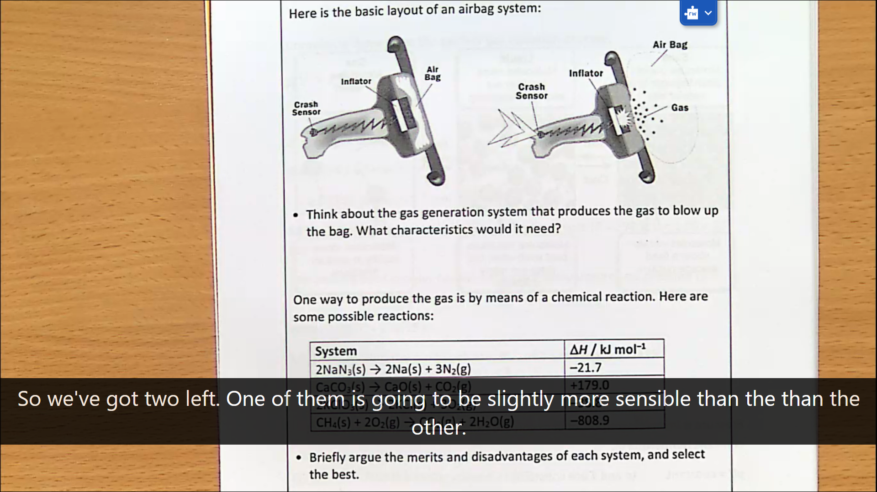
In this example, someone has gone back through the recording and rewritten the captions, however they have kept in a stumble in speech from the lecturer. This isn’t particularly hindering understanding of the subject but could make it more difficult to follow especially for those with processing difficulties and dyslexia. Unless it is needed for effect, avoid including stumbles or stutters in captions, and just keep the sentence you were trying to convey.

Coloured Pens
Coloured pens can be a very useful tool when making notes, either to create emphasis or to make the information being presented easier to understand. However, when presenting using a visualiser and projector those colours can seem to vanish or lose their contrast.
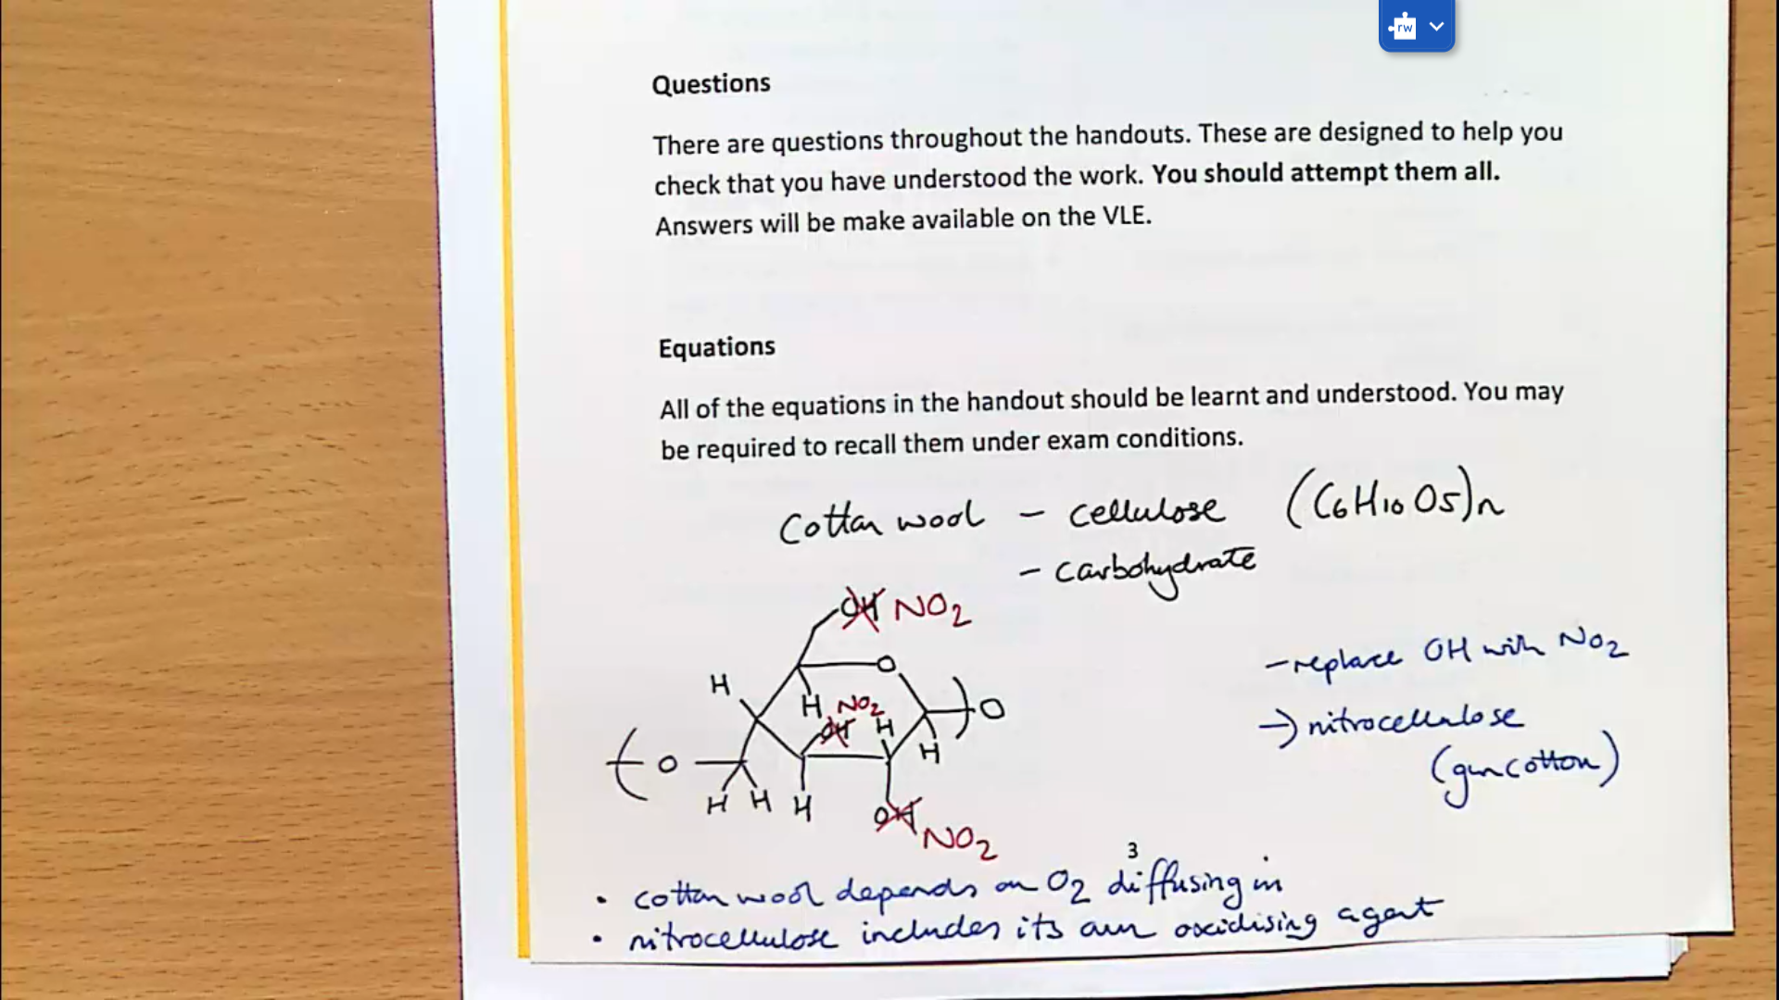
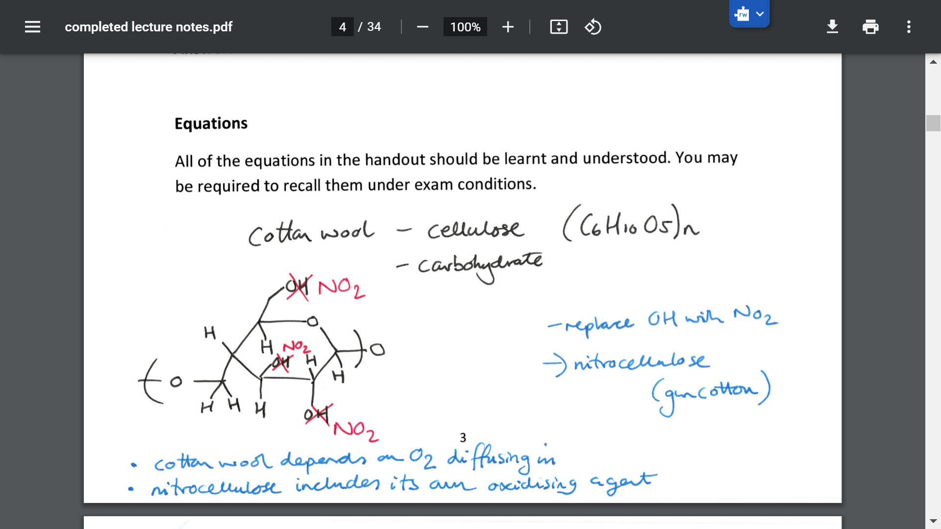
As you can see in this example, the lecturer has used different pen colours to note the difference between different biological molecules, which can be easily seen by the scanned copy of the handout (bottom). In the screenshot taken from the visualiser (top) these high contrast colours are no longer visible and now look very similar. When using colours it is important that they are high contrast and easily distinguishable by the audience. Red and green contrasts should also be avoided to include those with colour blindness and low colour acuity.

Demonstrations
Demonstrations can be a really useful tool when trying to explain a new concept to students, they also can increase engagement especially if the topic area is heavy going. When wanting to show a demonstration lecturers should try to consider a few things first. As the point of live demonstrations is that they are (usually) visually stimulating, it needs to be considered whether someone at the back of the audience or a visually impaired student would be able to see what was happening. For a live demonstration it would be best if it could be viewed through the visualiser or is large enough to be seen in a large lecture theatre.
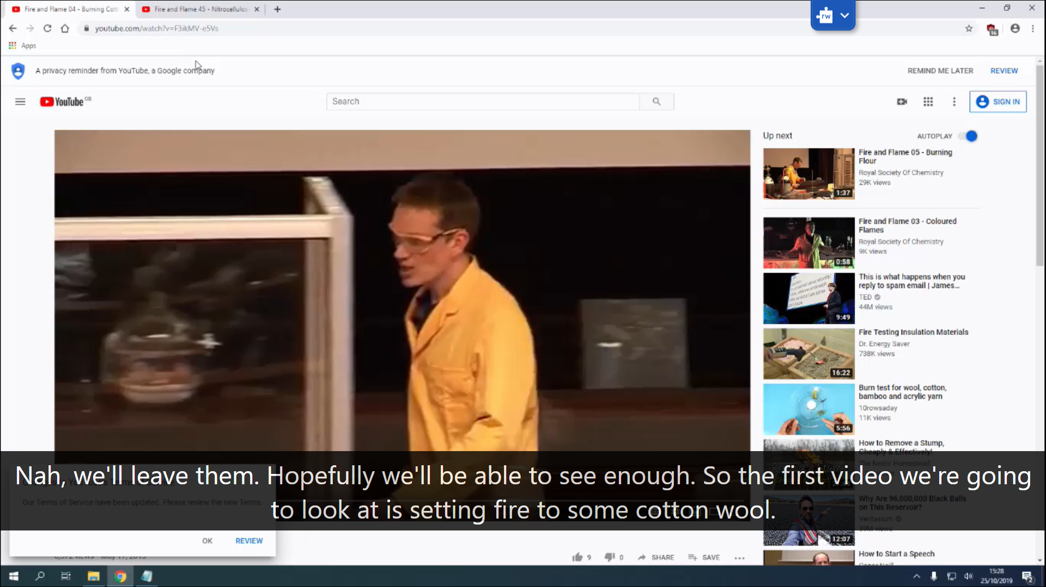
If this isn’t possible, or there are safety concerns, a good alternative would be a video of the demonstration with captions and an audio description of what’s happening whenever applicable.

Handwriting
A lot of lecturers find writing on handouts or writing their own notes whilst presenting favourable but there are definitely things to consider when doing this, most importantly of which are size and legibility. Those who handwrite notes tend to lean toward using cursive as it is faster, however this does have a downside as it can be much harder to read and copy quickly. Printing extended pieces of text can also pose issues for those with dyslexia, so writing in sentence case with little to no joining is preferable.

Laser Pointers
Laser pointers and pointer sticks can be useful when presenting to a large group and wanting to draw their attention to particular information. When using these tools ensure the audience is aware of what you’ll be using and how at the start of the presentation as students who are visually impaired or at the back of the group may miss the emphasis or piece of information if unprompted to look for these cues. Also it is important to hover the laser or stick over the information for enough time for students to locate the information on the board and take it in. It would also be good to avoid using lasers that are the same colour as the background of the presentation to increase contrast and visibility, and using red lasers on green backgrounds (and vice versa) to help those with colour blindness.

Questions/Answers From Audience
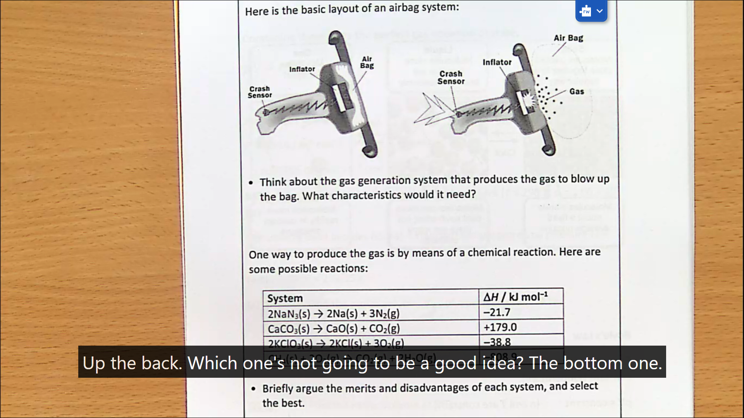
In this example the lecturer asks a question to the students and in the recording it isn’t possible to hear the response, which means it’s likely that other students that weren’t immediately around the answerer also didn’t hear. This is why it is important for lecturers to do what was done in this instance, to repeat what a student calls out to ensure that it was heard by everyone and can be captioned.

Speaking to the Audience
The majority of the lecturer’s job when presenting is talking to the audience, and ensuring that everyone can be included in the spoken information is to speak directly to the audience. All important and necessary information should be delivered facing the audience as it makes what’s being said clearer and it is useful for those who need to read lips to hear or process information.

Timing
All lectures are recorded on Panopto, and for a multitude of reasons students may opt to watch their lectures using these recordings. This means that these recordings must contain all the information given in the live lecture that is core and necessary. The best way to ensure this is for lecturers to keep their lectures within the 50 minute recording time, however if this is not possible for whatever reason, a supplementary video explaining the missed information should be included on the VLE.

Two Delivery Modes
For a document to be considered inclusive it needs to appear in at least two different formats, this could be written and spoken, tactile and drawn or any combination of two or more communication types. In terms of lectures these are referred to as delivery modes. It is important that any written information or diagram in the handout/presentation is described verbally and meaningfully so nothing is missed by students who are primarily listening or reading. This also means anything that is said, and is considered to be core material that can be assessed, should be written in the handout/presentation.
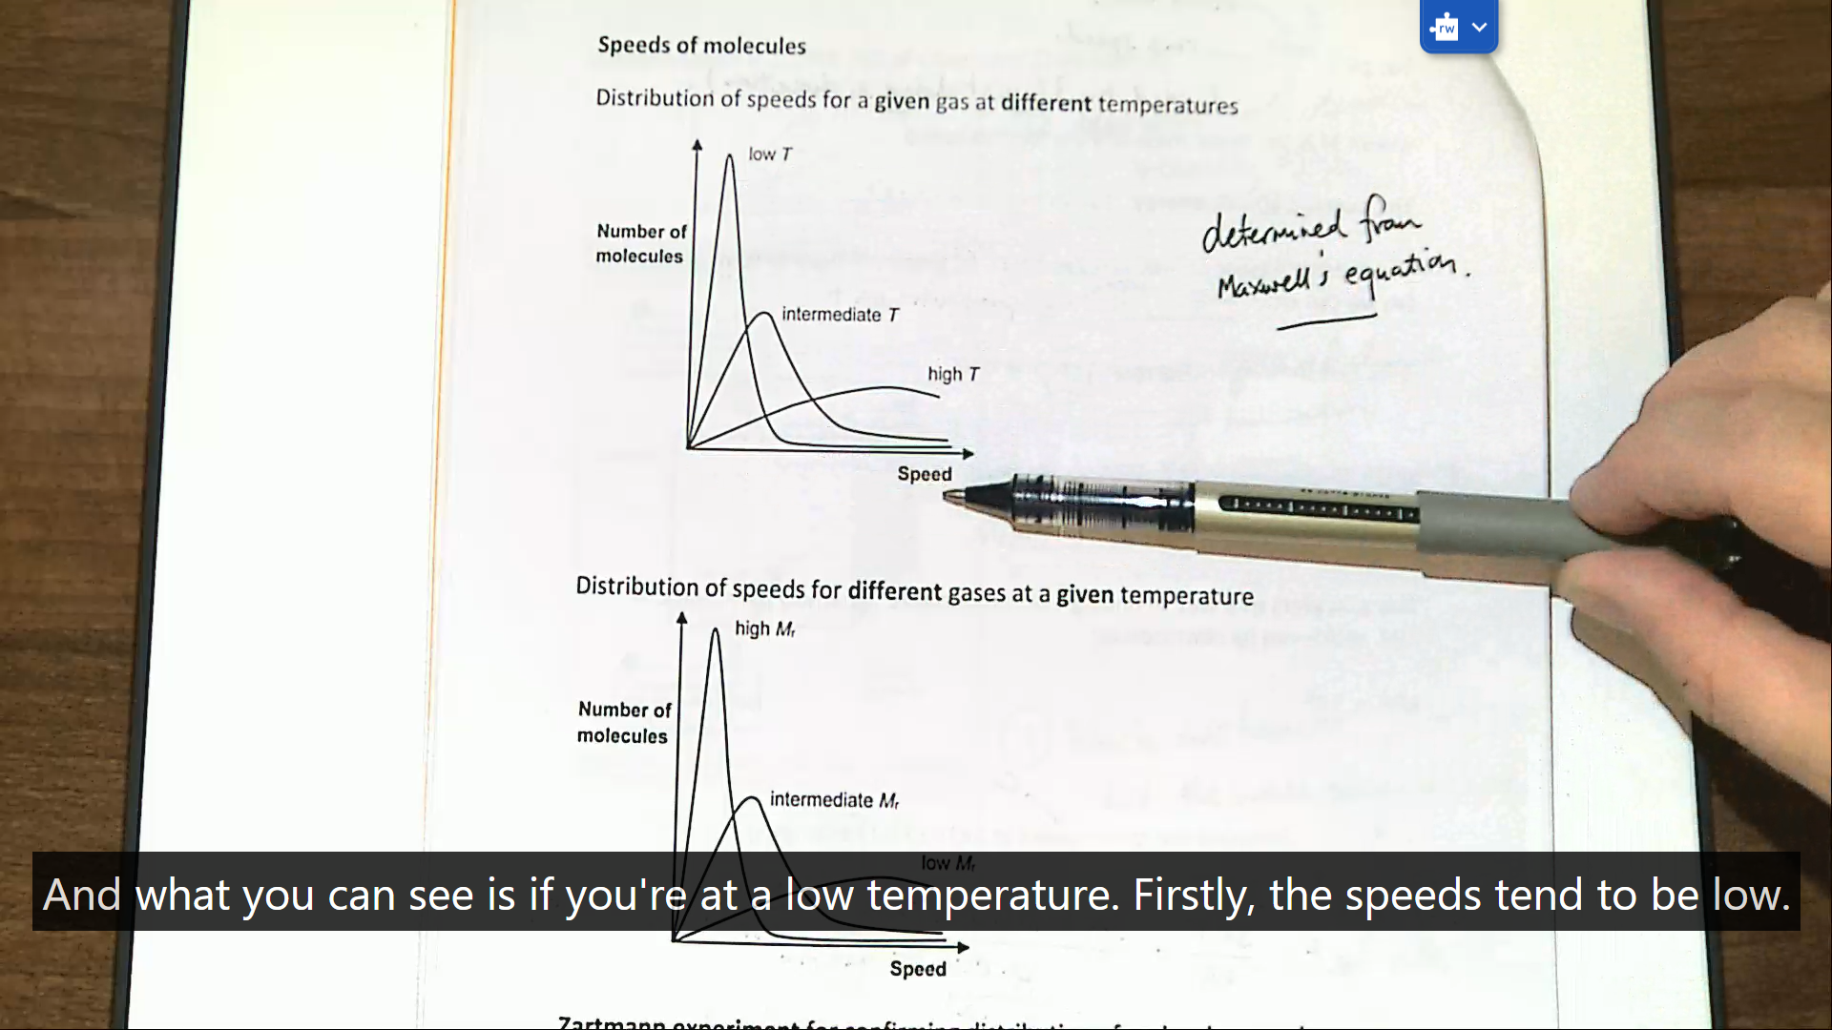
In this example, the lecturer is verbally describing exactly what is happening in the diagram to the audience in a meaningful manner. This is directly helping people understand what the diagram is showing as well as being a useful description to visually impaired students who are unable to see the diagram.

