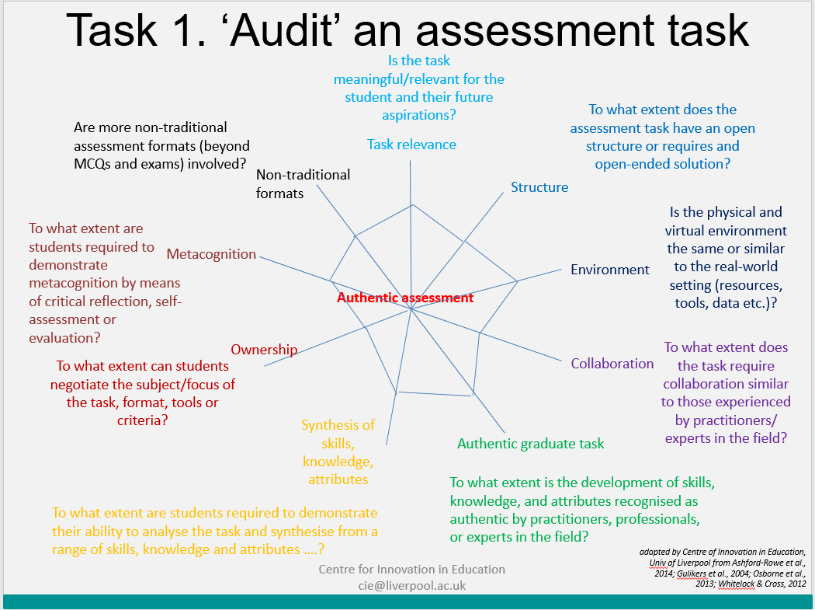
- Task relevance: The task is meaningful in the eye of the student, and relevant to their future aspirations;
- Task structure: Authentic assessment typically involves tasks with open structures or open-ended solutions, which require the student to draw knowledge and skills from multiple units of learning already undertaken (e.g. modules);
- Environment: Authentic assessment often takes place in a similar or simulated environment to the real-world setting, drawing on resources and tools appropriate to that environment, e.g. documents, data, digital tools or research;
- Collaboration: An authentic assessment task typically involves collaboration similar to that experienced by practitioners, professionals, or experts in the field.
- Authentic graduate task: Authentic assessment requires the development of knowledge, skills, attributes, products or performance that could be, or is, recognised as authentic by a practitioner, professional, or expert in the field;
- Synthesis of skills, knowledge, attributes: Students are required to demonstrate their ability to analyse the task and synthesise, from the range of skills, knowledge and attributes that they have acquired, those which will be necessary for the completion of a specific outcome;
- Metacognition: Authentic assessment requires students to demonstrate metacognition by means of critical reflection, self-assessment or evaluation. As such, it usually involves elements of self- and peer-review as an explicit part of the assessment process;
- Ownership: Typically, students will have a degree of ownership of/within the task. For example they may negotiate the subject focus of the task, or have freedom in choosing the format, tools used or assessment criteria;
- Non-traditional formats: Authentic assessment is usually presented via more non-traditional assessment methods (e.g. beyond exams and MCQs) and at different assessment points (versus a one-off).

