COMING TO A RAILWAY STATION NEAR
YOU IN SEPTEMBER 2014

OVER BY CHRISTMAS

Written by Helen Newall. Original Music by Matt Baker.

A choral commemoration featuring words and songs of the First World War, performed by actors, singers and musicians from across Cheshire.

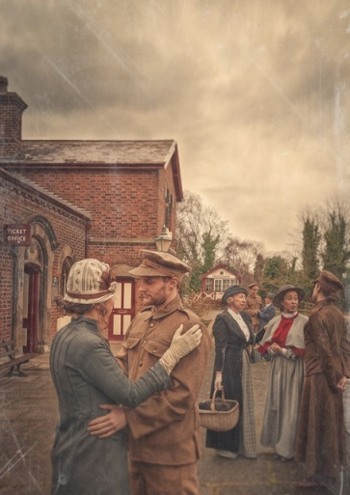

Over by Christmas is a site-specific production taking place in railway stations throughout Cheshire, which captures the spirit of optimism and patriotism of soldiers leaving for the front in autumn 1914. A community choir of ‘soldiers’, ‘nurses’ and their loved ones will recreate the departure through well-loved songs of the period, accompanied by live musicians. These free events are part of the Imperial War Museum’s First World War Centenary project, and will bring together people from the Cheshire region as both performers and audience members.
Established in 2005, Theatre in the Quarter works with professional actors, experienced creative teams and members of the local community to make high quality, original music theatre. Often performed in new, non-theatrical spaces, its work is inspired by the lives and experiences of the people of Chester and surrounding areas. Theatre in the Quarter also has two thriving Youth Theatres, which are specifically focussed on enabling young people to make new and exciting theatre with music. During 2014, over 700 people of all ages will participate in Theatre in the Quarter’s projects.
Over by Christmas is created by Theatre in the Quarter’s Writer-in-Residence Helen Newall, and the company’s founder and Artistic Director, Matt Baker. As well as being an acclaimed playwright and librettist, Helen is also a Reader in Performing Arts at Edge Hill University; and makes sound and visual installation work, digital sceneography and experimental visual narratives for performance. Matt is also Director of Theatre in the Quarter’s young people’s group Jigsaw Children’s Music Theatre and Director of award-winning Chester-based community choir A Handbag of Harmonies. He was composer for the highly successful Chester Mystery Plays 2013; and has worked extensively as a composer and musical director, including productions for the Dukes Playhouse, Lancaster and Nuffield Theatre, Southampton.

www.theatreinthequarter.co.uk www.facebook.com/theatreinthequarter @TintheQ

