Amy Friend

"In my use of the photographic medium, I am not specifically concerned with capturing a "concrete" reality. Instead, I aim to use photography as a medium that offers the possibility of exploring the relationship between what is visible and non-visible. I have been working on the Dare alla Luce series over a period of time; initially I responded to a collection of vintage photographs, retrieved from a variety of sources both personal and anonymous. Through hand-manipulated interventions I altered and subsequently re-photographed the images "re-making" photographs that oscillate between what is present and what is absent. I aim to comment on the fragile quality of the photographic object but also on the equal fragility of our lives, our history. All are lost so easily. By playing with the tools of photography, I "re-use" light by allowing it to shine through the D holes in the images. In a somewhat playful and yet, literal manner I return the subject of the photographs back to the light, while simultaneously bringing them forward. 'lhe images are permanently altered; they are lost and reborn, hence the title, Dare alla Luce, an Italian term meaning, "to bring to the light".

The photographs have new meaning, despite the mysteries they harbour. The title of each piece is significant; some titles were taken directly from the notations found written on the photographs, yet those without any indication of provenance were titled to reference the nuances of photography as a medium and the manner in which we interact with these images.

As I continued to work on this series, I became more aware of the weight each photograph carries. They display moments of love, excitement, solitude, tranquillity and fragments of stories that will remain unknown. These photographs are fragments of everything and nothing.

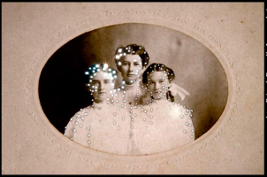

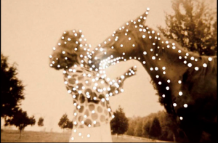

COMMENT
I find these images absolutely beautiful. They engage with light in an ethereal and symbolic way, and also in a pragmatic manner, reminding us that chemical photography is the action of photons on chemically treated paper. As with the images I have collected, their subjects, because they are anonymous (at least to us if not the artist) have the potent poignancy of nostalgic loss and lost time about them. These are the elegiac fragments of long gone and irretrievable moments.
I had every intention of experimenting with similar processes with the photographs I had bought. They are easily come by: eBay is just one source of readily available cartes de visite and cabinet photographs of people whose identities have fade away. I have stacks of them. In the end, I found it impossible to cut into them. I think I have positioned them in my mind as documentation: as fragile evidence of the historical existence of their subjects, and as such, I feel I cannot alter them physically because I construct this action as damage.
This is not to say that I disapprove of Friend's actions. These are recycled, repurposed images: she has taken them out of obscurity and brought them back into the light.
Friend notes the fragility of photographs as documentation, saying that they are 'lost and reborn', and that she uses notes written on the backs of photographs to title them. This of course resonates with my work.

Colette Saint Yves
"Since her childhood, Colette is interested in moving and immobile images. She uses different medias to produce her work: video, photography and collage. She is a huge images collector: found photos, postcards, old illustrated books, screencaps. They are the relics that shape her world, She feels reassured surrounded by them."

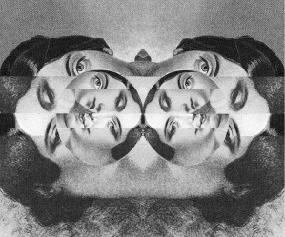

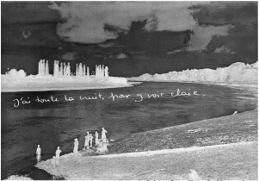

COMMENT
I find the stills engaging, but the moving images, while interesting, are not as engaging to me as they might be, because, while there is a postmodern disassociation at play which I find fascinating, the images do not involve me as a viewer as fully as they might: I find my emotions are not engaged. The images remain distant.
In my work, and specifically in Remember Me, I seek an emotional engagement with the subjects.
What is interesting in Saint Yves's work is the collision of image with sound, something that is paramount to the work I am creating. One of her works begins with the postmodern foregrounding of the sound of a needle on a gramophone. Another, Nitrate, mon amour, uses a classical music soundtrack overlaid with fragments of dialogue, in English and French, from classic movies. The images consist of a sequence of black and white movie clips of faces; of a woman disrobing; of people kissing... It's a dark and disjunctive world, unsettling and distancing. The juxtapositions are fascinating.

José Romussi

My work is a constant search to express and represent my ideas. My occurring artworks are a reaction of my inspiration. This starts with an image, that inspires me in certain way to do an embroidery that changes it into a new one. I am always searching for a new sense of interpretation for my pieces. My technique for that is using thread as the medium to merge different time spaces. I am not afraid of breaking a picture, the important thing for me is using embroidery, a technique not usually used on paper, to do it on a photograph, because this is a part of the process. I intervene images by applying my own perception of beauty to them. Sometimes by giving them a new identity or a different aesthetic concept. It's the chance to give this image a new emotion, a new life, a new interpretation of beauty through embroidering.
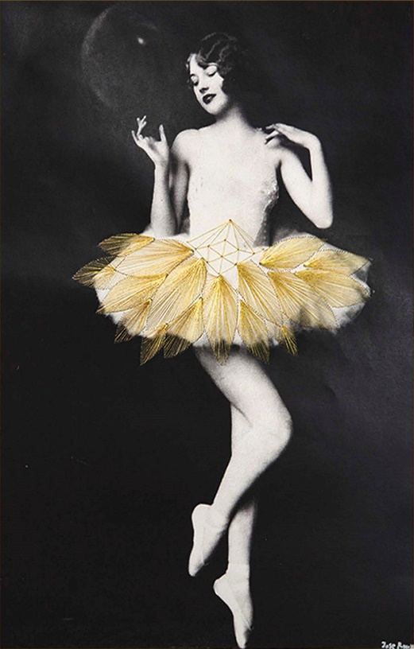

COMMENT
I adore these images. I am interested in the fact that in his stitching of these objects, there is a wonderful disruption in the sterotype of stitching and embroidery as feminized activity. Romussi's Dance series foregrounds the costume as part of the dance. One might also say, that since they are separated from the image by being part of the physicality of the paper of the image as opposed to the subject of it signified in light, they make ludic interrogation of what is real and unreal, of colour and monochrome, of presence and absence; of signifier and signified. They also interrogate notions of photography as documentation: these are photographs, but these are not the costumes the dancers wore as they were captured on film.
Recent academic initiatives in a new critical engagement with costume began at Edge Hill University two years ago with the 2014 Critical Costume Conference, and were advanced this year in Helsinki. It strikes me, that as an aesthetic comment on the beauty of costume in dance, Rosmussi is engaging with photography, documentation and notions of real and imagined costume.
As with Friend's images, I wanted to play with making some similar experiments, but failed to summon the courage. Romussi does speak of 'breaking' the picture. Piercing the card of 100 year old images feels like a sacrilege to me. Since they are all now captured digitally, perhaps I should print some out and see what happens. I note that the image shown here also exists with different coloured thread. Perhaps Romussi too is not using originals but reprints...

Lynn Skordal

"Most of my pieces involve old-style scissors-and-paper collage, a humble but immensely satisfying medium. I like the process of combining seemingly unrelated images (old photos, magazine clippings, colored bits of paper, images found in old books or on the internet) into a different reality that might startle, amuse or provoke. I live and work in the s Pacific Northwest, on an island in the middle of a lake, surrounded by a big city. www.regularpaper.blogspot.com www.lynnskordal.paspartout.com"

COMMENT
Skordal's images play with the dream-like narratives that arise from strange juxtaposition. I love this. She also makes art books using embroidery, collage and paper cutting. This foregrounds the physicality of the book and the artwork in an increasingly digital world which makes me feel a certain amount of guilt for not taking the risk of making physical artworks out of the images I have found, although they are the ghosts in a physical site-specific host. There is pleasure in the manual work of art which I find that digital creation cannot quite equal. Making things with our hands is primeval. For this reason, it's always been important to me that there is a physical host for the film work I am making. The films will be viewed in a physical setting using real vintage artefacts to host the digital work.
Skordal's imagery is surreal, dream-like, sometimes disturbing, always hypnotic. She combines images in a dialogic construction, so that there is dialogue between the different fragments. The bears and the boy appear to be in a communicative relationship. There is here not quite the harsh and brutal postmodern disconnect of the collages of Colette Saint Yves. Skordal's images aren't always as 'fluffy' as this one: others are as unsettling as nightmares...
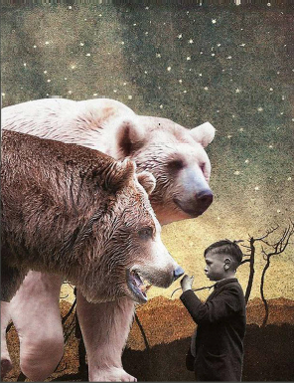
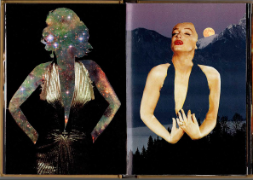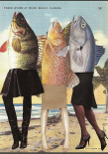

Maurizio Anzeri

"Maurizio Anzeri makes his portraits by sewing directly into found vintage photographs. His embroidered patterns garnish the figures like elaborate costumes, but also suggest a psychological aura, as if revealing the person's thoughts or feelings. The antique appearance of the photographs is often at odds with the sharp lines and silky shimmer of the threads. The combined media gives the effect of a dimension where history and future converge. The image used in Round Midnight is an early 20th century 'glamour shot' that at the time would have been considered titillating for both the girl's nudity and ethnicity. Anzeri's delicately stitched veil recasts the figure with an uncomfortable modesty, overlaying a past generation's cross-cultural anxieties with an allusion to our own.”

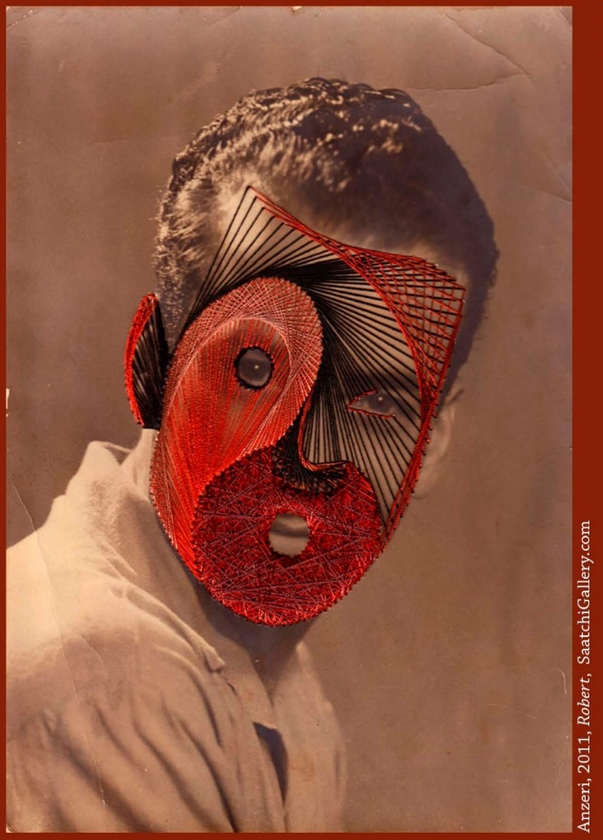

COMMENT
I can see the skill. I can appreciate the textures and the lines of visual flow created by Anzeri, but this work leaves me somewhat disengaged. It did however leave me wanting to 'have a go'.
The image shown, Robert, is one I quite like, possibly for the colour. The commentator at the Saatchi Gallery suggests the antique photo and the silky threads are at odds for textural reasons. Perhaps. For me, the silky threads are at odds with the antique appearance of the photographs because they are so disparate from its mode of creation and presentation. The embroidery here is functioning as a mask over someone whose identity is offered in the title of the work.
Since I've gone through my project, the shifts to the photographs I am working on have become more and more subtle, through the desire to not physically alter them, but also out of respect for the original subjects. I want viewers to be able to see what the photographers and the original owners of the photographs would have seen. The physical artefact is a connection back to them.

Rino Stefano Tagliafierro
"When I look at a painting, I imagine the previous moment and 1 the one coming afterwards, like in photography. Apart from few exceptions, I never show the action, but rather extend the moment framed by the artist, an extension of their feelings. I like the concept of time being dilated, but in the case of Beauty, I was never arrogant enough to add something to what the author of the painting had created."

COMMENT
This is simply beautiful. The first time I watched it, I was mesmerised. And after a second viewing, I knew I wanted to animate stills. There is something elegiac and mesmeric about the slow movement. Faster movement, even normal paced movement when animating stills, takes us into Terry Gilliam territory, and the pace of comedy. Where tragedy is slow motion, comedy is speeded up. Think, for example of Benny Hill. His speeded-up film routines took their cue from the pace of the old black and white movies: Chaplin, the Keystone Cops etc. Although, of course, the speeded up pace was in fact due to the discrepancies between the cameras and projectors on which these old films were made and viewed, and the technologies upon which they were subsequently viewed when the older projectors had become obsolete. So, the comedy had originally been slower paced. Nevertheless, the lesson here: too much movement would be unintentionally funny: I had to avoid what I am beginning to call the Captain Pugwash effect. In Tagliafierro's film Twister, the animation of still images, is even more subtle than in Beauty and is thus extreme slow motion, and unsettling. We are approaching the territory of Masahiro Mori's Uncanny valley.

My process in Photoshop and After Effects has been the same as Tagliafierro's, as described in his interview with Alessia Gargiulo. His film enjoys a dense soundtrack which amplifies the lush effect of the visuals. I commissioned a sound artist to make an accompanying track for my own work. This has been developed alongside the creation of the visuals, with sounds responding to the atmosphere of the sections within the filmwork, although not specifically to certain actions, because we were creating simultaneously, and things were changing all the time. But we are collaborators of old and there is deep mutual trust...
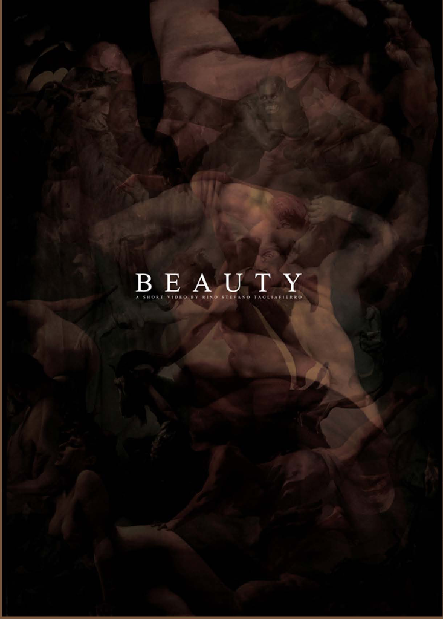

Yorgo Alexopoulos
"Yorgo Alexopoulos is a New York-based artist best known for combining a variety of media into immersive fine art installations and artworks. He makes works of art by fusing his own paintings, drawings, photographs, and films with digital animation and sound. He often creates his artworks by combining and synchronizing multiple monitors or projections. Alexopoulos' artworks often touch upon transcendental themes."
"You can hypnotise the audience with just a still image. Using the Kid Stays in the Picture technique, which is basically creating a parallax on the photograph, and creating spatial imagality [sic] out of it, you can create subtle nuances in the still image to create this three-dimensional effect. For me it was a huge epiphany. Because I realised that in doing this effect on my own images, I could then start to create narrative artworks that expressed what my interests are as an artist."

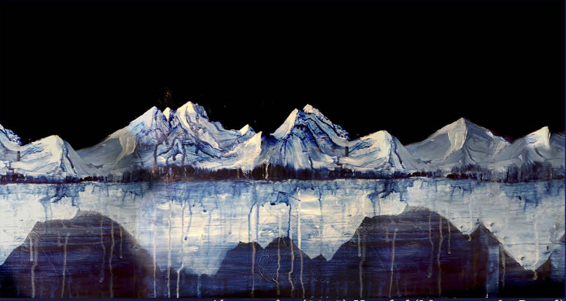

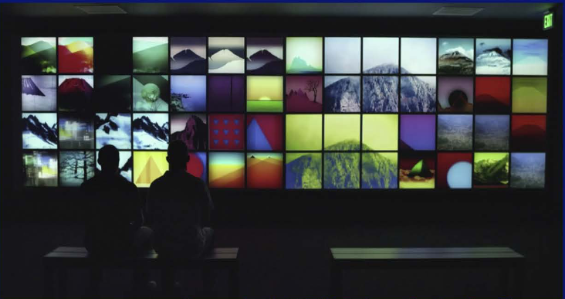

COMMENT
Alexopoulos's installation work is a stunning synthesis of multichannel multimedia projection and digital flat screen work. He combines his own photography, paintings, drawings, and digital animations with soundscapes to offer his audiences a haunting postmodern immersive experience. The results are truly beautiful. His artistic identity was consolidated after he worked on Brett Morgan and Nanette Berstein's award winning film, The Kid Stays in the Picture (2002), a documentary feature about Paramount producer Robert Evans, and which extensively deployed the parallax effect on the stills in the visual narrative. Testifying to the influence of the Morgan Bernstein film, the parallax effect, sometimes also referred to as the 2.5D effect because it resides between 2D and a true 3D, is often also called 'The Kid Stays in the Picture effect'. Matthew Fuller comments: 'You see it in documentaries all the time. It's a pretty common technique, and I think becoming the standard for how stills are treated in motion pictures' (2012: online).
Alexopoulos himself says: "I had a rich arsenal of images... photographs, paintings, drawings... and for years I hadn't really known what to do with it. I'd been looking for this artistic voice, and after working on The Kid Stays in the Picture, it all came together" (2013, The Creators' Project). His breakthrough is to use the parallax or 2.5D effect on photographs combined with paintings and drawings.
The combination across multi-screens is mesmeric. His work inspires me to work with the technique beyond this project on my own arsenal of images and photographs. His use of sound to amplify the visual effect is not noted in any of the commentaries I found but is also surely significant.

Joe Mellows / Make Productions
Joe Mellows is the founder of Make Productions, a design and motion studio based in London specializing in creative video content, animation, motion graphics and visual effects.

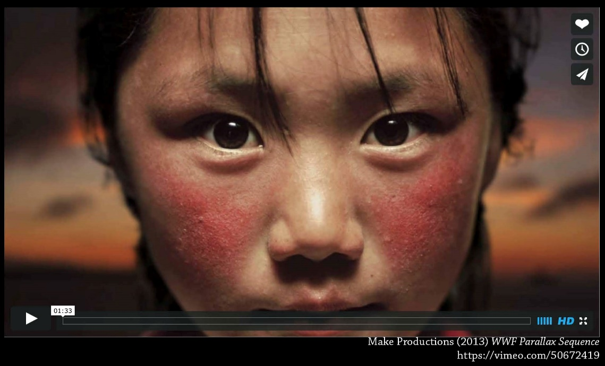

COMMENT
Joe Fellows's work for Ad Hoc Films and the World Wildlife Fund resulted in a powerful montage of animated stills called WWF Parallax Sequence and made from stills
in the photographic archives of the WWF, and which quickly went viral shortly after it was posted online. I remember seeing it at the time, and thought it was made with the extreme slow-motion technology that high frame rates of filming make possible. The term 'parallax sequence' meant nothing to me at this juncture! But Fellow's technique in fact paid homage to Alexopoulos's The Kid Stays in the Picture method, and the sequence was made via the deployment of multiple Photoshop layers for each image, with the 2.5D technique added in After Effects. The sequence caused such a stir that Fellows made a short how-it-was-made movie for The Creators Project, outlining how to shoot a suitable shot, making the plate in Photoshop, and virtual After effects camera techniques. He followed it up with a second instalment dealing with luma masks shortly after.
What is impressive is the quality of the shots selected for the sequence, and the ambition of the movement created: some sequences are as if taken in extreme slow motion. I want to foreground the 'photographic still'
quality of the images in my selection, so while I feel sometimes I could have pushed more movement in certain sequences, I feel that this would have foregrounded the 2.5D technique at the expense of the effect I was seeking which was not extreme slow mo, but photographs that breathe. Nevertheless, I'm keen to try this level of movement in future projects.

Jane Long
"Costicä Acsinte's black and white photos, taken almost 100 years ago, become the current canvas of Jane Long's photos. Now we start observing two stories, one about childhood, teenagers, marriage, happiness or the first World War as reflected in Romanian lives overseas and the second story, more suitable and updated to current realities, sometimes more sophisticated and going far away from the original photo. It's also important to acknowledge contemporary passionate Romanian photographer Cezar Mario-Popescu, who recovered and restored more than 6000 Costicä vintage photos"
'I wanted to change the context of the images,' says Long. 'Photographic practices at the time meant people rarely smiled in photos but that doesn't mean they didn't laugh and love. I wanted to introduce that to the images'.
The series has had its controversies with some people suggesting it is disrespectful to use images of people she doesn't know.
'On the contrary!' she responds. 'I wanted people to see these figures as real people, more than just an old photograph. Adding colour completely changes our perception of images.'
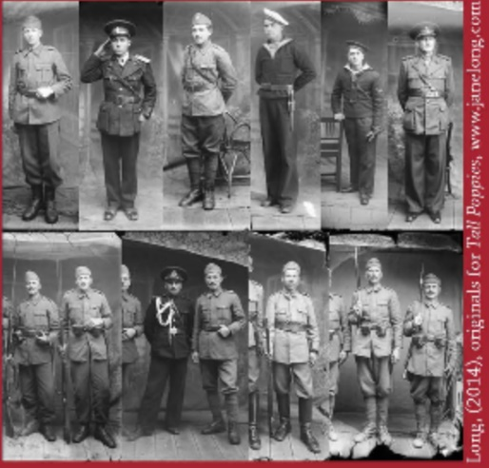

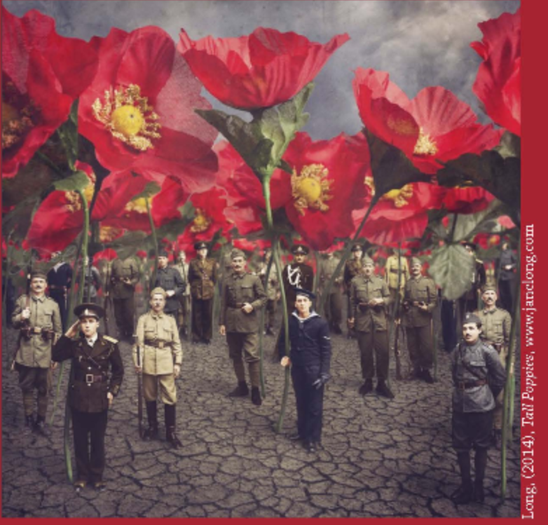

COMMENT
Jane Long's work in her Dancing with Costicä project involves taking photographic stills from the Costicä Acsinte Archive, published in the Flickr commons, and collaging and re-imagining them into surreal and parallel Photoshopped worlds. The image shown here was selected for its obvious parallels with a similar sequence in Remember Me, although, I must stress that I had decided on this configuration before I encountered Long's image. But this structure of assembly of disparate fragments is, after all, a deeply fundamental archetype of collage work: and such photographic collages were extant early in photography's history, as exemplified in the publication in 1867 of Celebrities in the Church, Science, Literature and Art, Photographic Groups of eminent Personages (cited in Hamilton & Hargreaves, 2001: 38-39); and exemplified throughout time in images such as Jann Haworth and Peter Blake's 1967 cover for the Sergeant Pepper's album.
Further synchronicity: Costicä Acsinte was himself an official war photographer during World War 1. And the doubts some have had about using images of unknown people is interesting, paralleling as is does my own sensibilities in dealing with the collection I have assembled.
I am interested in the ethical concerns some had about her actions in collaging and altering photographs. I felt similar things about respect towards my anonymous subjects.

