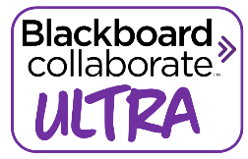Top tips for using Collaborate Ultra with your students
Virginia Kay

- Before the session, go into the Collaborate area and give yourself time to complete the tutorial. This is really helpful, especially if you have not used this platform for teaching before. A quick overview of this is below

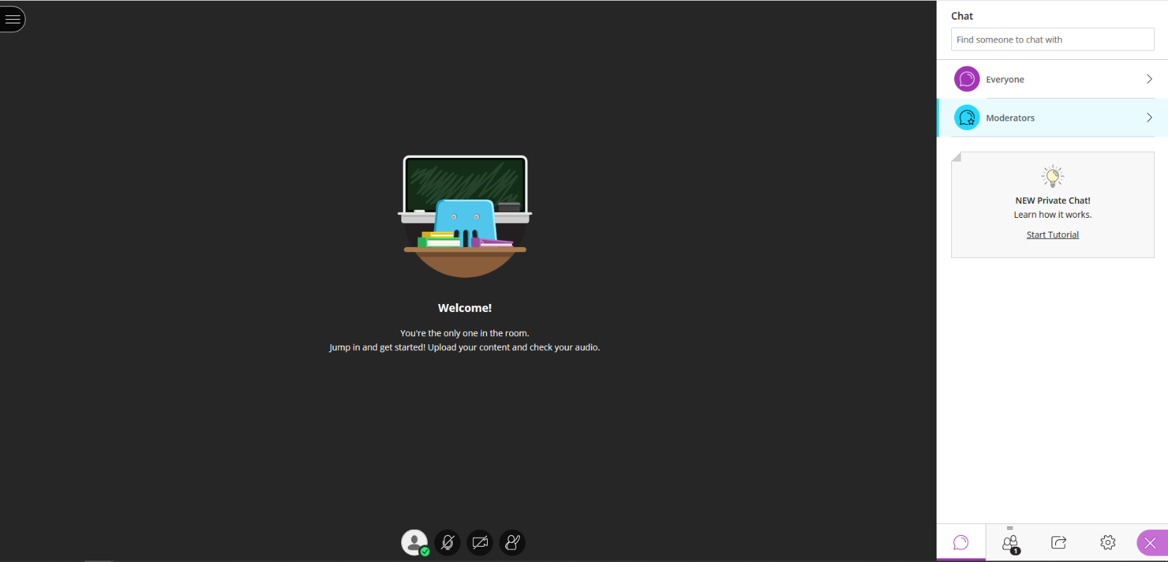

You can record your session by clicking here
Hand up icon
Show/stop showing video
Chat area
Turn microphone on and off
Settings
Information about users
Share content

- Before students enter the room, ensure that your PowerPoint is loaded (this may take a little time if you have a lot of pictures or a significant number of slides). Any other documents which you want students to be able to see (handouts for example will need to be converted to pdfs in order to upload them. Try to have some activities which students can do on paper just as you would in a face to face teaching session.

- Before the session email everyone to remind them that the session is taking place and that they need to use Google Chrome, Firefox or Safari (in my experience, students who are using Internet Explorer or other browsers often cannot hear you and will need to re-enter the session using another browser which gives better accessibility) I also ask students to bring along writing materials, any handouts which have been made accessible to them and a mobile phone for taking photos of the screen.

- Ask all students to log in around 15 minutes before you actually plan to start your session. Students appreciate the chance to informally speak to each other in the Chat box whilst you help to support those who are experiencing any access issues. To check this, I ask students to use the ‘hand up’ icon as I waffle on about something inane! I also type in the ‘Chat’ box to say that I am currently speaking and anyone who cannot hear me should check both their speaker volume and that they are logged in using Chrome, Firefox or Safari. This solves 99% of the issues with speakers. The default setting for student camera and microphone is initially set to ‘off’, although sometimes they will turn them on themselves. If you are using the platform for a one-to-one tutorial, this is fine. In a group setting however having students with microphones on interferes with the user experience for everyone else. You can see which student has their microphone on by clicking the ‘Information about users’ area, a microphone icon will appear next to their name, so you can ask them to switch this off.

- I always have my email screen up in the background so that students who are unable to access the session can contact me and receive a response. This is not a common problem but if a student receives the error code ‘J10’ or ‘J11’ this usually indicates that they are trying to access the session from a firewalled network (like a school or college). This will be less common whilst schools are closed, but if they receive this error code whilst at their home address, this link is useful https://blackboard.secure.force.com/publickbarticleview?id=kA71O0000008PM6 If all else fails there is always the option of students downloading the Blackboard app to their mobile phone and accessing the session through this.

- Although it is a bit scary being on camera (especially when you can’t see others in the room!) please do consider the benefits for students of being able to see you. They really appreciate being able to see your facial expressions and hand movements as you teach and they will get much more out of the session just by having you on screen. It also gives us a reason for a wash and brush up in these strange times of home working and self-isolation!

- In the settings area you can choose options which will make your teaching much easier. For example, under ‘Notification settings’ you can select whether or not you wish to hear a ping when a student sends a chat message to the group or when someone puts their hand up with a question. Under ‘Session Settings’ you can choose to deactivate students’ option to turn on their cameras and microphones. The settings you use will depend on personal preference, but I would advise that you leave the notifications on and that you deactivate only the cameras, leaving students the option to use microphones.

- One reason I recommend leaving students’ microphones on is for the Breakout groups option, which can be found in the ‘Share Content’ area. Once all students are logged in, you will see options here which allow you to place the students randomly into smaller discussion groups of a size of your choosing. While students are in groups, they may wish to turn on their microphones in order to speak to each other. They won’t be able to hear you whilst they are in breakout groups and you won’t be able to hear them (or see what they are typing) so it’s a good idea to give them the current time and tell them what time you will bring them back to the main room. To stop the group sessions just click on the square icon (stop) which will appear once they break out and then check to make sure all microphones are off in the ‘Information about users’ area once they return to the main room.

- There is a whiteboard feature in the ‘Share Content’ area, which is a really useful teaching tool, but there are a few issues to be aware of before using this. Students with slower internet connection may not be able to see this in real time and there is nothing which can be done about this from your end. Often, they find that the content appears after a number of minutes but this can be a little frustrating for them so you may need to narrate what you are writing if this is an issue for anyone in your session. Another pitfall of the whiteboard tool is that the eraser rubs out everything on the screen rather than just erasing the last thing you drew/wrote. Also, once you close the whiteboard, to return to your slides for example, everything on the whiteboard is lost. Students having a mobile phone with them means that you can prompt them to take a photo of the screen for later reference.

- Another useful tool for teaching is the ‘Polling’ option, which can also be found in the ‘Share Content’ area. Here you can quickly create polls which are either multiple choice or Yes/No. Great for seeing the overall feeling of the group for lots of reasons but will also show you how many of the students who are logged in are actually engaging in the session.

- Another option available in the ‘Sharing Content’ area is to ‘Share screen/application’. This works well, depending on what you are trying to share with students. If you wish to share a Word document that you have open this tends to be issue-free. If, however, you try to share your current internet screen with students (to demonstrate how to search on the library catalogue for example) you will find that this opens infinite versions of your screen, like looking at the reflections between two mirrors. If you have two screens attached to your PC you can get around this issue by selecting your other screen. If you only have one monitor, you will need to use screenshots or a Word document instead.

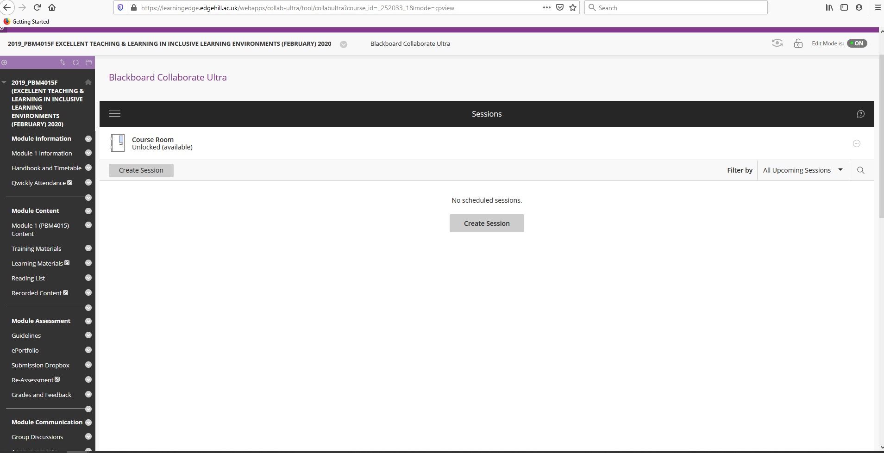
- If you have recorded your session, this will automatically save to the VLE area in which you are teaching. Depending on the length of the session this may take some time to become available but once this has copied across students will be able to access this immediately, by clicking on the icon circled below:

I hope you find this guide useful in getting started with your online teaching. Take care and stay safe everyone!

